Task 1:
Source code:
#include <stdio.h>
int main() {
float attendance;

printf("Enter attendance percentage: ");
scanf("%f", & attendance);

if (attendance >= 75) {
printf("Eligible for Exam\n");
} else {
printf("Not Eligible for Exam");
}

return 0;
}

Output:
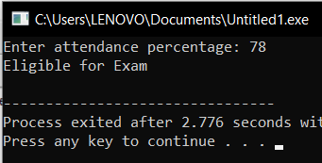

Task 2:
Source Code:
#include <stdio.h>

int main() {
int units;

printf("Enter total units consumed: ");
scanf("%d", &units);

if (units <= 100) {
printf("Low Usage\n");
}
else if (units <= 300) {
printf("Medium Usage\n");
}
else {
printf("High Usage\n");
}

return 0;
}

Output:
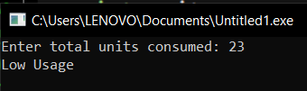

Task 3:
Source Code:
#include <stdio.h>

int main() {
int num;

printf("Enter an integer: ");
scanf("%d", &num);

if (num > 0) {
printf("Positive\n");
}
else if (num < 0) {
printf("Negative\n");
}
else {
printf("Zero\n");
}

return 0;
}

Output:
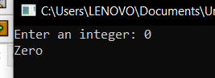

Task 4:
Source Code:
#include <stdio.h>
#include <string.h>

int main() {
char username[20];
int password;

printf("Enter username: ");
scanf("%s", username);

printf("Enter password: ");
scanf("%d", &password);

if (strcmp(username, "admin") == 0 && password == 1234) {
printf("Login Successful\n");
} else {
printf("Invalid Credentials\n");
}

return 0;
}

Output:
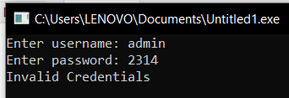

Task 5:
Source Code:
#include <stdio.h>

int main() {
int choice;

printf("ATM Menu\n");
printf("1. Balance Inquiry\n");
printf("2. Cash Withdrawal\n");
printf("3. Deposit\n");
printf("4. Exit\n");

printf("Enter your choice: ");
scanf("%d", &choice);

switch (choice) {
case 1:
printf("You selected Balance Inquiry\n");
break;
case 2:
printf("You selected Cash Withdrawal\n");
break;
case 3:
printf("You selected Deposit\n");
break;
case 4:
printf("Exit\n");
break;
default:
printf("Invalid Choice\n");
}

return 0;
}
Output:
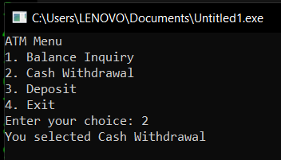

Task 6:
Source Code:
#include <stdio.h>

int main() {
int m1, m2, m3, m4, m5;
float total, percentage;

printf("Enter marks of 5 subjects (0–100):\n");
scanf("%d %d %d %d %d", &m1, &m2, &m3, &m4, &m5);

total = m1 + m2 + m3 + m4 + m5;
percentage = (total / 500) * 100;

if (percentage >= 85) {
printf("Grade A\n");
}
else if (percentage >= 70) {
printf("Grade B\n");
}
else if (percentage >= 50) {
printf("Grade C\n");
}
else {
printf("Fail");
}

return 0;
}

Output:
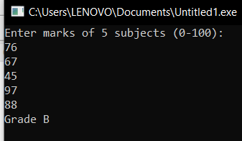

Task 7:
Source Code:
Task 7:
#include <stdio.h>

int main() {
float billAmount;

printf("Enter total bill amount: ");
scanf("%f", &billAmount);

if (billAmount >= 5000) {
printf("20%% discount\n");
}
else if (billAmount >= 3000) {
printf("10%% discount\n");
}
else {
printf("No discount\n");
}

return 0;
}

Output:
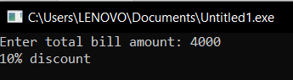

Task 8:
Source Code:
Task 8:
#include <stdio.h>
#include <math.h>

int main() {
int choice;
double num1, num2, result;

printf("Scientific Calculator Menu\n");
printf("1. Addition\n");
printf("2. Subtraction\n");
printf("3. Multiplication\n");
printf("4. Division\n");
printf("5. Square of a number\n");
printf("6. Cube of a number\n");
printf("7. Square Root of a number\n");
printf("8. Power (x^y)\n");
printf("9. Absolute Value\n");

printf("Enter your choice: ");
scanf("%d", &choice);

switch (choice) {
case 1:
printf("Enter two numbers: ");
scanf("%lf %lf", &num1, &num2);
result = num1 + num2;
printf("Result = %.2lf\n", result);
break;

case 2:
printf("Enter two numbers: ");
scanf("%lf %lf", &num1, &num2);
result = num1 - num2;
printf("Result = %.2lf\n", result);
break;

case 3:
printf("Enter two numbers: ");
scanf("%lf %lf", &num1, &num2);
result = num1 * num2;
printf("Result = %.2lf\n", result);
break;

case 4:
printf("Enter two numbers: ");
scanf("%lf %lf", &num1, &num2);
if (num2 == 0) {
printf("Error: Division by zero is not allowed.\n");
} else {
result = num1 / num2;
printf("Result = %.2lf\n", result);
}
break;

case 5:
printf("Enter a number: ");
scanf("%lf", &num1);
result = num1 * num1;
printf("Square = %.2lf\n", result);
break;

case 6:
printf("Enter a number: ");
scanf("%lf", &num1);
result = num1 * num1 * num1;
printf("Cube = %.2lf\n", result);
break;

case 7:
printf("Enter a number: ");
scanf("%lf", &num1);
if (num1 < 0) {
printf("Error: Cannot compute square root of negative number.\n");
} else {
result = sqrt(num1);
printf("Square Root = %.2lf\n", result);
}
break;

case 8:
printf("Enter base and exponent: ");
scanf("%lf %lf", &num1, &num2);
result = pow(num1, num2);
printf("Result = %.2lf\n", result);
break;

case 9:
printf("Enter a number: ");
scanf("%lf", &num1);
result = fabs(num1);
printf("Absolute Value = %.2lf\n", result);
break;

default:
printf("Invalid Choice\n");
}

return 0;
}

Output:
