PF LAB 1
Objective of the Lab 01.
The objective of these lab tasks is to design flowcharts, algorithms, and Scratch programs to understand basic programming concepts such as taking user input, performing calculations, and displaying results. These tasks include creating a student record system to input student details and calculate total marks and percentage, calculating the area of a rectangle using given dimensions, and converting temperature from Celsius to Fahrenheit using a standard formula. Together, these tasks help in developing logical thinking, problem-solving skills, and practical understanding of Scratch programming.

Task 1:
Scratch:
Description:
When the green flag is clicked, the program starts running. It first asks the user to enter the student’s ID and stores the entered value in the student id variable. Then it asks for the student’s name and saves the input in the student name variable. After that, the program asks the user to enter marks for subject 1, subject 2, and subject 3 one by one, and stores each entered value in the sub1marks, sub2marks, and sub3marks variables. Next, the program calculates the obtained marks by adding the marks of all three subjects. It then calculates the percentage by dividing the obtained marks by 3 to find the average marks. Finally, the program displays the student ID, student name, obtained marks, and percentage on the screen one after another, each for 2 seconds, so the complete result can be viewed clearly.

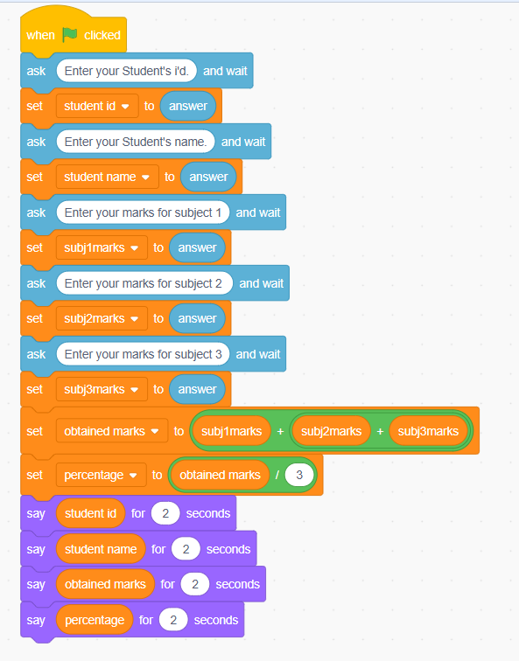
Algorithm:
- Start.
- Input the student’s ID from the user.
- Store the entered student ID in the student id variable.
- Input the student’s name from the user.
- Store the entered name in the student name variable.
- Input marks for subject 1 from the user.
- Store the marks in the sub1marks variable.
- Input marks for subject 2 from the user.
- Store the marks in the sub2marks variable.
- Input marks for subject 3 from the user.
- Store the marks in the sub3marks variable.
- Calculate the obtained marks by adding marks of all three subjects.
- Store the total in the obtained marks variable.
- Calculate the percentage by dividing the obtained marks by 3.
- Store the calculated value in the percentage variable.
- Display the student ID on the screen for 2 seconds.
- Display the student name on the screen for 2 seconds.
- Display the obtained marks on the screen for 2 seconds.
- Display the percentage on the screen for 2 seconds.
- Stop.

Flowchart:
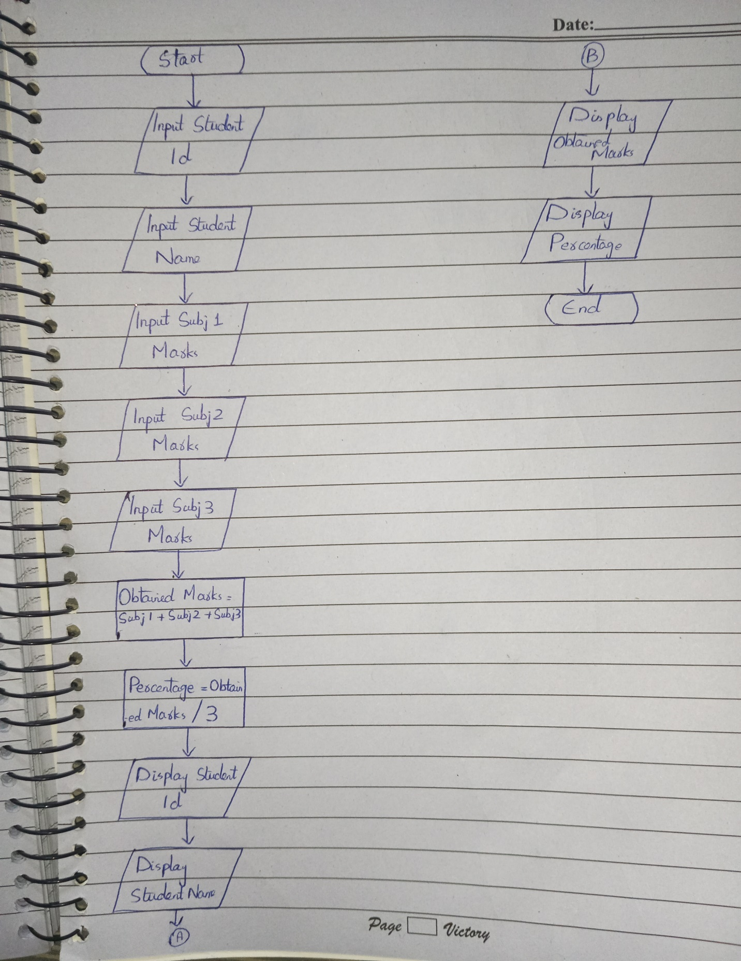
Task 2
Scratch:
Description:
When the green flag is clicked, the program starts running. It first asks the user to enter the length of the rectangle and stores the entered value in the length variable. Then, it asks the user to enter the width of the rectangle and saves the input in the width variable. After that, the program calculates the area by multiplying the length and width and stores the result in the area variable. Finally, the program displays the calculated area on the screen for 2 seconds so the user can see the area of the rectangle.

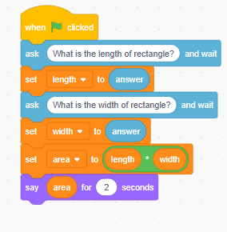
Algorithm:
- Start.
- Ask the user to enter the length of the rectangle.
- Store the length value.
- Ask the user to enter the width of the rectangle.
- Store the width value.
- Calculate the area by multiplying length and width.
- Display the area.
- Stop.
Flowchart:
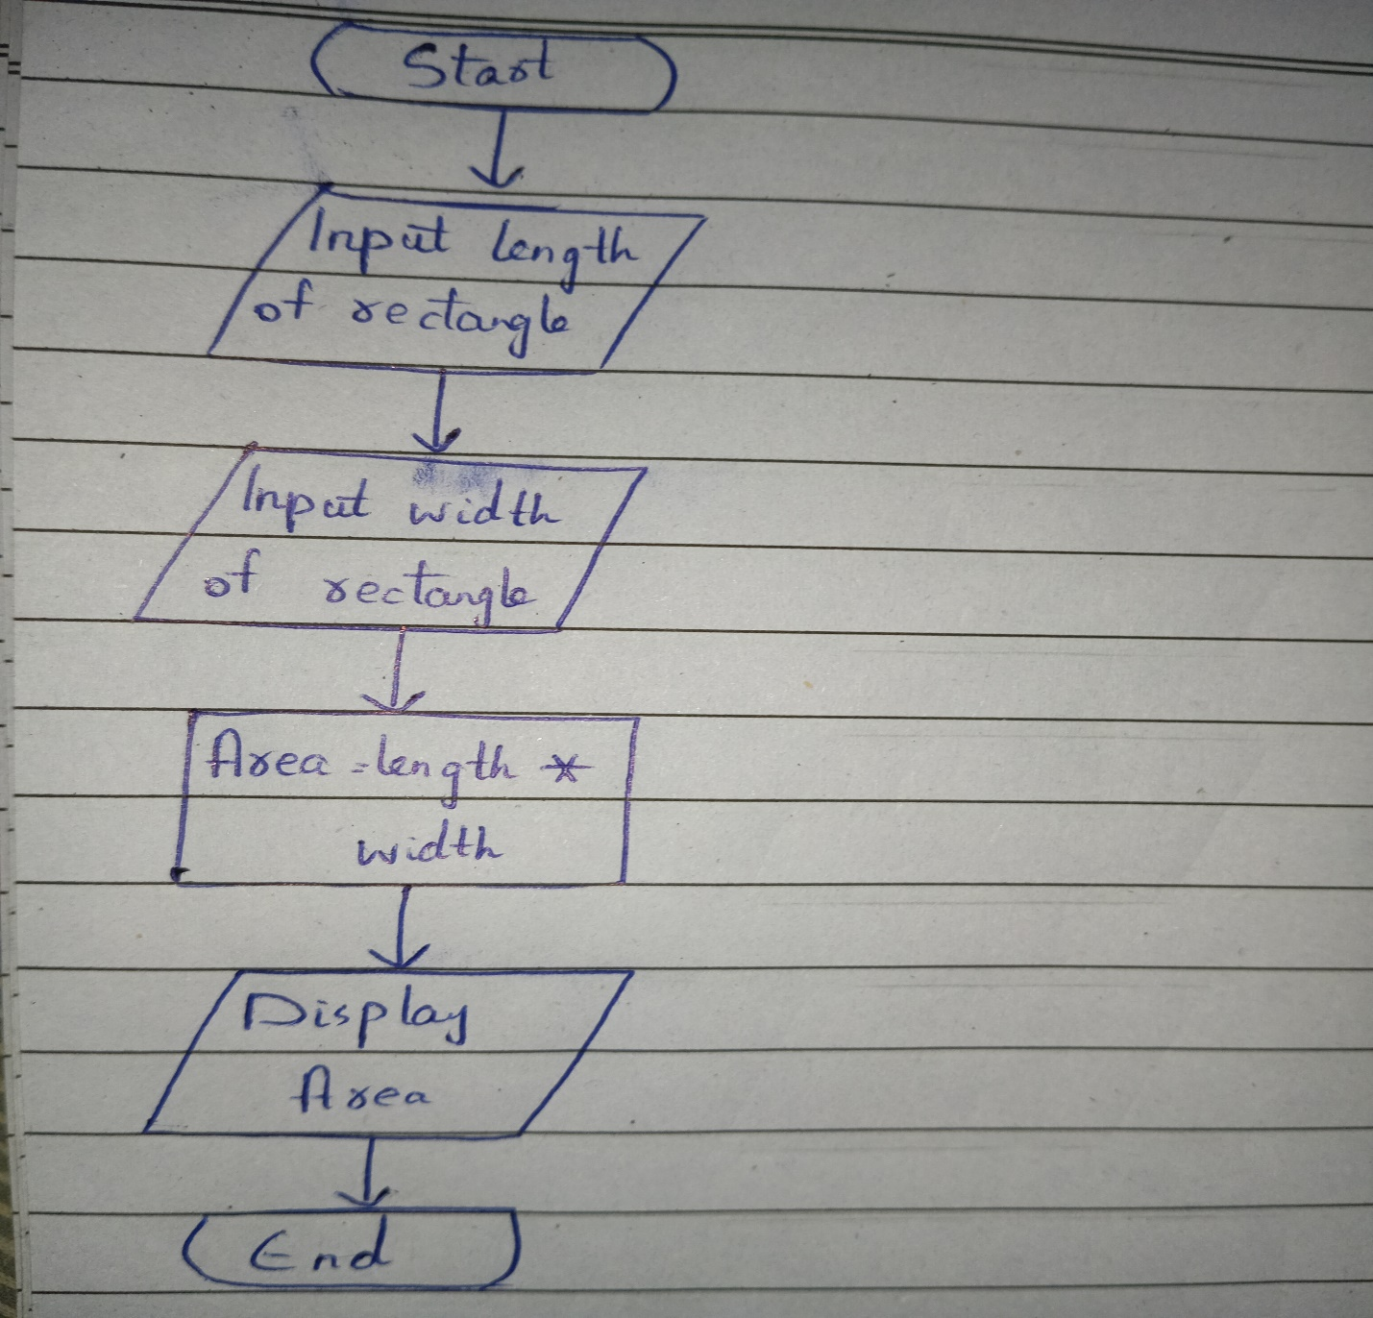
Task 3:
Scratch:
Description:
When the green flag is clicked, the program starts running. It first asks the user to enter the temperature in Celsius and waits for the input. The entered value is then stored in the celsius variable. After that, the program converts the temperature into Fahrenheit by multiplying the celsius value by 1.8 and then adding 32, and stores the result in the fahrenheit variable. Finally, the program displays the calculated Fahrenheit temperature on the screen for 2 seconds.
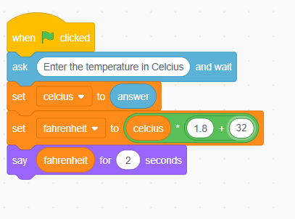
Algorithm:
- Start.
- Ask the user to enter the temperature in Celsius.
- Store the Celsius value.
- Convert Celsius to Fahrenheit using the formula:
Fahrenheit = (Celsius × 1.8) + 32
- Store the calculated Fahrenheit value.
- Display the Fahrenheit temperature on the screen.
- End.

Flowchart:
