PF LAB 2
Objectives:
- To learn how to take user input and show output.
- To understand how to store data using variables.
- To perform math calculations like addition, subtraction, and modulo.
- To use if-else blocks for making decisions.
- To use loops for repeating tasks and drawing shapes.
- To generate random numbers for interactive games.
- To integrate geometry with programming by using loops to control drawing tools like the Pen Extension.
Task 1:
Scratch:
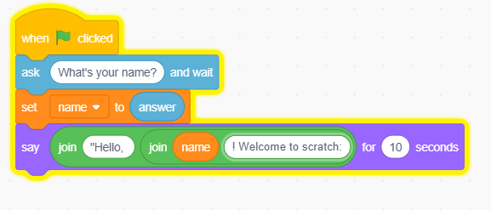

Description:
This program uses an input block to get the user's name. It stores the name in a variable and combines it with a greeting message to display on the screen.
Algorithm:
- Start.
- Ask name of the user and wait.
- Set name variable to user answer.
- Join the greeting text with the name.
- Say the final message for 10 seconds.
- End.
Task 2:
Scratch:
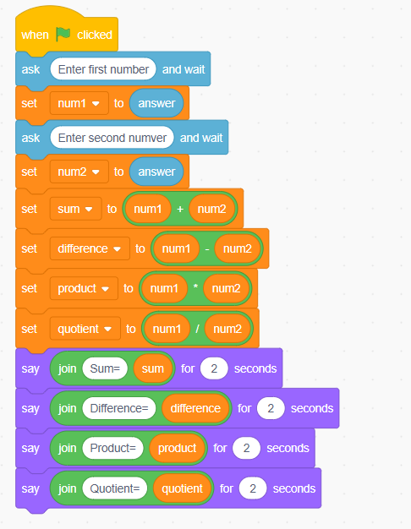
Description:
The script takes two numerical values from the user. It uses math operators to find the sum, difference, product, and quotient, then displays them one by one.
Algorithm:
- Start.
- Input two numbers from the user.
- Perform addition, subtraction, multiplication, and division.
- Store results in separate variables.
- Say each result one by one.
- End.
Task 3:
Scratch:
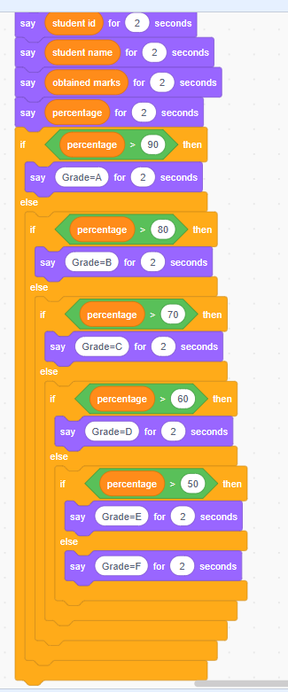

Description:
This task uses nested if-else blocks to check a score against different ranges. It assigns a specific grade based on which condition is met first.
Algorithm:
- Start.
- Check if marks are greater than 90, 80, 70, 60, or 50.
- Assign the correct letter grade based on the value.
- Display the grade using the say block.
- End.
Task 4:

Scratch:
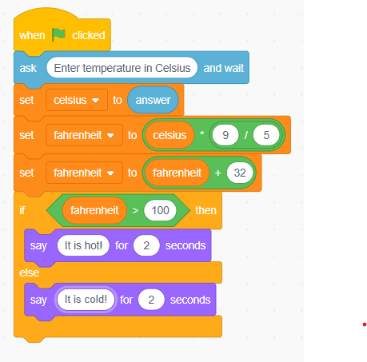

Description:
It converts Celsius to Fahrenheit using a formula. It then uses a decision block to tell the user if the temperature is high or low.
Algorithm:
- Start.
- Input the temperature value in Celsius.
- Use the formula to calculate Fahrenheit.
- If result is greater than 100 say Hot, else say Cold.
- End.

Task 5:
Scratch:
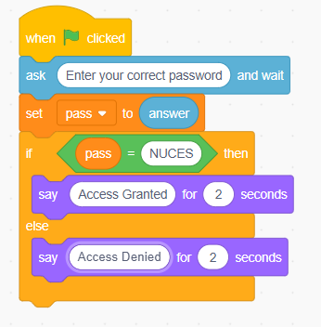
Description:
This program compares the user's text input to a saved password. It uses an if-else block to control access based on whether the text matches exactly.
Algorithm:
- Start.
- Ask the user to enter a password.
- If the input matches the correct word say Access Granted.
- If the input is wrong say Access Denied.
- End.
Task 6:
Scratch:
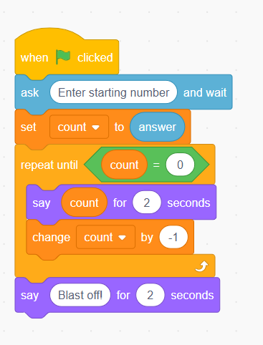

Description:
This script creates a timer using a repeat loop. It displays the current count and decreases the variable by one in every cycle until it reaches zero.
Algorithm:
- Start.
- Set a count variable to a starting number.
- Repeat until the variable reaches zero.
- Display the number and decrease it by 1 in each step.
- Say Blast off at the end.
- End.
Task 7:
Scratch:
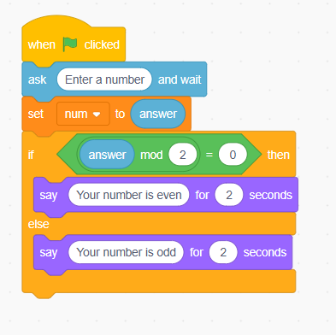

Description:
This program uses the modulo operator to find the remainder of a division by 2. If the remainder is zero, the number is identified as even.
Algorithm:
- Start.
- Input a whole number from the user.
- Check the remainder of the number divided by 2.
- If remainder is 0 say Even, else say Odd.
- End.
Task 8:
Scratch:
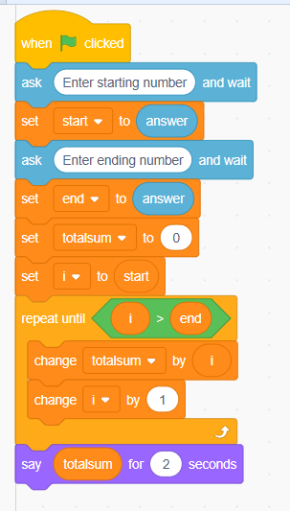
Description:
It uses a loop to go through a range of numbers. Each number is added to a total variable to calculate the final sum of the entire range.
Algorithm:
- Start.
- Input a starting and ending number.
- Use a loop to visit every number in between.
- Add each number to a total sum variable.
- Say the final sum result.
- End.
Task 9:
Scratch:
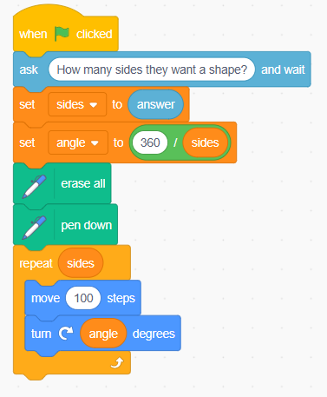

Description:
This task uses the pen tool and a repeat loop. It calculates the turn angle by dividing 360 by the number of sides to draw a perfect geometric shape.
Algorithm:
- Start.
- Input the number of sides for the shape.
- Calculate the turn angle by dividing 360 by sides.
- Move and turn inside a loop based on the side count.
- End.
Task 10:
Scratch:
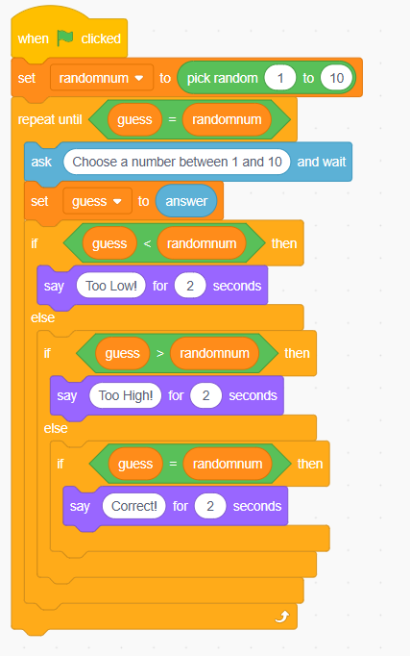

Description:
The scratch picks a random target number. The user keeps guessing inside a loop while the program provides hints until the guess is correct.
Algorithm:
- Start.
- Pick a random number between 1 and 10.
- Repeat asking for a guess until it matches the number.
- Give High or Low hints based on the user guess.
- Say Correct when they win.
- End.
Flowcharts
Task 1:
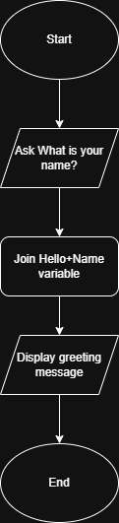
Task 2:
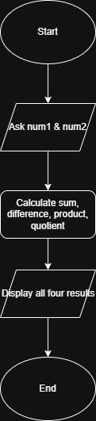
Task 3:
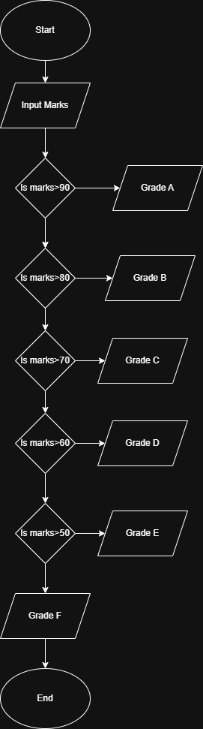
Task 4:
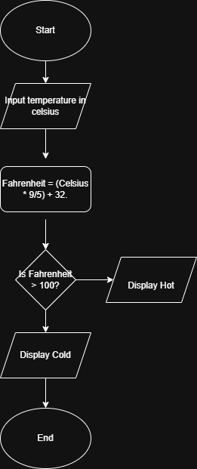

Task 5:
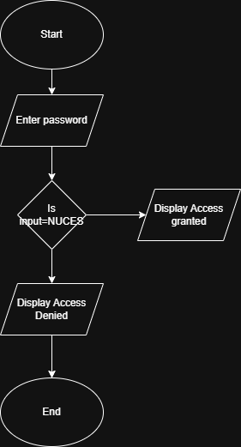

Task 6:
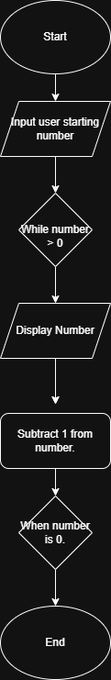

Task 7:
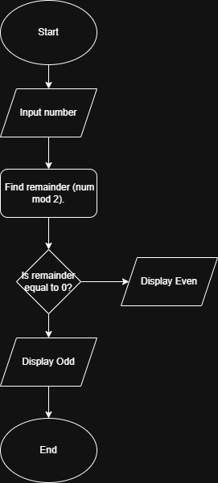
Task 8:
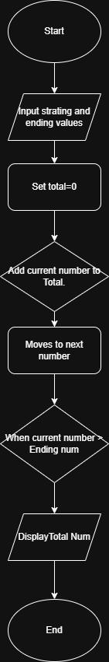
Task 9:
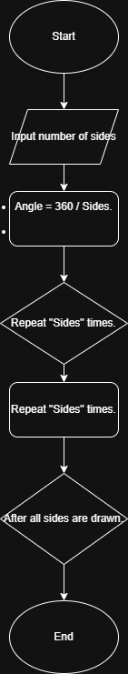

Task 10;
