Github profile link: https://github.com/r4yyanx/PF-Lab-03
Lab 5 Tasks
Q1:
#include <stdio.h>
int main() {
float cgpa;
float familyIncome;
printf("Enter CGPA: ");
scanf("%f", &cgpa);
printf("Enter Family Income: ");
scanf("%f", &familyIncome);
if (cgpa >= 3.5) {
if (familyIncome < 50000) {
printf("You are eligible for a 100%% Scholarship.\n");
} else {
printf("You are eligible for a 50%% Scholarship.\n");
}
} else {
if (cgpa >= 3.0 && familyIncome < 40000) {
printf("You are eligible for a 25%% Scholarship.\n");
} else {
printf("You are not eligible for any scholarship.\n");
}
}
return 0;
}
Output:
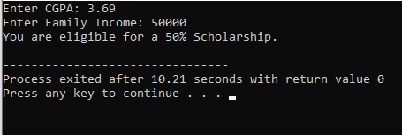

Q2:
#include <stdio.h>

int main() {
int units;
char customerType;
float totalBill;

printf("Enter the number of units consumed: ");
scanf("%d", &units);

printf("Enter the customer type (D for Domestic, C for Commercial): ");
scanf(" %c", &customerType);

if (units <= 100) {
totalBill = units * 10;
} else if (units > 100 && units <= 300) {
if (customerType == 'D' || customerType == 'd') {
totalBill = units * 12;
} else if (customerType == 'C' || customerType == 'c') {
totalBill = units * 15;
} else {
printf("Invalid customer type entered.\n");
return 1;
}
} else if (units > 300) {
totalBill = units * 20;
} else {
printf("Invalid input.\n");
return 1;
}

printf("Total electricity bill: Rs. %.2f\n", totalBill);

return 0;
}
Output:
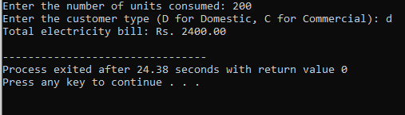
Q3:
#include <stdio.h>
int main() {
int vehicleType, parkingType, hours, fee;
printf("Enter Vehicle Type (1-Car, 2-Bike, 3-Bus): ");
scanf("%d", &vehicleType);
switch(vehicleType) {
case 1:
printf("Enter Parking Type (1-Regular, 2-VIP): ");
scanf("%d", &parkingType);
printf("Enter Hours Parked: ");
scanf("%d", &hours);
switch(parkingType) {
case 1: fee = 50 * hours; break;
case 2: fee = 100 * hours; break;
default: printf("Invalid Parking Type\n"); return 0;
}
break;
case 2:
printf("Enter Parking Type (1-Regular, 2-Premium): ");
scanf("%d", &parkingType);
printf("Enter Hours Parked: ");
scanf("%d", &hours);
switch(parkingType) {
case 1: fee = 20 * hours; break;
case 2: fee = 40 * hours; break;
default: printf("Invalid Parking Type\n"); return 0;
}
break;
case 3:
printf("Enter Hours Parked: ");
scanf("%d", &hours);
fee = 200 * hours;
break;
default:
printf("Invalid Vehicle Type\n");
return 0;
}
printf("Total Parking Fee: Rs. %d\n", fee);
return 0;
}
Output:
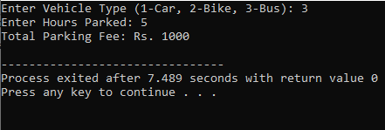
Q4:
#include <stdio.h>
int main(){
int category,item,quantity,price,total;
printf("Enter Category (1-Fast Food,2-Desi Food): ");
scanf("%d",&category);
switch(category){
case 1:
printf("Select Item (1-Burger,2-Pizza): ");
scanf("%d",&item);
switch(item){
case 1:price=500;printf("Selected: Burger\n");break;
case 2:price=1200;printf("Selected: Pizza\n");break;
default:printf("Invalid Item\n");return 0;
}
break;
case 2:
printf("Select Item (1-Biryani,2-Karahi): ");
scanf("%d",&item);
switch(item){
case 1:price=350;printf("Selected: Biryani\n");break;
case 2:price=1500;printf("Selected: Karahi\n");break;
default:printf("Invalid Item\n");return 0;
}
break;
default:printf("Invalid Category\n");return 0;
}
printf("Enter Quantity: ");
scanf("%d",&quantity);
total=price*quantity;
printf("Total Bill: Rs. %d\n",total);
return 0;
}
Output:
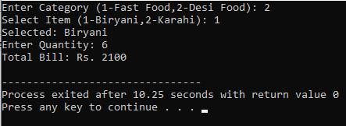
Q5:
#include <stdio.h>
int main(){
float salary,bonus;
int service;
printf("Enter Salary: ");
scanf("%f",&salary);
printf("Enter Years of Service: ");
scanf("%d",&service);
bonus=(service>10)?salary*0.30:(service>5)?salary*0.20:salary*0.10;
printf("Bonus Amount: %.2f\n",bonus);
return 0;
}
Q5:
#include <stdio.h>
int main(){
float salary,bonus;
int service;
printf("Enter Salary: ");
scanf("%f",&salary);
printf("Enter Years of Service: ");
scanf("%d",&service);
bonus=(service>10)?salary*0.30:(service>5)?salary*0.20:salary*0.10;
printf("Bonus Amount: %.2f\n",bonus);
return 0;
}
Output:
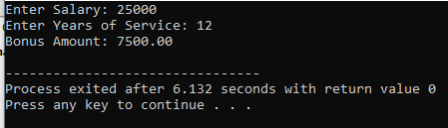
Q6:
#include <stdio.h>
int main(){
float a,b,c;
printf("Enter three sides: ");
scanf("%f%f%f",&a,&b,&c);
if(a+b<=c||a+c<=b||b+c<=a){
printf("Not a valid triangle\n");
}else{
if(a==b&&b==c){
printf("Equilateral Triangle\n");
}else{
if(a==b||a==c||b==c){
printf("Isosceles Triangle\n");
}else{
printf("Scalene Triangle\n");
}
}
}
return 0;
}
Output:
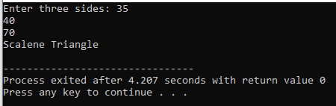
Q7:
#include <stdio.h>

int main() {
int correctID = 101;
int correctPass = 5555;
int correctOTP = 77;

int inputID, inputPass, inputOTP;

printf("Enter ID: ");
scanf("%d", &inputID);

if (inputID == correctID) {
printf("Enter Password: ");
scanf("%d", &inputPass);

if (inputPass == correctPass) {
printf("Enter OTP: ");
scanf("%d", &inputOTP);

if (inputOTP == correctOTP) {
printf("Login Successful!\n");
} else {
printf("Invalid OTP.\n");
}
} else {
printf("Incorrect Password.\n");
}
} else {
printf("Invalid ID.\n");
}

return 0;
}
Output:
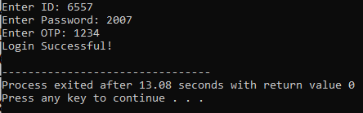
Q8:
#include <stdio.h>
#include <math.h>

int main() {
int choice;
double x, y, result;

printf("Advanced Scientific Calculator \n");
printf("1. Addition 2. Subtraction 3. Multiplication\n");
printf("4. Division 5. Square Root 6. Power (x^y)\n");
printf("7. Logarithm 8. Absolute Value 9. Sine\n");
printf("10. Cosine 11. Tangent\n");
printf("--------------------------------------\n");
printf("Enter your choice (1-11): ");
scanf("%d", &choice);

switch (choice) {
case 1:
printf("Enter two numbers: ");
scanf("%lf %lf", &x, &y);
printf("Result: %.2f\n", x + y);
break;

case 2:
printf("Enter two numbers: ");
scanf("%lf %lf", &x, &y);
printf("Result: %.2f\n", x - y);
break;

case 3:
printf("Enter two numbers: ");
scanf("%lf %lf", &x, &y);
printf("Result: %.2f\n", x * y);
break;

case 4:
printf("Enter two numbers: ");
scanf("%lf %lf", &x, &y);
if (y != 0) {
printf("Result: %.2f\n", x / y);
} else {
printf("Error: Division by zero is not allowed.\n");
}
break;

case 5:
printf("Enter number: ");
scanf("%lf", &x);
if (x >= 0) {
printf("Result: %.2f\n", sqrt(x));
} else {
printf("Error: Square root of a negative number is not allowed.\n");
}
break;

case 6:
printf("Enter base (x) and power (y): ");
scanf("%lf %lf", &x, &y);
printf("Result: %.2f\n", pow(x, y));
break;

case 7:
printf("Enter number: ");
scanf("%lf", &x);
if (x > 0) {
printf("Result: %.2f\n", log10(x));
} else {
printf("Error: Logarithm of zero or negative is not allowed.\n");
}
break;

case 8:
printf("Enter number: ");
scanf("%lf", &x);
printf("Result: %.2f\n", fabs(x));
break;

case 9:
printf("Enter angle in radians: ");
scanf("%lf", &x);
printf("Result: %.2f\n", sin(x));
break;

case 10:
printf("Enter angle in radians: ");
scanf("%lf", &x);
printf("Result: %.2f\n", cos(x));
break;

case 11:
printf("Enter angle in radians: ");
scanf("%lf", &x);
printf("Result: %.2f\n", tan(x));
break;

default:
printf("Invalid selection! Please choose a number between 1 and 11.\n");
}

return 0;
}
Output:
