OCR Computer Science NEA



Bullet hell A-level project using pygame.

OCR Computer Science NEA 1
Analysis 4
Describing the problem. 4
The goal 4
Explanation of shoot ‘em up 4
Explanation of bullet hell 5
Identifying the stakeholders. 5
Age and motivation 5
Explanation 5
Form questions 7
Form responses 7
Researching and identifying features. 12
Inspiration 12
Touhou 12
Osu! 15
Geometry dash 17
Limitations 18
Outlining computational methods. 19
Abstraction 19
Visualisation 20
Logic and Pipelining 21
Specifying game requirements. 23
Development hardware used 23
Hardware requirements 23
Development software used 23
Software requirements 24
Final success criteria 24
The scope of the solution 24
Design 28
Structure of the solution 28
Flow chart 28
Decomposition of the problem 28
Music handler 29
Input manager 30
Event handler 30
State manager 31
Quitting 31
Options 32
UI collision checks 32
Playing the game 33
Pausing the game 33
Collision management 33
Updating entities 33
Editor 34
Saving a stage 34
Creating stages and waves 34
Enemy wave 34
Boss wave 34
Identifying components and structures 35
Classes 35
Development 36
Evaluation 36

Analysis

Describing the problem.

The goal
Using PyCharm Community Edition 2024, I will develop a ‘bullet hell’ game using the module pygame from python, as well as JSON (JavaScript Object Notation) to store metadata. A bullet hell is a subgenre of the popular arcade game genre of ‘shmup’ (or shoot ‘em up).

Explanation of shoot ‘em up
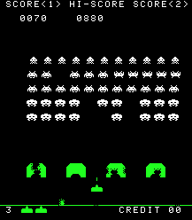
This style of games is commonly described as a 2D shooter where a spaceship or any other substitution for the player moves around the screen and dodges enemies shooting projectiles. The objective is to defeat the enemies on the screen using the players gun or any other form of projectile firing tool. The most famous arcade example of this genre being ‘Space Invaders’ featuring the iconic aliens:

Explanation of bullet hell
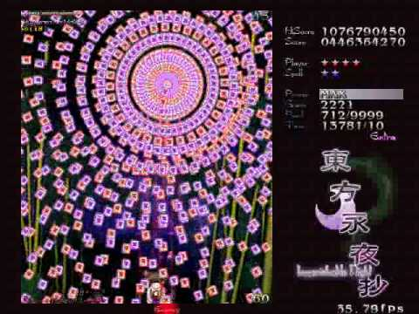
The bullet hell subgenre takes this to the next level by keeping the main objective of defeating enemies but shifting the objective by ramping up the number of bullets on the screen until the focus of the player is to dodge the bullets and survive and defeating enemies becomes a side goal. An example of a Japanese arcade bullet hell called ‘The Touhou Project’ (or just ‘Touhou’) can be seen below:

Identifying the stakeholders.

Age and motivation
The target audience for my game are people anywhere up from 14 years old but will probably be most prevalent with college students who have enjoy playing video games for the personal improvement and sense of achievement it gives, although older video game enthusiasts who enjoy the modernized approach of the arcade origins of my game are also a feasible demographic. The target platform will be most operating systems for computers. The game will be developed in windows 10/11 and Linux mint (a Linux distribution based on debian). While the game will not be tested on macOS, the game will probably run on apple computers as well.

Explanation
The game is suitable for this demographic as it has a high ceiling (there is room for a large amount of skill improvement) however has a low skill floor as the mechanics of a bullet hell are simple to grasp by any person. This means the game can cater to a large audience while pleasing the players that want to push the boundaries of what’s possible in terms of difficulty and spend a lot of time in the game.
To further gather opinions from my target audience I set up a form which I gave out to my peers at my college and other friends online.

Form questions
The questions featured in this form are:
- How would you describe your time spent gaming per week (in hours)?
- What game genres have you played and enjoyed?
- Rate the importance of these features when trying out new games:
  - Difficulty
  - Depth of mechanics
  - Music
  - Story
  - Immersion
- Why do you choose to spend your free time gaming?

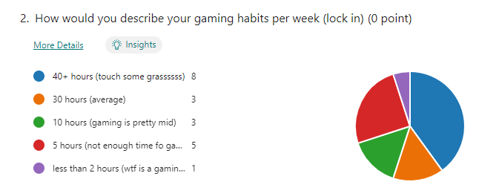
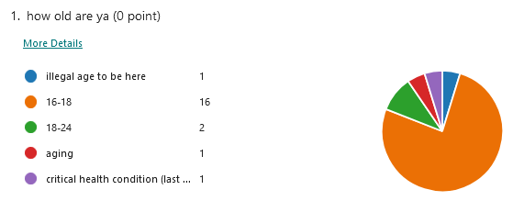
Form responses
The data showed that most people (aged 16-24) spend a large amount of time gaming, meaning they were relatively skilled and would most likely enjoy a game which provides a challenging experience.

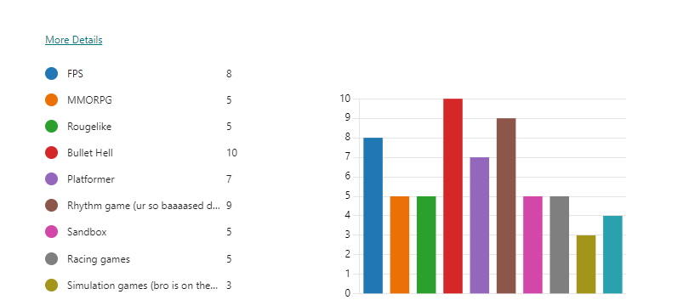
Furthermore, when asked about people’s preferences in the genre of games being made, the most popular response was bullet hell, which means most stakeholders would have some experience with shoot ‘em up games and thus would expect the challenge accompanying similarly styled games. The second and third most popular game genres were both games that are entirely based on the user’s skill that being rhythm games and FPS (first-person shooter) games, proving that games that reward skill are popular among my identified stakeholders.

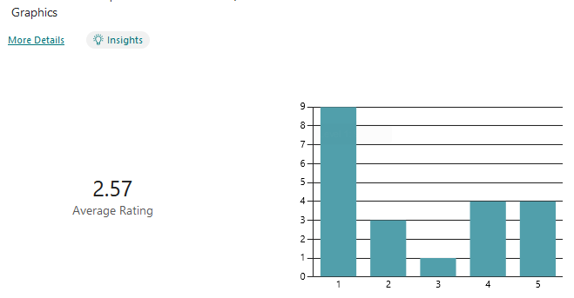
The next set of questions asked people to rate game features on a scale: 1 means the game feature has no impact on how much they enjoy the game, while 5 means the feature plays a big part in if they continue to play the game.
The answers to this question made it apparent that graphics shouldn’t be the main drawing point of my game, which makes sense since that would exclude people with weaker hardware from playing my game. This would in turn make the game less popular to the public.
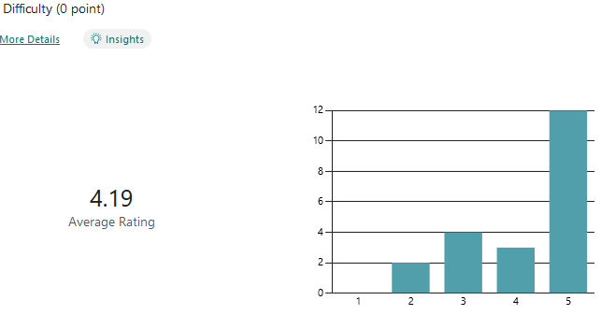
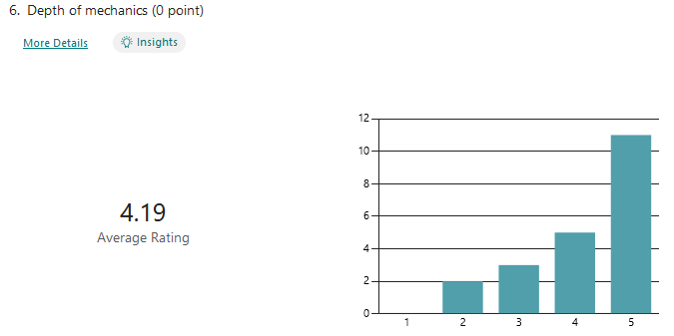
While some may not always enjoy playing an intense, difficulty focused game all the time, it is reasonable that there are other slower paced games people play when relaxing. This is also true for games that require a deep understanding of its mechanics. However, when making my game I am assuming people are playing for the thrill and difficulty and are expecting some depth of mechanics that will take time to master.

To clarify, by depth of mechanics I am referring to the number of actions able to be performed at each moment, and the difficulty to perform those. E.g., while a bullet hell might be difficult, its mechanics are usually quite flat as all that is required are movement keys and a button to shoot which is usually just held down since the concept of ammo doesn’t exist. A mechanically deep game would be one where the user is required to know a lot of keybinds and actions that require significant skill to execute in short succession.
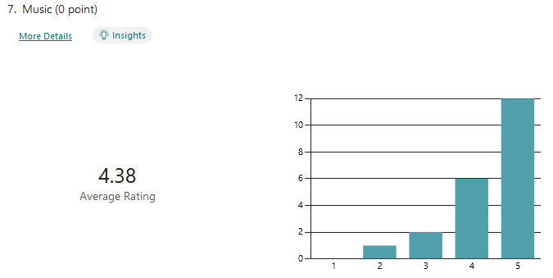
While I won’t be marked for the quality of the music in my game, I made sure to feature music from other game OSTs (Original Soundtracks) that I have enjoyed and tried to fit said music to the theme of my game.
However, even though most people expect a good story in the game their playing, this is misleading in the context of my game, since bullet hell games have never included any story since the games were meant to be played repeatedly at an arcade, rather than a singular playthrough e.g. something like a horror game. I decided to include some fun references to other games or things I like which some people might identify. This will leave the gameplay experience of those who don’t understand the reference the same, while providing a cool ‘easter egg’ (a secret feature that's hidden from players until they discover it) for those who understand it.
What I mentioned above about the inclusion of story can be applied to immersion as well: while people may enjoy immersive/realistic games, people playing bullet hells barely expect any immersion or realism as this is simply not the nature of the genre.
Here I saw that playing with friends is the most popular motivation for gaming, with simply having free time being close behind. This means while making the game somehow multiplayer would definitely attract more customers, I concluded that it was not worth it due to how bullet hells were not designed to be played together meaning not only would I have to come up of a way of making bullet hells compatible with multiplayer, but a large amount of development time and resources (including the cost of running an entire server) would have to be allocated to making this feature as well.

To summarise, based on the form, these are the requirements I ended up setting:
- Minimal focus on graphics
- Large focus on difficulty and gameplay experience
- Make the game replayable
- Add memorable background music
- Add varied interesting mechanics
- Only include lore for people who are looking for it

As for the reasoning for the target platform, I chose PC as the game was made with a keyboard and mouse in mind. A computer makes most sense for this hardware. While you can connect a keyboard and mouse to some consoles and mobile phones, since I will be developing the game on a PC, developing the game for mobile or console would take too much time. While mobile is the most popular platform for gaming, most mobile gamers are not as competitive as PC players, so the majority of the audience I am trying to make my game for plays games on PC.

Researching and identifying features.

Inspiration
My game will feature heavy inspiration from Touhou and other games I’ve played, bullet hell or not, adapted from a 4:3 display ratio to a more modern 16:9 ratio leaving a wide amount of room around the player horizontally allowing more creative bullet patterns and game mechanics.
As mentioned above I have played the bullet hell Touhou extensively and used other games I have played, as well as game design concepts from books I have read to approach the problem. Here I will describe my findings in those games and present my method of making a bullet hell game.

Touhou
The Touhou Project is a series of 2D vertically scrolling bullet hell shooting games made by Team Shanghai Alice. They were originally available to play on arcade, however, became available to play on PCs following the rise in availability of computers.
Since there are over 20 games featured in The Touhou Project, I will be referring to ‘Touhou Koumakyou: the Embodiment of Scarlet Devil’, the sixth game in the franchise, as I have the most time spent playing that game. From now on I will refer to this game as simply ‘Touhou 6’.
- Touhou 6 feature a set of available characters to pick from which change up the gameplay. Each character has multiple available shot types to pick from e.g. homing bullets in a wide spread, or fast-moving narrow bullets in a straight line. Below is an example of a ‘shot type’ from another Touhou game. It has a wide spread of blue bullets and 2 red lasers.

- The game has only one ‘level’, however the level is split up into stages, which are further split up into sections. Each stage has a theme and background to go along with it, e.g. a vampire mansion of a frozen lake. Each stage is split up into 4 sections.
- Section 1 and 3 consist of hordes of weaker enemies like what you would expect from a classic bullet hell, while stages 2 and 4 feature a singular stronger enemy. Usually, the stage 2 enemy is a weaker version of the boss that prepares the player for stage 4.
- The bosses (strong stage 4 enemies) in Touhou 6 have specific attacks, or bullet patterns that can be learned to improve at fighting the boss. These are identified by ‘spell cards’ that announces the name of the attack. The attack can be either ended by dealing enough damage to the boss, or by running out of time (each spell card starts a timer that ticks down to signify the duration of the attack. The final spell card sometimes cannot be ended by dealing enough damage and must instead by ended purely by surviving the attack.
- The game also features a ‘bomb’ system. This is an expendable resource that deletes all bullets on the screen and makes the character invulnerable for a short period, while dealing massive damage to the enemies on screen. The type of bomb is also dependent on the shot type picked.
- It also features a level system, whereby killing enemies drops a pickup which contribute to levelling up. Levels increase the number of bullets fired by the player, and upon reaching the level cap, all pickups turn into bonus points that reward an extra life after enough has been picked up (life system explained below). Referring back to the image of the shot type, you can see that the power bar is at MAX. If this was level one, you might expect way less blue bullets and the lack of the red lasers.
- The game uses a health system, with a life being lost each time the player collides with the enemy. Upon colliding, all enemies and their health persist through death and the game continues from the exact point the player died at. However, all bullets are cleared from the screen, the player loses some levels and becomes immune to dying again for a short period to help prepare for the next attack.
- A handy game mechanic is present in the form of ‘death bombing’ that is triggered by pressing the key to activate a bomb and is available for a tiny period after dying. At this point the player has not gone through the death and respawn animation yet, so the bomb triggers as if the player is still alive. This will not take any lives away from the player and the game will play out as if the player had bombed to avoid damage instead of dying and having 1 health removed.
From my analysis of Touhou 6, I have decided to implement the following features:
- The player has a set number of lives, with the game ending when the lives reach zero. Having the player’s game end immediately at any mistake will make the game not be fun to learn, so introducing a set amount of lives keeps some difficulty but leaves room for error to learn the game.
- Touching a bullet instantly kills the player and removes a life and resets the position of the user to the bottom of the screen. In order to have the game’s focus be on dodging bullets, having hitting bullets provide immediate feedback provides an intuitive goal.
- There is some form of ability to make the player invulnerable or assist in defeating enemies. A special ability provides diversity in the gameplay in that different characters in the game can have different abilities with different benefits. In addition to this an ability to become invulnerable or removing all bullets on the screen provides a way to skip some bullet patterns that are problematic to learn improves the enjoyment of the game.
- Using the ability mentioned within a short time-frame of dying reverts the effects of the death. Rewarding the player for their reflexes when getting hit by a bullet raises the games skill ceiling and helps remove deaths that would feel unfair to the player.
- There are stages featuring different waves and a set theme. This keeps the game diverse and makes it obvious that the player is progressing through the game. It also acts as a way to visualise how far into the game you are by paying attention to which stage you are in.
- Stages feature enemies appearing in waves with a final challenge at the end. The fights being formatted into waves means that the player has time to rest while new enemies are appearing after the previous ones. The challenge at marks the end of the stage and provides a different style of gameplay and serves as the focus of the entire stage.
- Attacks from tough enemies will be telegraphed in some way. This provides the player with a way for anticipating and dodging attacks and means they get less frustrated when dying.
- There are multiple characters to select from. This provides game replayability and provides a different playstyle for each character which appeals to a larger audience as there are more ways of playing to choose from e.g. fast character, character that deals a lot of damage but can easily die.
- Characters have multiple types of bullets to choose from. This means each character has an added layer of complexity and more playstyles and their variations can be derived from less characters (which are harder to design and make than bullets)
- Enemies drop collectibles which upgrade the player’s bullet. This provides an incentive to take risks in killing as many enemies as possible and getting closer to the enemy to pick up the upgrade.

Osu!
Osu! is a free-to-play rhythm game originally created and self-published by Australian developer Dean Herbert. Inspired by gameplay of the Osu! Tatakae! Ouendan series (released on the 28th of July 2005), it was released for Microsoft Windows on 16 September 2007. While Osu! is not a bullet hell game, I took great inspiration from Osu! when making the editor for my game. Osu! is a rhythm game where circles appear on the screen in set places and you have to aim and click them to the beat of a song playing. There are also sliders that you have to drag instead of click to the beat, and spinners which you have to spin as fast as possible. It features an editor for making ‘maps’ for different songs:
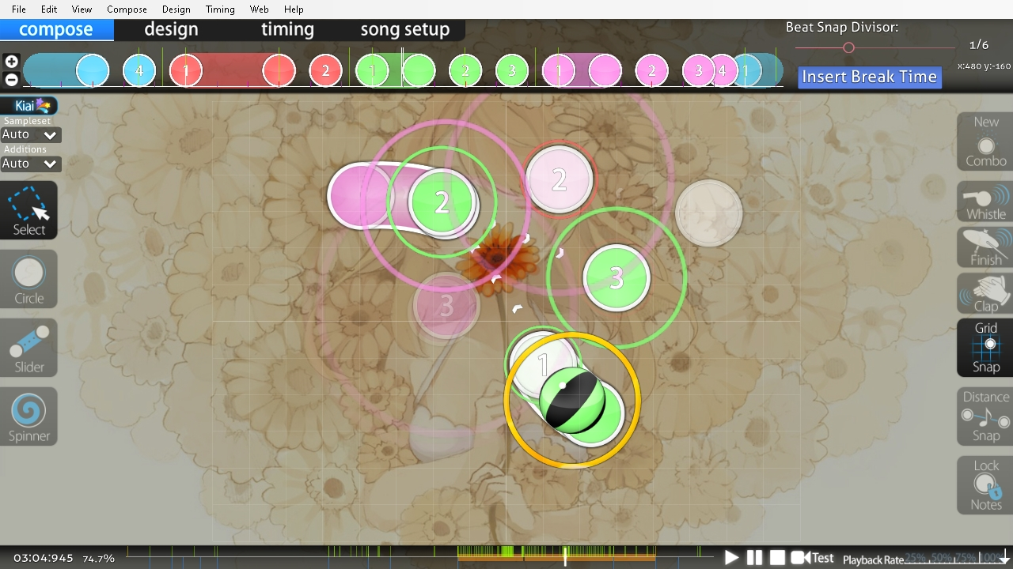
- Osu!’s main editor screen is split up into 5 UI (User Interface) elements: a side bar on the left, a sidebar on the right, a timeline at the top, a timeline at the bottom and a grid for placing objects that covers the rest of the screen.
- The timeline at the top has a header that can be dragged forward and back. The timeline counts in beats, set by the bpm (beats per minute) of the song, however the header can be moved inbetween beats by a set amount. The timeline acts as a slider with a set resolution that being some fraction of the bpm of the song used. The timeline also displays when an object appears in the song (more on this below).
- The left pane features different ‘modes’ the editor can be in, toggled by clicking between them (only one mode can be active at a time). The 4 modes are: select mode, circle mode, slider mode and spinner mode.
  - The select mode allows the user to select objects already placed and change their position on the screen by dragging them in the main grid or change their position in time by dragging the relevant object in the timeline.
  - The circle mode allows the user to place circles anywhere on the screen at the point of the header in the top timeline. The user can move the top header to place more circles at different points of the song.
  - The slider mode allows the user to do the same thing as circle mode. The only difference is that since sliders take time to hold through, they extend across in the timeline above.
  - The spinner mode does the same as mentioned above but for spinners.
- The right pane features utilities for editing existing objects placed on the screen.
- The bottom timeline is a condensed version of the entire song allowing for quick navigation to any point in the song. It also features a play button to see how the map appears when the song is playing.
The other screens of the editor include the design section which is for controlling the appearance of the map background, circles and general art aspects. The timing screen has utilities for changing the resolution of the top timeline mid song, for example changing the bpm fraction from 4 to 3 (in music this is equivalent to changing the time signature from 4/4 to 3/4, the song still remains on beat as this is independent from the songs bpm). Finally the song setup screen includes general information and data about the map such as name, song etc. It allows for saving and exporting the map as a file that can then be loaded up in order to edit or to play.
From my analysis of Osu!, I have determined I will implement the following features:
- My game will feature a timeline in some abstracted way. Enemies will be able to be placed on this ‘timeline’ in order to spawn on the screen at a specific point into the level. While some enemies do go away regardless of if the player killed them or not, some waves depend on being cleared entirely to progress. This would have to be displayed in some way on the timeline.
- In the case of bossfights (a wave featuring the boss enemy), the boss’s different attacks would also be able to be placed on the timeline.
- My game will feature a main grid or similar where enemies will be placed and their position will be able to be adjusted. However unlike Osu! multiple enemies will have the ability of appearing at once.
- The editor will feature modes for interacting with the main area like a select mode for highlighting enemies and a placing mode for placing new enemies on the screen. Once selected, an enemy will be able to have its data modified in a menu.
- The main area will feature a grid while will make aligning object easier. There will also be a manual way of typing in coordinates of objects as well.
- There will be a top header featuring tabs for the main editor I have been talking about above but also a different view for the general information about the stage being made.
- There will be a way of exporting and importing stages to and from files. These files will not only contain all the data for the editor but will also be used in order to play the stage.

Geometry dash
Geometry Dash is a side-scrolling music platforming game series developed by Robert Topala. The game was released on 13 August 2013 on iOS and Android. In Geometry Dash, players control the movement of an icon by tapping and navigate music-based levels (called maps in Osu!) while avoiding obstacles such as spikes. This game is also not a bullet hell game, however features an editor I have used extensively similar to Osu!.
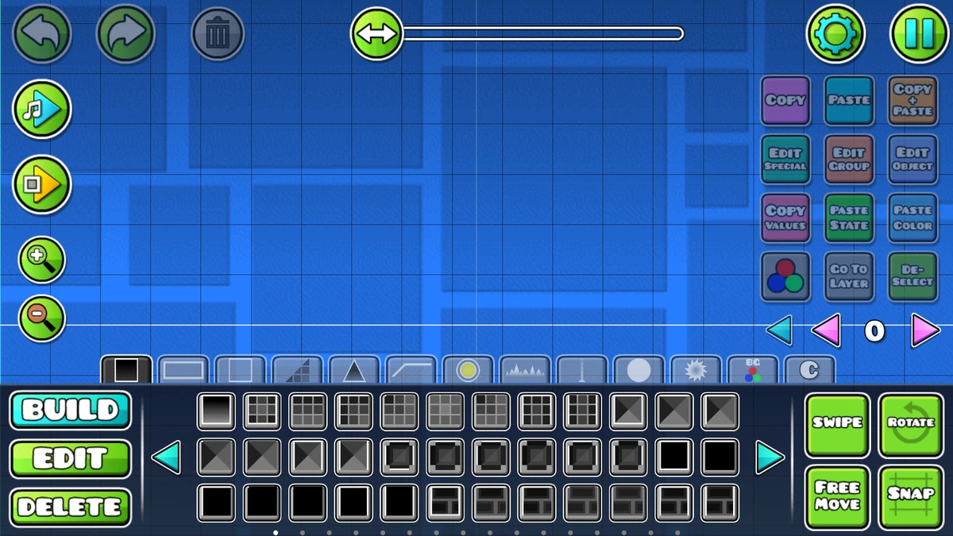
- The editor features a main bottom bar divided in to 3 sections:
  - The leftmost tab, that features the 3 modes the editor can be in. Clicking on them also switches the contents of the middle tab but not the rightmost tab. Build mode allows you to place objects, edit mode allows for highlighting objects, and delete deletes objects.
  - The middle tab contains the main contents based on the editor mode selected as mentioned above.
    - When in build mode, a list of selectable objects appear which can be clicked to select that object. That can then be placed on the main grid. When in the build tab, sub-tabs also appear above the bottom bar allowing for switching between different object types e.g. blocks that the player can jump on, spikes that kill the player, decorations that don’t affect the player etc.
    - When in edit mode, buttons for moving the object, rotating it, scaling it etc. appear.
    - When in delete mode, buttons for deleting objects are displayed. This includes filters for deleting such as delete block, delete spike, delete custom.
  - The rightmost tab contains general buttons that modify the entire grid. The swipe button allows for placing blocks by swiping the finger across the screen (previously tapping would place blocks while swiping would move the grid). The free move button allows for moving objects off the grid, while snap means all objects are centred on the grid.
- The editor also features a layer system. This means that when objects are placed on one layer, they cannot be interacted with in any way on other layers, and have low opacity. This helps keep complex levels easy to build in, as when selecting a point on the screen where multiple objects are placed on the same tile, you have to click multiple times to select an object at the bottom. This wouldn’t be the case if objects were instead placed on multiple different layers.
- The editor features undo/redo buttons that can be pressed in order to undo the last action or redo the last action that was undone.
- I will also implement an abstracted version of the practice mode. This will allow people to playtest a stage by starting from a specific wave, or a way of playing the stage from the beginning to see how it plays out.
The game also features a level select menu where levels are stored in a UI list and can be selected to either play or edit. Levels can also be played in ‘practice mode’ where checkpoints can be placed during playing that respawn the player at that location when dying. This allows hard or long levels to be playtested easier. From my analysis of Geometry Dash, I have decided to include the following features:
- A object select menu: in this case an enemy select window for selecting which enemy to place on the screen. Enemies will be sorted into groups depending on their features e.g. boss enemies. This menu will also be used for picking which boss attacks to place in bossfights.
- My game will also feature a screen for saving and loading stages, as well as a way to compile stages into full games (in this case a ‘game’ is just an arrangement of stages which will execute in succession.
- My game will also feature undo/redo buttons as well as a history log for viewing what was changed.

Limitations
- While the best place to develop a game would be either in another more popular language like C++ (most popular language for game development) or Rust for highly performant code, the time-frame and my background knowledge in python means that I don’t have the time to learn a new language, and even if I did already know it development would take longer since the languages are more complex. Python highlights and excels at rapid application development (RAD) which is a heuristic approach to making my game
- I also will not be able to use a game engine such as unreal engine or unity, even if it would greatly simplify the development of the game and provide the ability to greatly increase performance and quality of the graphics and visual effects. The time required to learn how to use such game engine would greatly offset the speed at which I can develop my game in the short-term (though would be an advantage for making future games). It is also not desirable for my particular project as a Computer Science NEA as such a game engine would abstract a lot of the code meaning less of the time spend making my game would be coding and thus less of the game would be marked.
- Since python uses an internal implementation detail called the GIL (global interpreter lock) in the C implementation of python (cPython) this means that I will not be able to utilise multiple cores in the CPU. All the game will run on one core in the CPU.
- I will also not be using multiple threads for running graphical processing. This is because for pygame to work all rendering needs to occur on one main thread. If my game has performance heavy logic outside of rendering, I might use multi-threading to run game logic on a separate thread.
- I will also not be utilising the GPU for rendering (apart from shaders). While this would help improve performance greatly since bullet hell games usually have many objects present on the screen at once and GPUs are optimised for parallel processing, pygame does not have a simple way of interacting with the GPU and implementing this would take too much development time.
- I will not be spending much time on the graphics or music of my game since this would extend development time. Instead I will use songs I like from other games and credit the original artist. As for graphics I will use pixel art to minimise time spent drawing game assets.
- The game will not feature downscaling as my game’s assets being pixel art means that any form of image compression will lead to pixels being lost or distorted at lower resolutions. The game will however feature upscaling to higher resolutions such as QHD (Quad High Definition) or 4K.
- My game will not feature an online leaderboard or any online elements, since that would require self-hosting a server that would take money to manage as well as time to set up.

Outlining computational methods.

Abstraction
Designing a game means a lot of the features have to be abstracted in order to create a scalable project that can be improved upon with more defined methods.
- The inputs of my game will come from the mouse and keyboard, with the users monitor/laptop being the output screen.
- The game will require multiple game states (A ‘state’ in this context refers to distinct screens in the game, such as the main menu or gameplay):
  - A title game state which appears upon opening the game. This includes the main game modes such as playing the game, accessing the editor and options states as well as exiting the game. It will feature the most developed graphical user interface as the main menu is what is going to be seen the most out of any screen in the game (not counting amount of time spent looking, just the amount of times it is displayed).
  - An options state with further sub-states for different categories for options. These include things like changing screen size, keybinds, graphics quality etc.
  - A game state where the game will occur. While this is counted as one state, it will encompass ever stage of the game which will be loaded in from files.
  - An editor state where the user will be able to make stages as described in my analysis of Osu! And Geometry Dash.
Other states will also be included that bridge between these states such as popups, but the states mentioned above are the main parts of the game
- The game will also require multiple UI objects:
  - A button object that can be clicked in order to perform an action. The button can have a text or image label.
  - A popup object (also counted as a state) with a text title and other UI elements below (such as buttons or an input text box)
  - A dropdown object that functions similarly to a button but when clicked reveals a list of other buttons that can be clicked in order to change the selection of the main dropdown element.
  - A combo-box object. This functioned identically to a dropdown, but the main element is a input text box that can be used to search through the elements of the dropdown.
  - A text input box object that functions like a button that can be typed in and features most of the features of a simple text editor (cursor, deleting highlighting)
  - A slider object which features a main bar and a slider head that can be dragged in one direction within the bounds of the bar.
- When in the actual gameplay portion of my game, entity objects will be required:
  - A player object for all the selectable characters that allows for moving around and stores data such as health bullet type etc.
  - An enemy object for all the different enemy types (except bosses) that stores the enemies health, attacks, as well as handles logic like when to attack and where to aim.
  - A boss object for controlling how boss enemies function (they are different enough from regular enemies to require their own object), their attacks and movement patterns.
  - A bullet object for creating bullets with different behaviours. This will define the movement of the bullet as well as its shape etc.
  - An attack type object that groups bullets into specific attacks for use by enemies. It stores the bullets start locations as well as paths and any special abilities such as homing or loose player tracking.
  - A bomb (special ability – this hasn’t been named yet) object for the players activate-able ability and its properties.
- My game will feature a state machine which will be an abstraction of different screens in my game. Each state will be a screen: e.g. the options state for the options screen, the game state for the screen where all gameplay occurs, and less obvious states like a popup state for displaying popups over other states.

Visualisation
My game will require a large amount of assets in order to run.
- My game will use spritesheets in order to combine some related sprites into one file. Spritesheets work by having one image file have multiple sprites that will be unpacked using a JSON file of the same name. The file has the name of each sprite within the image as well as its relative position in the image. All sprites/spritesheets are stored using the PNG (Portable Network Graphic) file ending for the lossless quality. Then I use a function to create subsurfaces of the original spritesheet image in order to extract the sprites out of the spritesheet. Spritesheets/sprites include:
  - The player spritesheet which has different sprites of the player looking in 4 directions. There is also a variation of the player spritesheet with the player’s hitbox shown. Every player also has a player mask sprite attached that consists of an all-white shape that indicates the hitbox of the sprite.
  - The enemy sprites.
  - Bullet sprites.
  - Button spritesheets for every state of the button (default, hovered and clicked). My game uses custom hand drawn buttons for more important buttons in my game. These use the above mentioned spritesheet.
  - Game ‘splash art’: splash art in games is a visual representation of a character or key moment from a game that players see when they first start the game or during loading screens.
  - The game’s backgrounds for each state of the game such as options and each stage of the gameplay.
- The game will also feature 2 custom .ttf (True Type Font) fonts. One that will be used for all of the game and is pixelated to match the rest of the art, and one that will be used for text input and anywhere, where pixelated text would be unreadable.
- The game features many audio files all in .wav (waveform) form for the lossless quality It provides. Audio files include:
  - Main menu music
  - Stage soundtracks
  - SFX (special effects) for UI elements e.g. button click
  - SFX for bullets firing
  - SFX for enemy being hit and dying
  - SFX for player being hit as well as casting abilities
  - SFX for boss casting specific attacks

Logic and Pipelining
Pygame’s main game loop works in a very procedural way. The way I have implemented my game loop is:
- Check to see if the game is still considered running (no quit events have been passed)
- Grab the events from pygame’s event queue using pygame.event.get() and pass them to a centralised event manager singleton class. (The Singleton is a design pattern that restricts a class to only one instance, which is globally accessible.)
- Handle the events using an centralised singleton event handler class that uses the observer algorithm. (The Observer design pattern allows objects (observers) to subscribe to updates from a specified subject (in this case an event).)
- Update the currently displayed state by calling its update method. This method handles the states logic.
- Render the currently being displayed state by calling its render method. This method handles the states rendering.
- Tick the internal clock forward by the game’s refresh rate.
- Run pygame.display.flip() which clears the entire display preparing it for the next render.
- Repeat
Every loop the game’s critical conditions are checked. Some critical conditions happen outside the scope of any displayed state.
These are:
- From the event manager:
  - Has a quit event occurred?
  - If any, which mouse buttons are being pressed?
  - If any, which mouse buttons being held down?
  - If any, which mouse buttons being released?
  - If any, which keyboard keys being pressed?
  - If any, which keyboard keys being held?
  - If any, which keyboard keys being released?
  - If any, which custom pygame events are in the event queue?
  - Is the existence of any of the above mentioned events being queried? If yes:
    - Are these events currently happening?
- From the event handler:
  - If any, which inputs relevant to currently bound actions are being detected by the event manager?
- From the audio manager:
  - Is audio being requested be played? If yes:
    - Is the channel busy playing audio?
  - Is audio playback being requested to be stopped?
  - Is the channel’s volume being changed?
- From the state manager:
  - Is a new state being requested to be displayed?
  - Is the currently displayed state being requested to be removed?
The aforementioned checks happen concurrently to the ones relevant to states mentioned below. Conditions relevant to states differ based on which state the person is in currently, however there are some global checks that are checked for all states:
- Is the state being displayed? If yes:
  - Has the state just been entered?
  - Is the state about to be removed?
  - Has the main display changed?
  - Has the state been requested to update its logic?
  - Has the state been requested to render itself to the screen?
There would normally be more checks relevant to each state, however because I have introduced an event manager and handler, all the critical conditions are checked within the class, meaning there are less checks along the lines of: if button right is pressed, move character right. These are replaced with statements rather than checks that happen every loop: Bind the right mouse button to right character movement, or, unbind the right mouse button from moving the character right.

Specifying game requirements.

Development hardware used
The game is being made on multiple computers, each with different hardware components. For the sake of identifying the minimum game development hardware requirements, I will use the worst performing system to identify my requirements.
- The game is being made on a 1920x1080 (FHD) display.
- The game takes up TODO storage (including documentation files as well as the virtual environment) as well as around 700MB for the Pycharm IDE (Integrated Development Environment).
- The game takes up TODO RAM when running the game as well as the PyCharm IDE and 10 tabs in the Firefox browser. I consider this a good representation of what developing the game would look like in terms of load on the RAM.

Hardware requirements
When the game is deployed, it will require:
- A monitor which has a resolution of at least FHD. The game will not feature downscaling as my game being pixel art means that downscaling will lead to pixels being lost at lower resolutions. The game will however feature upscaling to higher resolutions such as QHD or 4K The game will run at a tickspeed of 165 ticks per second internally, meaning no matter how many frames per second (fps) are being displayed on the screen, all the game data and states update every 165th of a second. The game will however be compatible with running at refresh rates higher and lower than this internal update speed. The game will compensate by calculating the delta time inbetween each frame and adjusting the players speed accordingly.
- 4GB of free RAM to run the game (16GB total RAM recommended). More RAM recommended so that users can open other windows such as a browser while running the game allowing for a smooth experience.
- x86 64-bit CPU (Intel / AMD architecture). ARM CPUs are not supported.
- At least 5GB of free disk space. This is for storing game assets such as sprites and music, as well as storing the users game save files to allow for saving the users progress in the game.
- A mouse and keyboard with a recommended 3 key rollover. Otherwise, there might not be enough keys on the keyboard (depending on the keyboard’s form factor) for every keybind in the game to be bound to.

Development software used
As mentioned above the game was developed on multiple computers. This includes multiple operating systems: Windows 10, 11 and Linux Mint 22 Cinnamon Edition. Each had the software requirements fulfilled. Though I have not tested the game on macOS, all of the libraries should be compatible with a mac (in theory). The software requirements for development include:
- Windows 7 or higher, any Debian based Linux distribution – preferably Linux Mint 22 or higher, (since Linux Mint is based on Debian, most Debian based distributions should run my game – though other distributions may still run the game as well) or possibly macOS (not tested).
- Python 3.12 or higher since my game’s code uses new features introduced in python 3.12.
- Pip 24.2 or higher.
- Pygame 2.6.1 or higher.
- Pycharm Community 2024.2.4 or higher, or any other compatible python IDE.

Software requirements
Software requirements when deploying are identical to the ones required for development, the only difference is that Pycharm is not required since when playing you do not need to open the source code of the game.

Final success criteria

The scope of the solution
Having done all of the research and planning for my project, I will now identify key criteria that must be fulfilled in order to finish the game. I will begin with identifying what needs to be included in the final game.
- Fully functional code for my game.
  - A menu system.
    - A main menu.
    - An options menu.
      - Graphics options.
      - Keybinds options.
      - Gameplay options.
      - Audio options.
    - An editor menu.
      - Stage load/saving menu.
      - Stage editing menu.
  - Interactable UI elements.
    - Buttons with labels.
      - Text labels.
      - Image labels.
    - Input box with simple text manipulation features.
      - Blinking caret displaying the location of the cursor in the text.
        - Arrow keys adjust caret location.
        - Clicking on the text moves the caret to the clicked position. If the clicked position is inside the text box but not inside the text the position is rounded to the beginning/end of the text.
        - Home moves the caret to the beginning of the line.
        - End moves the caret to the end of the line.
        - Control + left and right arrows moves the caret forward or back a word.
      - Text filtering if it is too long or invalid characters.
      - Deleting text with backspace and delete.
      - Pasting text from the paste buffer.
      - Highlighting text by dragging mouse or control + a to highlight everything or shift + left or right arrow to start highlighting from the caret location.
        - Moving highlighted end are forward and back with shift + left and right arrow.
        - Copying highlighted text with control + c.
        - Pasting over highlighted text with control + v.
        - Cutting the highlighted text with control + x.
        - Typing in order to replace highlighted text.
        - Deleting all the highlighted text with backspace or delete.
    - Dropdowns.
      - Text input for the dropdown value.
    - Sliders
      - Text input for the slider value.
  - Keybind features.
    - Ability to bind customisable keybinds including the keyboard and/or mouse.
      - Ability to bind combinations of keys/buttons.
    - Ability to remove/restore keybinds to default values.
  - Gameplay features.
    - Players.
      - Multiple selectable players.
        - Each player has their own special abilities.
      - Multiple selectable bullet types.
    - Enemies.
      - Each enemy has their own attacks.
      - Simple enemy movement patterns.
        - Predefined path.
        - Random with limitations.
    - Bosses.
      - Each boss has a set of complex attacks.
    - Stages.
      - Stages have multiple waves.
        - Normal enemy wave.
        - Boss wave.
      - Game has multiple stages.
      - Each stage is themed.
    - Items.
      - Enemies drop items upon death.
        - Items that level up the player’s attack.
        - Items that increase the player’s score.
        - Items that give the player more health.
        - Items that give the player more special abilities.
    - Bullets.
      - Follow a straight line path.
      - Follow a curved path.
      - Feature simple player tracking.
      - Special bullets (usually part of boss attacks).
        - Can bounce.
        - Strange pathing.
        - Spawn more bullets.
        - Other unorthodox effects.
        - Lasers.
        - Large obstacles
        - Other unorthodox projectiles.
  - Editor features.
    - Loading in/saving stages from files.
    - Playtesting stages.
      - From specific waves
      - From the beginning
    - Adding waves of enemies
      - Adding enemies to a location on the screen in a wave.
      - Controlling how a wave ends.
        - By killing all enemies.
        - After a set amount of time.
        - Combination of both of the above.
    - Adding a boss wave.
      - Adding boss attacks.
      - Controlling how boss attacks end.
        - By dealing enough damage to the boss.
        - After a set amount of time.
        - Combination of both of the above.
- Assets for all parts of my game.
  - Art.
    - Backgrounds.
      - For menus.
      - For stages.
    - Sprites/spritesheets.
      - For players.
      - For enemies.
      - For bullets.
    - UI graphics.
      - For buttons dropdowns etc.
      - For the editor.
    - Splash art
  - Music.
    - Background music.
      - For the main menu.
      - For when paused in game.
      - For different stages.
      - For bossfights.
    - SFX.
      - For clicking UI elements.
      - For bullet firing.
      - For bullet hitting.
      - For players/enemies being hit.
      - For enemies dying.
      - For special enemy attacks.
  - Fonts.
    - For UI elements.
    - For text input.

Design

Structure of the solution

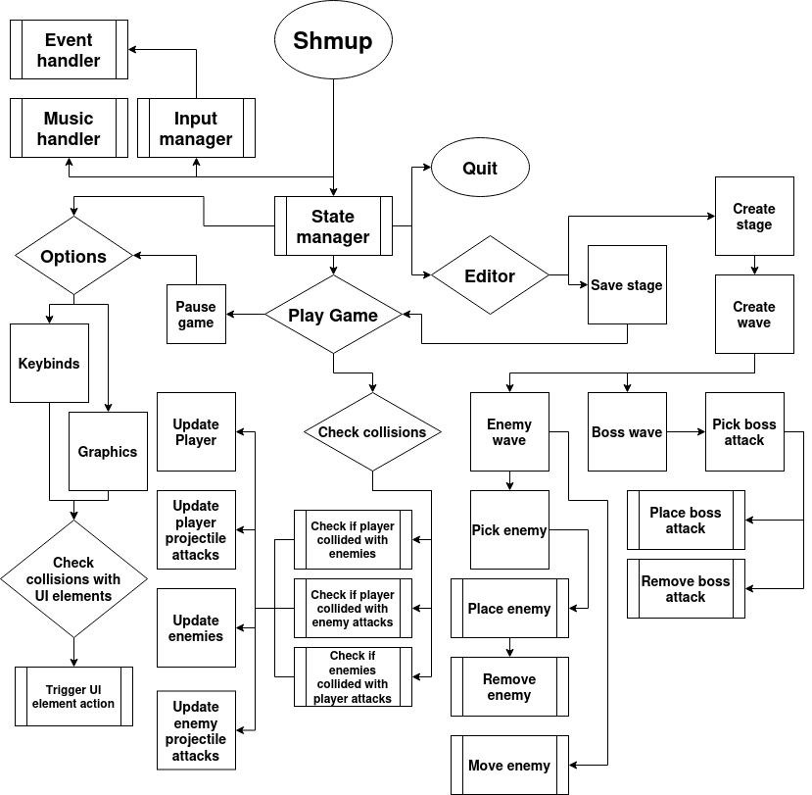
Flow chart

Decomposition of the problem
In this section, each module/function will relate to a box/set of boxes in the flow chart of the structure of my game as seen above.

Music handler
The music handler will be a class that when initialised, will create a new unique pygame.mixer.Channel instance. Audio will be able to be added to the channel with a tag to identify the audio file without the need of specifying the directory to the audio file each time. After all the relevant audio files have been added, they will be able to be played back and paused using their relevant tag.

I decided on using a music handler as music should run independent of any actions happening in the game, however, should also be accessible from any point in the game. By creating singleton classes, it ensures that the class is available from any scope. It also allows for lazy-loading audio files. Lazy loading is an optimization technique used to improve game performance by deferring the loading of non-critical resources until they are needed. This approach helps reduce initial page load times and enhances the user experience by loading only the essential content first.

Input manager
The input manager will be a module containing functions that will be used to query if an input is active as well as the type of input. In order to run my game, more detail will be required for inputs than just ‘is the input active’. For example, for key management the input manager will be able to track and be queried on when a key is being pressed, when it is being held, and when it is being released (a key press and release only happen at the beginning and end of the key input being active). These states will be stores in a stack. This ensures all the components of my game can check which input being held down was pressed first/last.

I used this method of managing input in order to have every module have access to the game’s input instead of having to directly link to the pygame.event.get() stack. This also allows me to define my own event types such as a key pressed event (whereas pygame.event.get only notifies about key up and key down events, and doesn’t indicate if a key was already being held down)

Event handler
The event handler also runs separate to the gameloop. It is a centralised singleton class that utilises the observer pattern to bind methods to be called when a specified event is detected by the input manager.

While it doesn’t make sense to use the event handler for objects in my game that require consistent updates rather than a one-off call, it is still useful in my game because of its efficiency. The observer design pattern is useful for keeping the input checking logic outside of classes that don’t require them e.g. global keybinds such as ALT + F4 for force quitting the game. Similar to the input manager it also allows for the event manager to be used in a global scope throughout my game (by importing when needed)

State manager
In order for the game to be displayed, a State manager is needed. This will be a centralised singleton class that stores a dictionary as well as a stack in the form of a list. The dictionary will be used to store a reference to each state class to keep all the states centralised and avoid having to import all the states whenever they need to be switched, while the list will be used for quick appending and popping from a LIFO (last in first out) stack for easy tracking of how to go ‘back’ through states. The state manager will manage all its connected items: the options menu and all its screens, the editor, the game state and quitting the game. The state manager will be used for the 4 main parts of my game: the options menus, the main game, the editor, and handling quitting the game from any state.

The state manager is used to decouple the state managing logic from any one state. It also uses a singleton in order to keep its access global across the game ensuring any state can control the state stack, however still ensuring the state stack is protected under a layer of abstraction.

Quitting
When quitting the game through any means, whether by pressing the quit button, or a key combination like ALT+F4, the state manager will call the active state’s ‘cleanup’ method that is usually called when a state is no longer at the top of the state stack. This ensures no data is lost and centralises exiting logic.

A cleanup method is required to ensure no data is accidentally lost when a state is forcefully exited. It also ensures no errors are raised and any processes can finish executing safely. This reduces the games volatility.

Options
The options menu will be a state class that contains buttons that lead to more specific options such as keybind or graphics options. Each of those will also be a class of their own. Allowing the user to change options in the game rather than through a configuration file allows for a clean user experience and minimises the need of restarting the game.

UI collision checks
For each menu state class, collisions with UI elements such as buttons will need to be checked. This will be done from within the button class using an update method called from the class the UI element is part of.

Keeping button collisions separate from sprite collisions simplifies the collision manager used for sprites at the cost of minimal performance. I deemed this a worthy trade since performance isn’t a concern in menus as much as it is during gameplay. Having each button manage its collisions also makes sense since while in the game 2 sprites are colliding, in a UI it is always the mouse cursor that is colliding with a button, which is a point on the screen rather than a shape. Also this allows for both rectangle buttons as well as buttons with different shapes using pixel perfect collision (masks).

Playing the game
The game will run as a state class that loads in a file that includes data about the waves and their enemies as well as stages. Why I chose this approach is explained in the editor section.

Pausing the game
Pausing the game will halt all updates to the sprites in the game but keep them displayed. It will allow to access the options screen and all of the settings from within the game, as well as provide a way of temporarily stopping and saving the game to a file if needed.

Collision management
For collisions happening in the game, a centralised singleton collision manager class will be used. This class will keep track of all the active sprites and collide them as needed. It will check whether the player is collided with enemies or their projectiles, then check if enemies are collided with the player projectiles. It will then call the needed methods of both colliders.

This keeps collision checking in a centralised location while having collision logic present in the sprite. The sprite will be able to update differently based on which sprite colliding. This will be done by passing in the collided sprite when calling each sprite’s collision method to ensure it is aware of what hit the sprite and what it should do.

Updating entities
After collisions have been detected, both players and enemies and their projectiles will be updated by calling their update methods. This will update the enemies and bullets positions on the screen, as well as update the player sprite based on pressed inputs.

Updates must happen after collision checks to ensure processing time isn’t spent updating a sprite that is already dead. Rendering must happen after both collision checks and updates as what the user sees on the screen should reflect the latest state of the game.

Editor
The editor will be the place where the gameplay of my game will be able to be made. Rather than hardcoding all the gameplay into the game I decided to make an editor for my game and make all the gameplay through that system.

This reduces the time spent making the game at the cost of increased upfront programming complexity. It also provides scalability in the form of ability to add more stages/alternate game modes.

Saving a stage
Once done developing, individual stages will have the ability of being saved to a JSON (JavaScript Object Notation) file that can be read to continue editing. A collection of stages will be able to be loaded in and played like a normal game using a metadata file that links all the relevant stages together. Linking stages together into a game will have its own menu and UI in the game.

Creating stages and waves
Once in the editor, you will have to first create a blank stage. A stage can have its own background and song, as well as regular and boss enemies. Inside individual stages waves will be able to be created. There are 2 types of waves: an enemy wave and a boss wave. This abstraction helps separate the endless feeling waves while playing the game into concrete collections of enemies.

Enemy wave
An enemy wave consists of a group of enemies that appear on the screen at the same time. Waves can either be ended by killing all the enemies in the wave or running out of time for the wave. If a timer is tied to the end of the wave, the enemies will leave the screen upon the timer running out. When a specific wave is selected, the user will have the ability of picking enemies out of an enemy list and placing them on the screen. Other forms of editing such as removing a placed enemy as well as moving an already placed enemy will also exist.

Boss wave
A boss wave consists of a single boss enemy, which has specific attacks tied to it. These attacks will be grouped into their own ‘waves’ in that they will either end upon enough damage being dealt to the boss, or by running out of time. Boss attacks will either be specific attacks or general attacks. General attacks will select from a pool of general attacks the boss can perform and use it. Specific attacks are reserved for complex attacks used at specific points during the bossfight. Boss attacks will be picked from a list of attacks similar to picking an enemy in an enemy wave. They will then be able to be placed on the screen or removed.

Identifying components and structures

Classes====
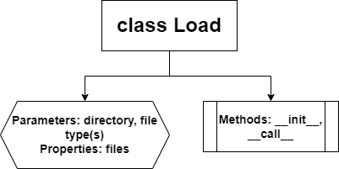
In order to load in all the files from my game such as images, music as well as custom text fonts that are scattered between multiple directories I will use a Load class. The parameters of directory and file type(s) will be used in order to specify where to look for files and which files to look for. The __init__ method of the class will use a recursive walk algorithm to traverse and locate all the files under the given directory even if they are in nested directories. Then, the __call__ method will take in a file name as a parameter and return the absolute path to that file. The property files will be a dictionary storing the name of the file as the key and the file path as the value. A class is useful for this case as the class can be instantiated multiple times with different file types in order to separate files logically (e.g. an instance for all images and an instance for all music)

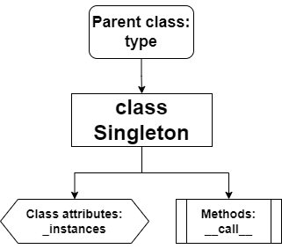
As explained previously the Singleton is a design pattern that restricts a class to only one instance, which is globally accessible. I implemented this design pattern as a class that inherits from the type class so that it can be used as a metaclass in other classes. This will have a class attribute _instances that will track all the active instances of any Singletons. In the __call__ method, the class will be instantiated if it isn’t in the _instances dictionary. Otherwise the active instance will be returned to ensure only one instance of the class remains instantiated ever.

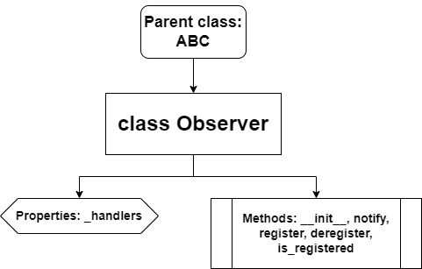
The observer class inherits from Abstract Base Class as it has abstract methods. It is an implementation of the Observer design pattern. The _handlers property will be created in the __init__ magic method, and will be a dictionary where the key is the event to detect while the value is the method to call. The notify, register and deregister methods are abstract methods meant to be filled out in classes that inherit from the observer class. The is_registered method checks if an event is registered to an observer.
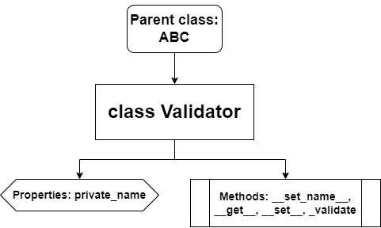
The validator class in an implementation of a decorator that has an abstract _validate method that is called whenever the public property is changed. The __set_name__ magic method sets the private version of the attribute by adding an underscore in front of it. The __get__ and __set__ methods functions like a regular getters and setter however calls the _validate method before setting the property.
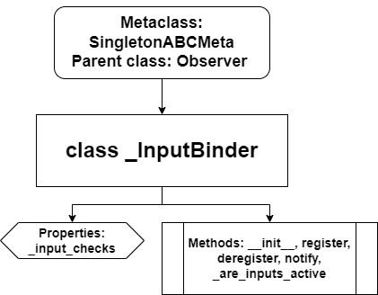
The _InputBinder is a class for using the observer design pattern to bind inputs to functions. It has SingletonABCMeta as a metaclass which combines the Singleton and ABCMeta into one metaclass. It has a property _input_checks which is a dictionary of pygame events as keys and the function to call to check for that event (from the Input Manager). The __init__ method just instantiates the _input_checks property. The register and deregister methods allow for registering events or a combination of events (e.g. a mouse click and the A key on the keyboard) to a function that will get called whenever the input (combination) gets detected. The notify method contains the above mentioned logic (checking if inputs are active via _are_inputs_active) and calls the bound functions.
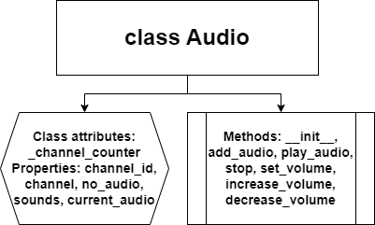

Development

Evaluation

