**ASSIGNMENT 2**

1.What are the two values of the Boolean data type? How do you write them?

**Ans1.** Boolean data type has 2 possible value **True** and **False**.

2. What are the three different types of Boolean operators?

**Ans2.** Three different types of Boolean operators are **AND**, **OR** and **NOT**

3. Make a list of each Boolean operator's truth tables (i.e. every possible combination of Boolean values for the operator and what it evaluate ).

**Ans3.** Truth Table of Boolean operators

1. **AND operator**:

|  |  |  |
| --- | --- | --- |
| **A** | **B** | **OUTPUT** |
| True | True | True |
| True | False | False |
| False | True | False |
| False | False | False |

1. **OR operator:**

|  |  |  |
| --- | --- | --- |
| **A** | **B** | **OUTPUT** |
| True | True | True |
| True | False | True |
| False | True | True |
| False | False | False |

1. **NOT operator:**

|  |  |
| --- | --- |
| **A** | **OUTPUT** |
| True | False |
| False | True |

4. What are the values of the following expressions?

(5 > 4) and (3 == 5 -- **True**

not (5 > 4) -- **False**

(5 > 4) or (3 == 5) -- **True**

not ((5 > 4) or (3 == 5)) -- **False**

(True and True) and (True == False) -- **False**

(not False) or (not True) -- **True**

5. What are the six comparison operators?

**Ans5.** Six comparison operators

1. Equal to (==)
2. Not equal to (!=)
3. Greater than (>)
4. Less than (<)
5. Greater than equal to (>=)
6. Less than equal to (<=)

6. How do you tell the difference between the equal to and assignment operators?Describe a condition and when you would use one.

**Ans6.** Assignment operator is denoted by a single sign of ‘=’ while equal to operator is denoted by two signs ‘==’.

When we want to assign some value to any variable, we use assignment operator (=) and to check if two values are equal or not, we use equal to operator (==)

7. Identify the three blocks in this code:

spam = 0

if spam == 10:

print('eggs')

if spam > 5:

print('bacon')

else:

print('ham')

print('spam')

print('spam')

**Ans7.** Three block in this code are if spam==10, if spam>5 and else.

8. Write code that prints Hello if 1 is stored in spam, prints Howdy if 2 is stored in spam, and prints Greetings! if anything else is stored in spam.

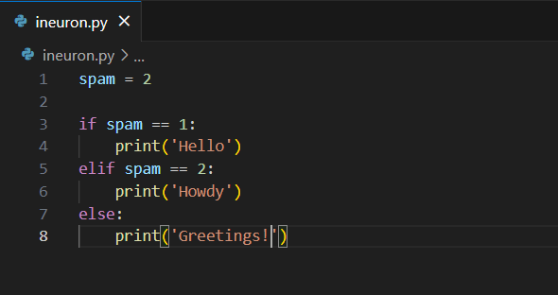

9.If your programme is stuck in an endless loop, what keys you’ll press?

**Ans9.** Ctrl+C is used to forcefully exit out of an endless loop.

10. How can you tell the difference between break and continue?

**Ans10.** Break keyword is used to exit out of the loop whereas continue is used to skip the current iteration and move to the next iteration of the loop.

11. In a for loop, what is the difference between range(10), range(0, 10), and range(0, 10, 1)?

**Ans11.** All the three versions of range will produce same iteration starting from 0 to 9.

12. Write a short program that prints the numbers 1 to 10 using a for loop. Then write an equivalent program that prints the numbers 1 to 10 using a while loop.

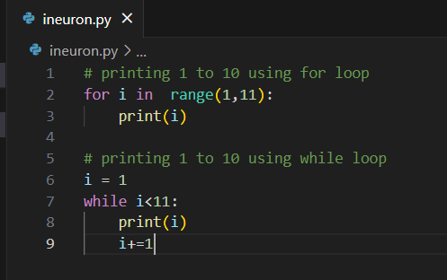

13. If you had a function named bacon() inside a module named spam, how would you call it after importing spam?

**Ans13.** To import a function from module we can use dot(.) operator like following.

Spam.bacon()