$Steepest descent method$ 範例1

**求 $Z\left(x,y,t\right)=3{\left(x-5\right)}^{2}+2{(y-20)}^{2}+20t$ 的最小值**

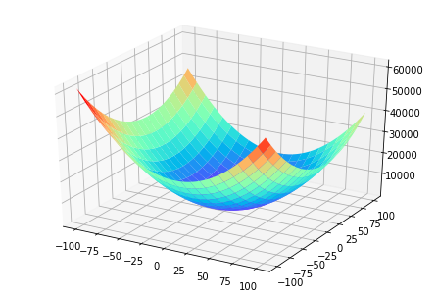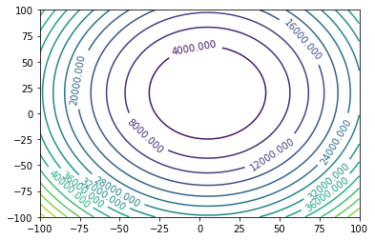

可以知道最小值是 $x=5、y=20、t$ 越小的情況(發散)

梯度:

$$\frac{∂Z}{∂x}=3×2\left(x-5\right)=6x-30$$

$$\frac{∂Z}{∂y}=2×2\left(y-20\right)=4y-80$$

$$\frac{∂Z}{∂t}=20$$

使用 $learning rate(lr)=0.01，x_{0}=100、y_{0}=100、t_{0}=0$

前幾步用手算的結果

|  |  |  |  |  |  |  |
| --- | --- | --- | --- | --- | --- | --- |
| X | Y | T | Z | 下一步(X) | 下一步(Y) | 下一步(T) |
| 100 | 100 | 0 | 39875 | -5.7 | -3.2 | -0.2 |
| 94.3 | 96.8 | -0.2 | 35719.55 | -5.358 | -3.072 | -0.2 |
| 88.942 | 93.728 | -0.4 | 32009.61 | -5.03652 | -2.94912 | -0.2 |
| 83.905 | 90.7788 | -0.6 | 28696.32 | -4.7343288 | -2.8311552 | -0.2 |

最終結果(走2000步)

|  |  |  |  |  |  |  |
| --- | --- | --- | --- | --- | --- | --- |
| X | Y | T | Z | 下一步(X) | 下一步(Y) | 下一步(T) |
| 5 | 20 | -399.8  (還能更小) | -7996 |  |  |  |

$Steepest descent method$ 範例2: 有局部最小值

**求 $Z\left(x,y,t\right)=6000sin\left(\frac{π}{24}x\right)+3{\left(x-36\right)}^{2}+2{(y-20)}^{2}+20t$ 的最小值**

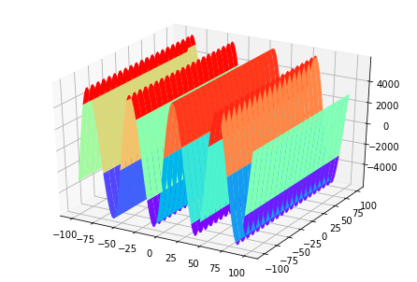 加上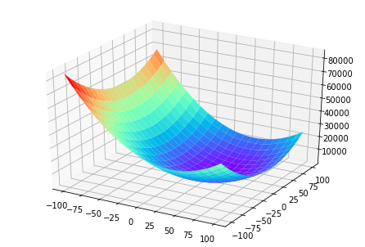=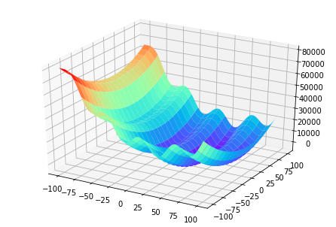 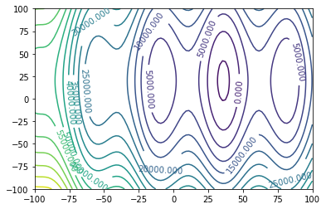

可以知道最小值是 $x=36、y=20、t$ 越小的情況(發散)

梯度:

$$\frac{∂Z}{∂x}=6000×\frac{π}{24}×\cos\left(\frac{π}{24}x\right)+6\left(x-36\right)=250π\cos\left(\frac{π}{24}x\right)+6x-216$$

$$\frac{∂Z}{∂y}=2×2\left(y-20\right)=4y-80$$

$$\frac{∂Z}{∂t}=20$$

1. 使用 $learning rate(lr)=0.01，x_{0}=100、y_{0}=100、t_{0}=0$

前幾步用手算的結果

|  |  |  |  |  |  |  |
| --- | --- | --- | --- | --- | --- | --- |
| X | Y | T | Z | 下一步(X) | 下一步(Y) | 下一步(T) |
| 100 | 100 | 0 | 28088 | -10.6417 | -3.2 | -0.2 |
| 89.35825 | 96.8 | -0.2 | 15750.13 | -8.26954 | -3.072 | -0.2 |
| 81.08872 | 93.728 | -0.4 | 11393.05 | 0.215799 | -2.94912 | -0.2 |
| 81.30452 | 90.77888 | -0.6 | 10534.42 | -0.00423 | -2.83116 | -0.2 |

最終結果(走2000步)

|  |  |  |  |  |  |  |
| --- | --- | --- | --- | --- | --- | --- |
| X | Y | T | Z | 下一步(X) | 下一步(Y) | 下一步(T) |
| 81.30039 | 20 | -399.8 | -7468.88 |  |  |  |

會走進局部最小值

1. 使用 $learning rate(lr)=0.01，x_{0}=100、y_{0}=100、t_{0}=0$

加上momentum概念，走的下一步跟上一步(加權0.99)有關係

前幾步用手算的結果

|  |  |  |  |  |  |  |  |  |  |
| --- | --- | --- | --- | --- | --- | --- | --- | --- | --- |
| X | Y | T | Z | 原本下一步(X) | 原本下一步(Y) | 原本下一步(T) | 加權後的下一步(X) | 加權後的下一步(Y) | 加權後的下一步(T) |
| 100 | 100 | 0 | 28088 | -10.641747 | -3.2 | -0.2 | -0.10641 | -0.032 | -0.002 |
| 99.89 | 99.97 | -0.002 | 27964.22 | -10.689403 | -3.19872 | -0.2 | -0.212247 | -0.063667 | -0.0039 |
| 99.68 | 99.90 | -0.00598 | 27715.93 | -10.780470 | -3.19617 | -0.2 | -0.317929 | -0.094992 | -0.00594 |
| 99.36 | 99.81 | -0.01192 | 27340.68 | -10.906807 | -3.19237 | -0.2 | -0.423818 | -0.125966 | -0.00788 |

最終結果(走3000步)

|  |  |  |  |  |  |  |  |  |  |
| --- | --- | --- | --- | --- | --- | --- | --- | --- | --- |
| X | Y | T | Z | 原本下一步(X) | 原本下一步(Y) | 原本下一步(T) | 加權後的下一步(X) | 加權後的下一步(Y) | 加權後的下一步(T) |
| 36 | 19.99988 | -480 | -15600 | -7.90226E-06 | 4.84498E-06 | -0.2 | -8.63465E-06 | 5.71684E-06 | -0.2 |

可以脫離局部最小值