EEG Analyzer  
a SPM M/EEG Visualization Toolbox  
Manual

Table of contents

1 Introduction 3

2 License 3

3 SPM and EEG Analyzer toolbox installation 4

4 Run EEG Analyzer 4

5 Visualizing M/EEG 5

6 Filtering M/EEG for analysis 7

7 Misc functionnalities 8

8 Future improvements 9

9 Acknowledgement 10

10 Bibliography 10

# Introduction

The "EEG Analyzer" toolbox for SPM provides a user-friendly interface for M/EEG visualization. It reads SPM M/EEG files and also offers basic M/EEG filtering options. If present, events are also shown.

Based on our previous work, this toolbox was developed as an alternative visualization tool for SPM "Graphics" in order to show selected signals without overlapping between them and even with different voltage scales. It can be used to display signals resulting from our co-developed SPM toolboxes:

* SpikeDet : a toolbox for detecting spikes in EEG, see <http://beams.ulb.ac.be/research-projects/spm-eeg-spike-detection-toolbox> [Nonclercq2016].
* SGTT - Synaptic Gains Tracking Toolbox, see <http://beams.ulb.ac.be/research-projects/synaptic-gains-tracking-toolbox> [Fan2018].

The current limitation of EEG Analyzer is that it can only display one trial of the SPM M/EEG File at a time.

If you use this toolbox for your research involving a publication (in a journal, in a conference, etc.), please cite it by including as much information as possible from the following:

*Rudy Ercek, EEG Analyzer: a SPM M/EEG Visualization Toolbox, Université Libre de Bruxelles,* [*https://bitbucket.org/ulbeeg/eeganalyzer*](https://bitbucket.org/ulbeeg/eeganalyzer) *, 2018*

This manual gives you a guideline to use EEG Analyzer (version 1) which was implemented in SPM version 12 (SPM12) [Ashburner2013]. Let us notice that the Matlab Signal Processing Toolbox is necessary if you want to display the filters frequency response (see section 6).

# License

As SPM, the license attached to this toolbox is GPL v2, see <https://www.gnu.org/licenses/gpl-2.0.txt>. From <https://www.gnu.org/licenses/gpl-2.0.html>, it implies:

*This program is free software; you can redistribute it and/or modify it under the terms of the GNU General Public License as published by the Free Software Foundation; either version 2 of the License, or (at your option) any later version.*

*This program is distributed in the hope that it will be useful, but WITHOUT ANY WARRANTY; without even the implied warranty of MERCHANTABILITY or FITNESS FOR A PARTICULAR PURPOSE. See the*

*GNU General Public License for more details.*

*You should have received a copy of the GNU General Public License along with this program; if not, write to the Free Software Foundation, Inc., 51 Franklin Street, Fifth Floor, Boston, MA 02110-1301, USA.*

# SPM and EEG Analyzer toolbox installation

1. Download SPM12 Toolbox on the SPM website : <http://www.fil.ion.ucl.ac.uk/spm/software/spm12/>
2. Decompress the SPM12 zip file (“spm12.zip”) in a folder of your choice.
3. Run Matlab and add the SPM folder to Matlab search path: Menu “HOME” and button “Set Path” in the last Matlab versions. Another solution: go to the SPM folder and type the command “addpath(pwd)” each time you want to run SPM in Matlab.
4. Exit Matlab.
5. Download the EEG Analyzer toolbox on the website: <https://bitbucket.org/ulbeeg/eeganalyzer>
6. Decompress the files and its folder in the SPM subfolder "toolbox".
7. Rename the decompressed folder to "EEGAnalyzer" (case sensitive).

# Run EEG Analyzer

1. After installing SPM and EEG Analyzer, run SPM by typing the “spm” command in Matlab; a window with 6 buttons appears.
2. Click on the “M/EEG” button; three windows (figures) appear, among which the “Menu” window shown in Figure 1.
3. In the “Toolbox” list box (1) of the SPM “Menu” window (see Figure 1), select the “EEGAnalyzer” item; The EEG Analyzer starts and is ready to use (see Figure 2).

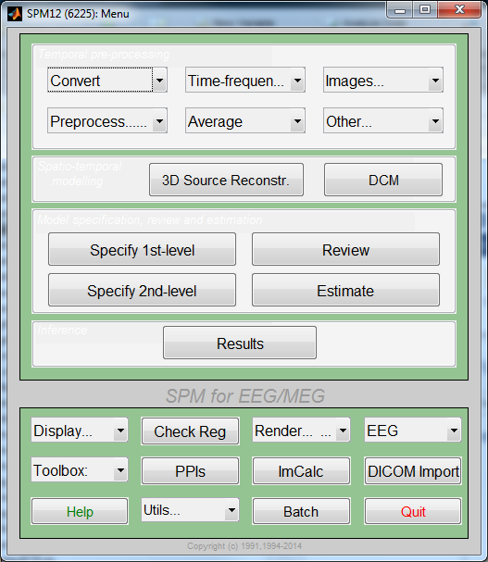

(1)

Figure 1: SPM Menu

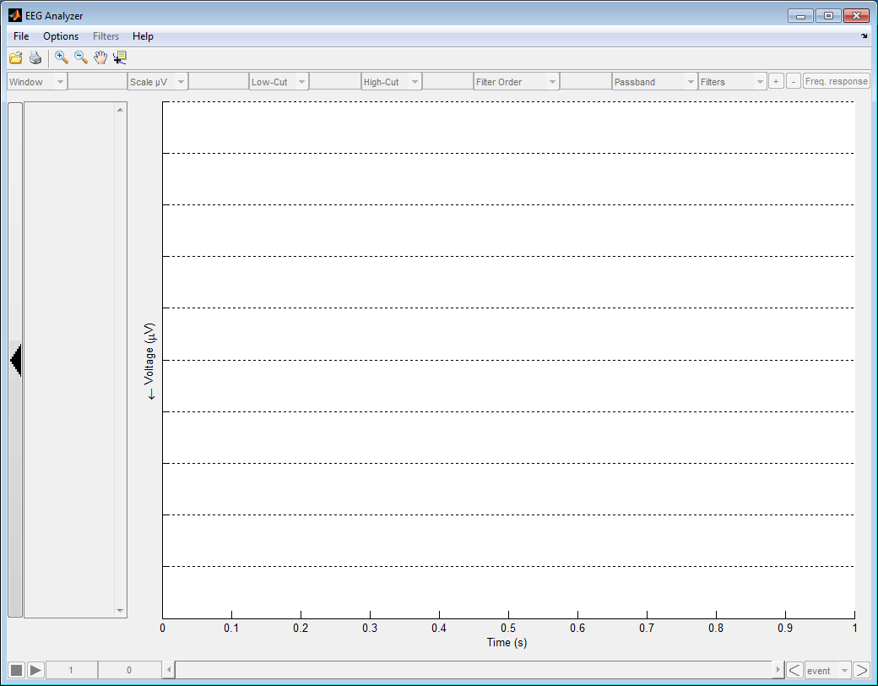

**Main area: selected EEG channels graphs**

**EEG signals**

**/channels selection list**

**filter configuration area**

**menu**

**toolbar**

**voltage scale**

**Time window moving**

**time window**

Figure 2: EEG Analyzer figure after start with a description of the different areas of this toolbox

# Visualizing M/EEG

After running EEG Analyzer (see Figure 2), you can open a file by using the menu “File 🡪 Open a SPM EEG File” (NB: a SPM file is composed of a .mat file and a .dat file, you have to choose the corresponding mat file). If the SPM file contains more than one trial, a dialog will ask which trial number have to be shown. After opening a SPM EEG File, the different EEG channels/signals of the file are displayed in the list on the left side of EEG Analyzer. By clicking the channels using the “Ctrl” key, the selected signals are displayed in the main area. It is possible to show/hide the channels list with the button (0) of Figure 3. By using the popup list or put the value in the time window area (sec), you can focus on a specific time window of the selected channels, for example a 10sec window length as shown in Figure 3. If you put a value equal or less than 0, the selected signals are entirely displayed in the window. The colored vertical lines (not black) shown in the main area of Figure 3 correspond to events (same color for same event type) in the EEG file: in this example, spikes event detected with the “SpikeDet” toolbox [Nonclercq2016]. When the user clicks on a vertical line (12), a dialog gives information about the clicked event, see example on Figure 4. By double clicking in the main area of EEG Analyzer, the black vertical line appears with the voltage values (11) of each selected channel. One single click in the area removes this vertical line and its information.

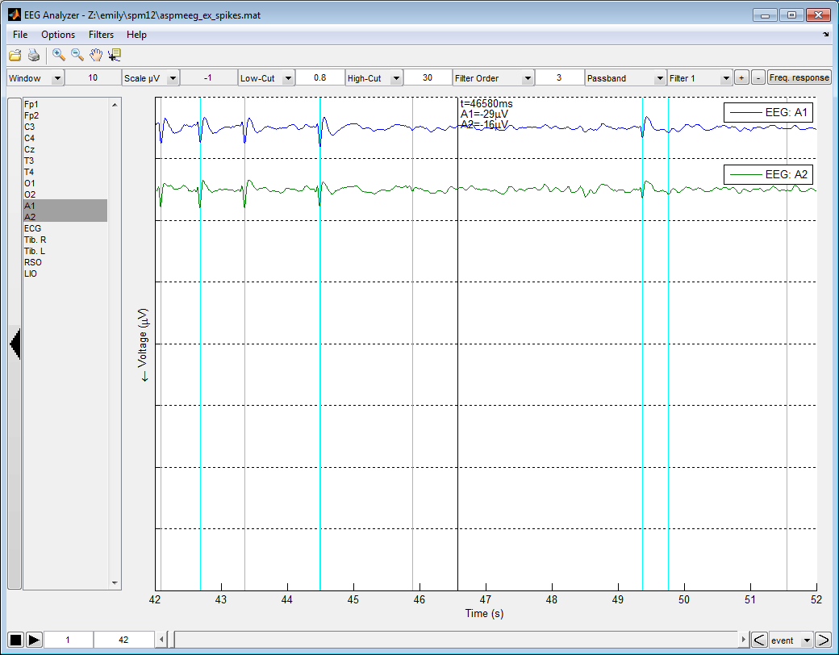

(10)

(0)

(12)

(11)

(h)

(g)

(f)

(e)

(c)

(d)

(b)

(a)

(9)

(7)

(8)

(6)

(5)

(4)

(3)

(2)

(1)

Figure 3: EEG Analyzer after opening a SPM M/EEG File and selecting two channels

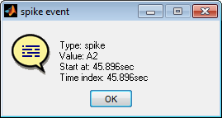

Figure 4: Event information when the user clicks on a vertical line corresponding to an event in EEG Analyzer

The bottom area of EEG Analyzer allows to move the time window: the central part (2) is a slider that allows to move freely the window in time; (3) allows to directly jump to the window beginning at a specific value (e.g. 42sec. in Figure 3); the button (5) allows to automatically move the window start by incrementing it with the value given in (4) (1sec. by default); the button (6) stops this automatic move; the buttons (8) or (7) respectively try to move the middle window to the next or previous event; the popup list (9) allows to select a specific event type to go to with buttons (8) or (7) (the default selection “event” corresponds to any event type).

In EEG Analyzer, the voltage axe (y) is reverse but it can be changed in the menu “Options” and each division separated by dash points in the main area is assigned to a selected signal and has different voltage (y) scales. The scale for each signal is adapted depending on the value given by the “Scale µV” popup or the corresponding area (10). With a value strictly below 0 (i.e. Auto), the scale is automatically adjusted in order to have the full channel amplitude in the time window. When the value is strictly positive, each channel is centred using its mean value on all signal length and limits the visible part around the +/- scale value, so, the voltage range for all displayed channels is equal to twice the “scale” value. Finally, when the value is equal to 0 (i.e. Full), each EEG signal is entirely contained in its division for all signal length, so, as “Auto” mode, the voltage range for all displayed channels is not the same.

# Filtering M/EEG for analysis

EEG Analyzer allows to filter EEG signals for visualization and analysis. It uses Butterworth filters to do it and directly applies filters on the displayed channels. When the user inserts a Low-Cut (a) (see Figure 3) or a High-Cut (b) frequency (above 0), it respectively creates a high-pass or a low-pass filter. When the user puts both frequencies, it creates a pass-band or a stop-band filter depending on the (d) selection. In all cases, the Butterworth filter order is specified by putting the value in (c). Several filters can be combined together by creating a filters cascade (e.g. for different orders). To add one filter, just click on button “+” (f), after that, you can select the current filter with the popup list (e) and remove it with button “-” (g). Finally, if Matlab Signal Processing Toolbox is installed, you can display the frequency response of the filters by clicking on button (h); see example on Figure 5 where the popup list (1) allows to select the filter frequency response (global, filter 1, …).

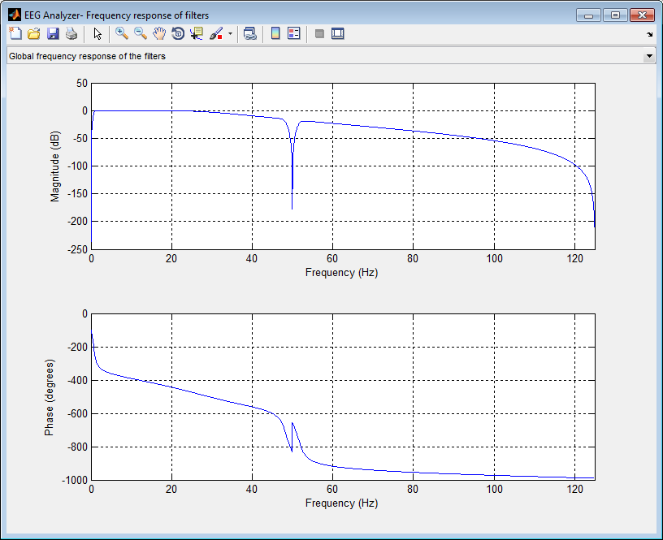

(a)

(1)

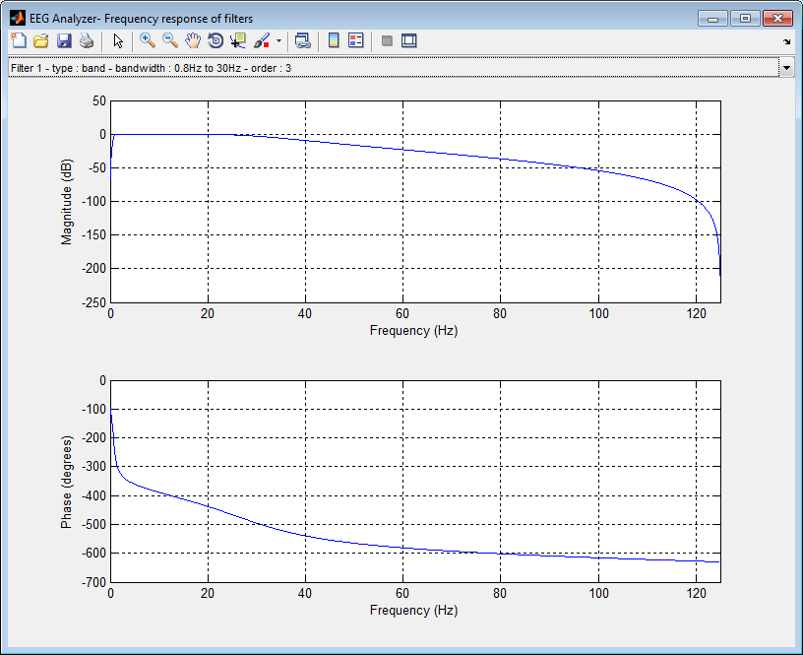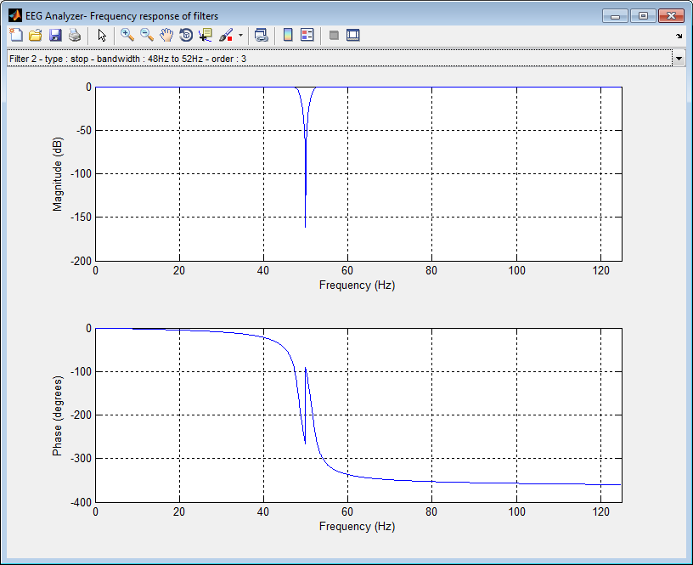

(c)

(b)

Figure 5: EEG Analyzer – Frequency response example – (a) all filters, (b) band-pass filter 1 & (c) 50Hz stop-band filter 2

A zero-phase filter is applied on the selected signals but it can be disabled in the “Filters” menu. Moreover, this menu allows to save the configured filters and also load them back.

The users are advised to unselect all channels (“Ctrl” Key with a left mouse click on all selected channels) when the filters are configured because, for each filter modification, the displayed channels are filtered again and it slows down the operation.

# Misc functionnalities

The toolbar area of EEG Analyzer (see Figure 2) presents most classical buttons of a Matlab figure (Print, Zoom In, Zoom Out, Pan and Data cursor). You can use Matlab help in order to have more information about these buttons. The “open” button allows to directly open a SPM EEG File. Let us notice that this toolbar could be replaced by the standard figure toolbar on Matlab versions above R2017a.

In the « File » menu, you can find “File information” that gives information on the opened SPM file as shown on Figure 6.

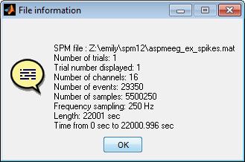

Figure 6: EEG Analyzer – File Information

In the menu “Options”, you have options in order to show/hide legends or the channel type in the legends. The “Display refresh delay” option shows a dialog that asks how long “EEG Analyzer” should wait before refreshing/updating the main area when the user selects channels to display. By default, this delay is 2 seconds.

The most interesting option is the “Number of channels divisions” that specifies the maximum number of channels displayed together in the main area, by default, its value is 8 when EEG Analyzer starts. If the number of selected channels is above this value, a slider will appear on the right side that allows to move the EEG graphics vertically. Figure 7 shows an example with two divisions in the main area when the user selects 3 channels (O2, A1 & A2) and put the focus on the last two channels (A1 & A2).

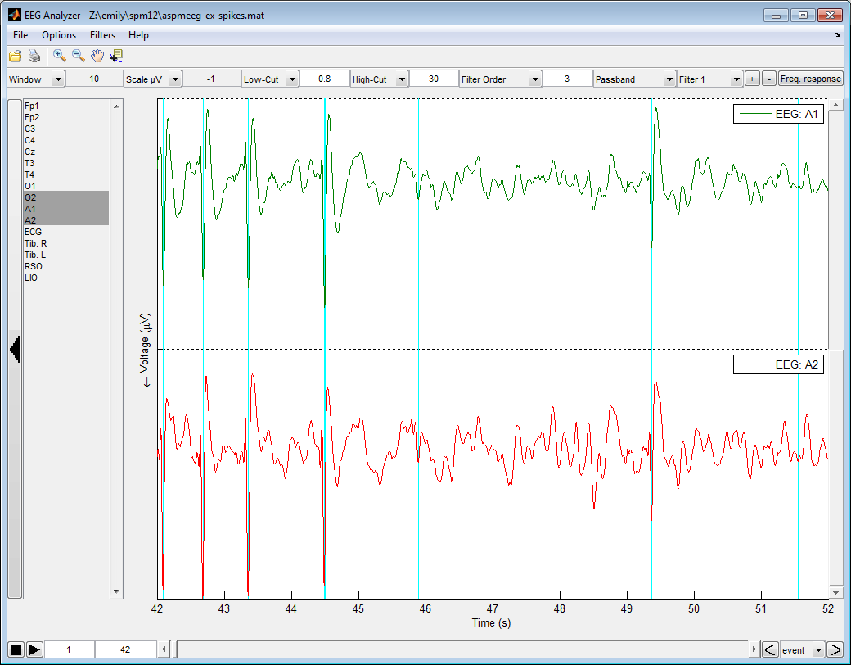

Figure 7: EEG Analyzer with two divisions in the main area and three selected channels

# Future improvements

Depending on the developers ‘schedule and EEG Analyzer’s use/success among people, several improvements are considered for future versions of EEG Analyzer, e.g.

* Export the displayed main area as an image for publications.
* Change the channels order.
* Add, edit and remove events in the opened SPM file .
* Save the displayed (and filtered) channels as a new M/EEG SPM file (with events).

# Acknowledgement

The developers of this SPM toolbox would like to thank the co-developers of SGTT [Fan2018] and SpikeDet [Nonclercq2016] toolboxes, namely Xiaoya FAN and Antoine NONCLERCQ for their advices, remarks and testing’s during the development phase of EEG Analyzer.

They also want to thank the SPM team for developing the SPM MATLAB toolbox.

# Bibliography

**[Ashburner2013]** Ashburner, J., Barnes, G., Chen, C., Daunizeau, J., Friston, K., Kiebel, S., … Stephan, K. (2013). SPM12 Manual The FIL Methods Group (and honorary members). *Functional Imaging Laboratory*, 475–1. doi:10.1111/j.1365-294X.2006.02813.x

**[Nonclercq2016]** Antoine Nonclercq & Rudy Ercek (2016). SpikeDet: a SPM EEG Spike detection toolbox, *Université Libre de Bruxelles*, <http://beams.ulb.ac.be/research-projects/spm-eeg-spike-detection-toolbox>.

**[Fan2018]** Xiaoya Fan, Rudy Ercek & Antoine Nonclercq (2018). SGTT: a SPM EEG Synaptic gain tracking toolbox, *Université Libre de Bruxelles*, <http://beams.ulb.ac.be/research-projects/synaptic-gains-tracking-toolbox>