Q1- Input temperature in farahenheit and output the temperature in degree celcius

Ans-

**Algorithm-**

Step1- start

Step2- read /take input of of and declare c

Step3- if(f>=-20&&f<=160) calculate c=(f-32)*5/9 and display c

Step4 -else display the "The Temperature is out of Faraheneit Scale"

Step5- stop

**Code-**

#include<stdio.h>

#include<stdlib.h>

int main(){

double c,f;

printf("Enter the temperature in farahenheit:");

scanf("%lf",&f);

if(f>=-20&&f<=160){

c=(f-32)*5/9;

printf("The Temperature in celcius is :%lf",c);

}

else{

printf("The Temperature is out of Faraheneit Scale");

}

}

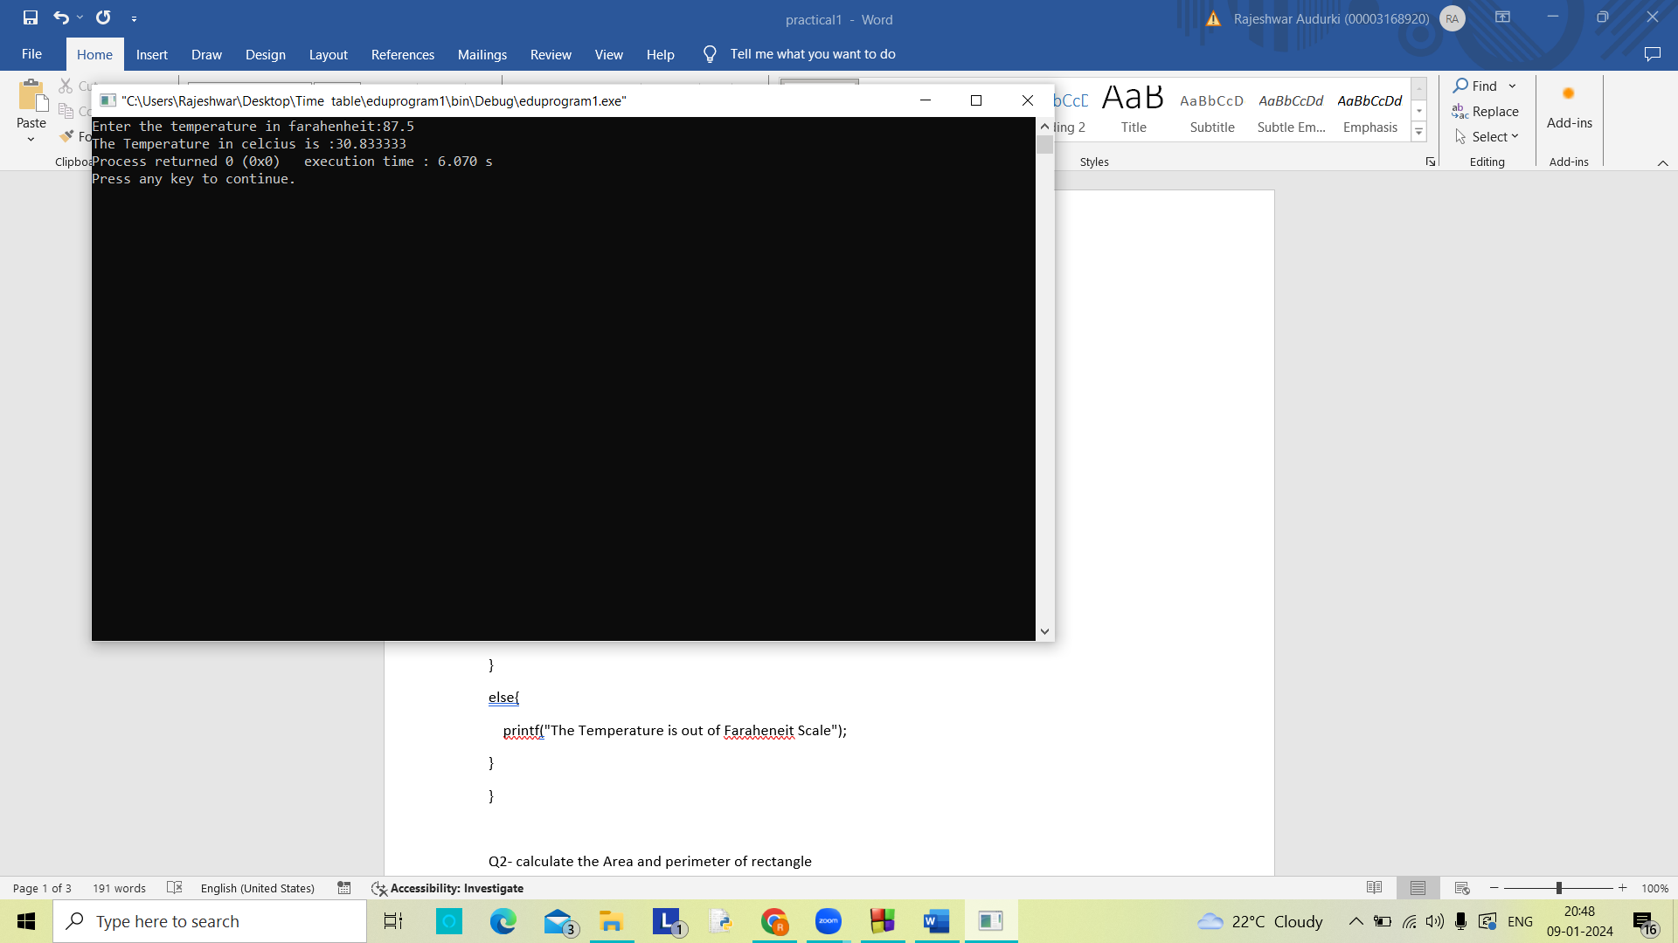

Q2- calculate the Area and perimeter of rectangle

Ans-

**Algorithm-**

Step1- start

Step2- read variables l and b from user

Step3- declare variable a and p

Step4- calculate a=l*b p=2*(l+b)

Step5- display a and p

Step6- stop

**Code-**

#include <stdio.h>

#include <stdlib.h>

int main()

{

double l,b,a,p;

printf("Enter the Length of Rectangle:");

scanf("%lf",&l);

printf("Enter the Length of Rectangle:");

scanf("%lf",&b);

a=l*b;

p=2*(l+b);

printf("The Area of Rectangle:%lf\n",a);

printf("The Perimeter of Rectangle:%lf\n",p);

}

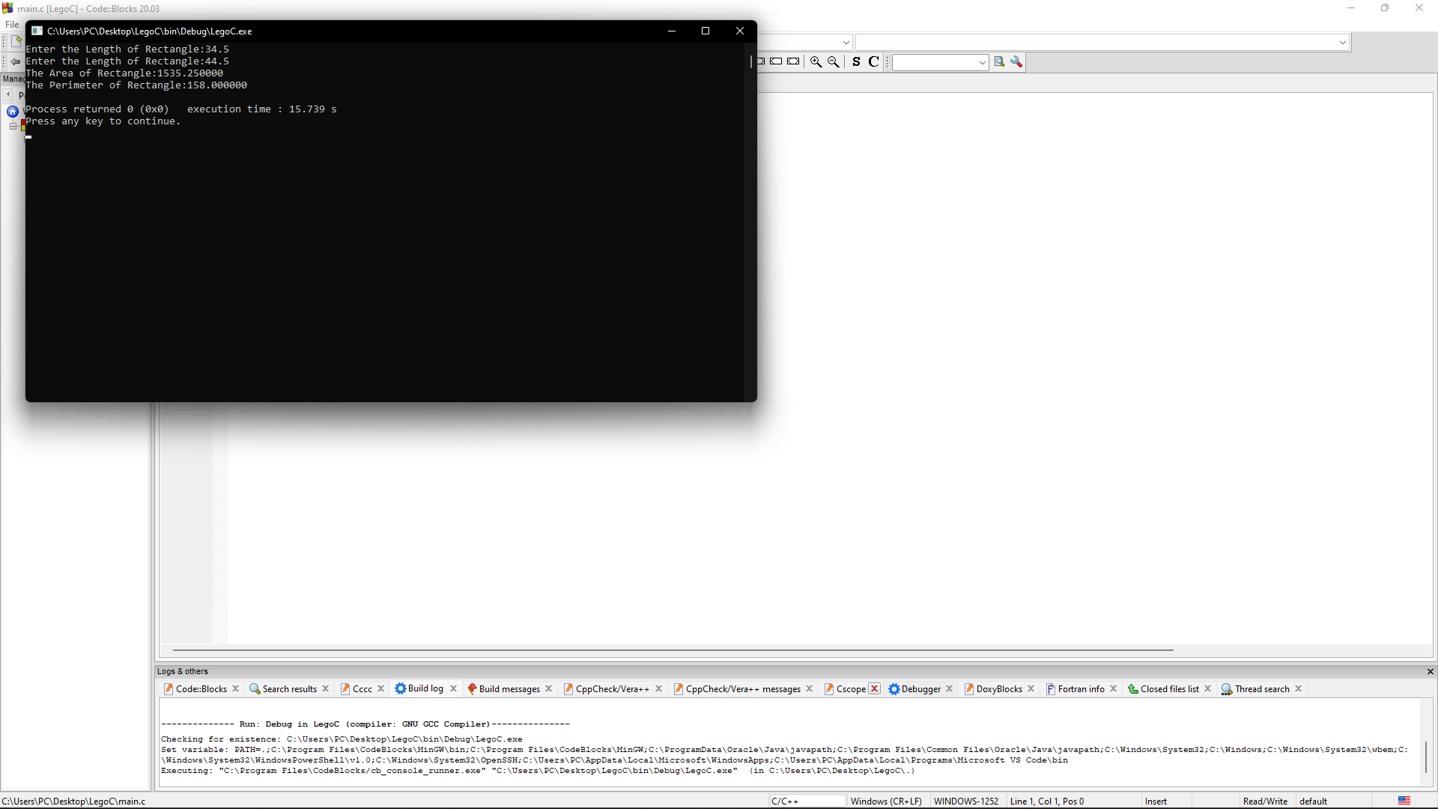

Q3- print average and percentage of marks of 5 subjects of students

Ans-

**Algorithm-**

Step1- start

Step2- create variables pe, avg , m and sum=0

Step3- read 5 values of m using for loop from i=1 to i=5

Step4- add values of m in sum(sum+=5) using for loop from i=1 to 5

Step5- pe=(sum/500)*100 and avg=sum/5

Step6- display pe and avg

Step7-stop

**Code-**

#include <stdio.h>

#include <stdlib.h>

int main()

{

double m,avg,sum=0,pe;

int i=0;

for(i=1;i<=5;i++){

printf("Enter the Marks of subject %d:",i);

scanf("%lf",&m);

sum+=m;

}

avg=sum/5;

pe=((sum/500)*100);

printf("The average of marks of student of 5 subjects is:%.2lf\n",avg);

printf("The percentage of marks of student of 5 subjects is:%.2lf\n",pe);

}

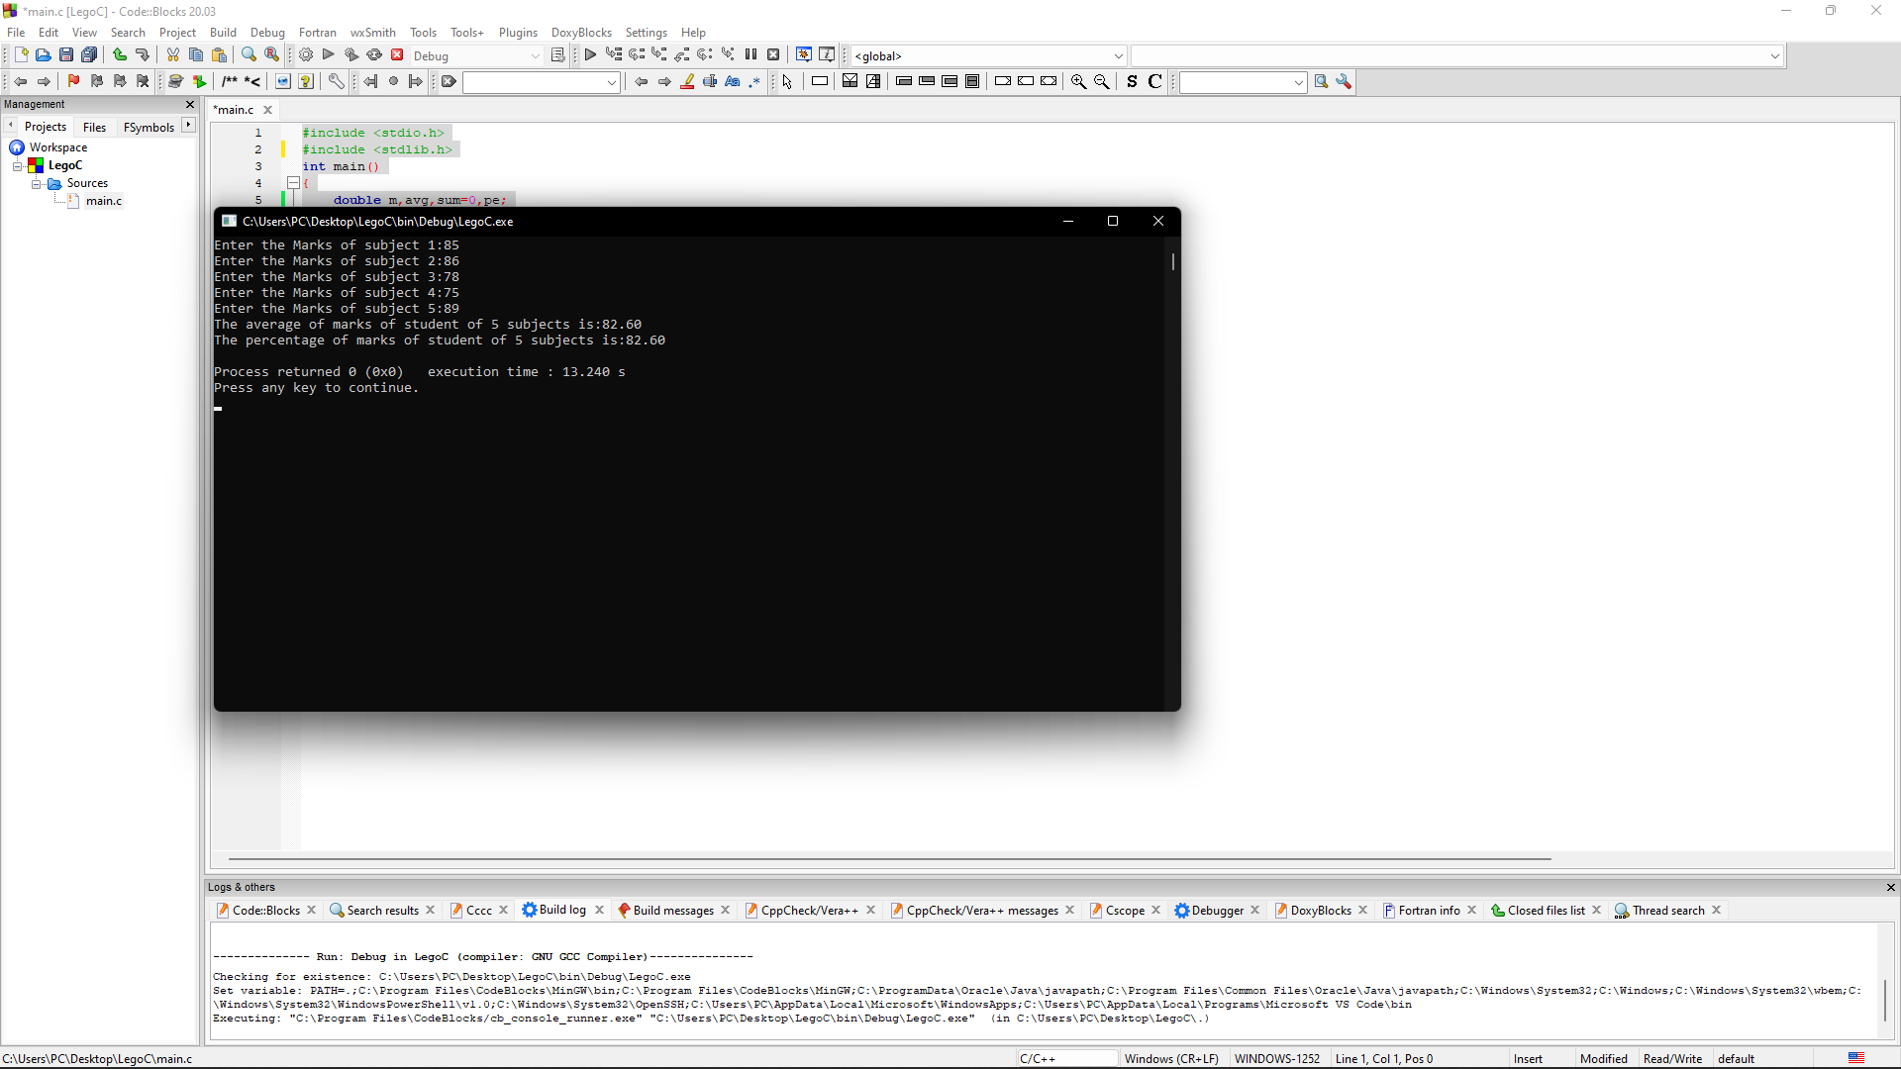

4- print a triangular pattern of *

Ans-

#include<stdio.h>

#include<stdlib.h>

int main(){

int i, space, rows=6, k = 0;

for(i=1;i<=rows;i++,k=0){

for(space=1;space<=rows-i;space++){

printf(" ");

}

while(k!=2*i-1){

printf("*");

k++;

}

printf("\n");

}

}

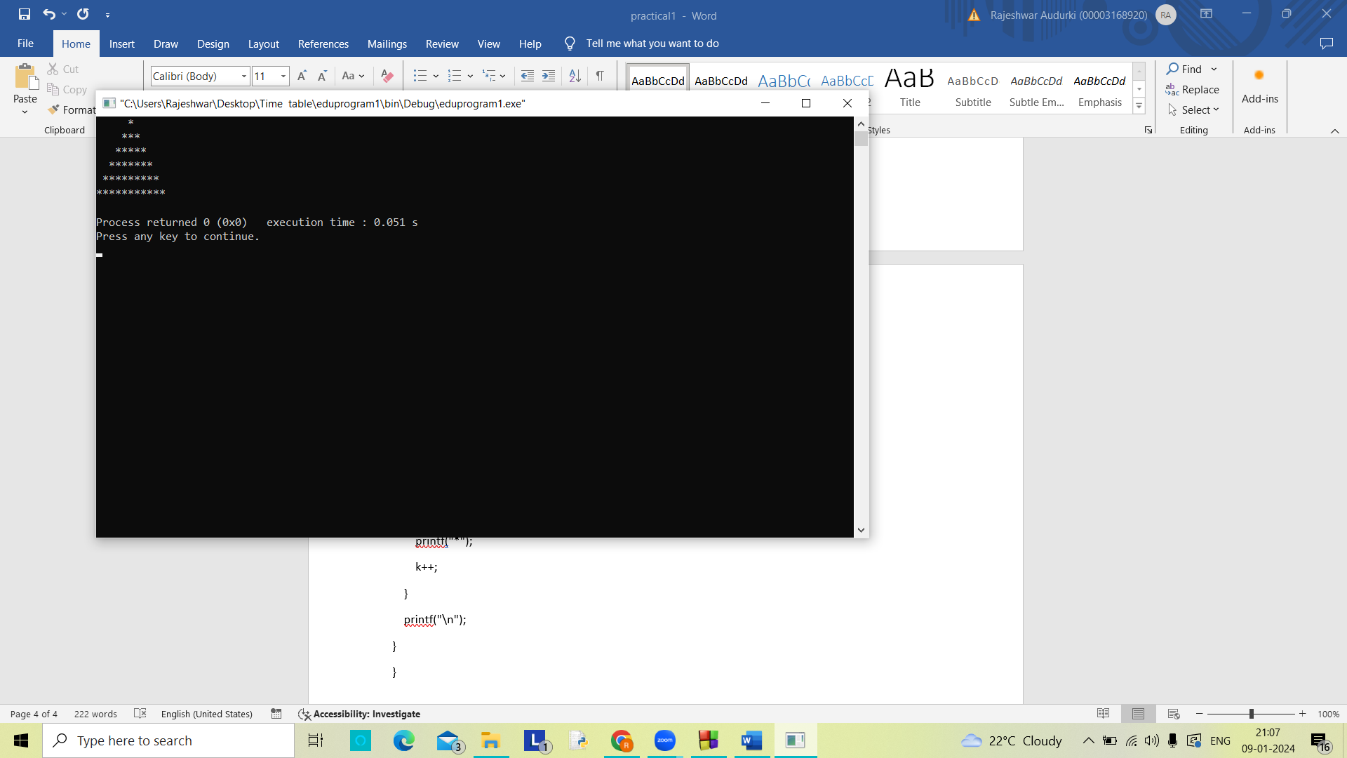

5- A ball released from height h each time it bounces on floor its velocity becomes halved write a c program which reads the value of y and prints total distance travelled by the ball when it touches the floor for 3rd time and g is 9.8

Ans-

#include<stdio.h>

#include<stdlib.h>

#include<math.h>

int main(){

int b=3;

double v,h,g=9.8,d=0;

printf("Enter the Height of drop:");

scanf("%lf",&h);

for(int i=1;i<=b;i++){

v=sqrt(2*g*h);

d+=h;

h/=2;

v/=2;

}

printf("The distance covered by ball during %d time is:%lf",b,d);

}

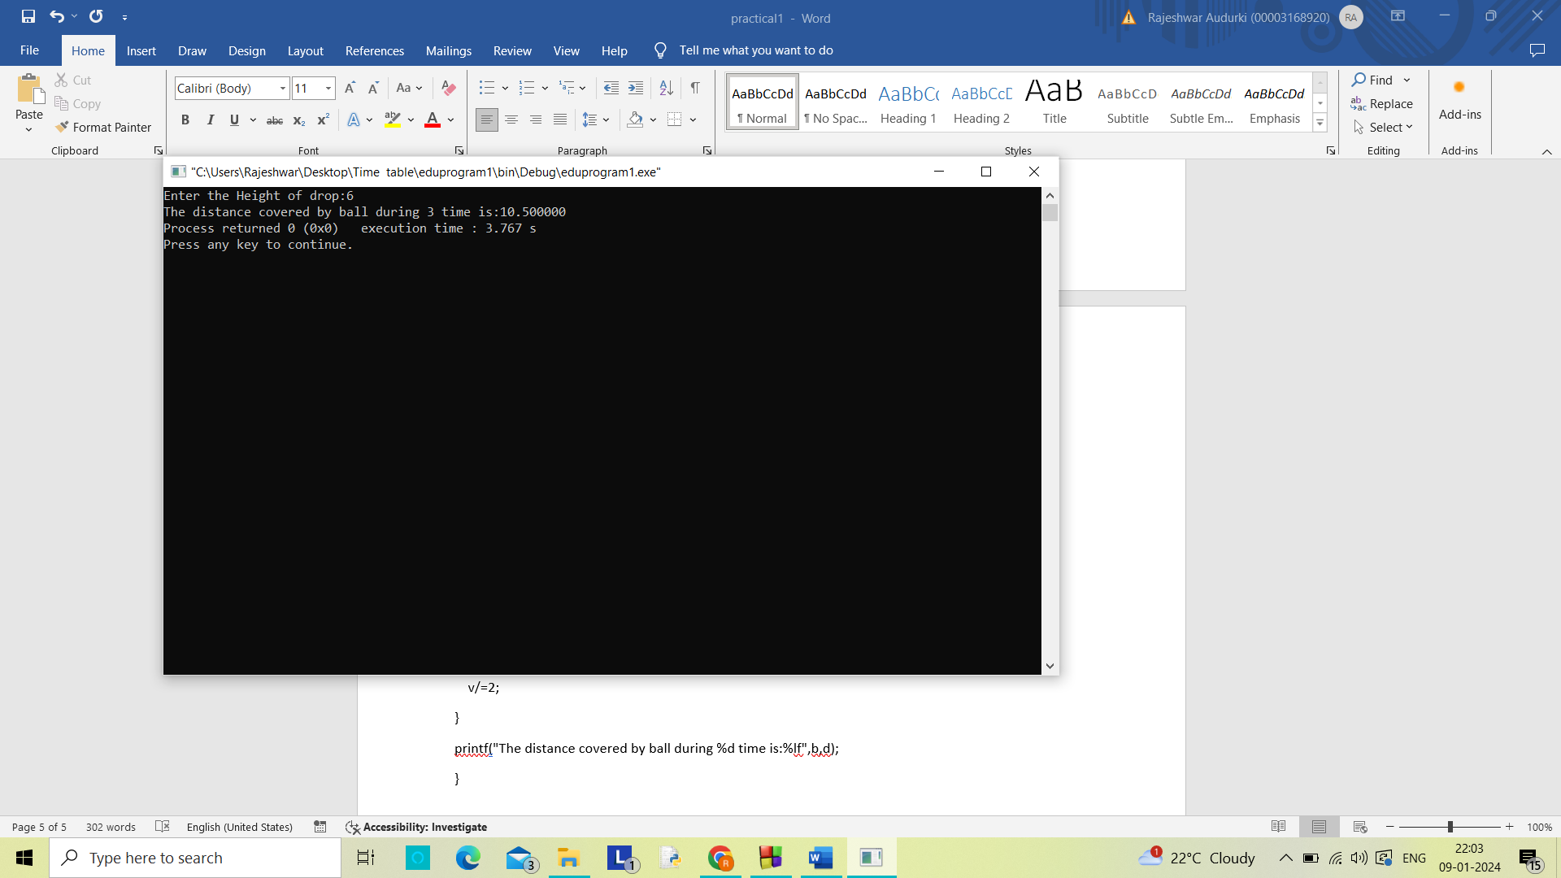

Q6-

Ans-

#include<stdio.h>

#include<stdlib.h>

#include<math.h>

int main(){

double amt;

printf("Enter the Investment:");

scanf("%lf",&amt);

double inte;

printf("Enter the Interest(%):");

scanf("%lf",&inte);

int i=1;

for(i=1;i<=5;i++){

amt+=((amt*inte)/100);

printf("The amount after %d yr is:%.2lf\n",i,amt);

}

printf("The total amount after 5 yrs is:%.2lf\n",amt);

}

