Screenshot – 1

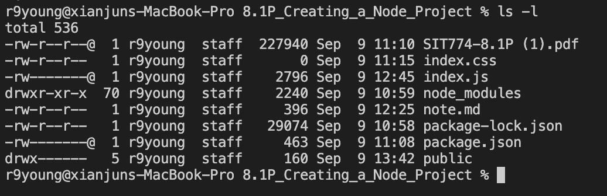

Screenshot – 2

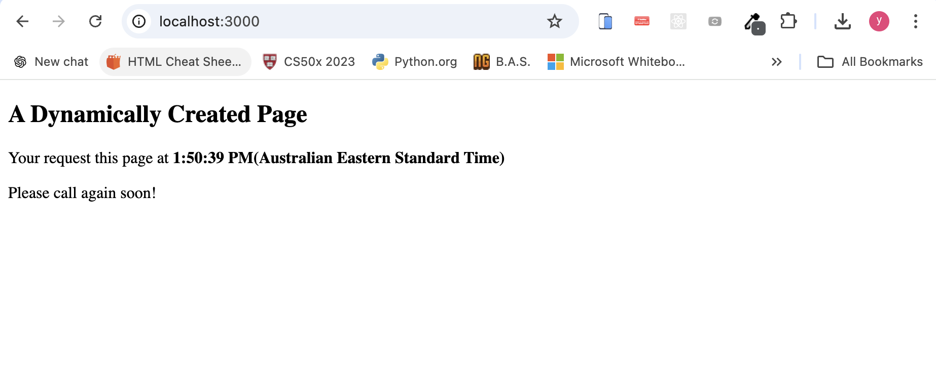

Screenshot – 3

Screenshot – 4

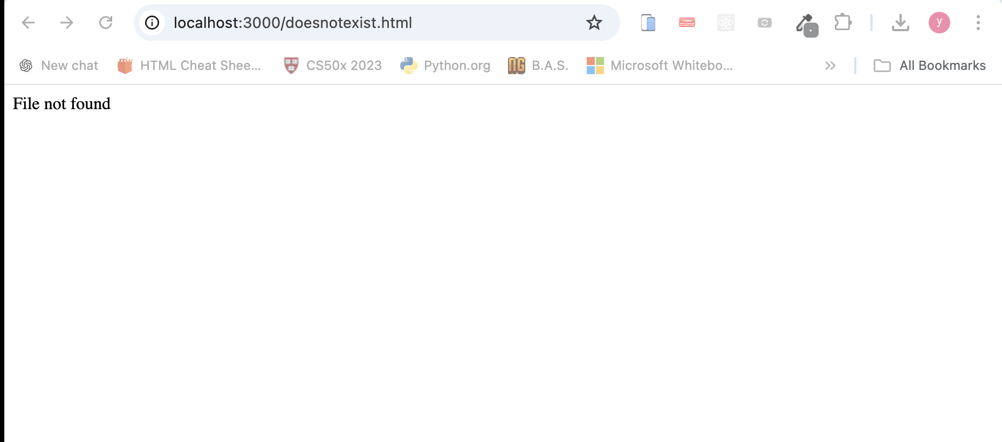

Screenshot -5

