1. What is the pattern behind σE?
   1. Strong pattern across variable type
   2. Biological variables are exposed to more “environment” variability than others

Macintosh HD:Users:Battrd:Documents:School&Work:WiscResearch:FatTails:FatFigures_v4:sigE_byType.pdf

1. What is the ξ of the ARMA residuals?
   1. The median of ξ from the residuals of the ARMA model (median ξARMA Residuals = -0.24) was lower than the ξ from the time series itself (median ξTime Series = -0.04)
   2. In both cases, there was no clear pattern of ξ across variable types (Bio, Chem, etc)

Macintosh HD:Users:Battrd:Documents:School&Work:WiscResearch:FatTails:FatFigures_v4:xi_variableType_TS&Resid.pdf

1. How does ξ in residuals compare to ξ in the time series?
   1. They are highly correlated.
   2. ξTS ~ ξResid regression gives R2 of 0.36, and a slope of 0.7
   3. Previously, regression did not show ξ to vary significantly across variable types. Multiple regression of the form ξTS ~ ξResid + Type shows that Chem, Phys, and Met variables are significantly less fat-tailed than Bio variables. W/o the residual ξ as a predictor, only Phys variables were significantly thinner in the tails.

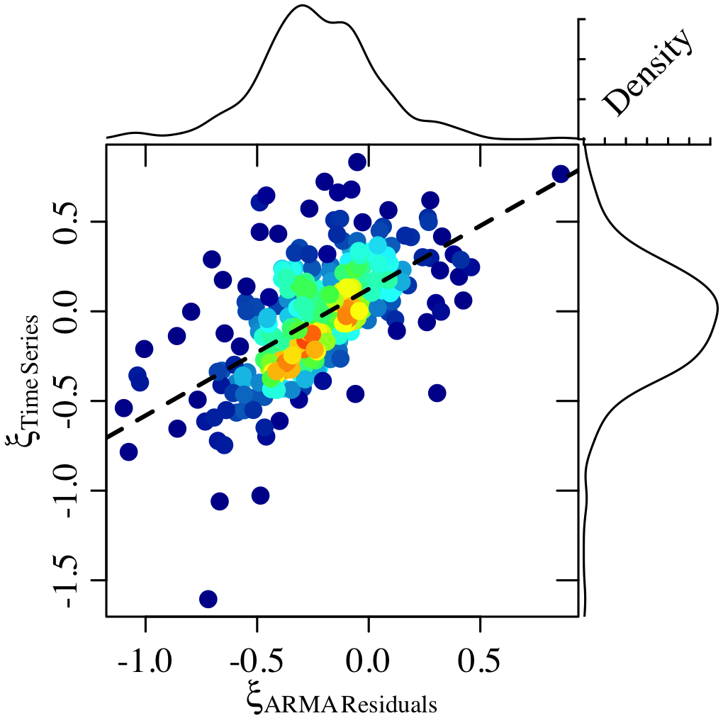

1. Compare return times for large observations vs. large ARMA residuals
   1. “How often would we be surprised if we know where we are (from GEV fitted to ARMA residuals), and how often would we be surprised if we don’t know where we are (from GEV fitted to time series observations)
   2. A “surprise” is 20% over the largest value in the time series of observations or time series of ARMA residuals.
   3. We know that Biology surprises us more often than other variables if we just look at the time series (top-left panel of figure), but pattern goes away for residuals (top-right panel)
   4. The frequencies of surprise (1/ return time for record breaking event) for the residuals/ time series observations are loosely correlated. Lower-left panel.
   5. ANSWER: We are surprised less often if we know where we are. This is super cool. Lower-right panel shows that we have to wait longer for residuals to surprise us.

Macintosh HD:Users:Battrd:Documents:School&Work:WiscResearch:FatTails:FatFigures_v4:surpriseFrequency_obs_resids.pdf

1. ARMA Simulations
   1. I could not create a fat-tailed time series from stationary ARMA time series with normal errors (no ξ was ever greater than 0).
   2. Non-stationary time series with normal errors could sometimes produce ‘fat tails’ … but these were just time series that increased very rapidly over time
   3. Stationary time series with fat-tailed errors could produce fat-tailed time series, but the relationship between time series ξ and residual ξ was not as good as in the empirical data
   4. Some evidence in the simulation that Lambda interacted with ξResiduals to produce ξObservations – evidence from multiple regression w/ interaction term. Low explanatory power, though.
2. ARMA w/o detrending first
   1. Many model fits had ||λ|| near 1
   2. Most patterns were similar. One exception was that the return time of a record-breaking residual became more similar to the return time of the record-breaking observation. In the detrended analysis, the residual record occurred less frequently (longer return time) relative to the frequency of breaking observation records
   3. Another exception is that the relationship between ξ in the residuals and ξ in the time series was weakened or disappeared
3. Influence of time series length on ξ: No relationship at all
4. Is ξ correlated with σE/mean(Time Series) (σE is s.d. of residual error in ARMA)? No!
5. Correlation between (ξResiduals/ξTimeSeries) and (length of time series)? No!