**Invention Disclosure Form**

The Invention Disclosure Form is the first step towards protection of the intellectual property and technology developed by you. Upon successfully reviewing and examination of the disclosure made by you, it may help us in strategizing for preparation of provisional patent application, non-provisional patent application and conducting patentability search.

Completion of the form assists in two important ways:

* First, it serves as a written, dated record of your invention.
* Second, it provides the basic information, which helps to examine, search, evaluate, subsequently protect and potentially commercialize the intellectual property associated with your invention/development.

**Use the following guidelines while filling out the form**:

* Provide as much detailed information about the technology as possible, citing all relevant publication/information.
* Please give a schematic diagram / drawing or an image relating to the invention or the disclosure to be made by you. This will assist the Patent Counsel to technically understand and rewrite the specification (provisional OR non-provisional), as may be required.
* Please cite patent(s) similar to your application, if you are aware of. For knowing patented technologies in the domain of research, please try research on general patent related sites, including but not limited to Google Patents, USPTO Patent search, Epicene etc..
* Please give references of any document that you may have referred during the phase of invention and development, a detailed bibliography of the reference material, with details of any existing or expired patents relating to the said invention or development, would assist in a more efficient process for protection of your invention.

1. **Title of the invention:**

Twitter Sentiment Analysis

1. **Field of the invention**

This invention provide analysis that allows you to keep track of what is being said about your product or service on social media, and can help you detect angry customers or negative mentions before they escalate. At the same time, Twitter sentiment analysis can provide valuable insights that drive decisions.

1. **Search terms/list of synonyms**

*Machine Learning, Natural Language processing, Data Pre-Processing,*

1. **Brief background of the existing knowledge. (Prior art includes patent and non-patent literature. It includes the existing products in the market and their drawbacks)**
2. Twitter is a platform created openly for public opinion. The consuming public is not an exception; we are sure to find them on the platform covering current issues. We find opinion leaders, key influencers, and relevant brands on Twitter. By using a Twitter sentiment analysis, companies will have a much clearer perspective on the sentiments of users concerning products and services, market trends, and the successes and failures of the competition. Twitter is an excellent metric of general consumer sentiment. It will be helpful to study a niche and its market trends.
3. These methods usually do not identify sarcasm, negation, grammar mistakes, misspellings, or irony. As the whole classification is based on your tags and rules, you should have sufficient data to create a reliable dictionary.
4. Machine learning algorithms can be trained to detect sarcasm, irony, or negation. The algorithms learn the affective valence of the words, so they do not require a pre-determined dataset. They are faster than traditional methods. Automated methods provide more accurate results.
5. **Brief description of the invention: How does this invention relate to new method or system etc.?**

People are using forums, social networks, blogs, and other platforms to share their opinion, thereby generating a huge amount of data. Companies and organizations are interested in automatically analyzing this user-generated data in order to efficiently learn about it at scale. Sentiment Analysis is related to generating a dictionary by tagging words, the latter involves the consideration of syntactic patterns. The sentiment score of a text is determined by:

* Giving each token a separate score based on the emotional tone,
* Calculating the overall polarity of the sentence,
* Aggregating overall polarity scores of all sentences in the text.

1. 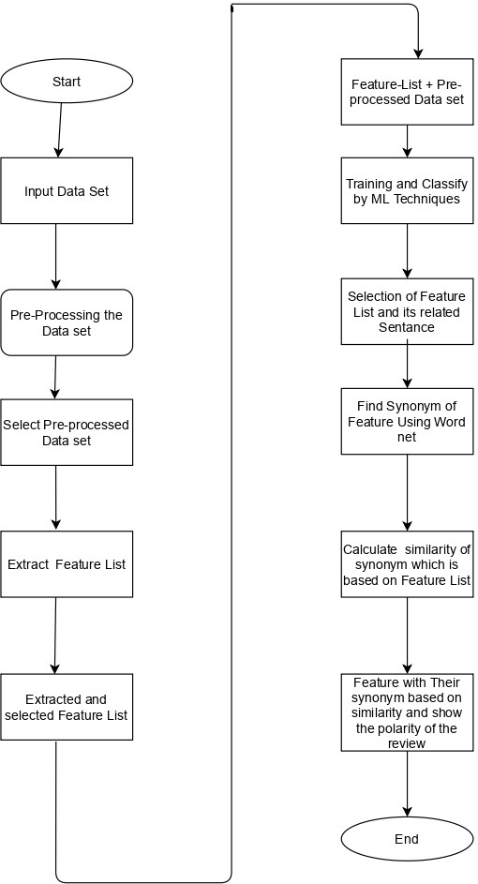**Describe the invention in details for technical evaluation. Please use additional sheets for sketches, drawing, photographs and other materials that help to illustrate the description.**
2. **What are the advantages of the present invention over comparable inventions available in patent and non-patent literature? OR Problem(s) addressed in the prior art (patents/ scientific literature/ traditional knowledge), if any. How does your invention solve the said problem?**

a) Sentiment analysis is a analysis technique that categorizes text data based on its aspects and identifies its sentiment. It is used to analyze customer feedback data by correlating sentiments to various aspects of a product or service.

b) Among many analytical fields, one in which humans outperform all others is the ability to recognize feelings. However, for feedback presented to you, such as**40–50** or even **100**, this is doable. However, if you have a data set of, say, **10,000** reviews, manually analyzing them becomes impossible.

C) Our invention solves the analysing thousands of revies fast and efficient using machine learning algorithms

1. **Please mention the use / applications (obvious and non-obvious) of your invention?**
2. [Voice of Customer (VoC) Programs](https://www.questionpro.com/voice-of-customer.html) is the feedback gathered better to understand customers’ feelings and concerns about a brand.
3. Sentiment analysis can identify how your clients feel about the highlights and benefits of your products or services. This may help and reveal areas of opportunity that may not have been mindful of before.
4. Sentiment analysis can offer assistance for companies to distinguish new trends, analyze competitors, and test emerging markets.