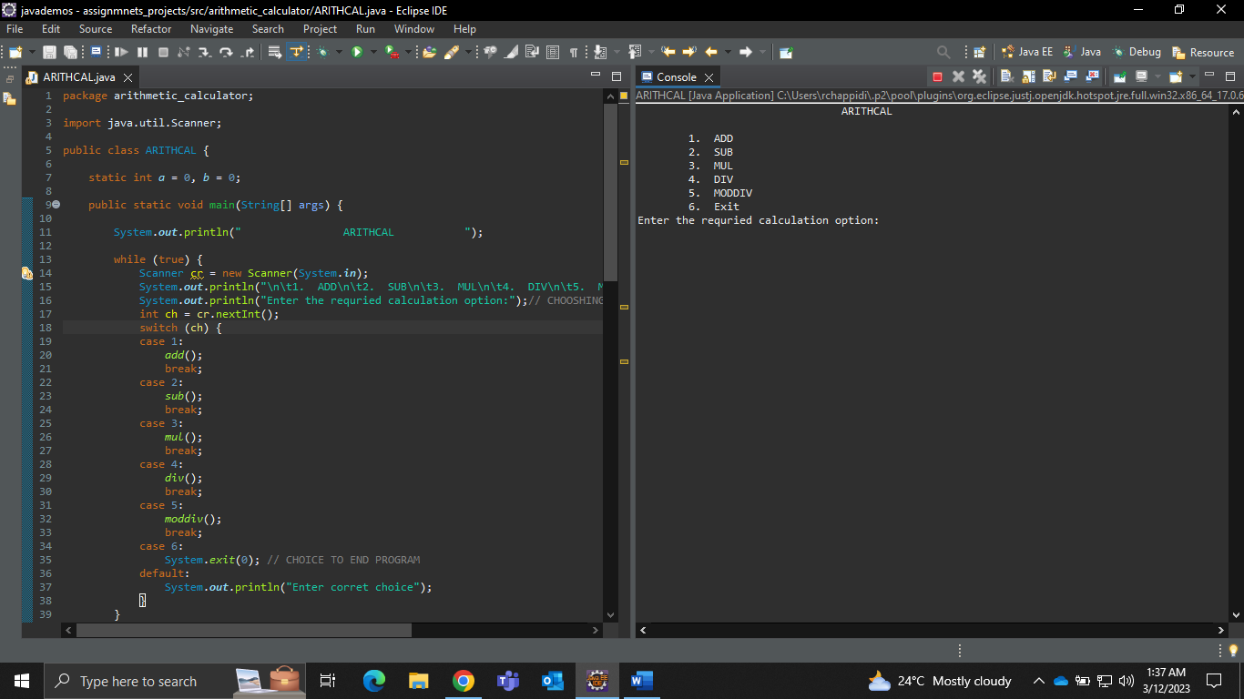ARITHMATIC CALCULATOR MENU

ADDITION

SUBTRACTION

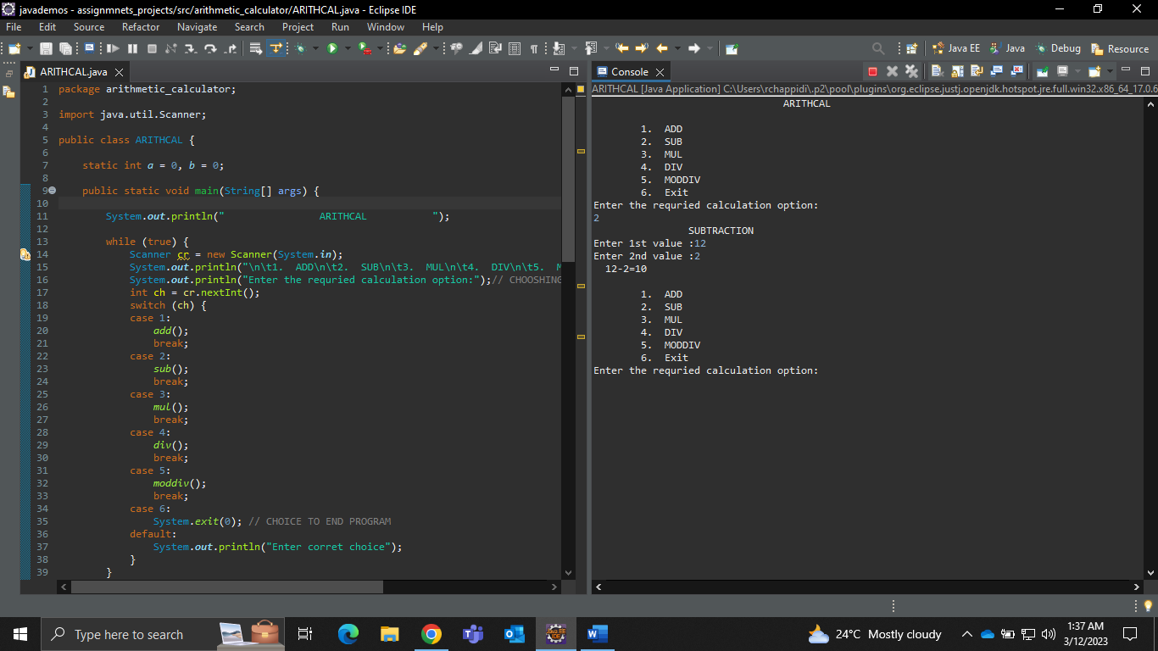

MULTIPLICATION

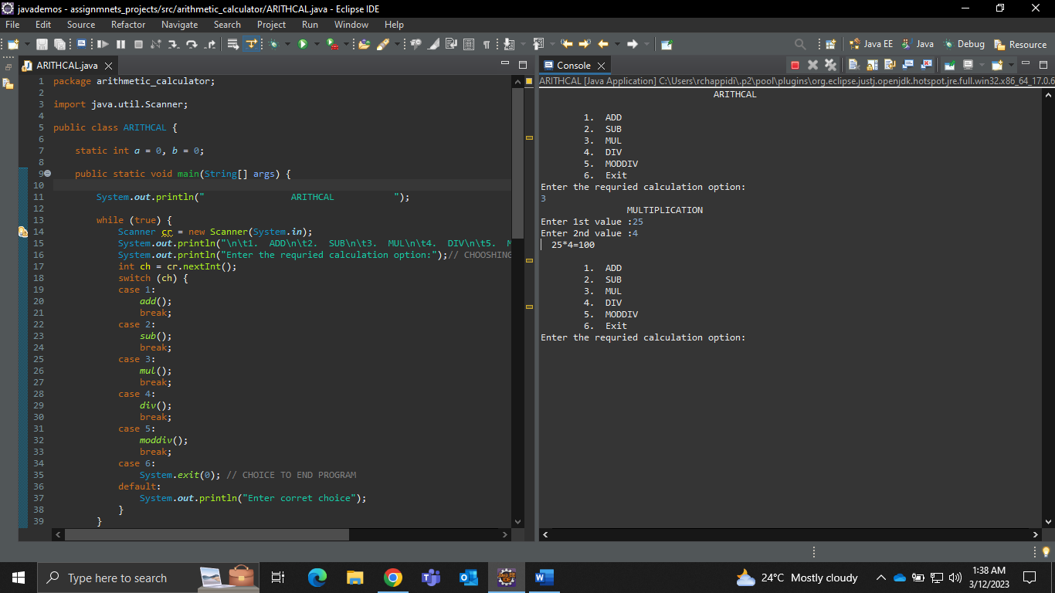

DIVISION

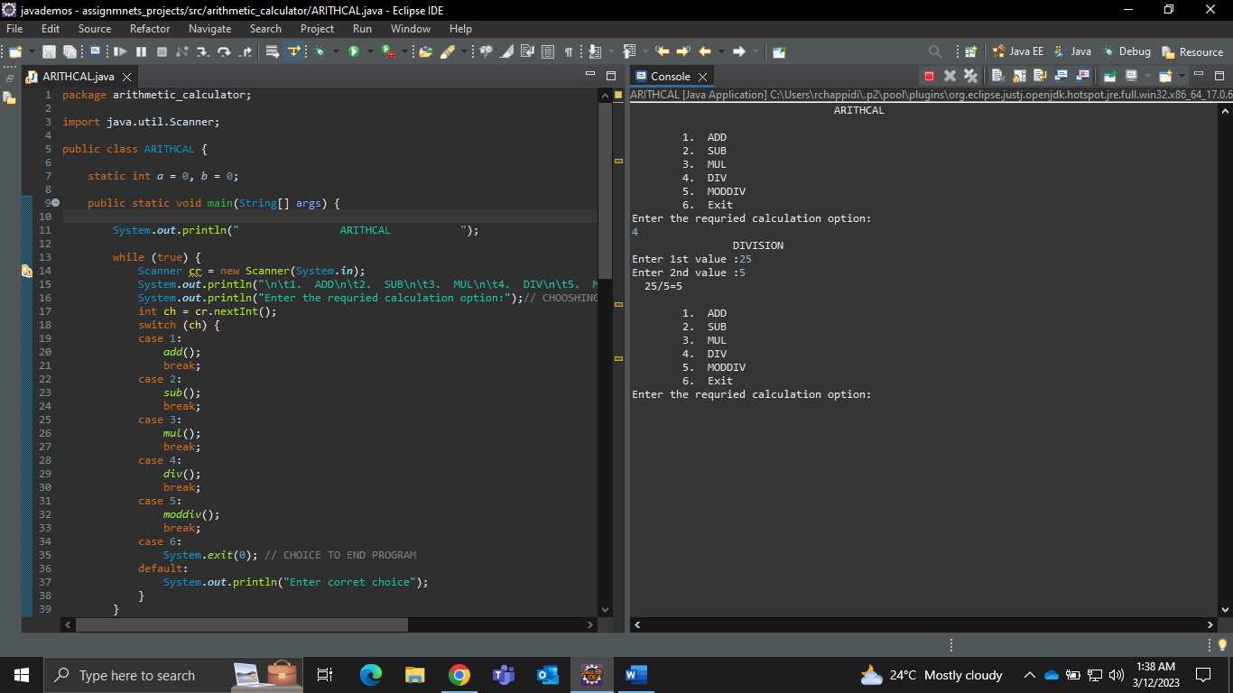

MODULO DIVISION

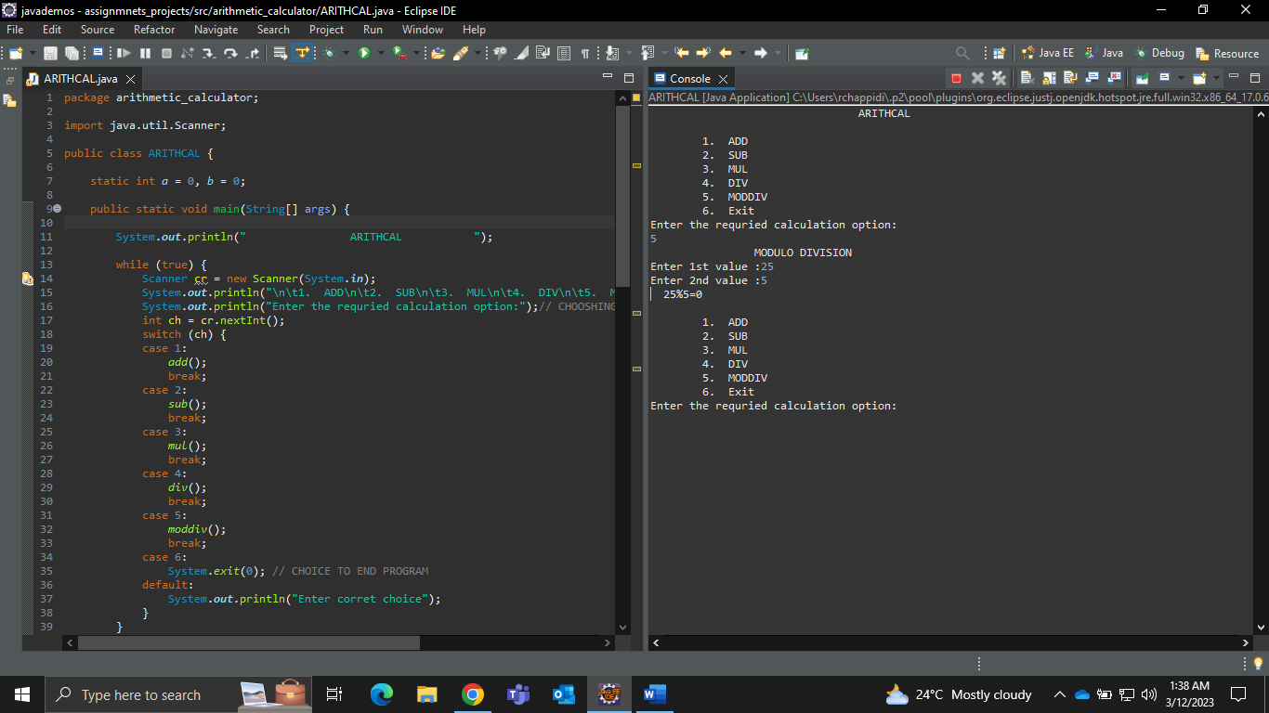

(EXIT) EXITING THE PROGRAM

