MAIN MENU

LISTING ALL FILES

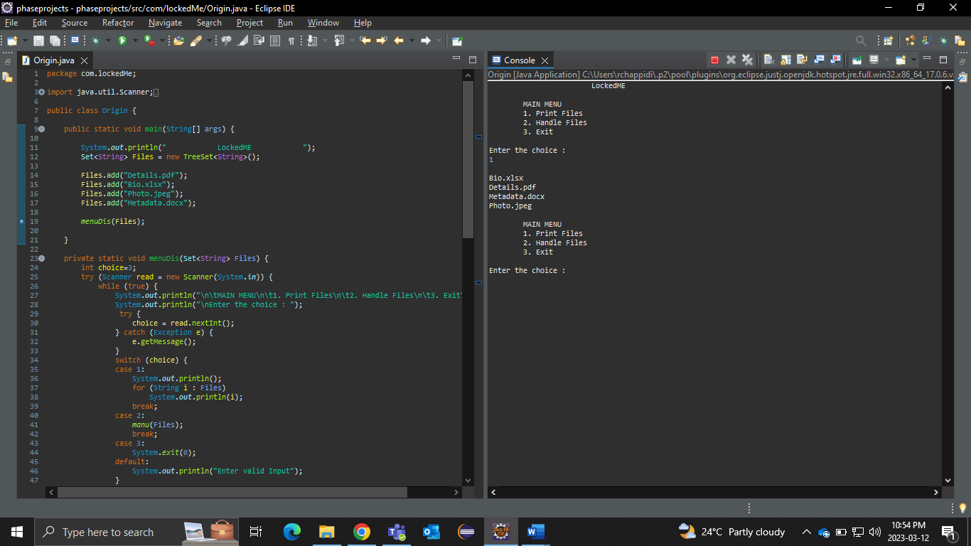

FILE HANDLING OPERATIONS

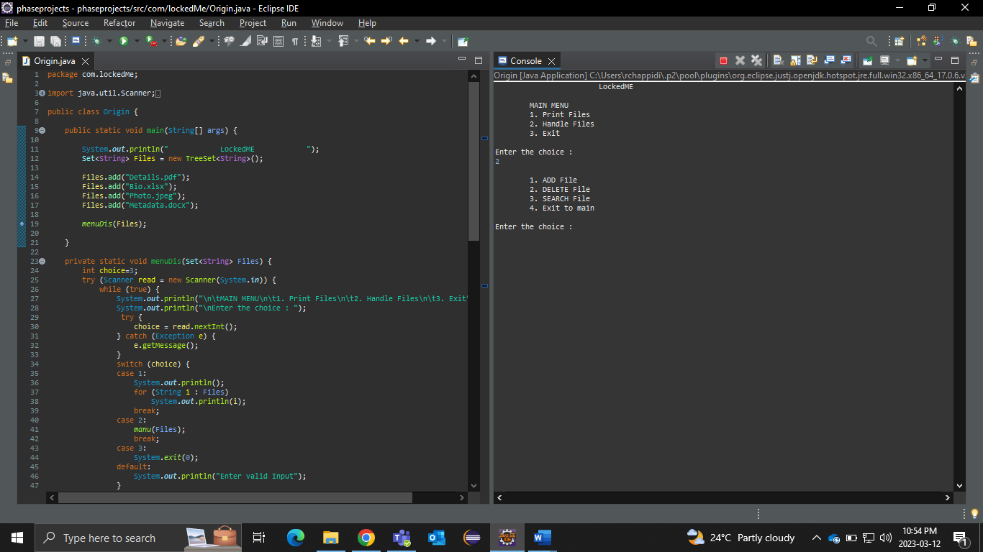

ADDING A FILE

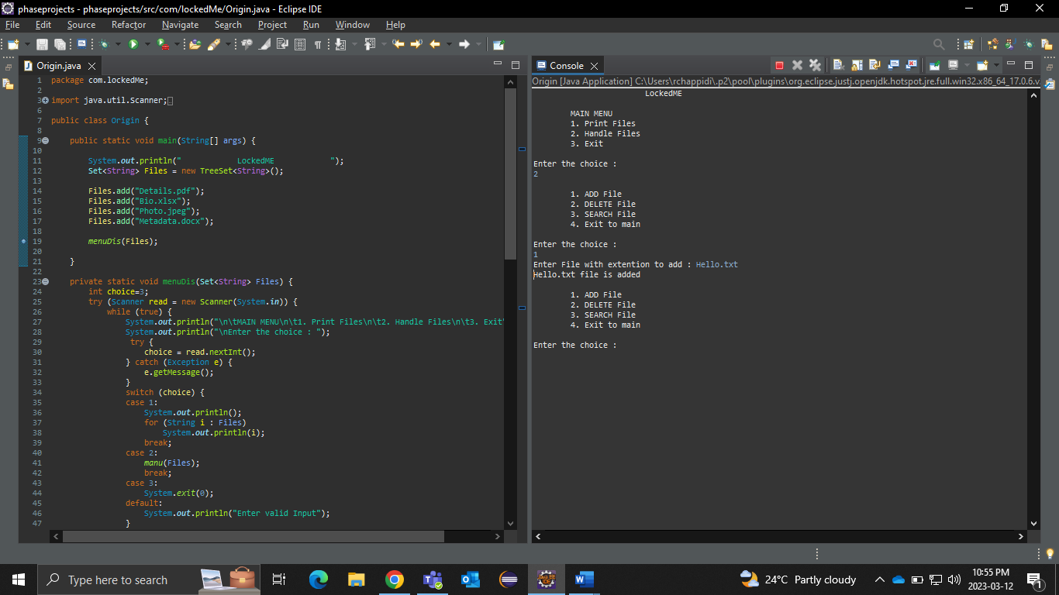

DELETING A FILE

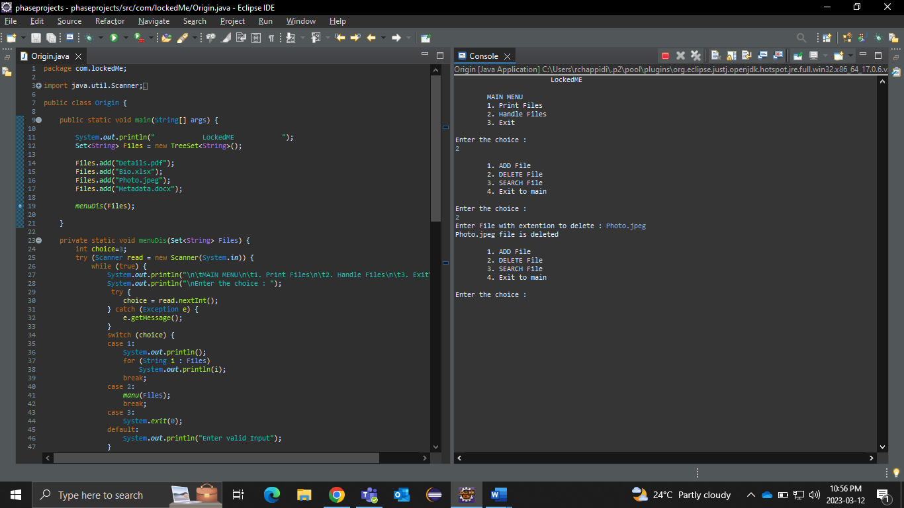

SEARCHING FOR A FILE

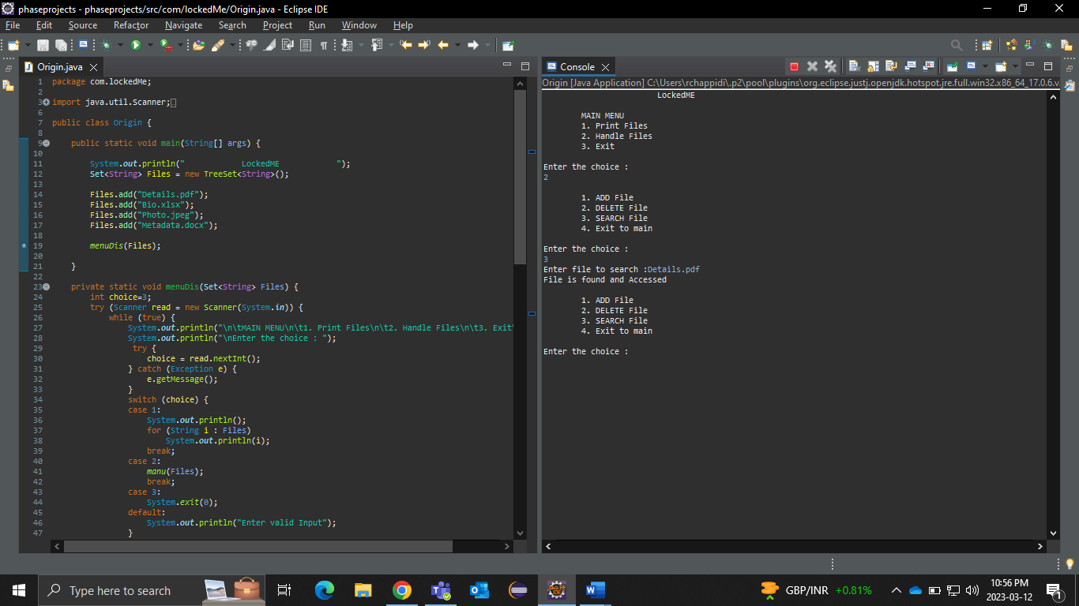

RETURNING TO MAIN MENU

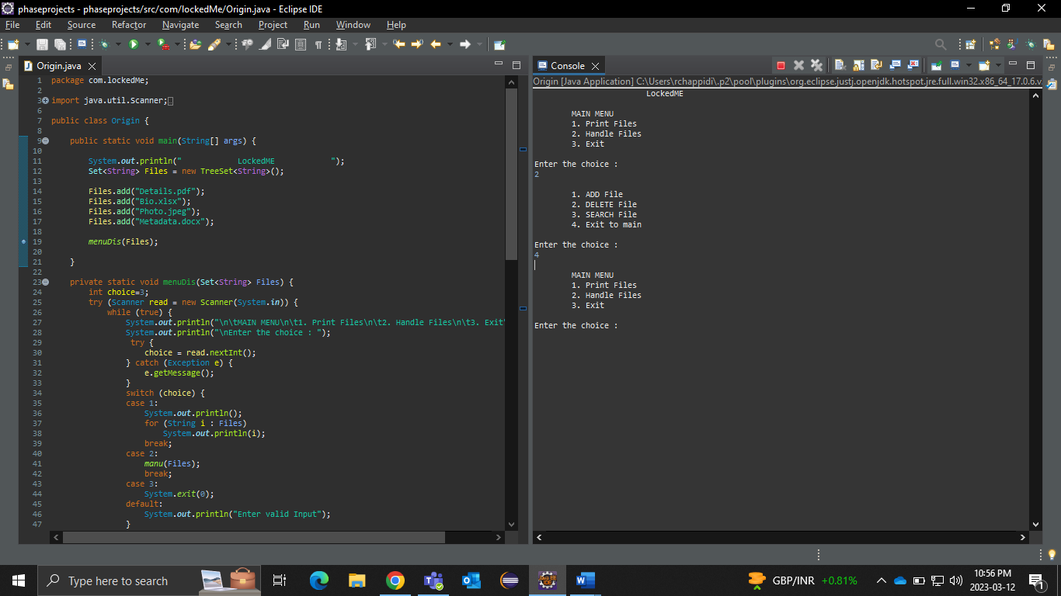

EXITING/ENDING PROGRAM

