OLA Data Analyst Project

ChatGPT Prompt to Create Data
Please create a spreadsheet with 1 lac rows, for Bengaluru city. Give the following columns. The data will be for 1 month. use the following column -
- Date
- Time
- Booking ID
- Booking Status
- Customer ID
- Vehicle Type
  - Auto
  - Prime Plus
  - Prime Sedan
  - Mini
  - Bike
  - eBike
  - Prime SUV
- Pickup Location (Create dummy location points Take any 50 areas from Bangalore)
- Drop Location (Take from dummy pickup locations)
- Avg VTAT (Time taken to arrive at the vehicle)
- Avg CTAT (Time taken to arrive the Customer)
- Cancelled Rides by Customer
- Reason for cancelling by Customer
- Driver is not moving towards pickup location
- Driver asked to cancel
- AC is not working (Only for 4-wheelers)
- Change of plans
- Wrong Address
13. Cancelled Rides by Driver
- Personal & Car related issues
- Customer related issue
- The customer was coughing/sick
- More than permitted people in there
- Incomplete Rides
- Incomplete Rides Reason
- Customer Demand
- Vehicle Breakdown
- Other Issue
- Booking Value
- Ride Distance
- Driver Ratings
- Customer Rating
Keep the overall booking status success for this data at 62%. If the booking status is successful, then only fare charge ratings, average VTAT, average CTAT, and other data will be there.
Make sure orders cancelled by customers should not be more than 7%
Make sure orders cancelled drivers should not be more than 18%
Also, increase the number of orders on weekends and match days. Keep match day by using the following dates.
keep incomplete rides less than 6% Keep order value high on weekends
in Food Category keep around 67 Indian keep order ID with 10 digits starting with CNR and then digits keep orders under 500 value 70% keep orders above 500 value 28% keep remaining orders above 1000.

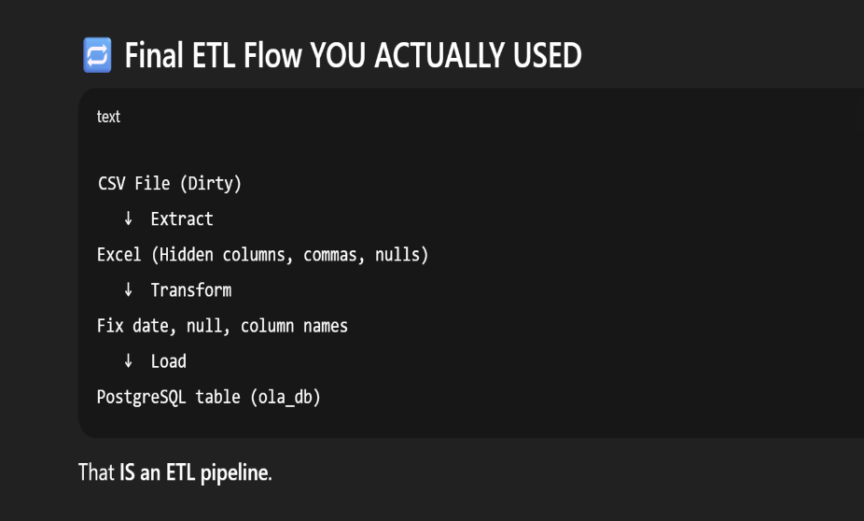


SQL Questions:
- Retrieve all successful bookings:
- Find the average ride distance for each vehicle type:
- Get the total number of cancelled rides by customers:
- List the top 5 customers who booked the highest number of rides:
- Get the number of rides cancelled by drivers due to personal and car-related issues:
- Find the maximum and minimum driver ratings for Prime Sedan bookings:
- Retrieve all rides where payment was made using UPI:
- Find the average customer rating per vehicle type:
- Calculate the total booking value of rides completed successfully:
- List all incomplete rides along with the reason:
Power BI Questions:
- Ride Volume Over Time
- Booking Status Breakdown
- Top 5 Vehicle Types by Ride Distance
- Average Customer Ratings by Vehicle Type
- cancelled Rides Reasons
- Revenue by Payment Method
- Top 5 Customers by Total Booking Value
- Ride Distance Distribution Per Day
- Driver Ratings Distribution
- Customer vs. Driver Ratings
Data Columns
- Date  - Time  - Booking_ID  - Booking_Status  - Customer_ID  - Vehicle_Type  - Pickup_Location  - Drop_Location  - V_TAT | - C_TAT  - cancelled_Rides_by_Customer  - cancelled_Rides_by_Driver  - Incomplete_Rides  - Incomplete_Rides_Reason  - Booking_Value  - Payment_Method  - Ride_Distance  - Driver_Ratings  - Customer_Rating
SQL Answers:
- Retrieve all successful bookings:
SELECT * FROM bookings WHERE Booking_Status = 'Success';
- Find the average ride distance for each vehicle type:
SELECT Vehicle_Type, AVG(Ride_Distance) as avg_distance FROM bookings GROUP BY Vehicle_Type;
- Get the total number of cancelled rides by customers:
SELECT COUNT(*) FROM bookings WHERE Booking_Status = 'cancelled by Customer';
- List the top 5 customers who booked the highest number of rides:
SELECT Customer_ID, COUNT(Booking_ID) as total_rides FROM bookings GROUP BY
Customer_ID ORDER BY total_rides DESC LIMIT 5;
- Get the number of rides cancelled by drivers due to personal and car-related issues: SELECT COUNT(*) FROM bookings WHERE cancelled_Rides_by_Driver = 'Personal & Car
related issue';
- Find the maximum and minimum driver ratings for Prime Sedan bookings: SELECT MAX(Driver_Ratings) as max_rating, MIN(Driver_Ratings) as min_rating FROM bookings WHERE Vehicle_Type = 'Prime Sedan';
- Retrieve all rides where payment was made using UPI: SELECT * FROM bookings WHERE Payment_Method = 'UPI';
- Find the average customer rating per vehicle type:
SELECT Vehicle_Type, AVG(Customer_Rating) as avg_customer_rating FROM bookings
GROUP BY Vehicle_Type;
- Calculate the total booking value of rides completed successfully:
SELECT SUM(Booking_Value) as total_successful_value FROM bookings WHERE
Booking_Status = 'Success';
- List all incomplete rides along with the reason:
SELECT Booking_ID, Incomplete_Rides_Reason FROM bookings WHERE Incomplete_Rides =
'Yes';
Power BI Answers:
Segregation of the views:
  - Overall
  - Ride Volume Over Time
  - Booking Status Breakdown
  - Vehicle Type
- Top 5 Vehicle Types by Ride Distance
  - Revenue
  - Revenue by Payment Method
  - Top 5 Customers by Total Booking Value
  - Ride Distance Distribution Per Day
  - Cancellation
  - Cancelled Rides Reasons (Customer)
  - cancelled Rides Reasons(Drivers)
  - Ratings
  - Driver Ratings
  - Customer Ratings
Answers:
- Ride Volume Over Time: A time-series chart showing the number of rides per day/week.
- Booking Status Breakdown: A pie or doughnut chart displaying the proportion of different booking statuses (success, cancelled by the customer, cancelled by the driver, etc.).
- Top 5 Vehicle Types by Ride Distance: A bar chart ranking vehicle types based on the total distance covered.
- Average Customer Ratings by Vehicle Type: A column chart showing the average customer ratings for different vehicle types.
- cancelled Rides Reasons: A bar chart that highlights the common reasons for ride cancellations by customers and drivers.
- Revenue by Payment Method: A stacked bar chart displaying total revenue based on payment methods (Cash, UPI, Credit Card, etc.).
- Top 5 Customers by Total Booking Value: A leaderboard visual listing customers who have spent the most on bookings.
- Ride Distance Distribution Per Day: A histogram or scatter plot showing the distribution of ride distances for different Dates.
- Driver Rating Distribution: A box plot visualizing the spread of driver ratings for different vehicle types.
- Customer vs. Driver Ratings: A scatter plot comparing customer and driver ratings for each completed ride, analyzing correlations.

SQL Questions & Answers
Create Database Ola;
Use Ola;
#1. Retrieve all successful bookings:
Create View Successful_Bookings As
SELECT * FROM bookings
WHERE Booking_Status = 'Success';
#2. Find the average ride distance for each vehicle type:
Create View ride_distance_for_each_vehicle As SELECT Vehicle_Type, AVG(Ride_Distance) as avg_distance FROM bookings GROUP BY Vehicle_Type;
#3. Get the total number of cancelled rides by customers:
Create View cancelled_rides_by_customers As
SELECT COUNT(*) FROM bookings
WHERE Booking_Status = 'cancelled by Customer';
#4. List the top 5 customers who booked the highest number of rides:
Create View Top_5_Customers As
SELECT Customer_ID, COUNT(Booking_ID) as total_rides
FROM bookings
GROUP BY Customer_ID
ORDER BY total_rides DESC LIMIT 5;
#5. Get the number of rides cancelled by drivers due to personal and car-related issues:
Create View Rides_cancelled_by_Drivers_P_C_Issues As
SELECT COUNT(*) FROM bookings
WHERE cancelled_Rides_by_Driver = 'Personal & Car related issue';
#6. Find the maximum and minimum driver ratings for Prime Sedan bookings:
Create View Max_Min_Driver_Rating As
SELECT MAX(Driver_Ratings) as max_rating,
MIN(Driver_Ratings) as min_rating
FROM bookings WHERE Vehicle_Type = 'Prime Sedan';
#7. Retrieve all rides where payment was made using UPI:
Create View UPI_Payment As
SELECT * FROM bookings
WHERE Payment_Method = 'UPI';
#8. Find the average customer rating per vehicle type:
Create View AVG_Cust_Rating As
SELECT Vehicle_Type, AVG(Customer_Rating) as avg_customer_rating
FROM bookings
GROUP BY Vehicle_Type;
#9. Calculate the total booking value of rides completed successfully:
Create View total_successful_ride_value As
SELECT SUM(Booking_Value) as total_successful_ride_value
FROM bookings
WHERE Booking_Status = 'Success';
#10. List all incomplete rides along with the reason:
Create View Incomplete_Rides_Reason As
SELECT Booking_ID, Incomplete_Rides_Reason
FROM bookings
WHERE Incomplete_Rides = 'Yes';
Retrieve All Answers
#1. Retrieve all successful bookings:
Select * From Successful_Bookings;
#2. Find the average ride distance for each vehicle type: Select * from ride_distance_for_each_vehicle;
#3. Get the total number of cancelled rides by customers: Select * from cancelled_rides_by_customers;
#4. List the top 5 customers who booked the highest number of rides:
Select * from Top_5_Customers;
#5. Get the number of rides cancelled by drivers due to personal and car-related issues:
Select * from Rides_cancelled_by_Drivers_P_C_Issues;
#6. Find the maximum and minimum driver ratings for Prime Sedan bookings:
Select * from Max_Min_Driver_Rating;
#7. Retrieve all rides where payment was made using UPI:
Select * from UPI_Payment;
#8. Find the average customer rating per vehicle type:
Select * from AVG_Cust_Rating;
#9. Calculate the total booking value of rides completed successfully: Select * from total_successful_ride_value;
#10. List all incomplete rides along with the reason:
Select * from Incomplete_Rides_Reason;

