# Modularity

We broke down each of or routines into very small subroutines with the goal of not having to repeat large amounts of code. This approach allowed us to create very generic code that we could use in many places.

# Flow Chart

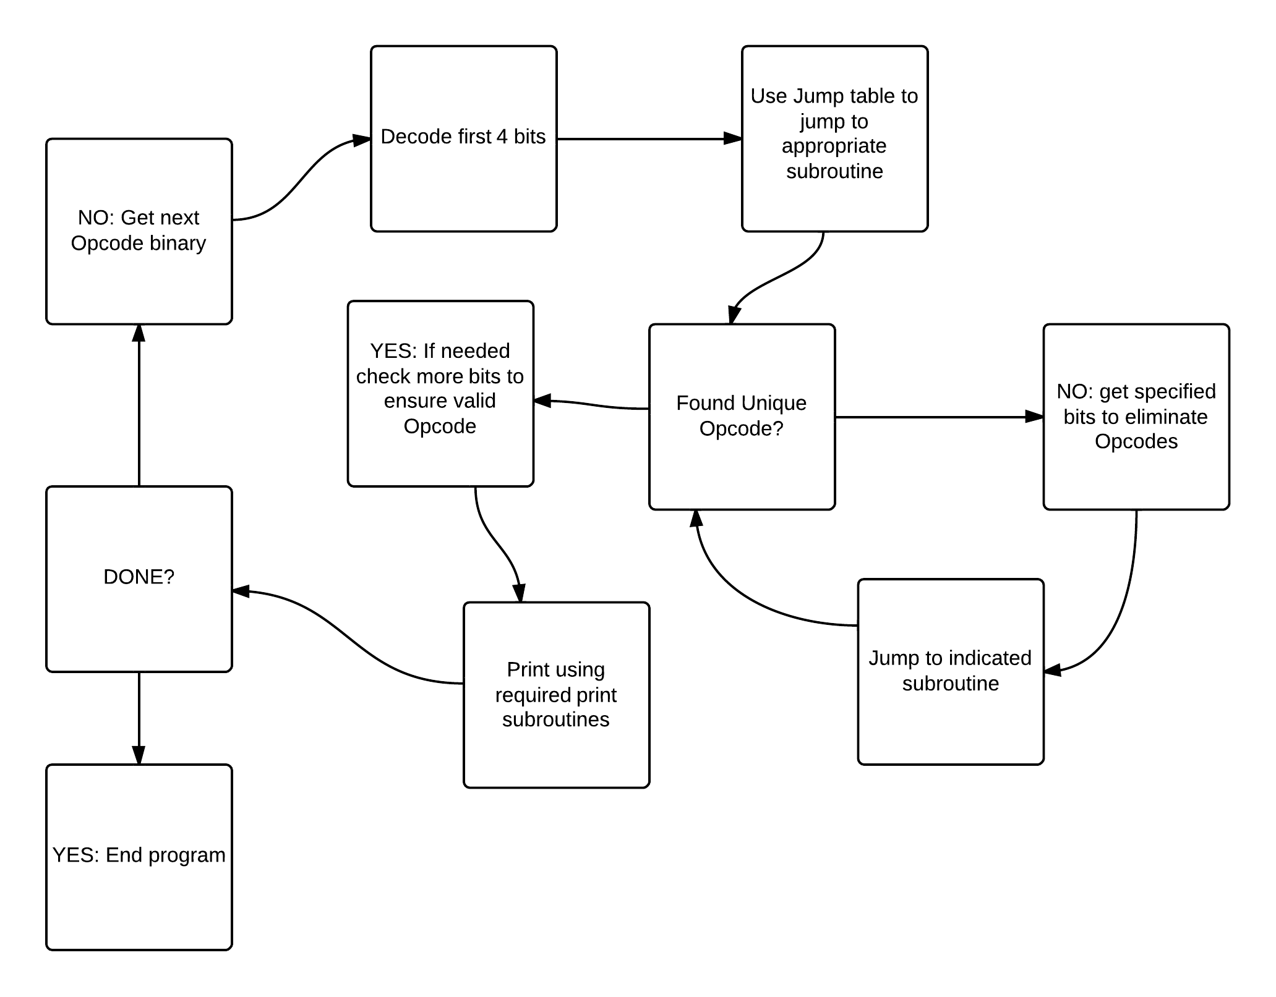

# Bit Masking

Our program uses a bit mask to extract out bits that we need to differentiate between different Opcodes. The bit mask subroutine takes in the binary number containing the bits you wish to retrieve, the index of the least significant bit you want, as well as the number of bits you wish to retrieve that are more significant that it. It then logic shifts out the bits that you don’t want and shifts the ones you do want down into the least significant positions.