COMP 3123 – Full Stack Development I – Lab Week 10

React JS

References:
- https://www.w3schools.com/react/react_getstarted.asp
- https://reactjs.org/docs/create-a-new-react-app.html

React JS Environment Setup:

- Required NPM or node.js (Your machine is already equipped with node). To verify execute following command on command line

$ node –version

- Create new ReactJS application name labweek10 and GitHub repository with same name

$ npx create-react-app labweek10

- Execute the labweek10 exercise

$ cd labweek10
$ npm start

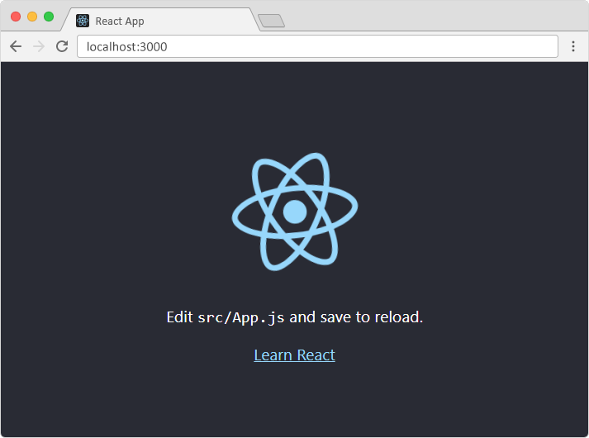
Exercise: This exercise contains 2 parts

Part – I Update the default layout to create data entry form.

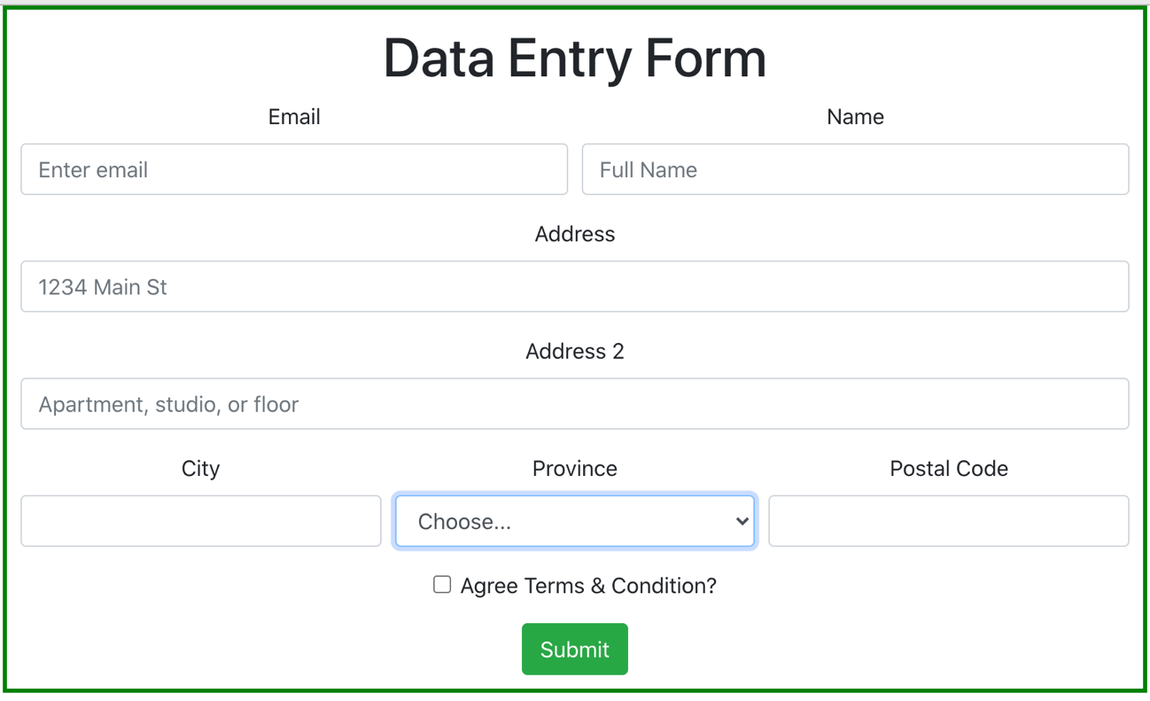

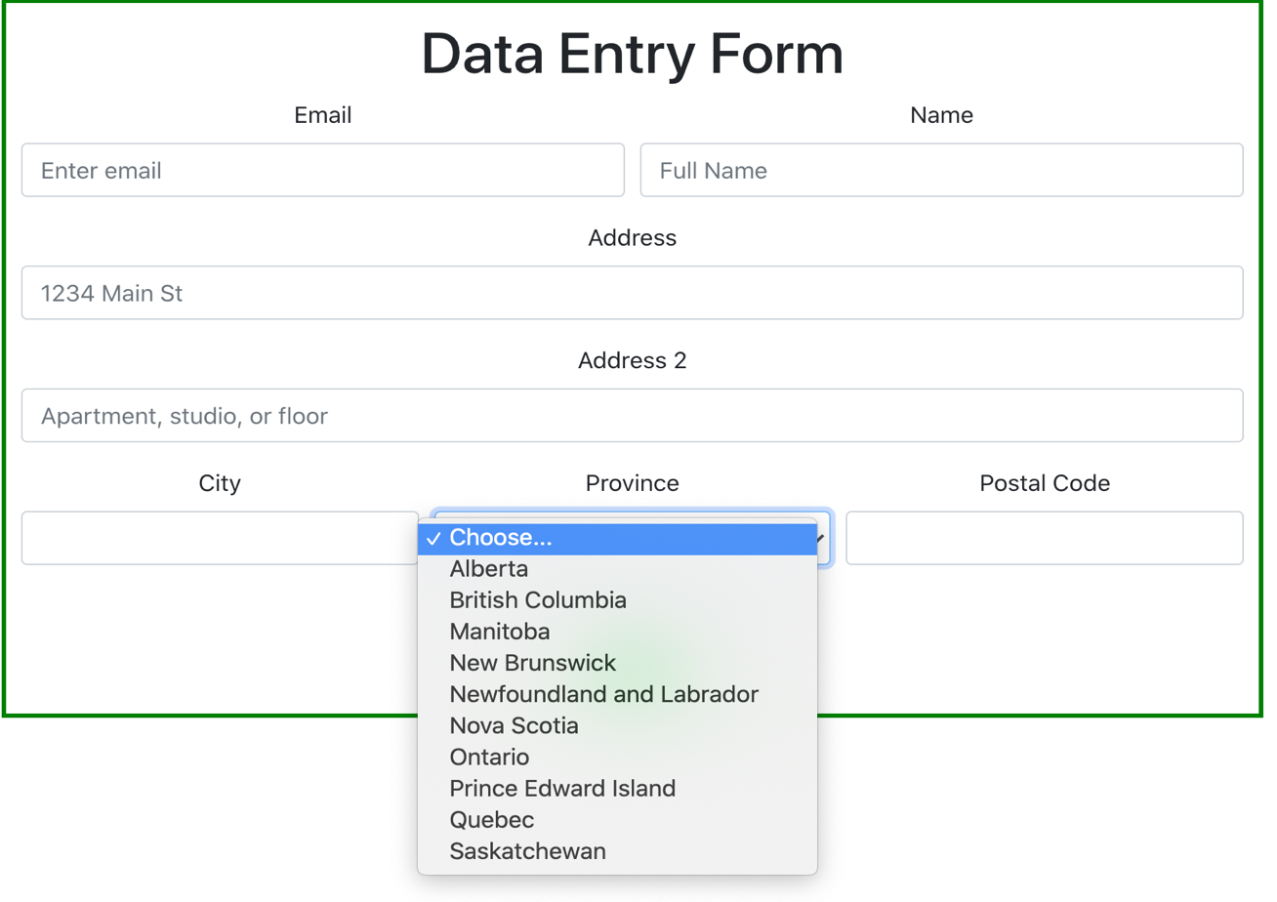
Part – II When you press Submit button you should display all the information entered at the bottom of the data entry form in given format.

Email: | Pritesh.patel2@georgebrown.ca
Full Name: | Pritesh Patel
Address: | 160 Kendal Ave
City: | Toronto
Province: | Ontario
Postal Code: | M5R 1M3

Submission Details

- After modifying the application upload ZIP having name labweek10.zip and Screenshot of your output and code to black board on or before deadline.
- Also submit GitHub repository link on BB
- Please delete node_modules folder before upload

