

2025-2026
Internship Commencement Kit

Intern Name: Prashik Ramteke
Department: Computer Science and Engineering
Internship Company/Firm: Wiriya Technology
Training Duration: 6 months

Industry Mentor Details:
Mentor Name: Praful Kamble
Mentor Designation: HR Mentor
Contact No.:
Email id: praful@wiriyatechnology.com

Faculty Mentor Detail:
Mentor Name: Mr. Jitendra Madavi
Mentor Designation: ______________________________
Contact No.:_____________________________________
Email id:________________________________________

INDEX

- Internship Objectives (Attached with Document)
- Benefit to Students (Attached with Document)
- Outcomes of the Internship (Attached with Document)
- General guidelines for Internship (Attached with Document)
- Offer Letter (Required hard copy/ Soft Copy)
- Monthly Overview Of Internship Activities (Regular entry required and take signature of your faculty mentor during visit)
- Internship Report ( need to submit in hard binding, format already shared)
- Geotag Photograph with Industry Mentor ( color printout)
- Attendance (Need to verify by the company with signature and stamp)
- Industry Mentor Evaluation (Ignore if already submitted)
- Completion Certificate (Required hard copy/ Soft Copy)
- Feedback Form (Take the printout after filling Google form)

Internship Scheme

Course Code | Course Title | Hours / Week |  |  | Credits | Maximum Marks |  |  | ESE
 |  |  |  |  |  | Continuous Evaluation | End Sem. Exam | Total | Duration (Hrs.)
Course Code | Course Title | L | T | P
PROJCS801 | Industry Internship | - | - | 12 | 6 | 75 | 75 | 150 | -

Course Objective
This course is envisioned to provide a valuable opportunity for gaining real-world experience and skills to get ready for employment.

Course Outcomes
After successful completion of this course the student will be able to:
CO1 | Apply: Develop a professional network, recognize potential career opportunities and ethical practices within the industry.
CO2 | Analyze: Analyze industry trends and identify potential areas for growth and improvement as an individual and as a member or leader in diverse team to manage project in multidisciplinary domain.
CO3 | Apply: Apply the theoretical learning in practical situations by accomplishing the tasks assigned during the internship period.
CO4 | Create: Apply industry specific knowledge and skills to develop ecofriendly solutions for industrial & societal problems and communicate the inferences with professional presentations and reports.
CO5 | Analyze: Analyze the functioning of internship organization and recommend changes for improvement in processes.

Internship Objectives

- Develop strong problem-solving computational skills through different software platforms
- Enhance employability quotient in software Industry
- Expose students to the industrial expectations in the relevant field
- Exposure to the current technological developments in the relevant field
- Gain hands-on experience on software computing
- Applicability on the job
- Undertake Projects and learn project management skills
- Exposure to the Engineer’s responsibilities and ethics
- Expose students to future employers
- Provide opportunity to learn new skills and supplement knowledge
- Sharpen the real time technical / managerial skills
- Foster personality and inculcate professional skills
- Provide practical experience in an organizational setting
- Expose students to the work environment
- Provide opportunity to learn strategies like time management, multi-tasking etc.

Benefit to Students

- An opportunity to get hired by the Industry/ organization
- Practical experience in an organizational setting.
- Opportunity to learn new skills and supplement knowledge.
- Excellent opportunity to see how the theoretical aspects learned in classes are integrated into the practical world. On-floor experience provides much more professional experience which is often worth more than classroom teaching.
- Helps them decide if the industry and the profession is the best career option to pursue.
- Opportunity to practice communication and teamwork skills.
- Opportunity to learn strategies like time management, multi-tasking etc in an industrial setup.
- Opportunity to meet new people and learn networking skills.
- Makes a valuable addition to their resume.
- Enhances their candidacy for higher education.
- Creating network and social circle and developing relationships with industry people.
- Provides opportunity to evaluate the organization before committing to a full time position.

General guidelines for Internship

- The students should strictly follow the rules and regulations of the Internship Organisation and the Instructions of the Organisation’s Mentor Incharge.

- The student should maintain discipline and a good code of conduct while undergoing Internship.

- The students should be well acquainted with the safety norms of the Organisation and should rigorously follow the same throughout the Internship period.

- Any kind of misbehaviour/ misconduct/disobedience in the Organisation shall not be tolerated and will be penalised if found guilty.

- The student should report to the Organisation on time and shall leave the premises only after informing the Mentor In charge of the Organisation.

- The students shall always carry the college Identity card with him/her while on Internship.

- Leave/ half day shall be taken with prior permission from the Institute Internship Co-ordinator and Organisation Mentor.

- Any kind of photography, recording etc. may be done only with the permission of the Organisation’s Mentor In-charge.

- The student shall maintain the learning records viz. equipment ratings, process, flow diagrams etc. learned on that particular day on daily basis. The report has to be prepared and submitted in a standard format in view of above records.

- The student will be representing the Institute on its behalf and shall strive to maintain its dignity throughout the Internship.

OFFER LETTER:

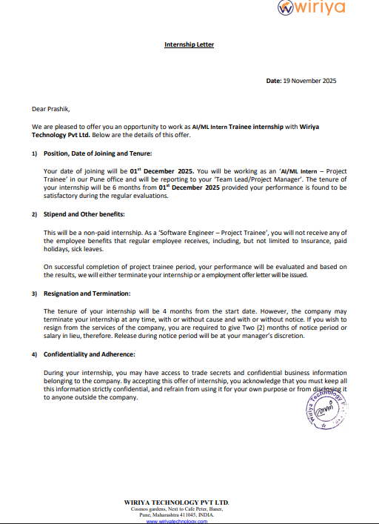

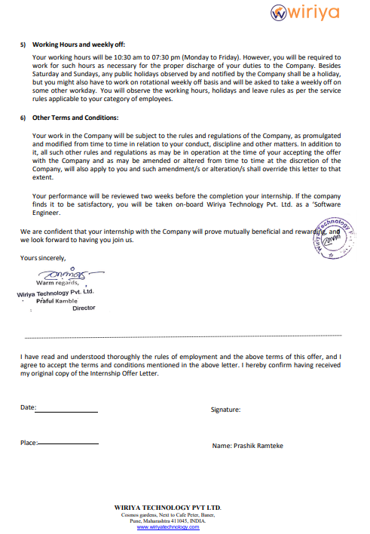

MONTHLY OVERVIEW OF INTERNSHIP ACTIVITIES

1st MONTH | DATE | NAME OF THE TOPIC/MODULE COMPLETED
1st MONTH | 22 /12/2025 | Model creation
1st MONTH | 25/12/2025 | Analysis using SQL
1st MONTH | 29/12/2025 | Exception Script
1st MONTH | 31/12/2025 | Logger Script
1st MONTH | 6/01/2026 | Data Ingestion pipeline
1st MONTH | 12/01/2026 | Prediction script
2nd MONTH
3rd MONTH
4th MONTH*

LEARNING ACTIVITY REPORT PER WEEK

WEEK 1 (Date: 22/12/2025 TO DATE: 26/12/2025)

In first week, I was firstly tasked to create a model for student performance which involves data ingestion, data transformation, feature engineering, model creation and also model performance analysis using linear/logistic regression. Then I was tasked to create various different models for same data including random forest, KNN, decision tree and also calculate and compare performance metrics of all the create and model and conclude which one is the best. Meanwhile I was also tasked to analyze a dataset using SQL queries which was used in project.

WEEK 2 (Date: 29/12/2025 TO DATE: 2/01/2026)
In week 2, I was given a task to create a logger and exception script using python which was also used in project. My created scripts required changes which were suggest and supported by my mentor to develop required script.

WEEK 3 (Date: 5/01/2026 TO DATE: 9/01/2026)
In week 3, I was tasked to create a data ingestion pipeline, which was a python script for scrapping data which may have anything as its source including csv files, MongoDB, AWS S3 bucket etc., only thing required was to change source path. For trial purpose I tried to ingest student performance dataset. Later in same script I was tasked to add logging and exception to check what operation were performed in pipeline.

WEEK 4 (Date: 12/01/2026 TO DATE: 16/01/2026)
In week 4, I was given a task to create a prediction pipeline for project for which I tried to create a pipeline for same model which was created earlier i.e. student performance. Script created by me needed various changes which were guided by mentor.

WEEK 5 (Date: 12/01/2026 TO DATE: 16/01/2026)
In week 5, I was given a task to create the API of model created to use it directly into the project.

(Up to LAST WEEK, including DATE: _______/ Sign of Faculty Mentor :_________)

Any modification/improvement in any process/method/ practice observed/identified and suggested to the Organization
_________________________________________________________________________________________________________________________________________________________________________________________________________________________________________________________________________________________________________________________________________________________________________________________________________________________________________________________________________________________________________________________________________________________________________________________________________________________________________________________________________
Any Industrial problem identified that could be solved through research/development/consultancy by the Institute.
_______________________________________________________________________________________________________________________________________________________________________________________________________________________________________________________________________________________________________

ATTENDANCE

DATE | DAY | In-Time | Out-Time | Remarks
22/12/2025
23/12/2025
24/12/2025
25/12/2025
26/12/2025
29/12/2025
30/12/2025
31/12/2025
5/01/2026
6/01/2026
7/01/2026
8/01/2026
9/01/2026
12/01/2026
13/01/2026
14/01/2026
15/01/2026
16/01/2026
19/01/2026
20/01/2026
21/01/2026
22/01/2026

- The attendance details have to be filled by the student and get it certified by the Mentor In-charge.
- If the organization has its own attendance system, the same can be accepted as a proof by the student but should be certified by the Organization.

Student’s Name: Industry Mentor’s Name:

Students Signature: Industry Mentor’s Designation:

Internship Organisation: Organisation Stamp/Seal:

GEOTAG PHOTOGRAPHS WITH INDUSTRY MENTORS

INDUSTRY MENTOR EVALUTION

COMPLETION CERTIFICATE:

FEEDBACK FORM: (PRINTOUT OF GOOGLE LINK FORM)

https://forms.gle/H6itWe9KhR3ddg8C8

