|  |
| --- |
| College LaSalle |
| Project -WEB CLIENT Technical Manual |
|  |
| Presented to: Mihai Maftei |

|  |
| --- |
| Varun Grover  12/11/2022 |

**Start by adding a short description of your project, and the languages (technologies) used**

Languages:

1. HTML/XHTML/Bootstrap
2. CSS
3. JQuery

Browser used:

1. Google Chrome

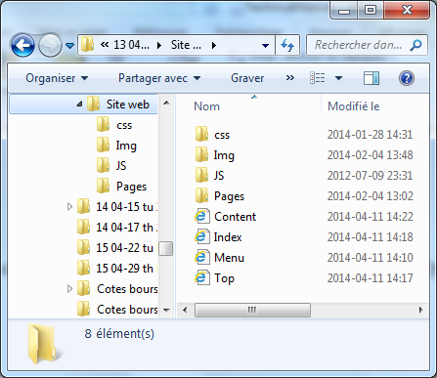**Presenting how the files/folders are organised.**

index.html

second.html

gallery.html

search.html

index_login.html

newsletter.html

references.html

1. css
   1. style.css
   2. second.css
   3. index.css
2. img
3. js
   1. JQUERY file
   2. app.js
   3. search.js

**Present the functions and/or methods that you create or you did use into the web project.**

|  |  |
| --- | --- |
| **Function/Method** | **Description** |
| 1. document.getElementById() | To get the content from html page |
| 1. alert() | Give alert to user |
| 1. getCookie() | Get the cookie |
| 1. setCookie | Set the cookie |

**Present the difficulties that you have, what was the hardest and the easiest part of your project.**

I was not able to login even the code is written in the required way. I tried with both, JavaScript and jQuery, but the result is same.