Problems encountered during setup
Error 1)
: Airflow 3.0:
“ airflow command error: argument GROUP_OR_COMMAND: invalid choice: 'users' (choose from api-server, assets, backfill, cheat-sheet, config, connections, dag-processor, dags, db, db-manager, info, jobs, kerberos, plugins, pools, providers, rotate-fernet-key, scheduler, standalone, tasks, triggerer, variables, version), see help above. airflow-init exited with code 2”

Ans) In Airflow 3.1, airflow users create is only available when the Flask AppBuilder (FAB) auth manager is enabled. Your error means Airflow is running without FAB auth enabled, so the users command does not exist in that container.

Error 2)
airflow.exceptions.AirflowConfigException: The object could not be loaded. Please check "auth_manager" key in "core" section. Current value: "airflow.providers.fab.auth_manager.fab_auth_manager.FabAuthManager". airflow-init exited

with code 1 on docker compose run --rm airflow-init airflow version /home/airflow/.local/bin/airflow: line 2: import: command not found /home/airflow/.local/bin/airflow: line 3: from: command not found /home/airflow/.local/bin/airflow: airflow: line 5: syntax error near unexpected token '.exe'' /home/airflow/.local/bin/airflow: airflow: line 5: if sys.argv[0].endswith('.exe'):'

Ans) Airflow 3.1 have multiple dependencies issues when it comes to windows and dockers thus I switched back to older version of Airflow 2.9

Error 3)
Ans) That means one of these is true:
- the DAG file running in Airflow is not the latest version
- merge_processed_data is still an EmptyOperator or disconnected in the version Airflow loaded
- downstream dependencies still point around it

Error 4) Could not connect MLFlow to Docker inconsistency in between dependencies

Task 0:
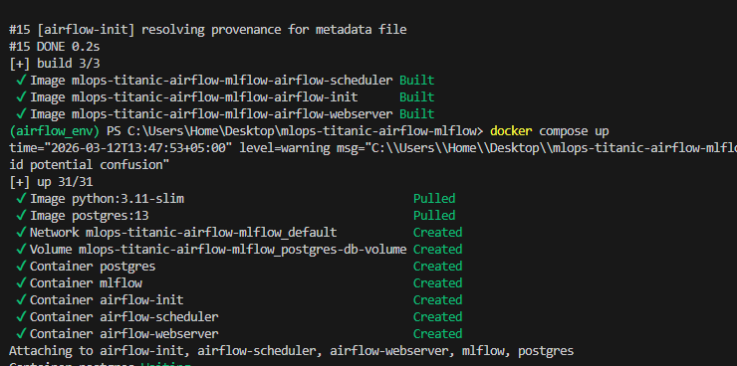
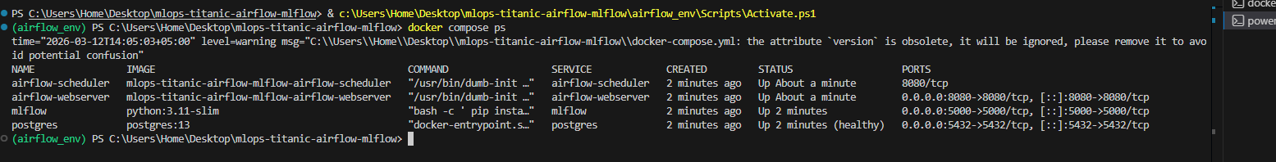
Task 1:
Task dependency explanation:
The DAG starts with data_ingestion, where the Titanic dataset is loaded. The output then moves to data_validation to check data quality. After validation, the workflow splits into two parallel tasks: handle_missing_values and feature_engineering, which reduces total pipeline time by processing independent steps simultaneously. Once both tasks finish, they merge into merge_processed_data, followed by data_encoding, model_training, and model_evaluation. After evaluation, a BranchPythonOperator applies decision logic: if the model performs well, it follows the register_model path; otherwise, it follows the reject_model path. Both branches finally connect to the end task. This design contains no cyclic dependency because all task relationships move in one direction only.
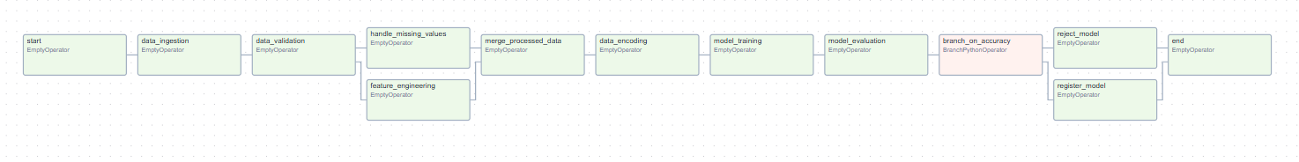
Task 2 – Data Ingestion:
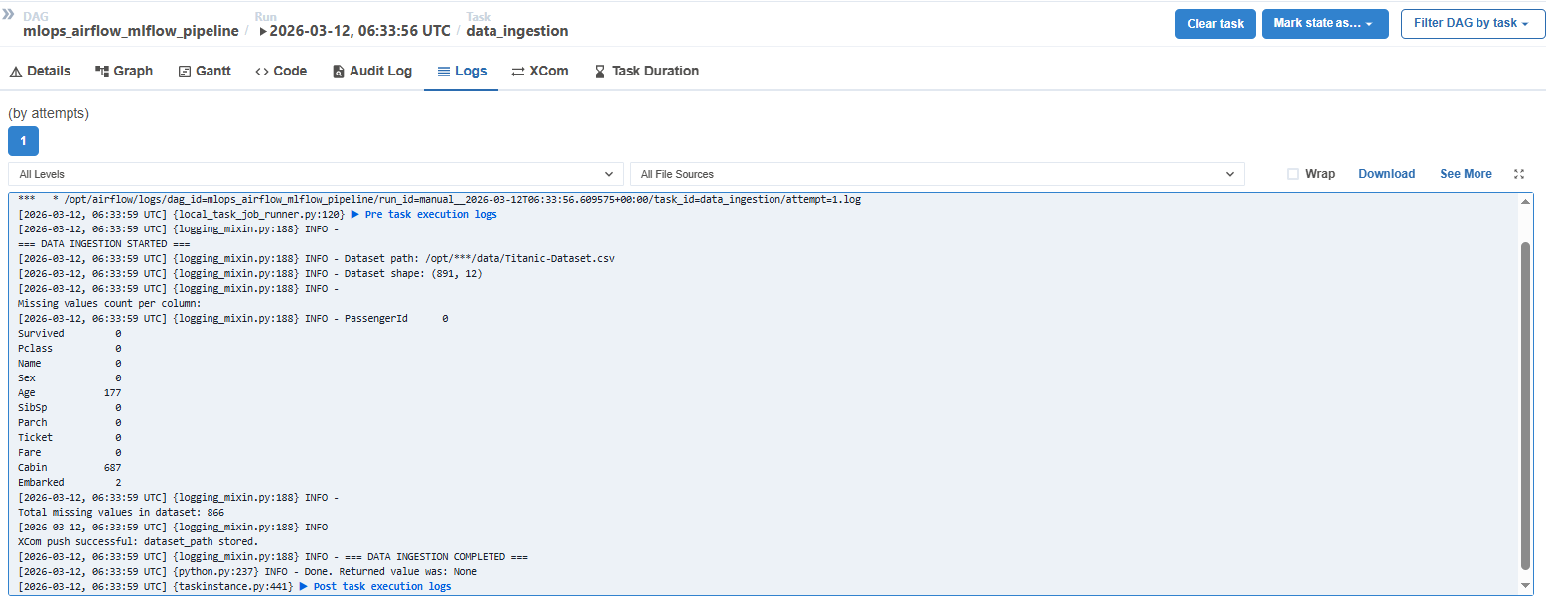
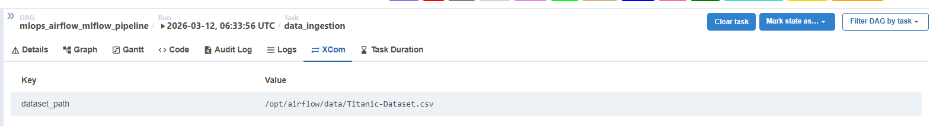

The data ingestion task was implemented using PythonOperator. It loads the Titanic CSV file from the mounted Docker volume, prints the dataset shape for verification, and logs the missing values count for each column. The dataset path is then pushed using XCom so downstream tasks can dynamically access the input dataset without hardcoding the path again.

Task 3 -
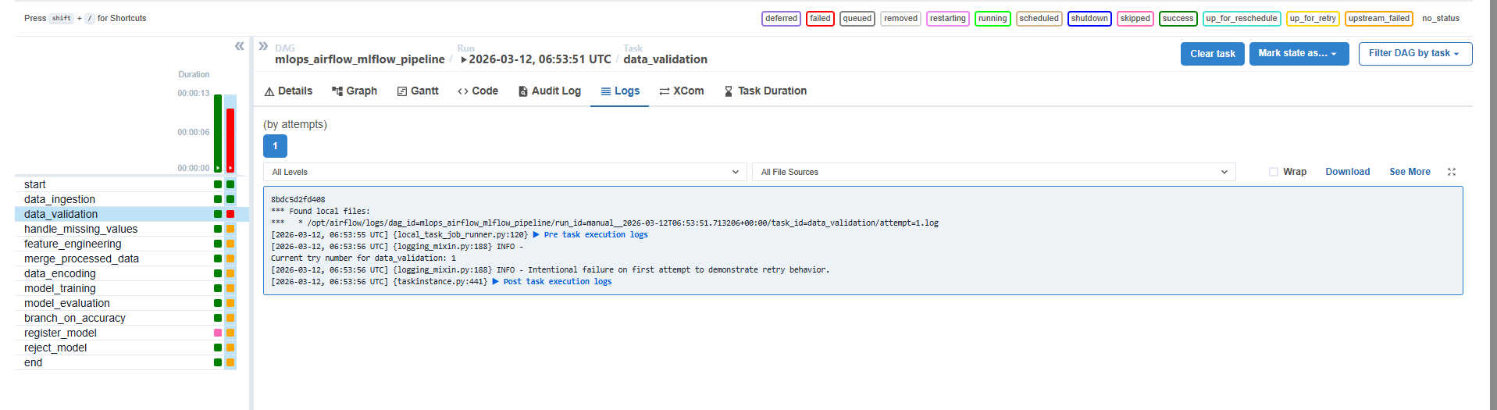
Intentional failed on first run
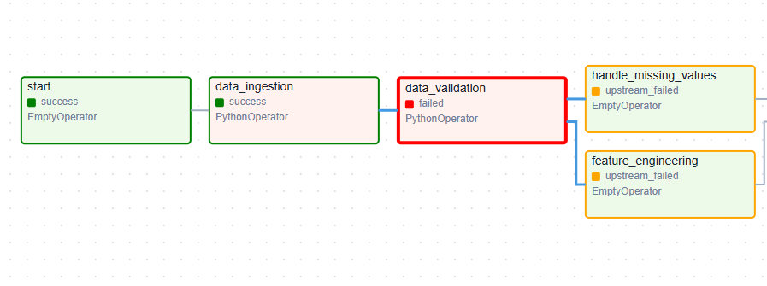
2nd Attempt:
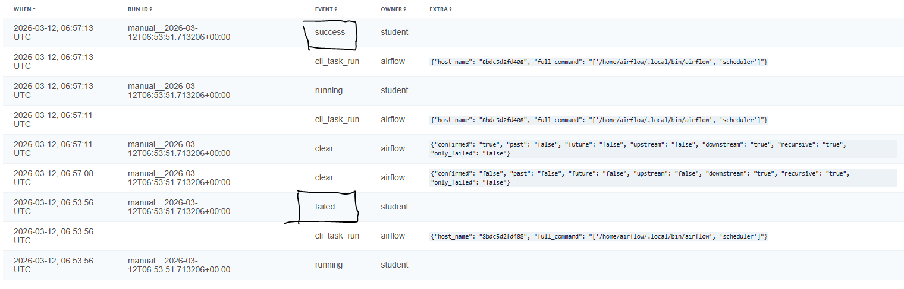
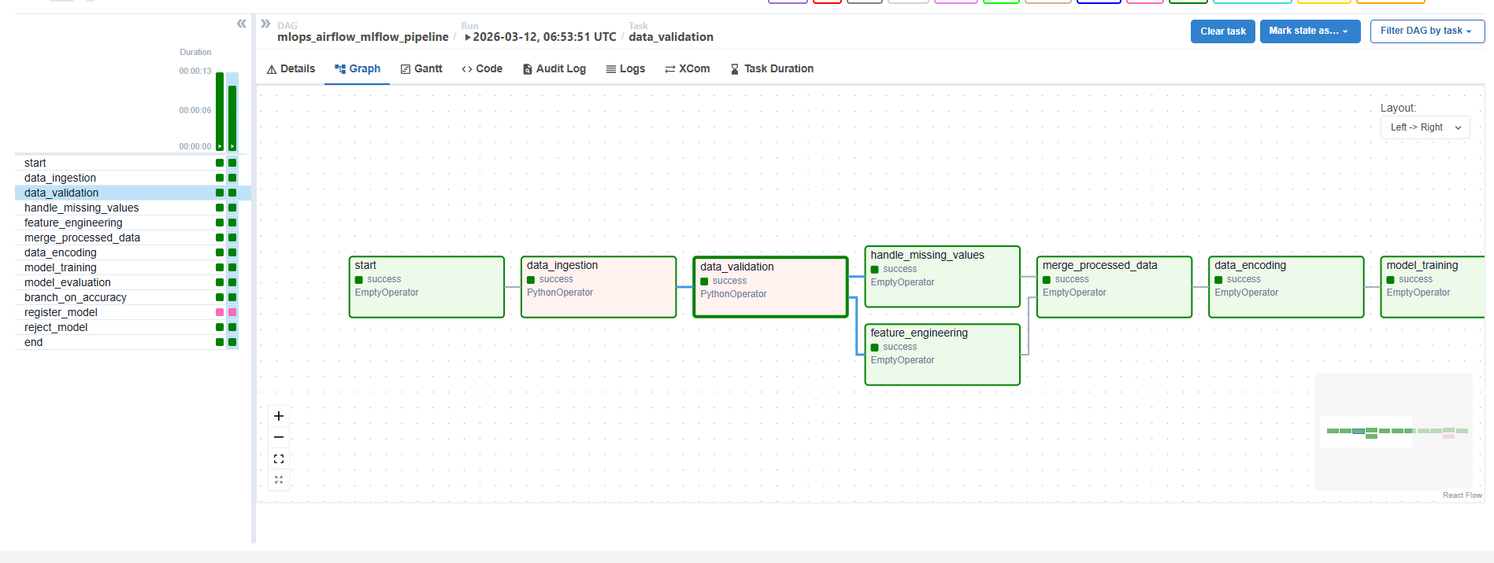

Task 4:
logs of handle_missing_values:
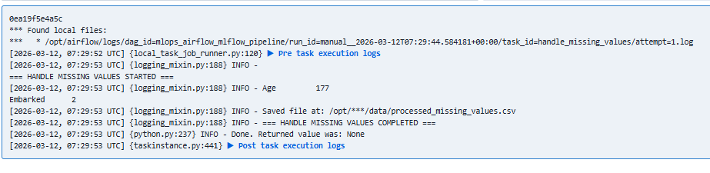
logs of feature_engineering:
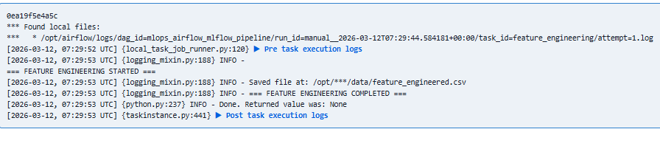logs of merge_processed_data:
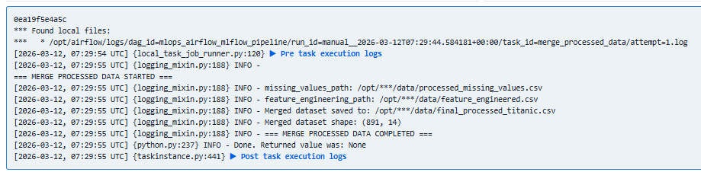
Graph:
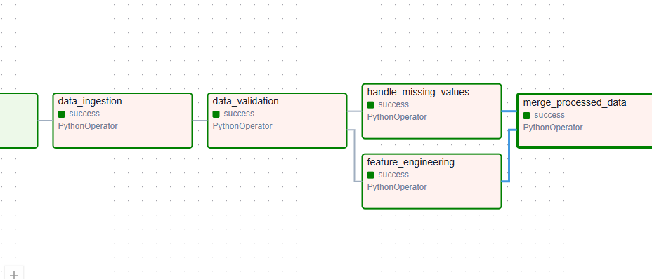
Task 5 – Data Encoding:
The encoded dataset was created from the processed Titanic data after missing value treatment and feature engineering. The categorical variable Sex was label-encoded as male = 0 and female = 1, while Embarked was encoded as S = 0, C = 1, and Q = 2. Irrelevant columns such as Name, Ticket, and Cabin were removed to prepare a simpler numerical dataset for model training. The final encoded dataset was saved and its path was shared with downstream tasks using XCom.
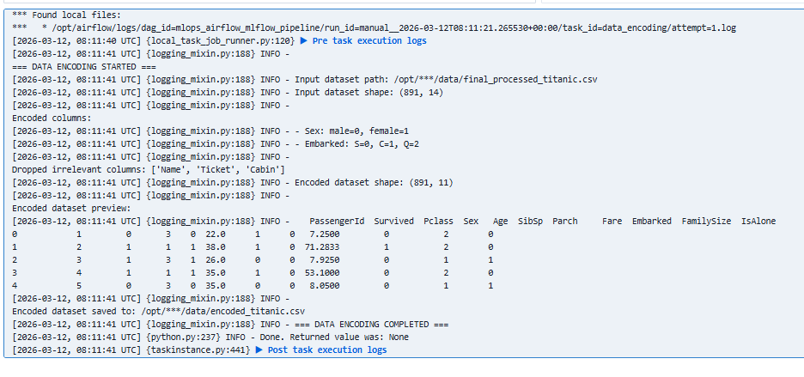

Task 6
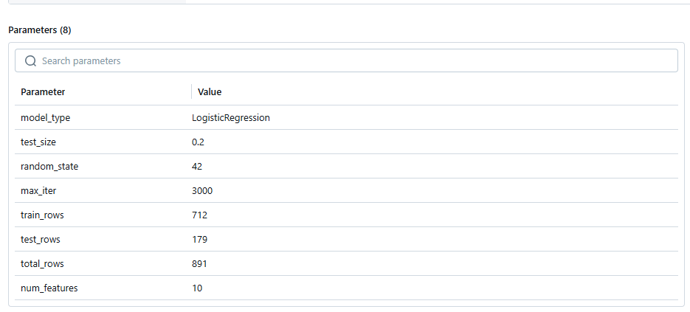
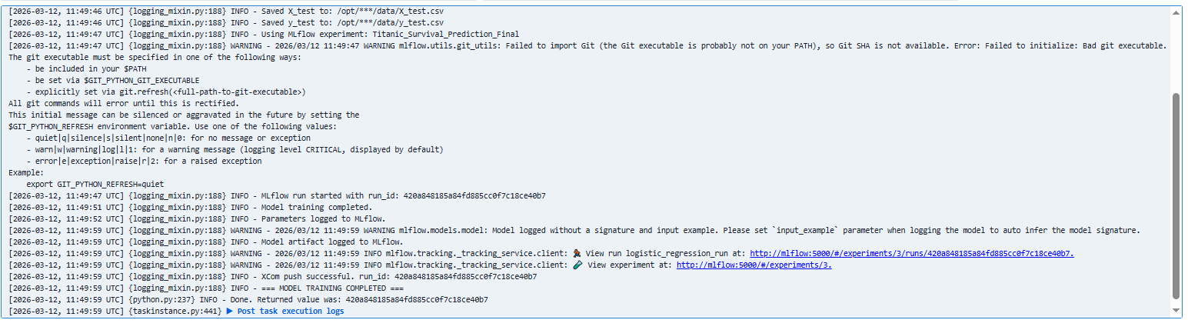
These warnings are not failures:
- MLflow schema integer warning
- Git warning from earlier
- convergence warning from earlier
Question 7 - Precision matric etc
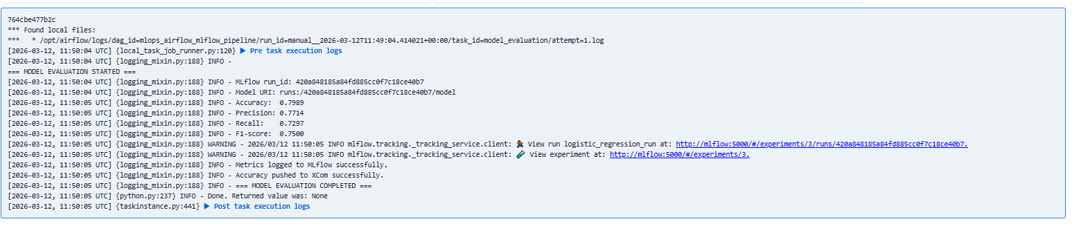
Accuray using xcom
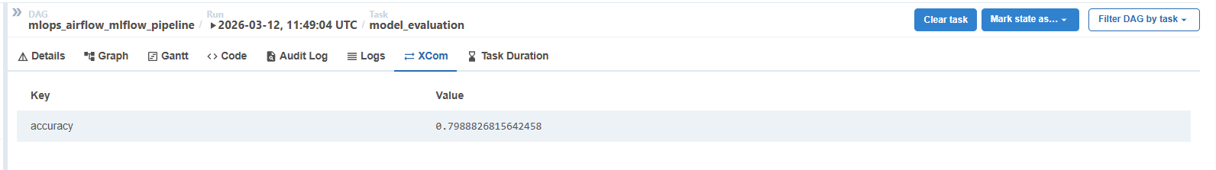
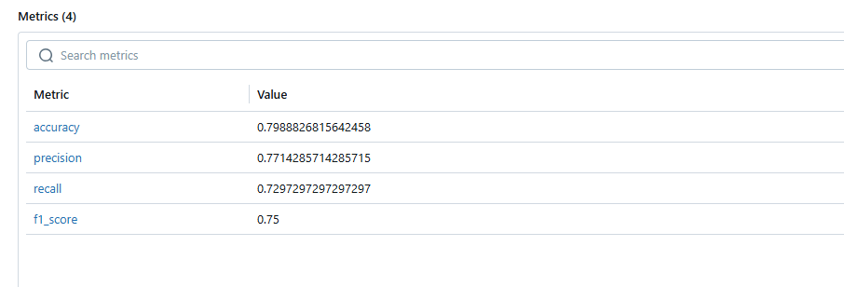
Task - 8: Branching logic
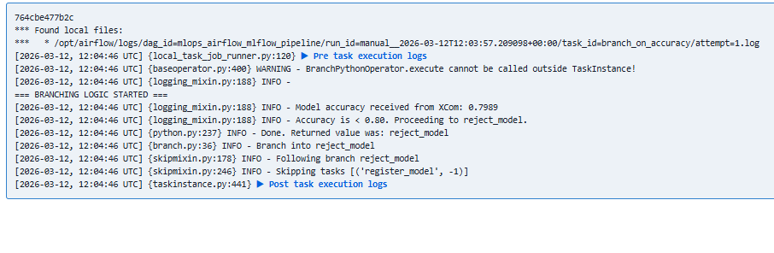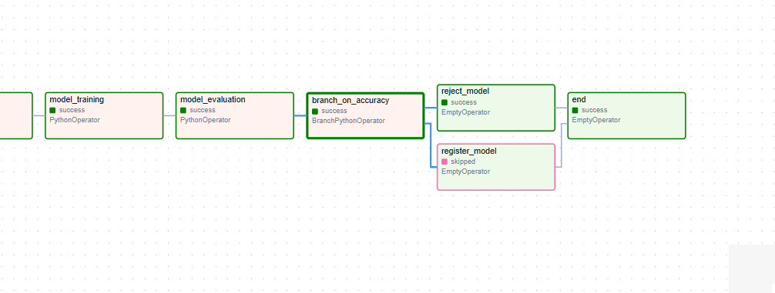
A BranchPythonOperator was used to implement decision-making after model evaluation. The task reads the model accuracy from XCom, which was pushed by the evaluation stage. If the accuracy is greater than or equal to 0.80, the workflow follows the register_model branch. Otherwise, it follows the reject_model branch. This makes the pipeline performance-aware and ensures that only sufficiently accurate models are considered for registration.

Task 9:
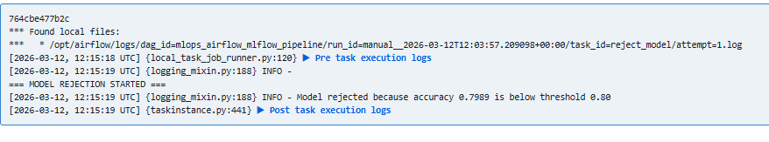
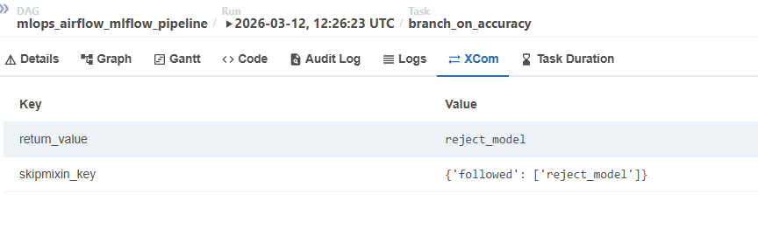
Task 10
