About project

=============

Our project focuses on reducing food wastage and enhancing food security by creating a platform where individuals and organizations can easily donate and share surplus food. Whether you are a person with leftover food at home or a restaurant owner with extra meals, you can contribute through the platform. People in need or organizations that assist those in need can request food, ensuring that excess food is redirected where it’s needed most. To encourage participation, donors receive points for each donation they make, fostering a sense of community involvement and responsibility.

In addition to facilitating food sharing, the platform also serves as an educational hub. We feature awareness posts and informative content about food security, aiming to educate users on the global issue of food wastage and the importance of sustainability. Through this dual approach of direct action and awareness, we hope to contribute to a more equitable and sustainable food system.

Roles:

=====

• **Admin**: Oversees platform operations, manages user content, ensures compliance with policies, and maintains data integrity.

• **Food Donor**: Lists surplus food, manages donations, tracks contributions, and promotes sustainable practices.

• **Recipient Organization**: Requests food donations, coordinates distribution logistics, and ensures food reaches those in need.

• **Data Analyst**: Monitors food waste patterns, analyzes usage data, and creates reports to optimize resource distribution and reduce waste.

General features

**Food Donation Platform**:

* Allows individuals, restaurants, or organizations to donate surplus or leftover food.
* Easy-to-use interface for listing available food items with details such as quantity, type, and pickup location.

**Food Request and Sharing**:

* Needy individuals or recipient organizations can browse, request, or share available food.
* Facilitates direct communication between food donors and recipients for efficient food distribution.

**Points and Rewards System**:

* Donors receive points for each successful donation, incentivizing them to contribute regularly.
* Points can be tracked and may be linked to recognition or rewards within the platform.

**User Roles and Permissions**:

* Different user roles such as Admin, Food Donor, Recipient Organization, and Data Analyst, each with specific permissions and functionalities.
* Secure login and role-based access ensure smooth operations.

**Awareness and Education**:

* Posts and articles that raise awareness about food security, sustainability, and ways to reduce food waste.
* Encourages users to adopt practices that minimize food wastage in their daily lives.

**Data and Analytics Dashboard**:

* A feature for data analysts to track and visualize food donations, wastage reduction statistics, and platform activity.
* Provides insights into the impact of the platform on food security.

Technologies Going to be used:

==============================

Frontend: HTML , vite + ReactJS

Middleware: Spring Boot

Database : MySQL

Webservices : Restful Web Services [REST API]

Architecture : Microservices

Prototype Link

<https://www.figma.com/proto/OqTSw8CrAIkaNtoQxaX9Ac/JFSD-PROJECT?node-id=30-51&node-type=canvas&t=Yc5gkAZyXu1oar8V-1&scaling=contain&content-scaling=fixed&page-id=1%3A11&starting-point-node-id=30%3A51&share=1>

Class Diagram  
===========

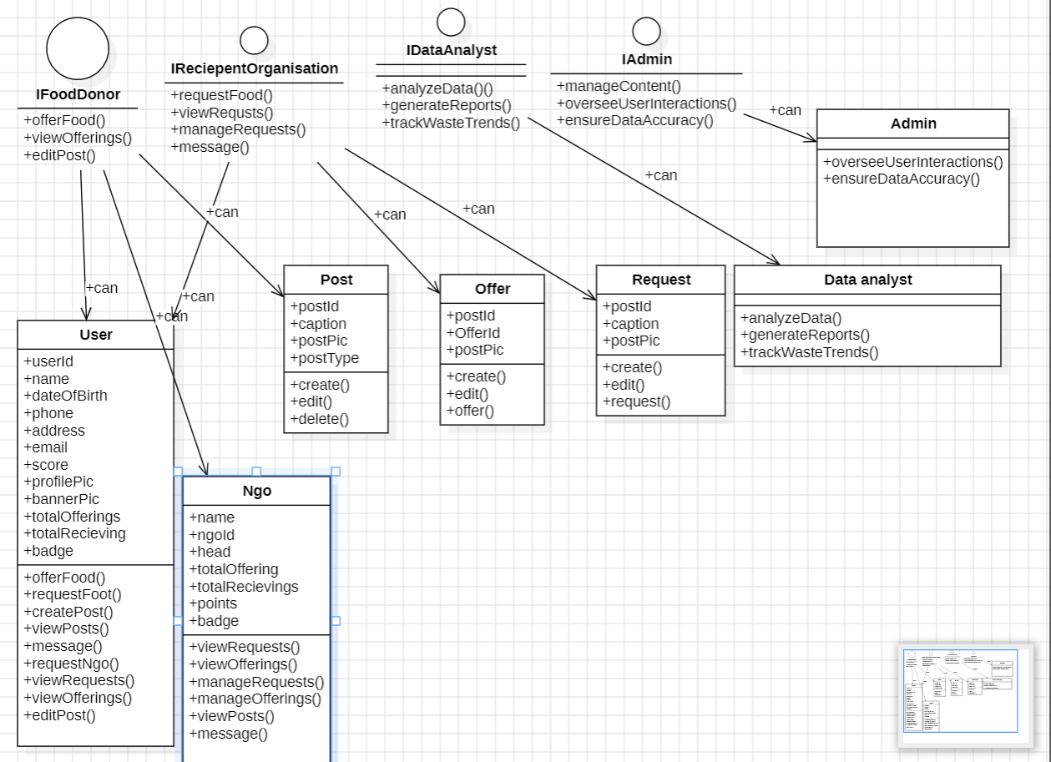

Conclusion

===========

In conclusion, our platform is a comprehensive solution designed to reduce food wastage while improving food security by connecting donors and recipients in a seamless and efficient manner. By enabling individuals, restaurants, and organizations to donate surplus food and rewarding them for their contributions, we create a community-driven effort to minimize waste and help those in need. With added features like awareness posts, and data analytics, our platform not only facilitates food redistribution but also promotes education and long-term sustainability.