# Assignment 6 – Shared Environment Monitor

[*Submit on Blackboard*](https://blackboard.usc.edu/)

## Goals

* Connect TMP36 and store sensor data
* Display data on OLED
* Publish events to Particle cloud
* Subscribe to events and process data

Overview

This assignment is to create a public temperature feed for ITP 348. You will read the temperature from their home and send the data as public event to the Particle cloud. You will then use an OLED to display two screens: 1) feed of the most recent temperatures from all students, and 2) your own temperature along with the average and max of all the temperatures.an electronic die. When a button is pressed, the die will be “rolled” and a new value will appear. The die roll will be simulated by generating a random number 1-6

Here is an example:

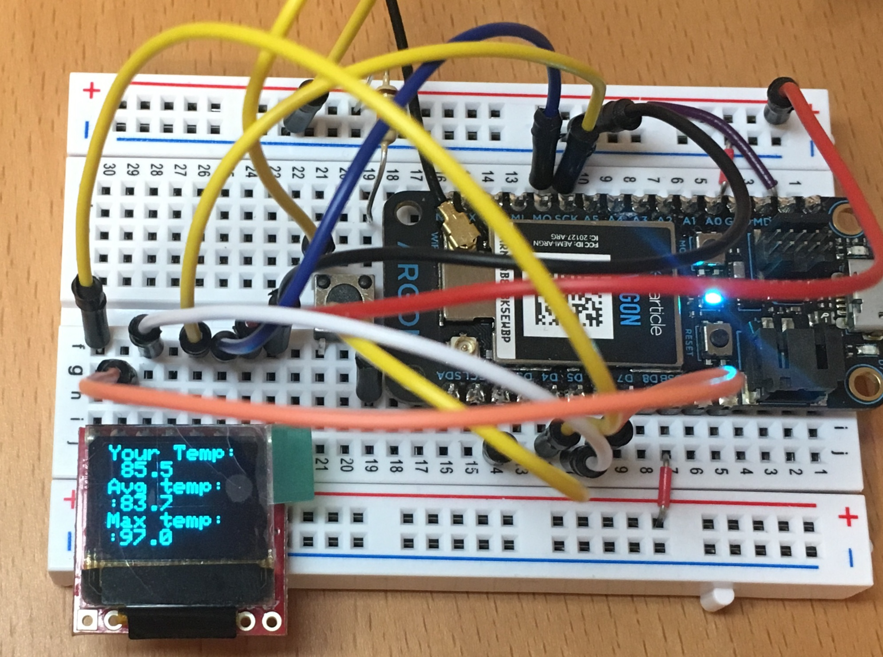

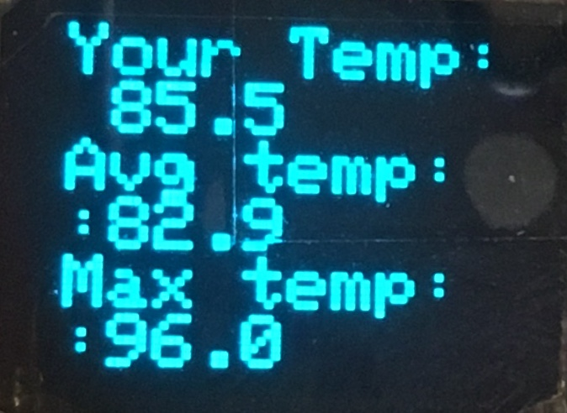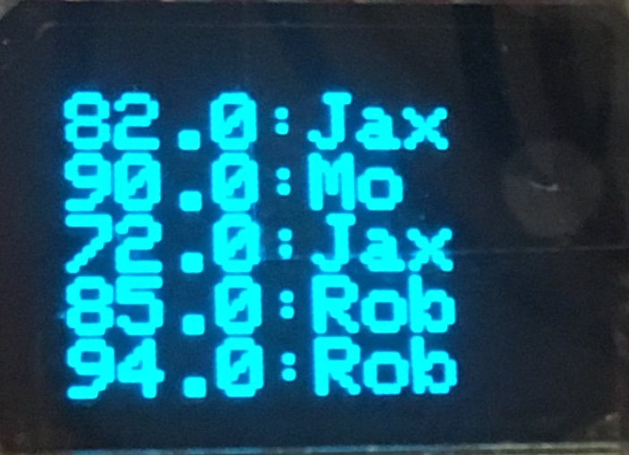

Components

* Argon
* Breadboard
* 1 x micro OLED
* 1 x TMP36
* 1 x\ push button (plus any necessary resistors)
* Jumper wire (standard male-male)

Requirements

* Create a Fritzing breadboard prototype layout of your design. Once you’re satisfied with the design, connect the device
* It is recommended to code the device in stages, and test at each stage

**Global variables**

* You can create other variables as needed, but these are required
* **String names[20]** to store the names of the most recent events
* **double temperatures[20]** to store the most recent public temperatures
* **int currentIndex**

**Stage 1: Temperature sensor**

* Connect the temperature sensor
* Use necessary conversion formulas to calculate temperature in Fahrenheit
* Display it on serial monitor to verify

**Stage 2: Publishing events**

* Publish the temperature as a **PUBLIC** event
* For the event name, you must use the following format  
  **ITP348-A6/XXX** *replace XXX with your 3 letter initial*
* Check the Particle console to make sure the event is publishing properly

**Stage 3: Subscribing and storing events**

* Subscribe to the event: **ITP348-A6**
* You will create what is called a “ring buffer.” Basically, when the first event arrives, you will store the name and temperature in index 0, and increment in the **currentIndex**. This will continue until **currentIndex** reaches the max size, and then it will reset to 0
* To store the temperature, you can use the C++ function **atof()**, which takes a **char \*** as input and returns a double. For example,   
  **double num = atof(data)**, where data is a **char \***
* To store the name, first convert the char * to a string and then use the [substring](https://www.arduino.cc/reference/en/language/variables/data-types/string/functions/substring/) method to select certain characters from the event name

Required naming convention (replace # with the current assignment number)

* **Project Name** 
  + itp348_a#_lastname_firstname
* **Zip File** (include entire project folder)
  + itp348_a#_lastname_firstname.zip

## Deliverables

1. A compressed file containing your project. Follow the guidelines for full credit.

Here are the instructions for submission

1. Navigate to your project folder.
2. Include the *entire* folderin a zip file
3. Rename the zip file based on naming convention
4. Upload zip file to Blackboard site for our course
5. A photograph of your device connected to USB with the blue light on.
6. A (very) short video demonstrating your project functioning

## Grading

|  |  |
| --- | --- |
| Item | Points |
| Fritzing layout | 5 |
| 9 LEDS connected correctly | 5 |
| Button press changes lights | 10 |
| Die value patterns stored as arrays | 10 |
|  |  |
| Total | 30 |

**Credits**

* Image by [Clker-Free-Vector-Images](https://pixabay.com/users/Clker-Free-Vector-Images-3736/?utm_source=link-attribution&amp;utm_medium=referral&amp;utm_campaign=image&amp;utm_content=26772) from [Pixabay](https://pixabay.com/?utm_source=link-attribution&amp;utm_medium=referral&amp;utm_campaign=image&amp;utm_content=26772)
* Inspiration for project from [Dr. Peter Dalmaris](https://www.udemy.com/course/arduino-step-by-step-2017-getting-started-projects/)