**We live in the information age.**



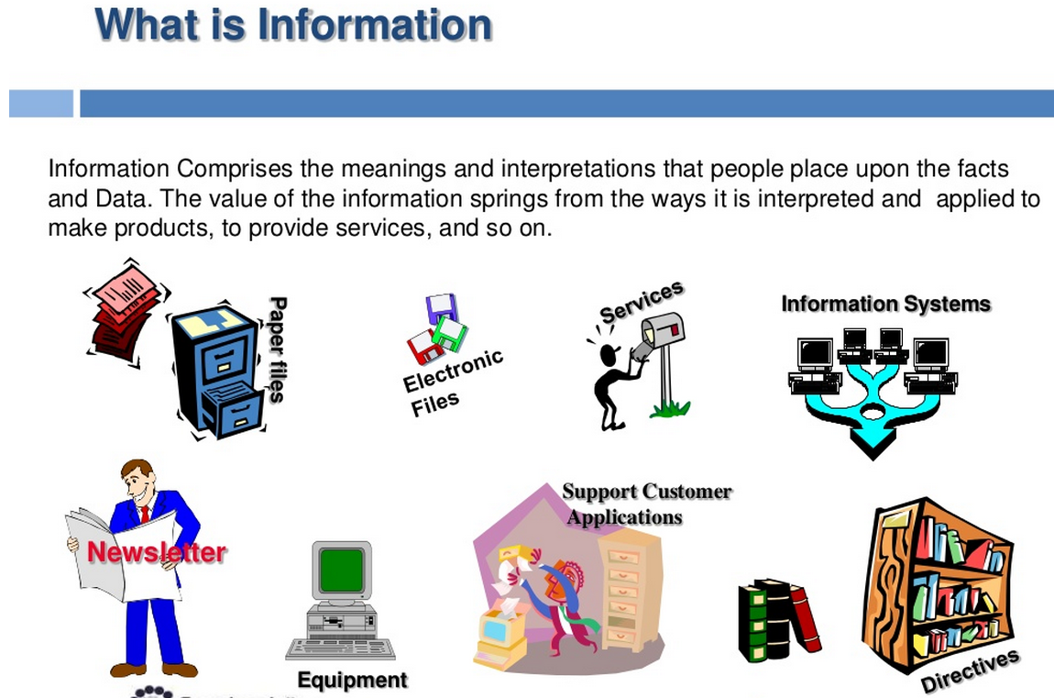

Dictionary Definition: Information

* Knowledge communicated or received concerning a particular fact or circumstance; news.
* Knowledge gained through study, communication, research, instruction, etc.; factual data.
* …

Then, what is knowledge?

* This may eventually lead to intelligence, human intelligence…
* What is intelligence? What separates human from animals in communication

If aliens from Outer space is talking to us now, how do we know? Let’s listen…

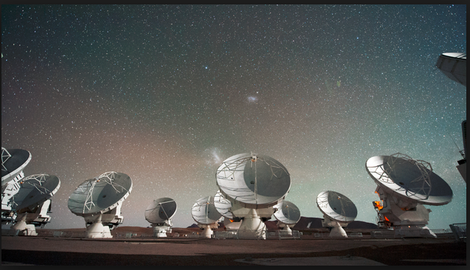

All we get is something like this:

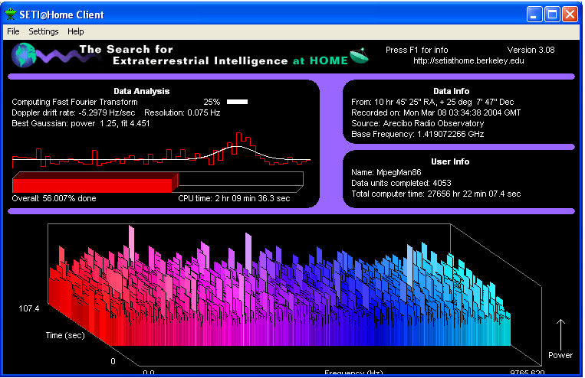

From the 3D-waveform, how do you make sense, in there is a message/intelligence in the signals? Is it just simple noise?

Suggestions/Answers:

* First, let’s digitized the data! This means, to encode the 2D/3D into digital binary data. Why? (Our computer process information this way…) How? (Subject of Encoding Theory…).
* We look for patterns/transitions in the sequence of digitize data.
* Specifically, we look for rules on how the data changes (its transitions).

As an example, this is the intelligence on a household light switch is designed as follows:

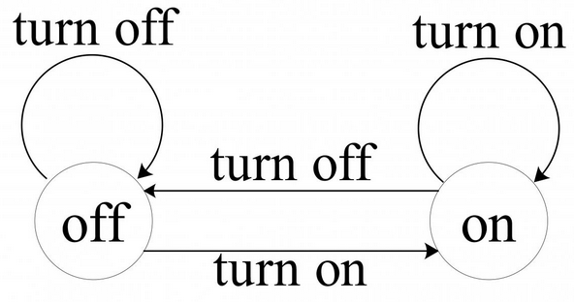

Think “off”, “on”, as the state of the system.

Input/Stimulus to the system are: “turn off”, “turn on”, users actions.

Even in the simple example, there are rules on state transitions, based on the user inputs.

In Computer Science, the subject above is termed “State Automata”.

In Computer Engineering, the subject above is termed “Digital Logic, Finite State Machine” Design.

In Linguistic, the subject above is termed “Grammar”.

(Learn more about this by following the scientific work of N.Chomsky, <https://en.wikipedia.org/wiki/Noam_Chomsky>

)

**How is this related to Information Technology Service Management?**

* It is about rules, steps, procedures, the best practices in solving IT issues.
* It is about process, repeatable process (instead of gibberish data output in alien’s message).
* It is about how to do more with less (Efficiency).
* …

Class Lab/Interactive Session:

1. Open a web session window to: <http://regexpal.com/>
2. Enter the following at the bottom panel:

01101001 00100000 01101100 01101111 01110110 01100101 00100000 01111001 01101111 01110101 00001101 00001010 01111001 01101111 01110101 00100000 01101100 01101111 01110110 01100101 00100000 01101101 01100101 00111111 00001101 00001010

1. Enter the following at the top panel:

01111001 01101111 01110101

1. Explains what do you see?
2. What adjustments, and explorations you like to make?
3. What if we encode the 8-digit “01…”, into the standard ASCII code: <http://www.asciitable.com/>

Then do the pattern search in English?

1. Open a new web window to: <http://regexpal.com/>
2. Enter the following at the bottom panel:

i love you

you love me?

1. Enter the following at the top panel:

You

1. What do you see? (Smile…)
2. In Computer programming, this is the fundamental subject of regular expression/pattern searching…