## Schedule of Course Activities: Session 10

## *[CS 519: Introduction to Cloud Computing Online-Based]*

|  |  |
| --- | --- |
| **Overview of Session** |  |
| We will answer the following questions: | 1. Introduction to Learn Amazon’s Cloud Service. 2. General concept and vision of AWS. 3. … |

**Learn Amazon’s Web Services (AWS):**

**What is AWS?**

It is a collection of remote computing services, also called web services, make up a cloud-computing platform offered byAmazon.com. These services operate from 11 geographical regions across the world. The most central and well-known of these services arguably include Amazon Elastic Compute Cloud and Amazon S3. Amazon markets these products as a service to provide large computing-capacity more quickly and more cheaply than a client company building an actual physical server farm.

**A Business View:**

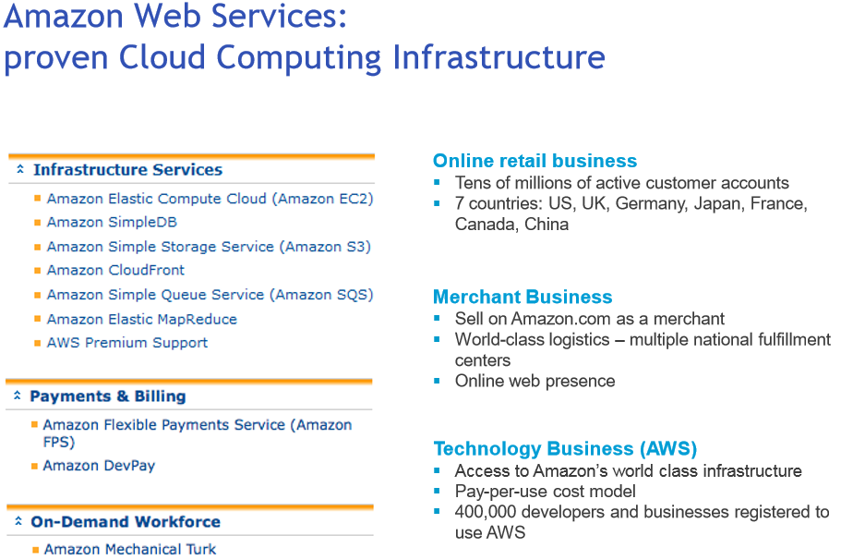

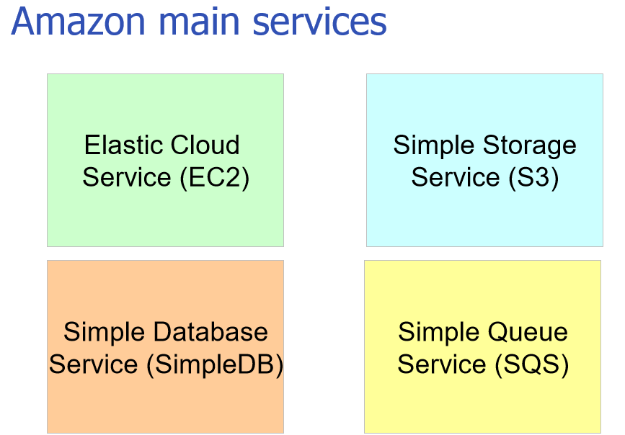

**Features of each service are explaned in more detail on the next several slides.**

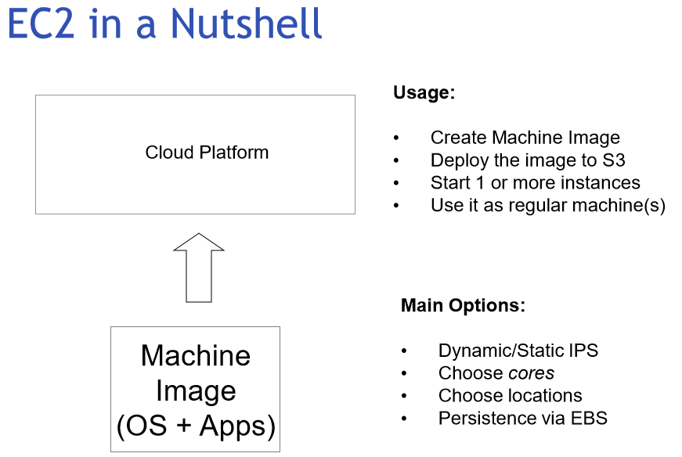

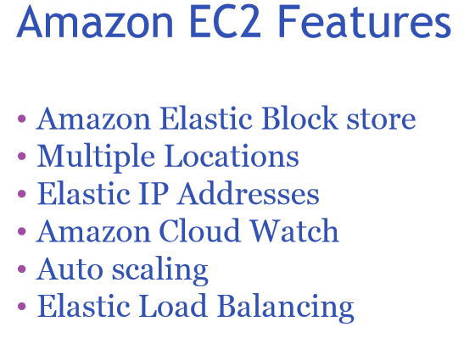

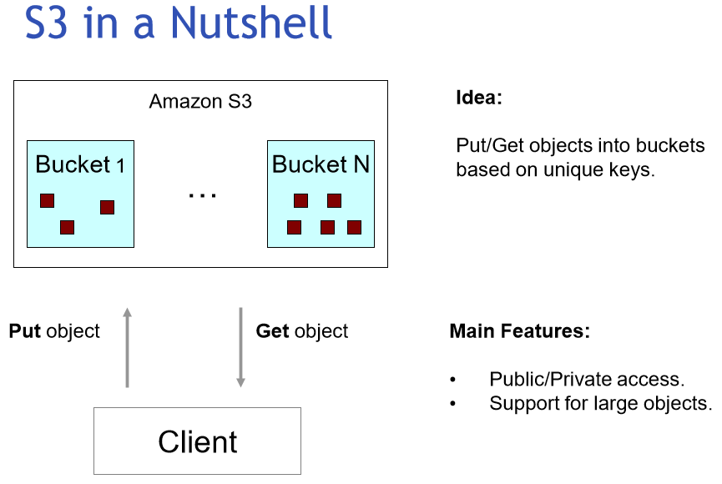

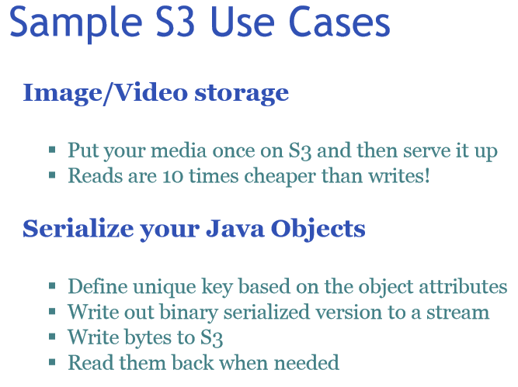

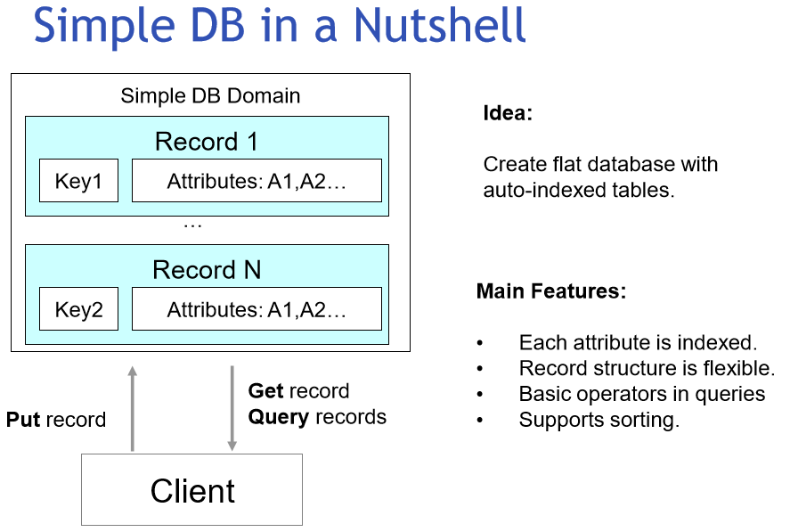

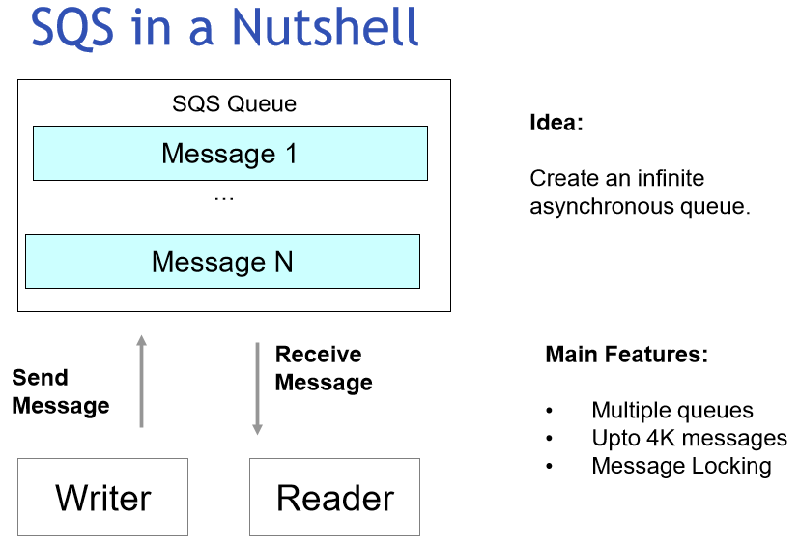

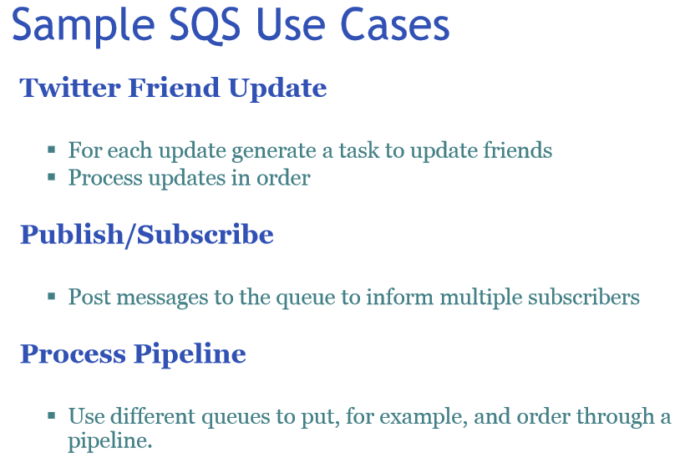

**Amazon’s Web Services is a fast growing business. It is an alternatives to MS Azure. The following video captures the guts of Amazon’s AWS. As always, some commercial message are embedded, and digest it with an open mind.**

[**https://www.youtube.com/watch?v=3fkGCM0feC0**](https://www.youtube.com/watch?v=3fkGCM0feC0)

**Get a taste of its official website:**

[**https://aws.amazon.com/**](https://aws.amazon.com/)

**This website, is how corporate users access AWS, and gain access to it.**

**Well, I am able to sign-up and login (as I made purchase from AWS before).**

**The current list of services AWS offers are seen as follows:**

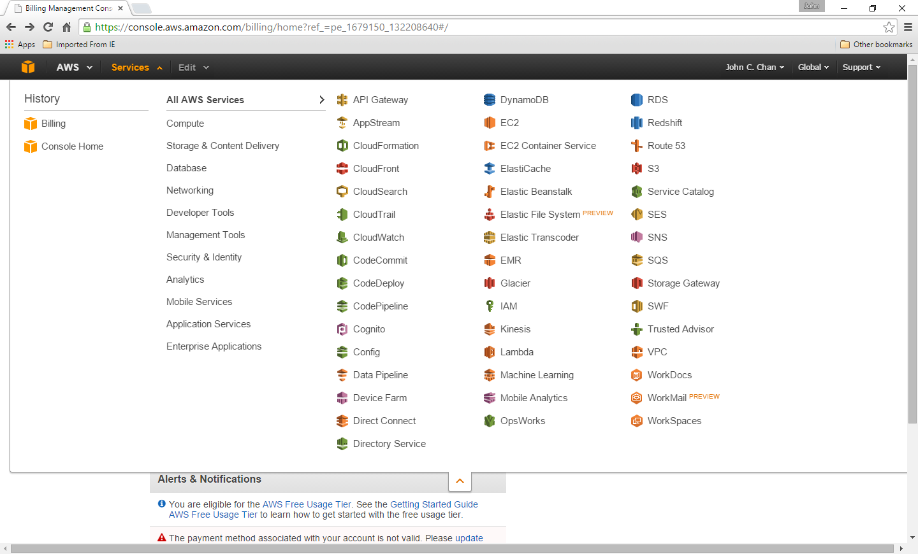

**I found out: 1) I have very limited access to its features. 2) Many of the services are tailored for software programmers. Example: AWS Cloud Trail.**

**Class Assignment: Please explore the website. What is Amazon Lambda?**

I share your thought:

The guts of Amazon’s AWS are abstracted out (As we are NOT an Amazon employee). Your primary goal to learn about AWS, is its usage model, the service it provides. We are going to learn about the nuts and bolts of cloud computing, later in the class, through Cloud Infrastructure.

End-of-Class Module.

Questions? Please email to me, or post it on Blackboard.

Thank you.