## Schedule of Course Activities: Session 11

## *[CS 519: Introduction to Cloud Computing Online-Based]*

|  |  |
| --- | --- |
| **Overview of Session** |  |
| We will answer the following questions: | 1. Introduction to Learn Google’s Cloud Service. 2. General features of Google Cloud Services. 3. … |

**An Overview of Google’s Cloud Services:**

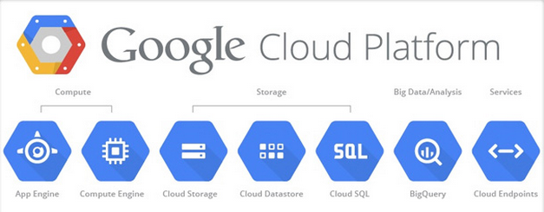

In this class module, we are going to focus on Google’s App Engine. (The other services share many attributes with other providers, which will be study later in this course.)

# **Google App Engine**

**Google App Engine** (often referred to as **GAE** or simply **App Engine**) is a platform as a service (PaaS) cloud computing platform for developing and hosting web applications in Google-managed data centers. Applications are sand boxed and run across multiple servers. App Engine offers automatic scaling for web applications—as the number of requests increases for an application, App Engine automatically allocates more resources for the web application to handle the additional demand.

Google App Engine is free up to a certain level of consumed resources. Fees are charged for additional storage, bandwidth, or instance hours required by the application. It was first released as a preview version in April 2008 and came out of preview in September 2011.

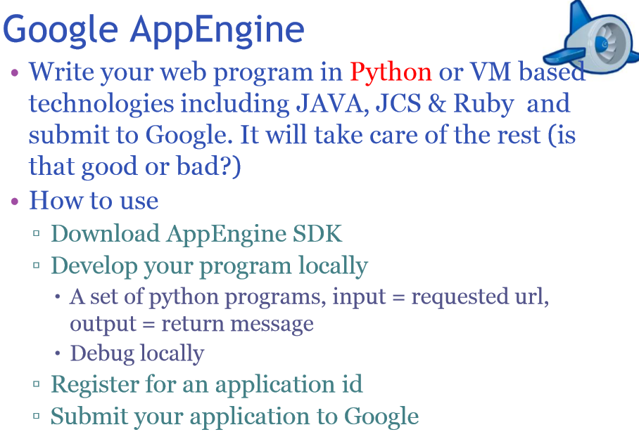

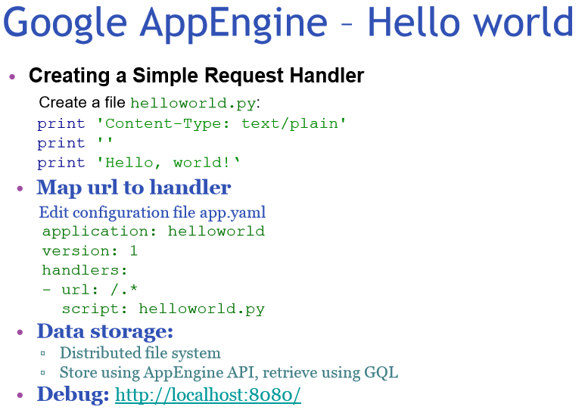

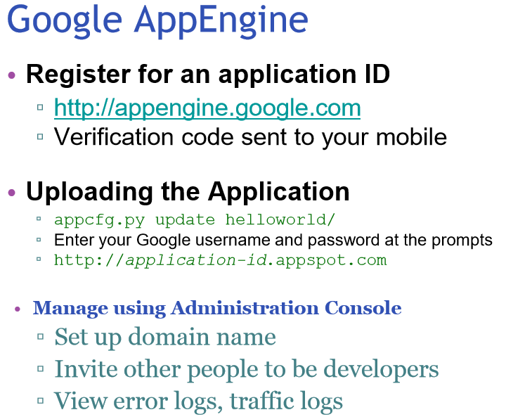

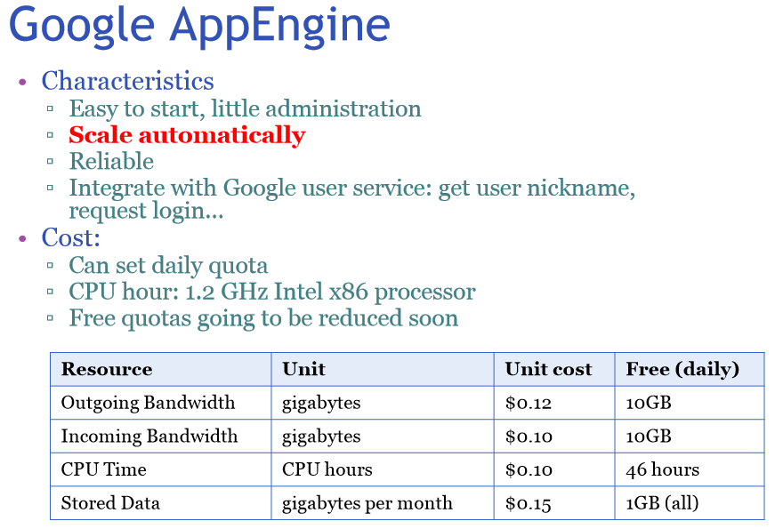

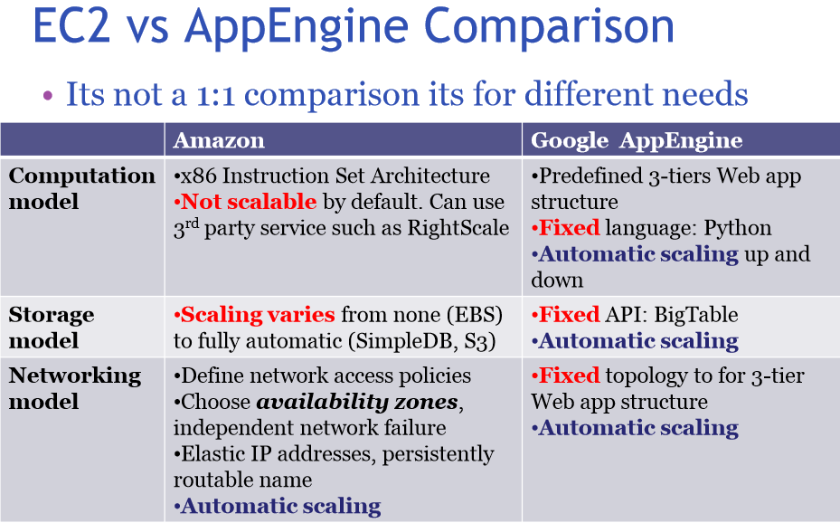

Learn how to use Google’s AppEngine directly from Google by watching this video:

<https://www.youtube.com/watch?v=-7ml51INtEM>

Key Take-Away:

* Let you focus on writing your code, instead of worrying the infrastructure supporting it (e.g. SDK, Software Development Kit).
* Store and retrieve your data.
* Google cloud storage.
* It is tailored for Web Apps development.

End-of-Class Module.

Questions? Please email to me, or post it on Blackboard.

Thank you.