## Schedule of Course Activities: Session 12

## *[CS 519: Introduction to Cloud Computing Online-Based]*

## *[Instructor: John C. Chan]*

|  |  |
| --- | --- |
| **Overview of Session** |  |
| We will answer the following questions: | 1. Introduction to Learn Microsoft’s Azure. 2. General concept and service of Azure. 3. … |

**Microsoft’s Cloud Services:**

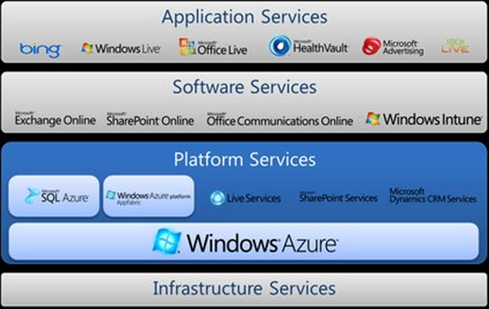

Note: This class module will focus on “Azure”.

**What is Microsoft’s Azure?**

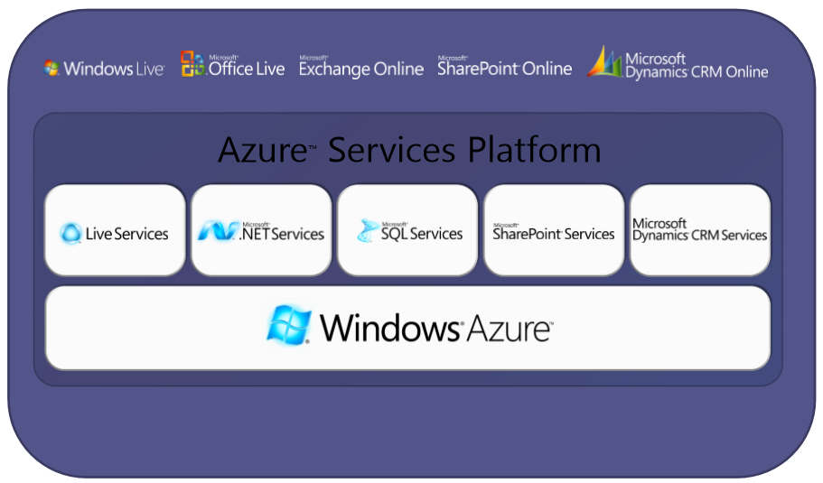

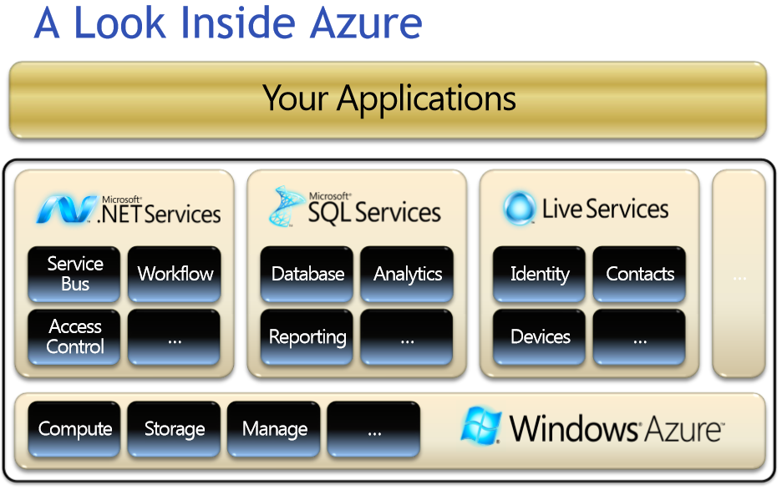

**Learn Microsoft Azure:**

**Microsoft is a major software company. Many of its products are migrated to operate on the cloud. It is one of the 1st Cloud computing product to be familiar with.**

**The following video captures the guts of MS Azure. As always, some commercial message are embedded, and digest it with an open mind.**

[**https://www.youtube.com/watch?v=ZNgvZE0MLeo**](https://www.youtube.com/watch?v=ZNgvZE0MLeo)

**Key Take Away:**

* **Usage Models: App Services, Data Services, and Infrastructure Services.**
* **Data Centers.**
* **Flexible, Scalable, Secure.**
* **Mobile Services.**

**Microsoft Azure, as introduced by its employee:**

[**https://www.youtube.com/watch?v=2zscgz-Pj_A**](https://www.youtube.com/watch?v=2zscgz-Pj_A)

**Thought provoking questions about Azure:**

* + **Is it going to be a survivor, in the industry with fierce competition?**
  + **What happen, if Microsoft decides to withdraw this service?**
  + **…**

**Explore Azure’s Official Website (the hands-on touch):**

[**http://azure.microsoft.com/en-us/**](http://azure.microsoft.com/en-us/)

* **This website, is how corporate users access Azure, and gain access to it.**
* **Well, I was going to sign up for a month-free trial run. It insisted for my credit card number. This is NOT practical for the class to do so (Case of foreign students). But feel free to try it on your own. Here is its instruction:** <http://azure.microsoft.com/en-us/documentation/videos/sign-up-for-microsoft-azure/>

**Additional information for those who like to explore Azure further:**

* + **Link:** <http://azure.microsoft.com/en-us/get-started/>
  + **Example:** <http://azure.microsoft.com/en-us/documentation/videos/create-a-windows-server-virtual-machine/>
  + **We are going to learn more about MS Azure in several subsequent class sessions.**

End-of-Class Module.

Questions? Please email to me, or post it on Blackboard.

Thank you.