## Schedule of Course Activities: Session 13

## *[Cloud 519: Introduction to Cloud Computing Online-Based]*

|  |  |
| --- | --- |
| **Overview of Session** |  |
| We will answer the following questions: | 1. Introduction to Learn OpenStack. 2. General concept and fundamentals of OpenStack. 3. … |

**Learn OpenStack, the Open Source For Creating Clouds:**

**We need to embrace the free, open source Cloud software movement. It is still in its infancy stage. Then, in a matter of couple years, the cloud computing community will likely converge onto OpenStack (Like Linux/Ubuntu). So, this deserves your attention, and effort.**

**To start, this is the most basic introduction about OpenStack that I can find:**

[**https://www.youtube.com/watch?v=Qz5gyDenqTI**](https://www.youtube.com/watch?v=Qz5gyDenqTI)

**Key Take Away:**

* **This is a movement. It is real, despite it is NOT widely known.**
* **Virtual machines, Hypervisors…**
* **You get a glimpse of what the inside of a data center is like.**
* **OpenStack is free, it is open source. (Yes, we all can contribute to it.)**
* **…**

**OpenStack, it official website:**

[**https://www.openstack.org/**](https://www.openstack.org/)

**How it works (key diagram):**

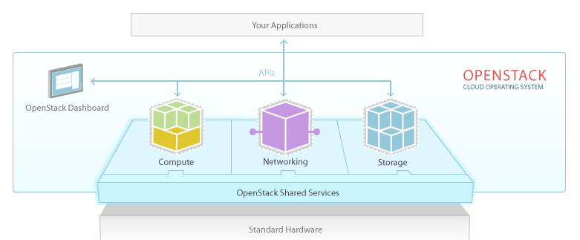

**Notes (Per diagram above):**

* **Standard Hardware: This means off-the-shelve hardware components that you can readily buy in the open market. (e.g. disk drives, network interface cards, computer mother boards.)**
* **OpenStack abstracts the hardware resources, into 3 major pillars: a) Compute. b) Network. c) Storage. This indeed, is the hardware infrastructure foundation of the Cloud (Big Data). We are going to examine each pillar in detail later in the class!**
* **OpenStack Dashboard: This is how the data center in setup, control, and monitor. There are many complex issues here. Examples include: what if disk-drive fail, a network interface is NOT active, not enough computing resource… We are going to explore each of the subjects later in the class.**

**Thought provoking questions:**

* + **MS Azure, or Amazon’s AWS : Why there are no mention of the infrastructure of its Cloud?**
  + **MS Azure, AWS, each has its own Dashboard (like OpenStack’s Dashboard), yet, there is nothing in their respective presentation. I feel OpenStack is more empowering, what about you?**
  + **…**

**In short, both MS Azure, Amazon AWS are propriety cloud service providers. The information are abstracted out from the users, and the public. Its progress, knowledge, and mightiness is entirely profit-driven.**

**Is there hope for OpenStack? This is a profound question. Yes, there is. Look at Linux OS, specifically Ubuntu. It is open source. It is pervasively used in both academic, corporate and the general public. (You can buy a laptop with Ubuntu pre-installed. In fact, 45% of the PC used in China, has pre-installed Ubuntu OS).**

**Learn about OpenStack’s Dashboard (KILO):**

[**https://www.youtube.com/v/y39CAXJAW3M?autoplay=1**](https://www.youtube.com/v/y39CAXJAW3M?autoplay=1)

**Key Take-away:**

* **It manages cloud hardware resources.**
* **Launching a virtual compute instance, with IP address, volume size etc.**
* **Notice, it is based on the Linux OS platform. With commands like: ping 162.242.140.107; uname –a;**
* **Resource Configuration/Management: File/Object Access Security; Load Balance; Cluster Management; Resource View of the System; User/Project Admin;**

**Class Assignment: What is an IP address? What does it usually associated with (in Cloud Compute)?**

**NOTES:**

* **You can download, and install OpenStack onto your PC. Though, your PC is NOT likely have enough hardware resources to fully support its features.**
* **Instead, it is better to learn more about the Linux OS. These are the tangible and useful skills that can help you to land your next job.**
* **We are going dig deeper later in the class, the hardware components in STORAGE, NETWORK, and COMPUTE. (These are also very specific, and NOT cloud/fluffy stuff).**

End-of-Class Module.

Questions? Please email to me, or post it on Blackboard.

Thank you.