## Schedule of Course Activities: Session 14

## *[IS 519: Introduction to Cloud Computing Online-Based]*

## *[Instructor: John C. Chan]*

|  |  |
| --- | --- |
| **Overview of Session** |  |
| We will answer the following questions: | 1. Learn about the 3 pillars on cloud computing in more detail. 2. General concept of clustering. 3. Concept of a file system. 4. … |

**What are the three pillars in Cloud Computing?**

* **Storage: e.g. Where your Facebook photos being stored.**
* **Network: e.g. This enables your Facebook photos being remote accessed.**
* **Computer Server: e.g. Run your MS Excel spreadsheet application online.**

**Notice, when you use the cloud, you don’t have the notion of where the Storage, Network, and its Compute Server are located. It is a shared resource.**

**In this session, we are going to examine each “pillar” in more detail.**

**Cloud Storage:**

**Cloud storage** is a model of data storage where the digital data is stored in logical pools, the physical storage spans multiple servers (and often locations), and the physical environment is typically owned and managed by a hosting company. These cloud storage providers are responsible for keeping the data available and accessible, and the physical environment protected and running. People and organizations buy or lease storage capacity from the providers to store user, organization, or application data.

An architectural view is shown next:

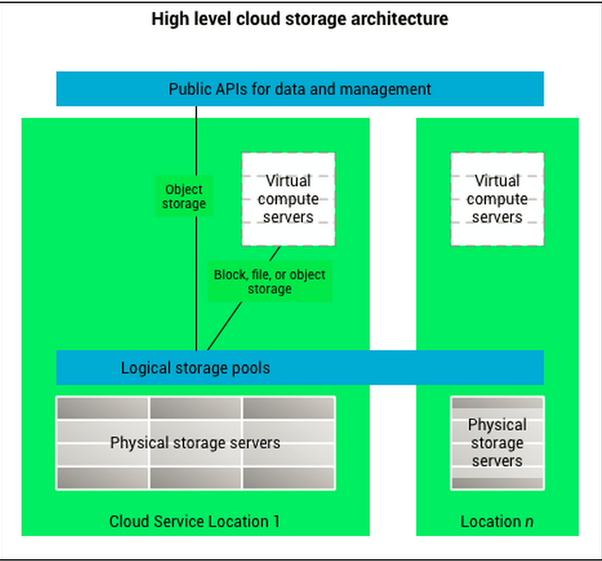

Cloud storage is:

* Made up of many distributed resources, but still acts as one - often referred to as federated storage clouds. This is the concept of clustering, where individual storage nodes are clustered together to form “Big Data”.
* Highly fault tolerant through redundancy and distribution of data.
* Highly durable through the creation of versioned copies.
* Enables data backup/redundancy service.
* …

This video explains key requirements of cloud storage:

<https://www.youtube.com/watch?v=vFmadKerDD8>

Key take-away:

* Data replication, for redundancies (in case a disk drive fail).
* Scalability. (How can we add more storage capacity, without disruption?)
* Data clustering via SAN (Storage Area Network).
* File System, the concept.
* …

A typical storage node can has storage capacity of 144TB (Tetra Bytes. 1TB=1000GB). There are different types of storages devices. We are going to examine physical storage in further details later in this class.

What is your cloud storage experience? This video provides usage model comparisons.

[**https://www.youtube.com/watch?v=SnRo1zl7pDM**](https://www.youtube.com/watch?v=SnRo1zl7pDM)

Thought provoking questions about Cloud Storage:

* + What if the cloud storage service provider, supplier go bankrupt?
  + Are you concern, your private data stored in the cloud, may be hacked, and access by others?
  + What to do, when you can NOT access the data, when you travel abroad? (e.g. China bans Google/Facebook access)?
  + …

Class Assignment: Please share your thoughts/experiences mentioned above?

**Network (Switches):**

What is a network switch?

A switch is a device in a computer network that electrically and logically connects together other devices. Multiple data cables are plugged into a switch to enable communication between different networked devices. Switches manage the flow of data across a network by transmitting a received message only to the one or more devices for which the message was intended. Each networked device connected to a switch can be identified using a MAC address, allowing the switch to regulate the flow of traffic. This maximizes the security and efficiency of the network.

Network switches, enables the formation of “Big Data”, its reliability, and scalability.

This video will let you know how a network switch work:

<https://www.youtube.com/watch?v=Ofjsh_E4HFY>

Key take-away:

* HUB switch, and network traffic compromises.
* MAC address.
* Router.

Example of a Network Switch: (Cisco 28-port Gigabit Ethernet rack mount Switch)

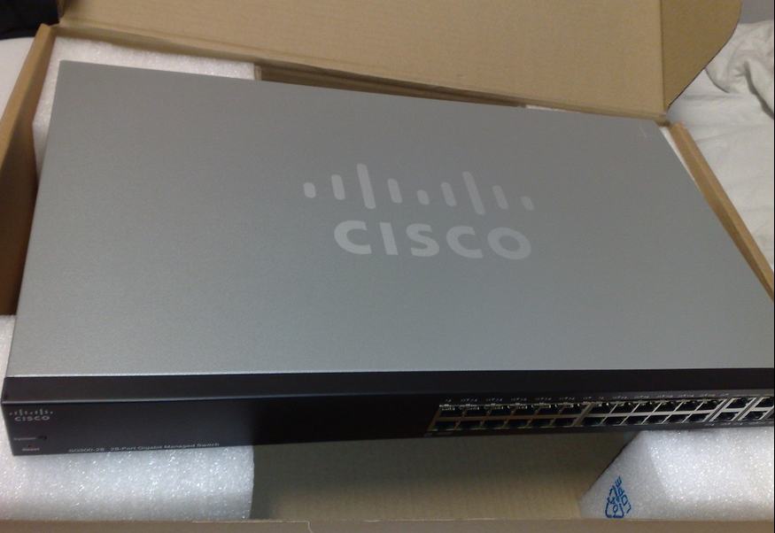

Cloud storage nodes, can be clustered together via high speed Ethernet switches. In many commercial products, they use another clustering protocols, the infiniband switch, which is designed to Storage Area Network (SAN). An example is show next (Mellanox 100Gb/s Infiniband Switch).

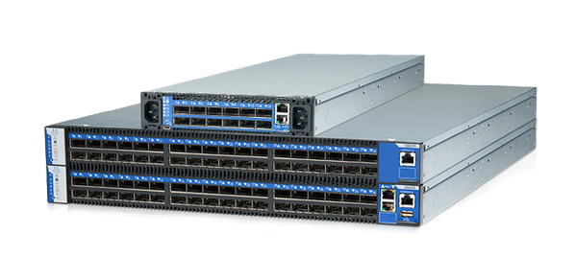

**Compute, the Servers:**

What is a computer server?

A **server** is both a running instance of some software that is capable of accepting requests from clients, and the computer that executes such software.

Servers operate within a client-server architecture, in which "servers" are computer programs running to serve the requests of other programs, the "clients. This may be to share data, information or hardware and software resources. Typical computing servers are database server, file server, mail server, print server, web server, gaming server, and application server.

Example of a rack mount computer server (Top cover removed):

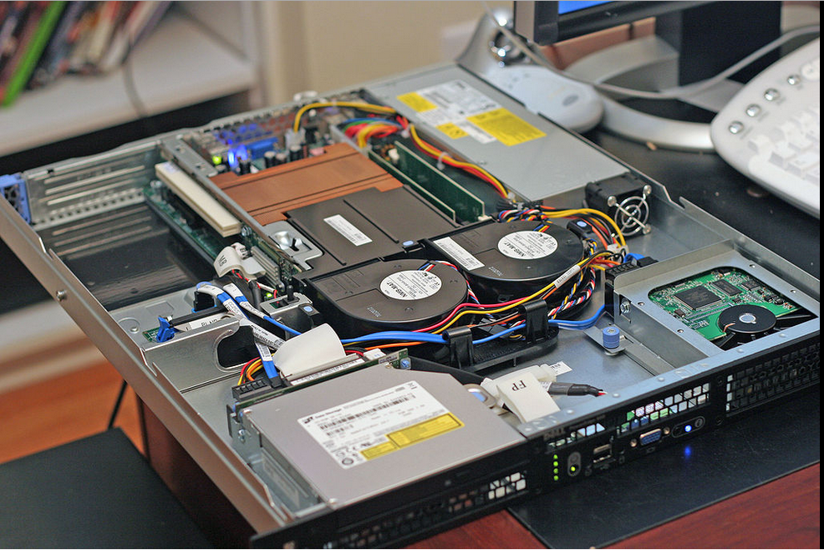

Important Characteristics of Cloud Servers:  
Large traditional single servers would need to be run for long periods without interruption. Availability would have to be very high, making hardware reliability and durability extremely important. Mission-critical enterprise servers would be very fault tolerant and use specialized hardware with low failure rates in order to maximize uptime. Uninterruptible power supplies might be incorporated to ensure against power failure AND

Hardware redundancy such as dual power supplies and RAID disk system ECC memory, along with extensive pre-boot memory testing and verification.

Critical components might be hot swappable, allowing technicians to replace them on the running server without shutting it down, and to guard against overheating, servers might have more powerful fans or use water cooling. They will often be able to be configured, powered up and down or rebooted remotely, using out-of-band management, typically based on IPMI. Server casings are usually flat and wide, and designed to be rack-mounted.

Learn about the guts of a Compute Server from this video:

<https://www.youtube.com/watch?v=QtTF9pDQxPc>

Key Take-away:

* Motherboard. Intel processor.
* Heat Sinks. Fans.
* Power Usage.
* Swap components.
* …

Thought provoking questions:

* Why data center consumes so much power? What are the main contributors?
* Can we one day remove power consumptions, e.g. NO heat sink, NO thermal fans?
* How much profit, does Intel make, from this business?
* Will mobile phone, power usage model, ever adopted in the data center?
* …

Please elaborate your thoughts above and beyond!

(Note: Compute Server performance measurements is beyond the scope of the class, but it is an important subject of research.)

End-of-Class Module.

Questions? Please email to me, or post it on Blackboard.

Thank you.