## Schedule of Course Activities: Session 16

## *[CS 519: Introduction to Cloud Computing Online-Based]*

|  |  |
| --- | --- |
| **Overview of Session** |  |
| We will answer the following questions: | 1. Data storage hardware overview. 2. Storage suppliers, performance, capacities. 3. Industry trends. |

**What is Computer Data Storage?**

**Computer data storage**, often called **storage** or **memory**, is a technology consisting of computer components and recording media used to retain digital data. It is a core function and fundamental component of computers.

The central processing unit (CPU) of a computer is what manipulates data by performing computations. In practice, almost all computers use a storage hierarchy, which puts fast but expensive and small storage options close to the CPU and slower but larger and cheaper options farther away.

Often the fast volatile technologies (which lose data when powered off) are referred to as "memory", while slower persistent technologies are referred to as "storage"; however, "memory" is sometimes also used when referring to persistent storage.

**Data Storage Usage Model:**

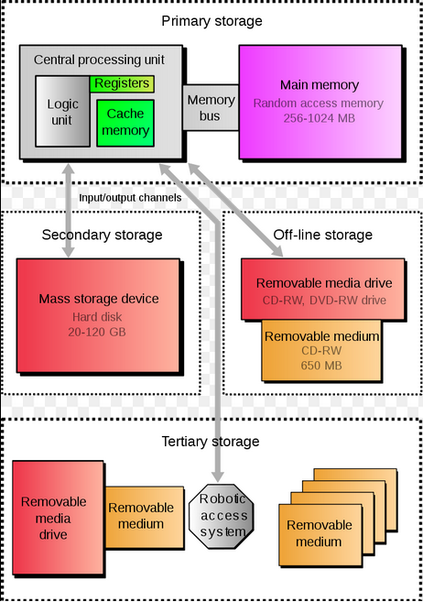

**NOTES:**

* **The capacity info is a bit outdated (Fast advancement in the Tech industry).**

**What are the Characteristics of Storage?**

* [Volatility](https://en.wikipedia.org/wiki/Computer_data_storage#Volatility): Data retain when power is off?
* [Mutability](https://en.wikipedia.org/wiki/Computer_data_storage#Mutability): Allows information to be overwritten at any time?
* [Accessibility](https://en.wikipedia.org/wiki/Computer_data_storage#Accessibility): Random Access (DRAM) vs Sequential Access(CD).
* [Addressability](https://en.wikipedia.org/wiki/Computer_data_storage#Addressability): Can each individually accessible unit of information in storage is selected with its numerical memory address?
* [Capacity](https://en.wikipedia.org/wiki/Computer_data_storage#Capacity): The total amount of stored information that a storage device or medium can hold.
* [Performance](https://en.wikipedia.org/wiki/Computer_data_storage#Performance): Latency**-**The time it takes to access a particular location in storage. Throughput-

The rate at which information can be read from or written to the storage.

* [Energy use](https://en.wikipedia.org/wiki/Computer_data_storage#Energy_use): How much power does the device consume in normal operation?

**What is a Disk Drive?**

A **disk drive** is a device implementing such a storage mechanism. Notable types are the hard disk drive (HDD) containing a non-removable disk.

Digital disk drives are block storage devices. Each disk is divided into logical blocks (collection of sectors). Blocks are addressed using their logical block addresses (LBA). Read from or writing to disk happens at the granularity of blocks.

The drive stores data onto cylinders, heads, and sectors. The sectors unit is the smallest size of data to be stored in a hard disk drive and each file will have many sectors units assigned to it.

**Who are the major suppliers?**

There used to be many Disk Drive Suppliers. Over the last 15 years, the industry has being severely contracted. There are currently just few suppliers. They are: 1) Seagate, 2) Western Digital. 3) Samsung.

**What are the key challenges to Disk Drive Usages?**

Despite its large storage capacity (6TB+ per drive, as this note is written), Disk Drive Usage has many of its disadvantages. These include:

* Data access speed. HDD has much lower access speed than Sloid State Drives (SSD).
* HDD relies on mechanical head movement to access the information being store. Thus, it is quite subject to the issue of vibrations.
* Power usage is much higher for HDD.
* …

**What are Solid State Drive (SSD, or Flash Memory)?**

A **solid-state drive** (**SSD**) (also known as a **solid-state disk**though it contains no actual disk, nor a drive motor to spin a disk) is a solid-state storage device that uses integrated circuit assemblies as memory to store data persistently.

SSDs have no moving (mechanical) components. This distinguishes them from traditional electromechanical magnetic disks such as hard disk drives (HDDs) or floppy disks, which contain spinning disks and movable read/write heads.

Most SSDs use NAND-based flash memory, which retains data without power. For applications requiring fast access, but not necessarily data persistence after power loss.

Hybrid drives or solid-state hybrid drives (SSHDs) combine the features of SSDs and HDDs in the same unit, containing a large hard disk drive and an SSD cache to improve performance of frequently accessed data.

**Who are the major suppliers?**

Many technologist have predicted that SSD will replace HDD in the NOT so distant future. Like radio, HDD will be around, may be relegated to the backup-storage domain. In any case, the supplier chain on SSD is far more robust currently. They include:

* Micron.
* Samsung.
* Western Digital (Hitachi).
* SanDisk.
* Taiwanese Suppliers.
* Korean Suppliers.
* …

**SSD vs HDD, as seen in this video:**

[**https://www.youtube.com/watch?v=j84eEjP-RL4**](https://www.youtube.com/watch?v=j84eEjP-RL4)

Key Take-Away:

* Speed.
* Power Consumptions (This is NOT mentioned).
* The PC is much lighter (more mean less).
* …

**What are DRAM?**

**Dynamic random-access memory** (**DRAM**) is a type of random-access memory that stores each bit of data in a separate capacitor within an integrated circuit. The capacitor can be either charged or discharged; these two states are taken to represent the two values of a bit, conventionally called 0 and 1.

The main memory (the "RAM") in personal computers is dynamic RAM (DRAM). It is the RAM in desktops, laptops and workstation computers as well as some of the RAM of video game consoles. In contrast, SRAM, which is faster and more expensive than DRAM, is typically used for CPU caches.

The advantage of DRAM is its structural simplicity: only one transistor and a capacitor are required per bit.

There are only 3 DRAM suppliers in the world. They are: 1) Micro. 2) Samsung. 3) Hynix.

**Packaging Forms (DRAM memory modules):**

* Single In-line Pin Package ([SIPP](https://en.wikipedia.org/wiki/SIPP_memory))
* Single In-line Memory Module ([SIMM](https://en.wikipedia.org/wiki/SIMM))
* Dual In-line Memory Module ([DIMM](https://en.wikipedia.org/wiki/DIMM))
* Rambus In-line Memory Module ([RIMM](https://en.wikipedia.org/wiki/RDRAM)), technically [DIMMs](https://en.wikipedia.org/wiki/DIMM) but called RIMMs due to their proprietary slot.
* Small outline DIMM ([SO-DIMM](https://en.wikipedia.org/wiki/SO-DIMM)), about half the size of regular DIMMs, are mostly used in notebooks, small footprint PCs (such as [Mini-ITX](https://en.wikipedia.org/wiki/Mini-ITX)motherboards), upgradable office printers and networking hardware like routers.
* Small outline RIMM (SO-RIMM). Smaller version of the RIMM, used in laptops. Technically SO-DIMMs but called SO-RIMMs due to their proprietary slot.

Shown on the next figure are Common DRAM packages. From top to bottom: DIP, SIPP, SIMM (30-pin), SIMM (72-pin), DIMM (168-pin), DDR DIMM (184-pin).

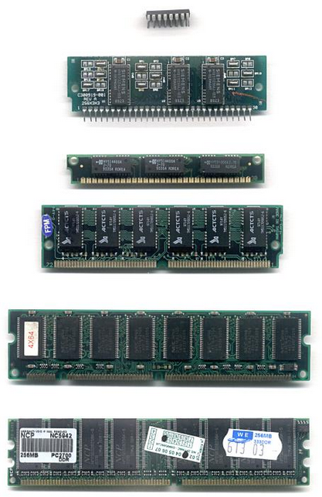

**This Video summarizes many subjects covered in this session (enjoy):**

[**https://www.youtube.com/watch?v=yQqvL0Q51HE**](https://www.youtube.com/watch?v=yQqvL0Q51HE)

* **Key Take Ways:**
  + **Bit: 1 or 0.**
  + **Memory Organization.**
  + **RAM, ROM.**
  + **HDD.**

**Thought provoking questions:**

* + **Will DRAM and SSD merge? (Hint: Intel and Micron just made such a technological breakthrough announcement).**
  + **…**

End-of-Class Module.

Questions? Please email to me, or post it on Blackboard.

Thank you.