## Schedule of Course Activities: Session 18

## *[IS 519: Introduction to Cloud Computing Online-Based]*

## *[Instructor: John C. Chan]*

|  |  |
| --- | --- |
| **Overview of Session** |  |
| We will answer the following questions: | 1. Network Infrastructures in cloud computing 2. Different types of switches. 3. Major players |

**What is Computer Network?**

A **computer network** or **data network** is a telecommunications network which allows computers to exchange data. In computer networks, networked computing devices exchange data with each other along network links (data connections). The connections between nodes are established using either cable media or wireless media. The best-known computer network is the Internet.

Network computer devices that originate, route and terminate the data are called network nodes.[[1]](https://en.wikipedia.org/wiki/Computer_network#cite_note-1) Nodes can include hosts such as personal computers, phones, servers as well as networking hardware. Two such devices can be said to be networked together when one device is able to exchange information with the other device, whether or not they have a direct connection to each other.

Computer networking may be considered a branch of electrical engineering, telecommunications, computer science, information technology or computer engineering, since it relies upon the theoretical and practical application of the related disciplines.

This video introduces the subject well:

[**https://www.youtube.com/watch?v=EWTJKcg7Pj8**](https://www.youtube.com/watch?v=EWTJKcg7Pj8)

Key Take-Away:

* MAC address.
* Router/Switch, directs traffics.
* Switch replaces HUB.

**What is Network Packet?**

Most information in computer networks is carried in *packets*. A network packet is a formatted unit of data (a list of bits or bytes, usually a few tens of bytes to a few kilobytes long) carried by a packet-switched network.

In packet networks, the data is formatted into packets that are sent through the network to their destination. Once the packets arrive they are reassembled into their original message. With packets, the bandwidth of the transmission medium can be better shared among users than if the network were circuit switched. When one user is not sending packets, the link can be filled with packets from others users, and so the cost can be shared, with relatively little interference, provided the link isn't overused.

Packets consist of two kinds of data: control information and user data (also known as payload). The control information provides data the network needs to deliver the user data, for example: source and destination network addresses, error detection codes, and sequencing information. Typically, control information is found in packet headers and trailers, with payload data in between.

Often the route a packet needs to take through a network is not immediately available. In that case the packet is queued and waits until a link is free.

**The Basics of a Network Packet:**

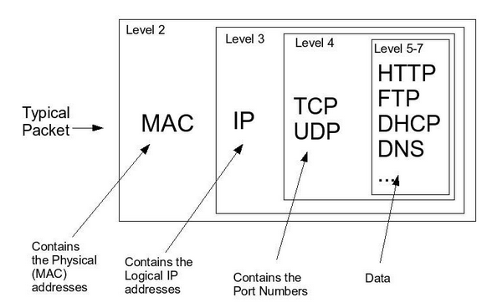

**Ethernet:**

A widely adopted *family* of transmission media used in local area network (LAN) technology is collectively known as Ethernet. The media and protocol standards that enable communication between networked devices over Ethernet are defined by IEEE 802.3. Ethernet transmits data over both copper and fiber cables. Wireless LAN standards (e.g. those defined by IEEE 802.11) use radio waves, or others use infrared signals as a transmission medium. Power line communication uses a building's power cabling to transmit data.

The Ethernet standards comprise several wiring and signaling variants of the OSI physical layer in use with Ethernet. The original 10BASE5 Ethernet uses coaxial cable as a shared medium, while the newer Ethernet variants use twisted pair and fiber optic links in conjunction with hubs or switches. Over the course of its history, Ethernet data transfer rates have been increased from the original 2.94 megabits per second (Mbit/s)to the latest 100 gigabits per second (Gbit/s), with 400 Gbit/s expected by early 2017.

Systems communicating over Ethernet divide a stream of data into shorter pieces called frames. Each frame contains source and destination addresses and error-checking data so that damaged data can be detected and re-transmitted. As per the OSI model, Ethernet provides services up to and including the data link layer.

Since its commercial release, Ethernet has retained a good degree of backward compatibility. Features such as the 48-bit MAC address and Ethernet frame format have influenced other networking protocols.

Like your home PC network, Ethernet’s usage in data center is pervasive. However, even with 100 Gbits/s Ethernet, it has NOT widely deployed for data storage clustering in the data centers. Though, this may change in the future, as its cost is the most competitive.

The next video shows the inside of a high speed Ethernet switch (cool stuff).

<https://www.youtube.com/watch?v=JfgdF48KveI>

**Examples of Network Switches:**

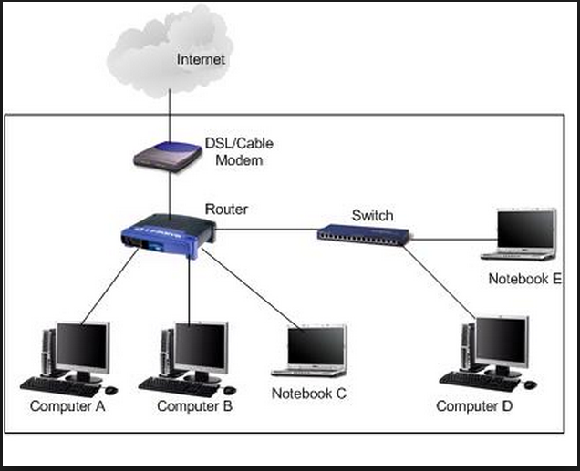

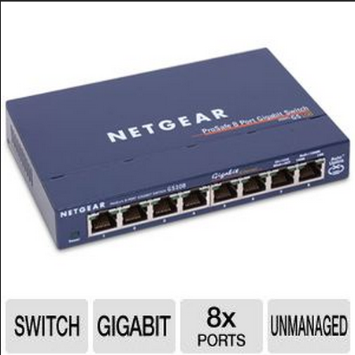

**Network Interface Card (MAC Address):**

A network interface controller (NIC) is computer hardware that provides a computer with the ability to access the transmission media, and has the ability to process low-level network information. For example, the NIC may have a connector for accepting a cable, or an aerial for wireless transmission and reception, and the associated circuitry.

The NIC responds to traffic addressed to a network address for either the NIC or the computer as a whole.

In Ethernet networks, each network interface controller has a unique Media Access Control (MAC) address—usually stored in the controller's permanent memory. To avoid address conflicts between network devices, the Institute of Electrical and Electronics Engineers (IEEE) maintains and administers MAC address uniqueness. The size of an Ethernet MAC address is six octets. The three most significant octets are reserved to identify NIC manufacturers. These manufacturers, using only their assigned prefixes, uniquely assign the three least-significant octets of every Ethernet interface they produce.

An example of a NIC Card is shown next.

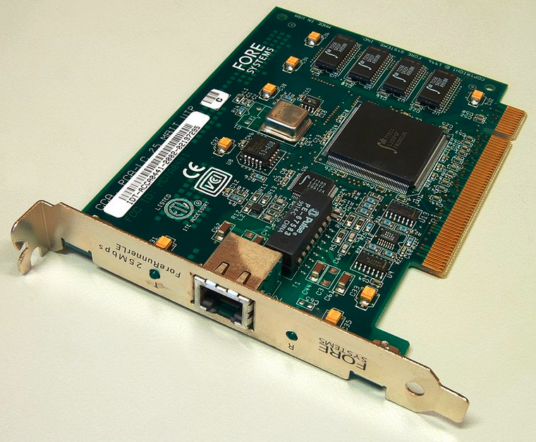

**Commutation Protocols:**

A communications protocol is a set of rules for exchanging information over network links.

An important example of a protocol stack is HTTP (the World Wide Web protocol) running over TCP over IP (the Internet protocols) over IEEE 802.11 (the Wi-Fi protocol). This stack is used between the wireless router and the home user's personal computer when the user is surfing the web.

The next figure shows the classic view of the TCP/IP model or Internet layering scheme and its relation to common protocols often layered on top of it.

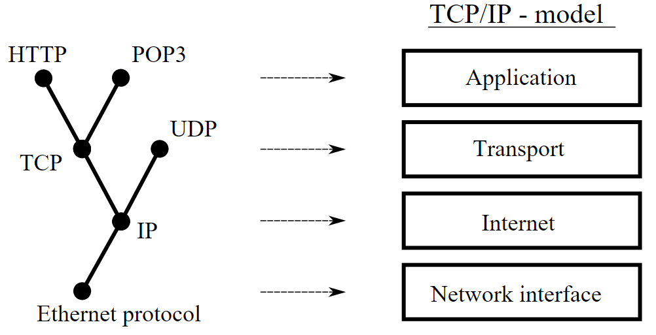

In the next class, we are going to examine computer network that are particularly relevant to cloud computing. They are SAN, and NAS.

End-of-Class Module.

Questions? Please email to me, or post it on Blackboard.

Thank you.