## Schedule of Course Activities: Session 19

## *[IS 519: Introduction to Cloud Computing Online-Based]*

## *[Instructor: John C. Chan]*

|  |  |
| --- | --- |
| **Overview of Session** |  |
| We will answer the following questions: | 1. Network Infrastructures NAS, and SAN 2. Important features of SAN 3. Why SAN is becoming the choice of cloud computing. |

**What is NAS (Network Attached Storage)?**

**Network-attached storage** (**NAS**) is a file-level computer data storage server connected to a computer network providing data access to a heterogeneous group of clients. NAS is specialized for serving files either by its hardware, software, or configuration. It is often manufactured as a computer appliance – a purpose-built specialized computer. NAS systems are networked appliances which contain one or more hard disk drives, often arranged into logical, redundant storage containers or RAID.

Network-attached storage removes the responsibility of file serving from other servers on the network. They typically provide access to files using network file sharing protocols such as NFS, SMB/CIFS, or AFP. As of 2010, NAS devices began gaining popularity as a convenient method of sharing files among multiple computers. Potential benefits of dedicated network-attached storage, compared to general-purpose servers also serving files, include faster data access, easier administration, and simple configuration.

Example of a NAS setup is shown next:

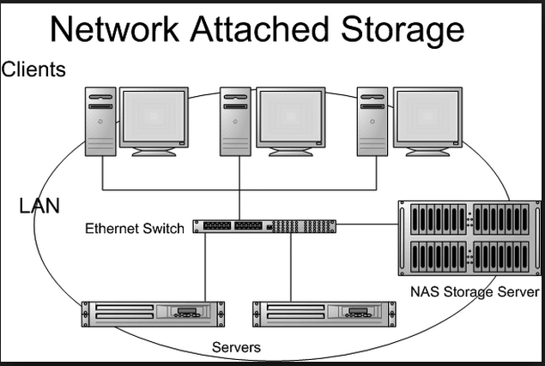

**SAN: Storage Area Network:**

A storage area network (SAN) is a dedicated network that provides access to consolidated, block level data storage. SANs are primarily used to make storage devices, such as disk arrays, tape libraries, and optical jukeboxes, accessible to servers so that the devices appear like locally attached devices to the operating system. A SAN typically has its own network of storage devices that are generally not accessible through the local area network by other devices. The cost and complexity of SANs dropped in the early 2000s to levels allowing wider adoption across both enterprise and small to medium-sized business environments.

The SAN switch protocol can be high speed Ethernet, fiber-optic (expensive), or Infiniband. The QLoigc SAN switch, as seen in the figure below, utilize the Infiniband protocol.

(To learn further about Infiniband, this is a great starting point: <https://en.wikipedia.org/wiki/InfiniBand> )

Example of a SAN network setup is shown next:

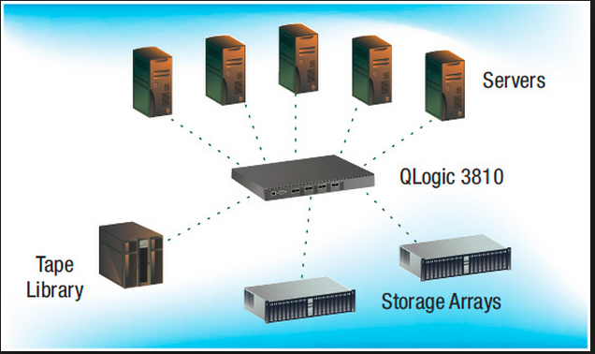

### **NAS vs. SAN**

NAS provides both storage and a file system. This is often contrasted with SAN (Storage Area Network), which provides only block-based storage and leaves file system concerns on the "client" side. SAN protocols include Fibre Channel,iSCSI, ATA over Ethernet (AoE) and HyperSCSI.

One way to loosely conceptualize the difference between a NAS and a SAN is that NAS appears to the client OS (operating system) as a file server (the client can map network drives to shares on that server) whereas a disk available through a SAN still appears to the client OS as a disk, visible in disk and volume management utilities (along with client's local disks), and available to be formatted with a file system and mounted.

Despite their differences, SAN and NAS are not mutually exclusive, and may be combined as a SAN-NAS hybrid, offering both file-level protocols (NAS) and block-level protocols (SAN) from the same system. An example of this is Openfiler, a free software product running on Linux-based systems. A shared disk file system can also be run on top of a SAN to provide filesystem services.

**The video (25-minutes duration) shown next, elaborate NAS, SAN in further details:**

[**https://www.youtube.com/watch?v=csdJFazj3h0**](https://www.youtube.com/watch?v=csdJFazj3h0)

**Key Take-Away:**

* **NAS, SAN, it purpose: For storage purpose only.**
* **NAS: Shared File/Drive on a network. No Apps. Chance of virus is reduced.**
* **NAS: Use standard file transfer protocol (ftp).**
* **SAN: Cluster storage device. Data is recoverable depends on replication/redundancies. Great for disk drive failures.**
* **SAN: Can mount storage drive, to your local file system.**
* **SAN: Has Scalability. It is important for virtualization.**
* **SAN: Fiber-optic connections/switches, very expensive.**

A Personal Views: SAN will be the future of cloud storage network methodology. Its advantages are as describe in the video: 1) Data Recovery. 2) Scalability. 3) Supports virtualization.

Class Assignment: Referring to the two figures in this session, what is the main difference? (Compare NAS-Figure vs SAN-Figure)

End-of-Class Module.

Questions? Please email to me, or post it on Blackboard.

Thank you.