## Schedule of Course Activities: Session 20

## *[CS 519: Introduction to Cloud Computing Online-Based]*

## *[Instructor: John C. Chan]*

|  |  |
| --- | --- |
| **Overview of Session** |  |
| We will answer the following questions: | 1. Computer Server Overview. 2. Data Center Compute Server Performance, Issues. 3. Industry trends. |

# **What is a Server (computing)**

A **server** is both a running instance of some software that is capable of accepting requests from clients, and the computer that executes such software.

Servers operate within a client-server architecture, in which "servers" are computer programs running to serve the requests of other programs, the "clients". This may be to share data, information or hardware and software resources. Typical computing servers are database server, file server, mail server, print server, web server, gaming server, and application server.

The clients may run on the same computer, but typically connect to the server through a network.

In the hardware sense, a computer primarily designed as a server is generally specialized in some way for its task. Sometimes more powerful and reliable than standard desktop computers, they may conversely be simpler and more disposable if clustered in large numbers.

**Operating Systems on a Server**

On the Internet the dominant operating systems among servers are UNIX-like open source distributions, such as those based on Linux and FreeBSD,with Windows Server also having a very significant share. Proprietary operating systems such as z/OS and Mac OS X are also deployed, but in much smaller numbers.

**Energy Consumptions:**

In 2010, data centers (servers, cooling, and other electrical infrastructure) were responsible for 1.1-1.5% of electrical energy consumption worldwide and 1.7-2.2% in the United States. One estimate is that total energy consumption for information and communications technology saves more than 5 times its carbon footprint in the rest of the economy by enabling efficiency.

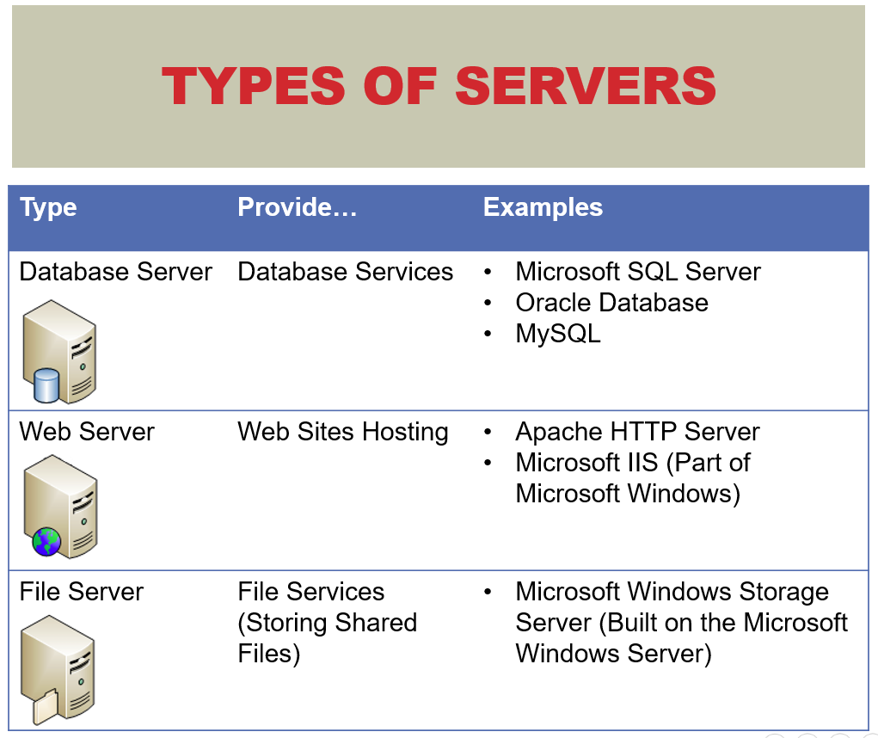

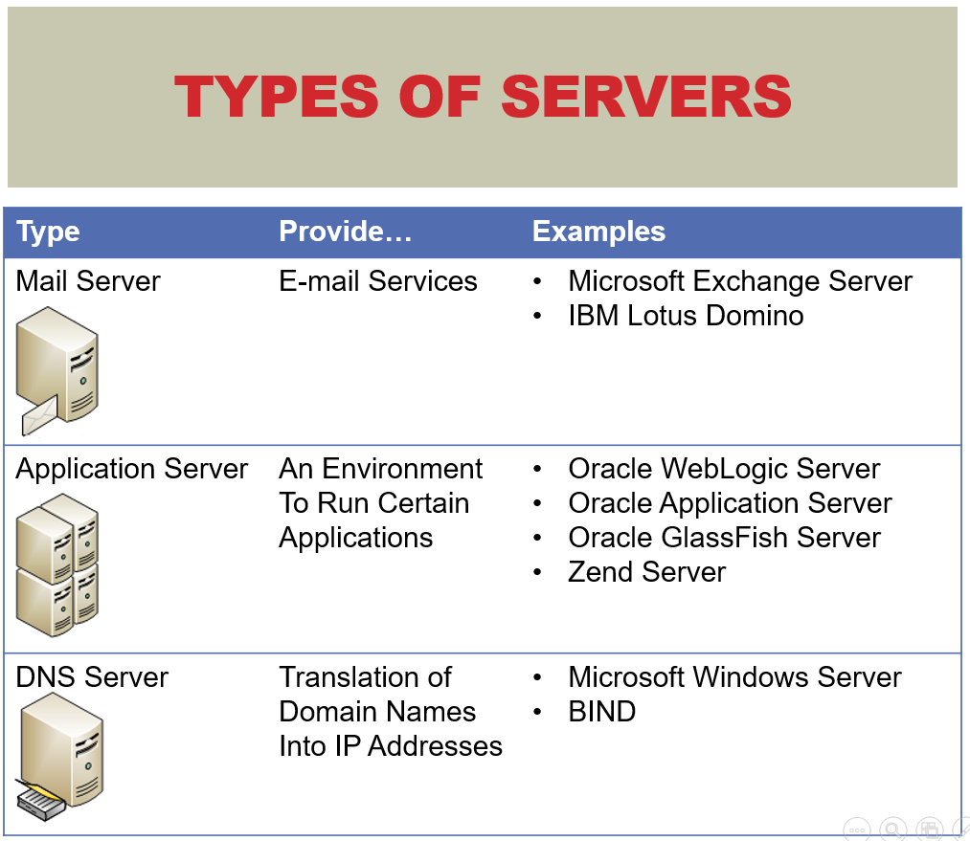

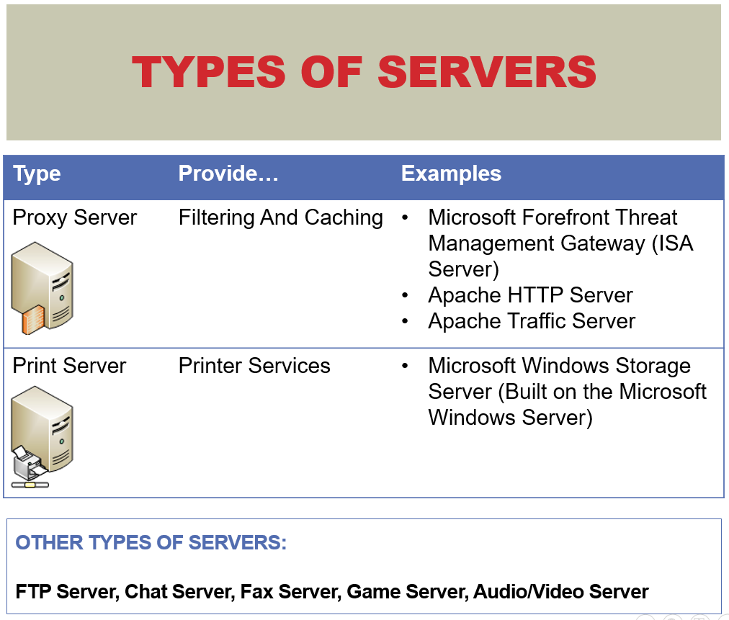

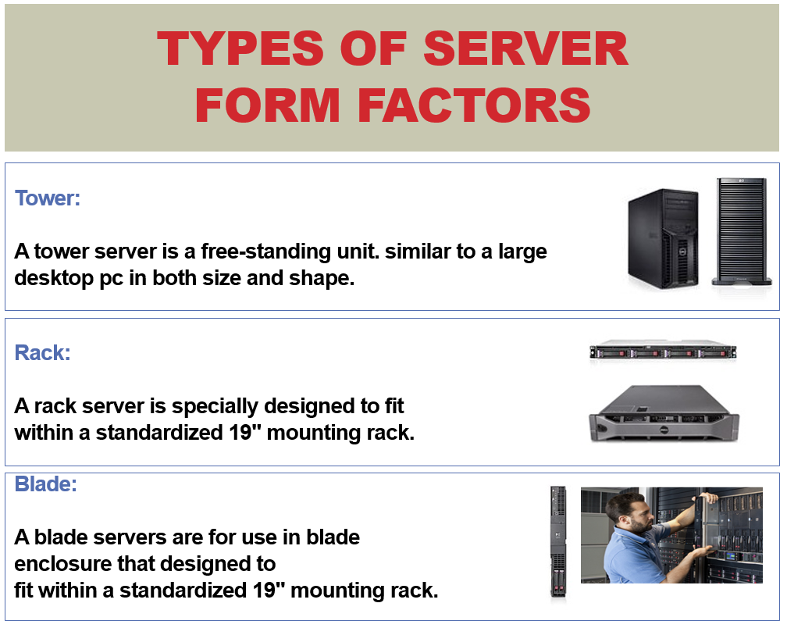

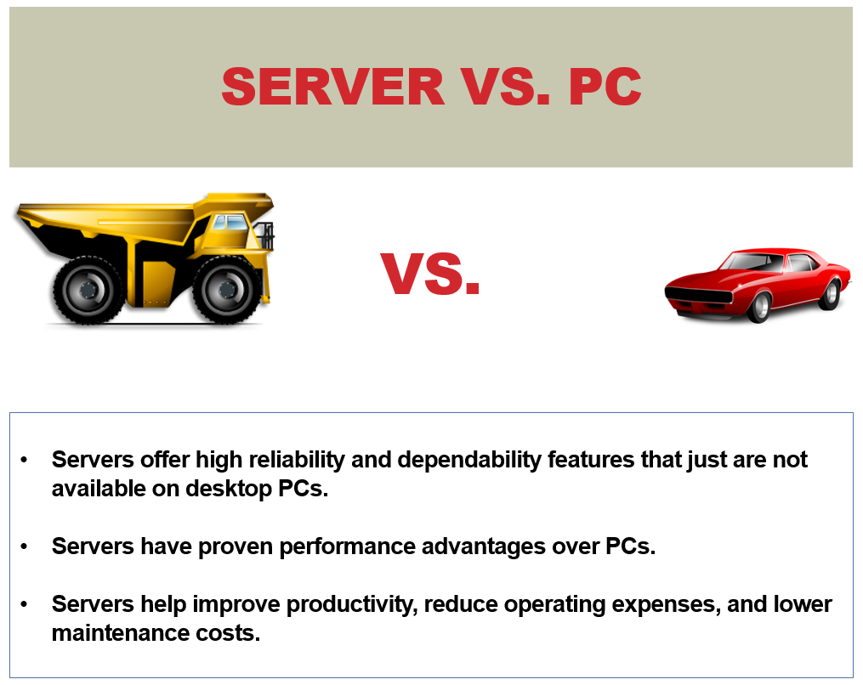

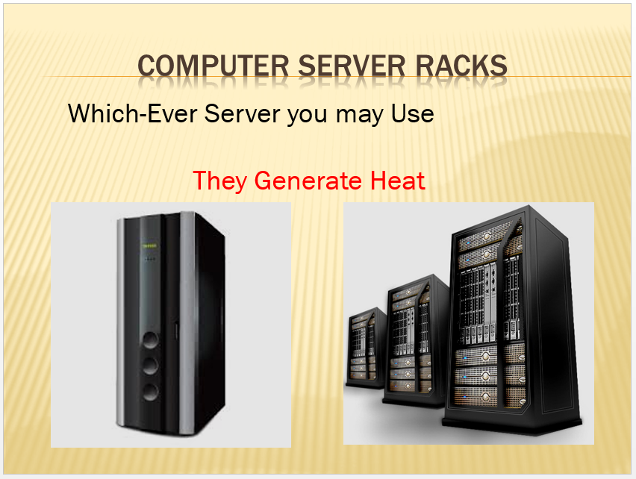

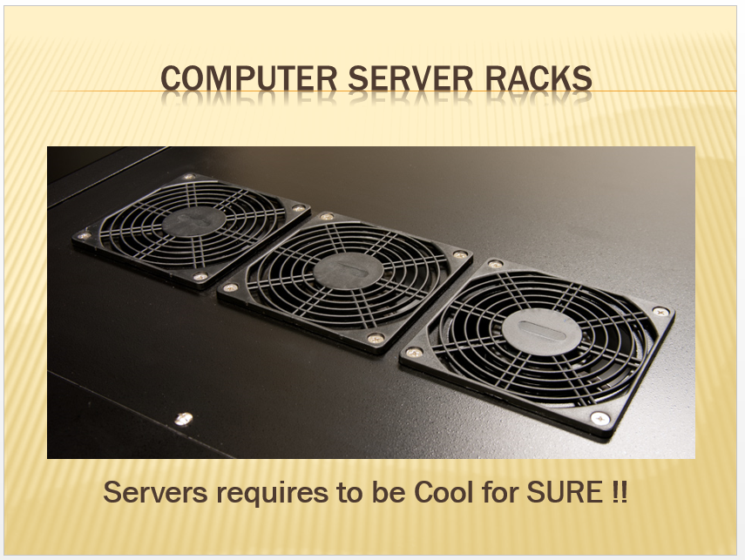

A [fan-cooled](https://en.wikipedia.org/wiki/Air_cooling) heat sink on the processor of a personal computer.

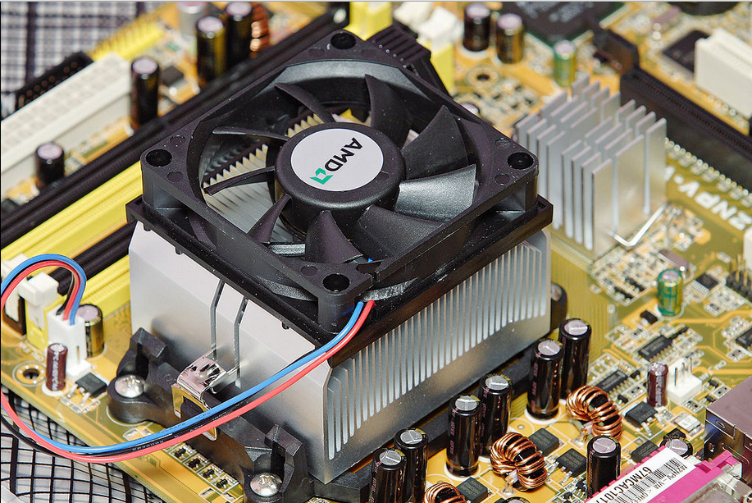

Thermal/Power consumption has become a major issue in data center computing. This video describes the latest innovations on the subject:

<https://www.youtube.com/watch?v=VFmFEZIzYg8>

Key Take-away:

* Cloud computing, computer server generates large amount of heat. This may become the limiting factor to the scale of economies in Cloud computing.
* How to harness these heat, and or reduce the heat consumptions, are the frontier of innovations.
* …

We are going to examine computer server performance further in the next module.

End-of-Class Module.

Questions? Please email to me, or post it on Blackboard.

Thank you.