## Schedule of Course Activities: Session 21

## *[Cloud 519: Introduction to Cloud Computing Online-Based]*

## *[Instructor: John C. Chan]*

|  |  |
| --- | --- |
| **Overview of Session** |  |
| We will answer the following questions: | 1. Major Building Blocks of Computer Server. 2. DIMM, CPU, LCD, PCIExpress. 3. Industry trends. |

# **Central processing unit**

A **central processing unit** (**CPU**) is the electronic circuitry within a computer that carries out the instructions of a computer program by performing the basic arithmetic, logical, control and input/output (I/O) operations specified by the instructions. The term has been used in the computer industry at least since the early 1960s. Traditionally, the term "CPU" refers to a processor, more specifically to its processing unit and control unit (CU), distinguishing these core elements of a computer from external components such as main memory and I/O circuitry.

The form, design and implementation of CPUs have changed over the course of their history, but their fundamental operation remains almost unchanged. Principal components of a CPU include the arithmetic logic unit (ALU) that performs arithmetic and logic operations, processor registers that supply operands to the ALU and store the results of ALU operations, and a control unit that fetches instructions from memory and "executes" them by directing the coordinated operations of the ALU, registers and other components.

Most modern CPUs are microprocessors, meaning they are contained on a single integrated circuit (IC) chip. An IC that contains a CPU may also contain memory, peripheral interfaces, and other components of a computer; such integrated devices are variously called microcontrollers or systems on a chip (SoC). Some computers employ a multi-core processor, which is a single chip containing two or more CPUs called "cores"; in that context, single chips are sometimes referred to as "sockets". Array processors or vector processors have multiple processors that operate in parallel, with no unit considered central.

**Intel CPU Pictures #1:**

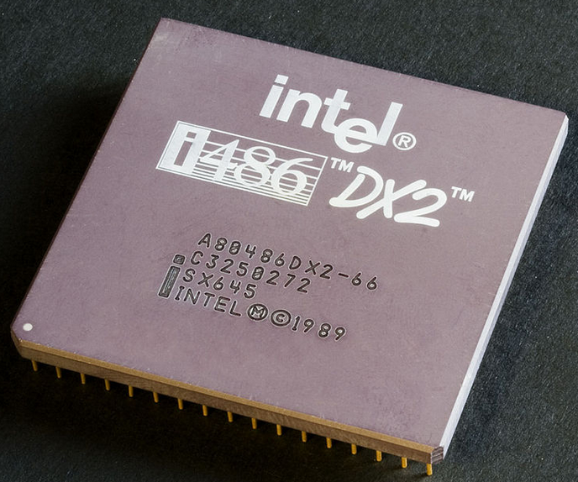

**Intel CPU Pictures #2:**

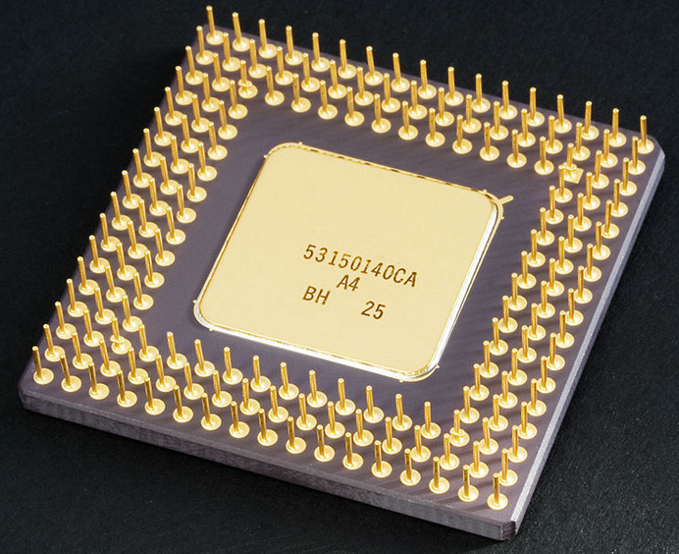

**Learn how a CPU works by watching this video:**

[**https://www.youtube.com/watch?v=cNN_tTXABUA**](https://www.youtube.com/watch?v=cNN_tTXABUA)

Key Take-Away:

* Clock. Clock rate.
* Motherboard; RAM, data access, the memory sub-system.
* Indirect memory addressing.
* Instruction set. E.g. load/add/store/compare/jump_if/out/in…
* Basic blocks: Control Unit, ALU, Registers, Instruction fetching.
* Modern CPU, can execute 1 instruction per clock cycle in most cases.
* Control Bus, Data Bus, etc.
* Peripheral IO, e.g. Disk Drive.

CPU, its memory sub-system, and its peripheral IO Interfaces, constitute the major building blocks of a computer server. (Graphics, in old/classic CPU architecture, was considered part of its IO subsystem).

Until the early 2000s, CPU performance, was driven by its operating frequencies (Up to 5GHz). Then, it was realized, thermal/heat issue, make it impossible for have the frequency go much higher. From this, we have the Multi-Core designs approach (by leveraging parallel processing, with software compiler support).

Intel, and ARM Inc., and AMD are the only open CPU-business players in the commercial market.

With CPU execution rate of achieving 1-instruction/clock cycle, the overall system performance depends largely on it memory sub-system. In other words, the CPU is starving of data (information) that it can process. How do you provide this data, in the timely manner, to keep in sync with the need of the CPU, is the challenge of modern computer system design.

Memory Sub-system, and IO Sub System, are explore in further detail on the next class module.

End-of-Class Module.

Questions? Please email to me, or post it on Blackboard.

Thank you.