## Schedule of Course Activities: Session 23

## *[Cloud 519: Introduction to Cloud Computing Online-Based]*

## *[Instructor: John C. Chan]*

|  |  |
| --- | --- |
| **Overview of Session** |  |
| We will answer the following questions: | 1. Cloud Software: Virtualization! Hardware, OS, Network, Storages... 2. Hypervisor. 3. Major platforms. 4. … |

**An Overview of Virtualization Techniques:**

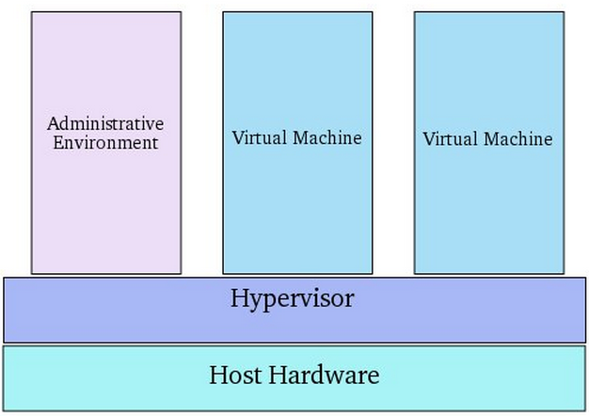

# **Hypervisor**

A **hypervisor** or **virtual machine monitor** (**VMM**) is a piece of computer software, firmware or hardware that creates and runs virtual machines.

A computer on which a hypervisor is running one or more virtual machines is defined as a *host machine*. Each virtual machine is called a *guest machine*. The hypervisor presents the guest operating systems with a virtual operating platform and manages the execution of the guest operating systems. Multiple instances of a variety of operating systems may share the virtualized hardware resources.

**Two types of “Hypervisor”:**

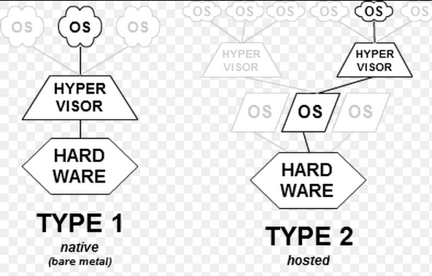

**Type-1: native or bare-metal hypervisors**

These hypervisors run directly on the host's hardware to control the hardware and to manage guest operating systems.

**Type-2: hosted hypervisors**

These hypervisors run on a conventional operating system just as other computer programs do. Type-2 hypervisors abstract guest operating systems from the host operating system. VMware Workstation, VMware Player and VirtualBox are examples of type-2 hypervisors.

**Let’s learn Hypervisor, its introduction via this video:**

[**https://www.youtube.com/watch?v=NmrJlWDG0yk**](https://www.youtube.com/watch?v=NmrJlWDG0yk)

**Key Take-Away:**

* Hardware abstractions. There is a layer, between OS, and the hardware layer.
* Container, VM. We have several VM from 1 underlying hardware.
* Hypervisor Players: VMWare, Microsoft, Citrix.
* Type 1 Hypervisor has better performance.
* How a virtual Machines is presented to the user/administrator. NOTE: different OS models are supported.
* Other types of virtualizations: Desktop, I/O, Network, Storage, Application.
* …

Class Assignment: What is main reason of doing hardware virtualizations?

1. Better utilization of hardware resources.
2. Accommodate users’ diverse computing needs (e.g. OS).
3. Making software applications hardware agnostic.
4. All of above.

**What does virtualization involved at the hardware layer?**

* Inventory of the underlying hardware resource.
* Execution constraints of the hardware resources.
* Create a software programming model of the hardware resources.
  + CPU or higher level operation instructions.
  + Memory access models. Read, Write, Bus Contentions etc.
  + Peripheral IO usage models: USB, Disk Drives, Display, Net Work interfaces.
* Ultimately, we need to know:
  + What are the instruction sets of the VM?
  + What the registers, memory resources?
  + What are the restrictions in the instruction sequence?
* **…**

End-of-Class Module.

Questions? Please email to me, or post it on Blackboard.

Thank you.