## Schedule of Course Activities: Session 24

## *[Cloud 519: Introduction to Cloud Computing Online-Based]*

## *[Instructor: John C. Chan]*

|  |  |
| --- | --- |
| **Overview of Session** |  |
| We will answer the following questions: | 1. CloudStack 2. Main features. 3. … |

# **Apache CloudStack**

**CloudStack** is an open source cloud computing software for creating, managing, and deploying infrastructure cloud services. It uses existing hypervisors such as KVM, VMware vSphere, and XenServer/XCP for virtualization.

## Key features

* Built-in high-availability for hosts and VMs
* AJAX web GUI for management
* AWS API compatibility
* Hypervisor agnostic
* Snapshot management
* Usage metering
* Network management (VLAN's, security groups)
* Virtual routers, firewalls, load balancers
* Multi-role support

## Deployment Architecture

The minimum production installation consists of one machine running the CloudStack Management Server and another machine to act as the cloud infrastructure (in this case, a very simple infrastructure consisting of one host running hypervisor software). In its smallest deployment, a single machine can act as both the Management Server and the hypervisor host (using the KVM hypervisor).

Multiple management servers can be configured for redundancy and load balancing, all pointing to a common MySQLdatabase.

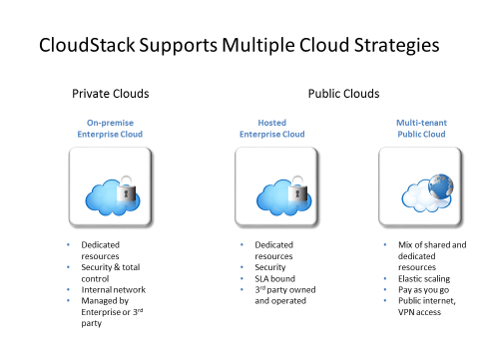

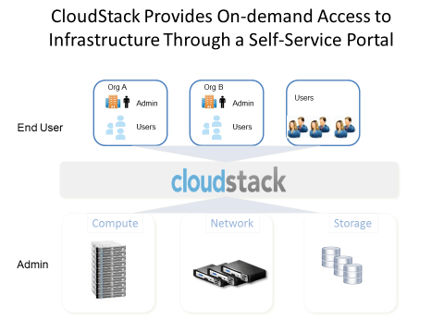

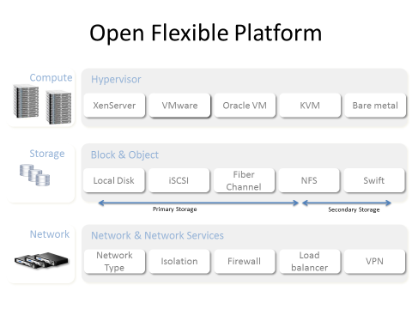

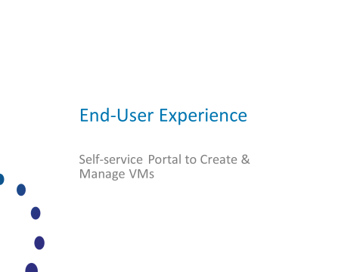

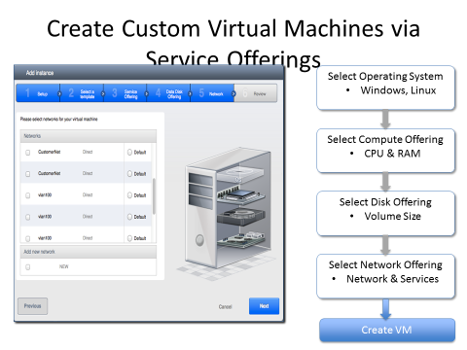

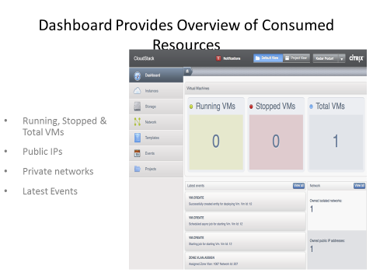

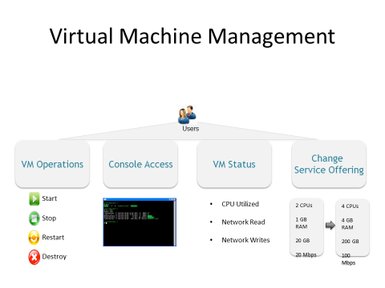

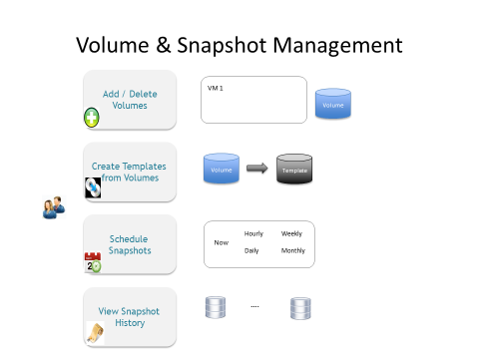

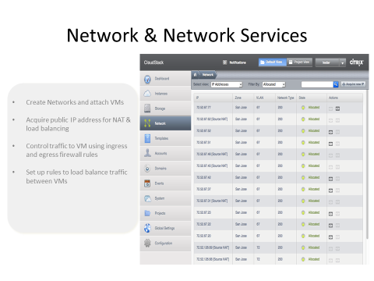

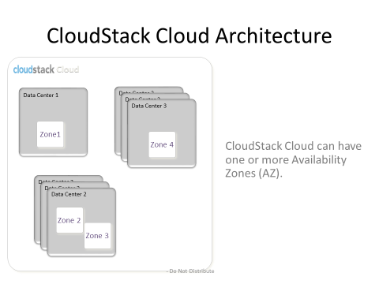

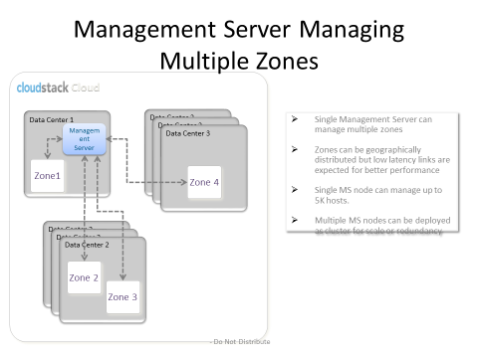

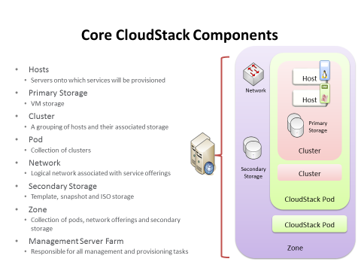

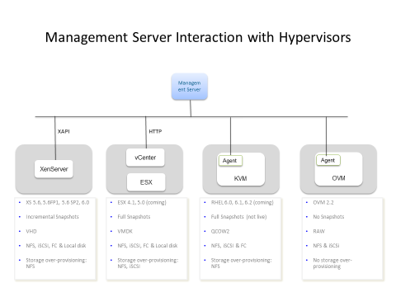

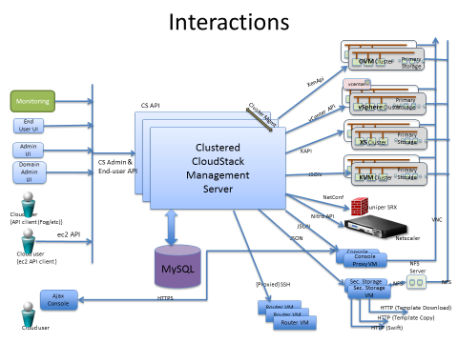

We complete this class module on CloudStack by watching this introductory video:

<https://www.youtube.com/watch?v=WbBTDUMk0w0>

Key Take-Away:

* This a way of manage your cloud. Notice the many features, the adjustments that you can make.
* …

End-of-Class Module.

Questions? Please email to me, or post it on Blackboard.

Thank you.