## Schedule of Course Activities: Session 25

## *[Cloud 519: Introduction to Cloud Computing Online-Based]*

## *[Instructor: John C. Chan]*

|  |  |
| --- | --- |
| **Overview of Session** |  |
| We will answer the following questions: | 1. OpenStack 2. Main features. 3. … |

OpenStack is more encompassing than CloudStack. We briefly learn about OpenStack earlier in the class.

In this class module, we examine OpenStack a deeper.

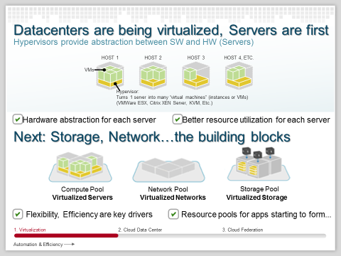

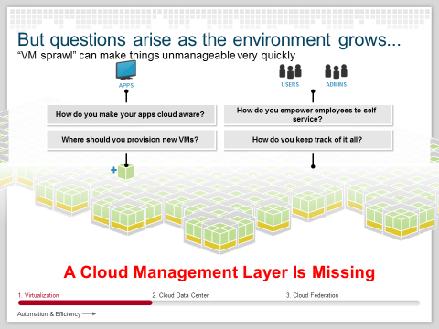

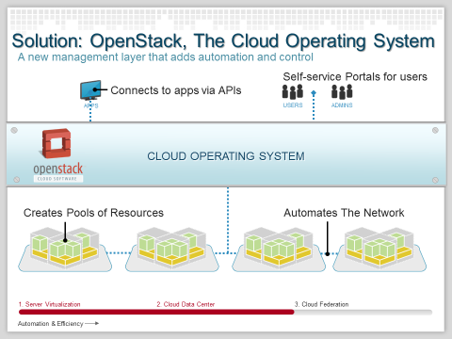

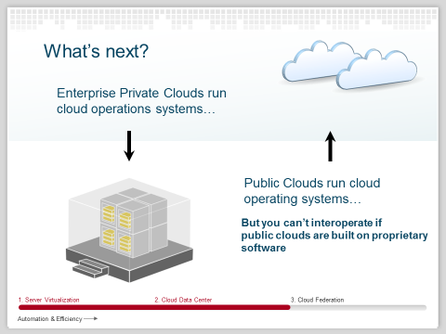

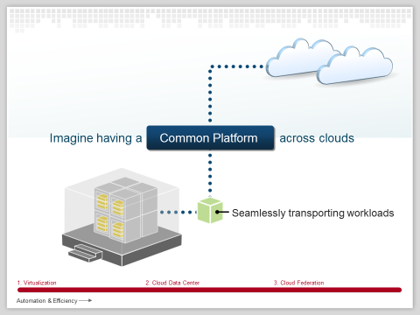

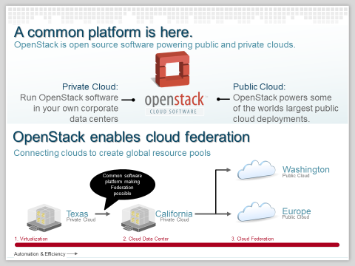

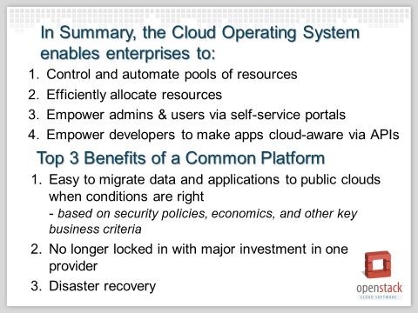

**OpenStack Operation Model, the Concept:**

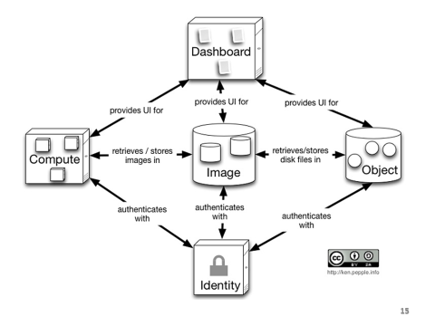

“Images”: the many OS flavors, File System Flavors, etc.

“Object”: the data resources.

**The “Compute” Aspect of Cloud:**

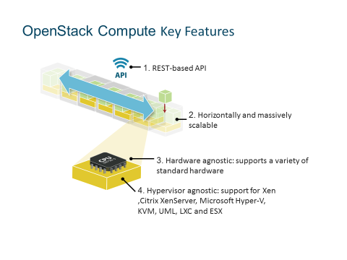

**The “Storage” aspect of Cloud:**

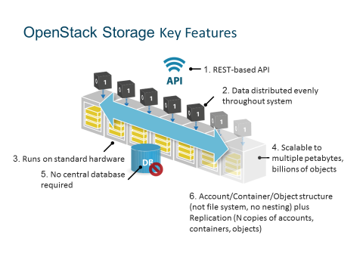

**How OpenStack does manage and retrieves the various OS?**

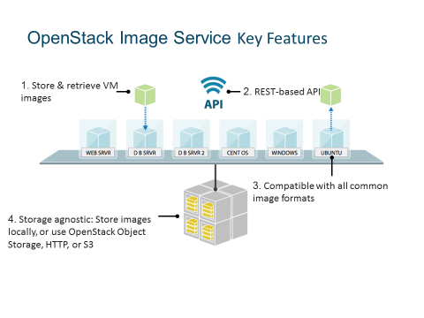

**OpenStack Usage Models:**

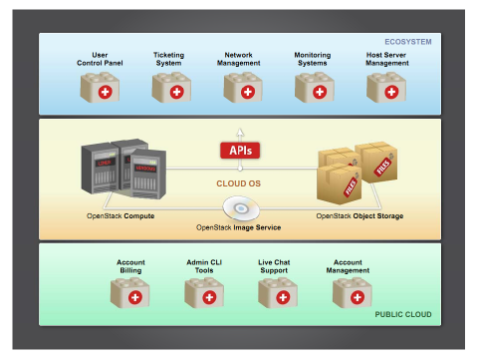

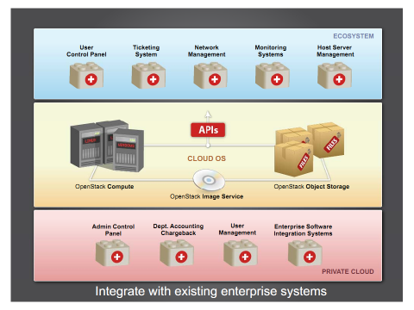

Further detail on OpenStack (including its “Network” aspect of Cloud), is beyond this introductory class. We will explore the subject in the follow-on class.

Let’s complete this class module, by watching this introductory video on OpenStack:

<https://www.youtube.com/watch?v=c1GFoY4btpo>

Key Take-Away:

* Existing Cloud Computing layers.
* Open Source.
* Major Blocks.
  + “Glance” Images.
  + “Nova” Compute.
  + Network.
  + “Swift” Storage.
* …

End-of-Class Module.

Questions? Please email to me, or post it on Blackboard.

Thank you.