## Schedule of Course Activities: Session 28

## *[Cloud 519: Introduction to Cloud Computing Online-Based]*

## *[Instructor: John C. Chan]*

|  |  |
| --- | --- |
| **Overview of Session** |  |
| We will answer the following questions: | 1. Introduction Machine Learning. 2. How is it different from AI, artificial Intelligence? 3. Examples of ML in our daily life. 4. …   NOTE: Most of the slides are from Seattle Codecamp 2015. Credits goes to them. |

# **Machine learning**

**Machine learning** is a subfield of computer science that evolved from the study of pattern recognition and computational learning theory in artificial intelligence. Machine learning explores the study and construction of algorithms that can learn from and make predictions on data. Such algorithms operate by building a model from example inputs in order to make data-driven predictions or decisions, rather than following strictly static program instructions.

Machine learning is closely related to and often overlaps with computational statistics; a discipline that also specializes in prediction-making. It has strong ties to mathematical optimization, which delivers methods, theory and application domains to the field. Machine learning is employed in a range of computing tasks where designing and programming explicit algorithms is infeasible.

Example applications include spam filtering, optical character recognition (OCR), search engines and computer vision.

Machine Learning, is still relatively a young computer/scientific field. This video introduce the subject in understandable terms.

<https://www.youtube.com/watch?v=WXHM_i-fgGo>

Key Take-Away:

* Wring software to learn from past experience. It is more closely related to data mining (Big Data) and statistics.
* Classification and categorized data, and make prediction.
* Supervised, unsupervised, re-enforced learning.
* An example of the data set with “red”, and “blue” entries.
* Neural network, and its application to speech recognition.
* Annotations to a picture, an example.
* …

Machine learning is showing up in our daily life. Examples include self-driving car, speech recognition, and facial recognitions in photo/images. The nest set of slides are captured this, with Microsoft’s Azure flavor.

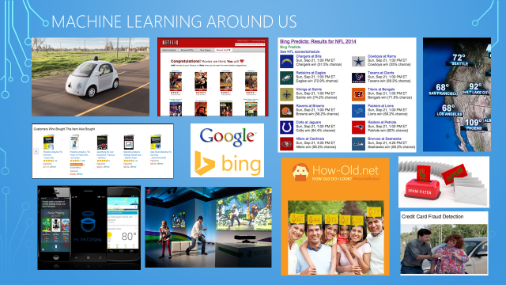

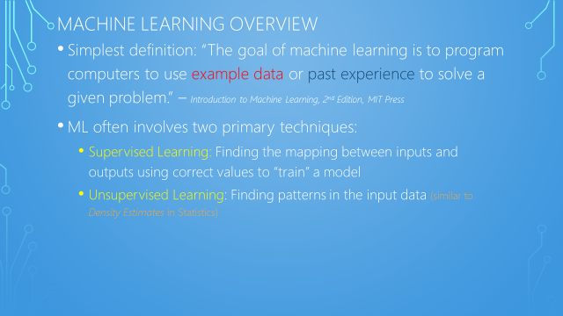

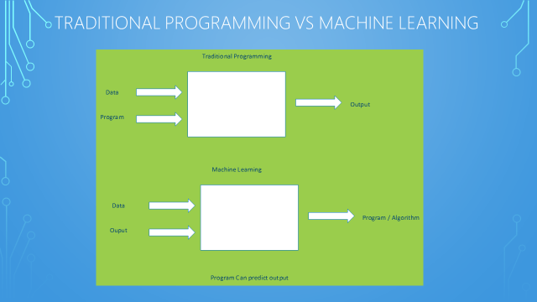

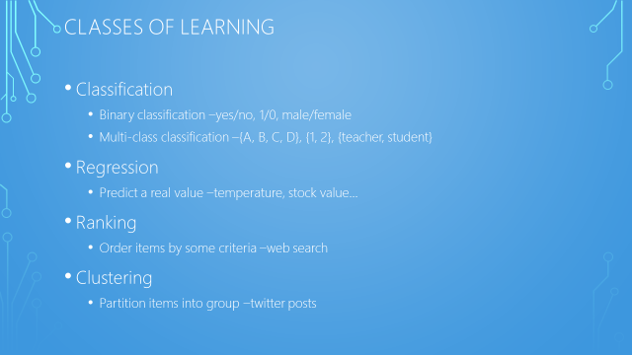

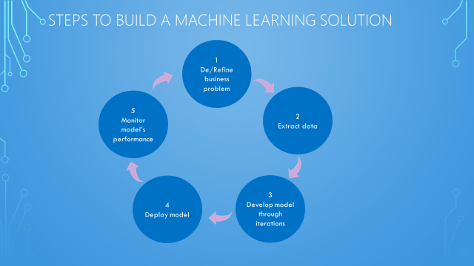

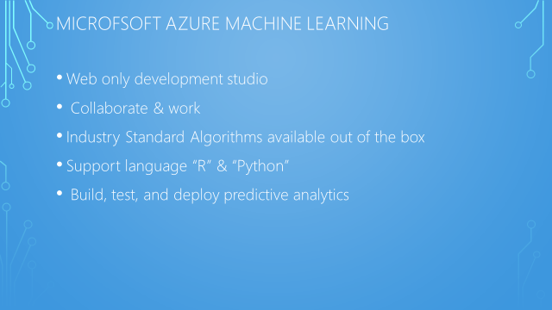

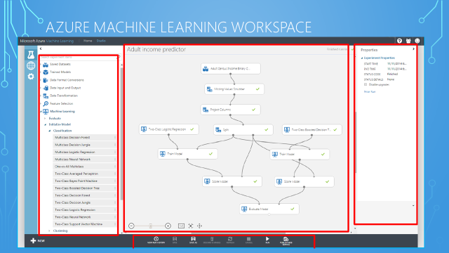

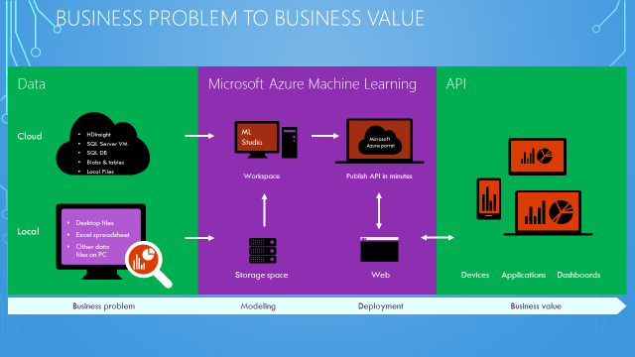

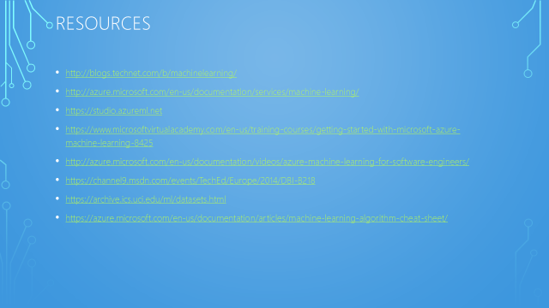

Class Assignment:   
Is voice activated command on your phone, a machine learning process?

End-of-Class Module.

Questions? Please email to me, or post it on Blackboard.

Thank you.