## Schedule of Course Activities: Session 29

## *[Cloud 519: Introduction to Cloud Computing Online-Based]*

## *[Instructor: John C. Chan]*

|  |  |
| --- | --- |
| **Overview of Session** |  |
| We will answer the following questions: | 1. Internet-of-Things. 2. What about chip/device cost? 3. How do you fit in? 4. … |

# **Internet of Things**

The **Internet of Things** (**IoT**) is the network of physical objects or "things" embedded with electronics, software, sensors, and network connectivity, which enables these objects to collect and exchange data.[]](https://en.wikipedia.org/wiki/Internet_of_Things#cite_note-1) The Internet of Things allows objects to be sensed and controlled remotely across existing network infrastructure, creating opportunities for more direct integration between the physical world and computer-based systems, and resulting in improved efficiency, accuracy and economic benefit.

Each thing is uniquely identifiable through its embedded computing system but is able to interoperate within the existing Internet infrastructure. Experts estimate that the IoT will consist of almost 50 billion objects by 2020.

"Things," in the IoT sense, can refer to a wide variety of devices such as heart monitoring implants, biochip transponders on farm animals, electric clams in coastal waters, automobiles with built-in sensors, or field operation devices that assist firefighters in search and rescue operations. These devices collect useful data with the help of various existing technologies and then autonomously flow the data between other devices.

The Internet-of-Thing revolution is just started. This video show the guts of it all.

<https://www.youtube.com/watch?v=S64s3GrZlSM>

Key Take-Away:

* Thing: any object that has sensor, where its data can be transferred to the internet infrastructure.
* Soon, more IoT than people on the internet.
* Current hardware constraints on IoT: Battery life, inter-operability, accumulate and process the data.
* Samsung’s pledge, all its hardware products will be IoT by 2020.
* ARM is a major CPU player on IoT.
* Low-Power OS: Event Driven, instead of polling. Etc.
* IoT: small, and there is a gate way for it to transfer data to the internet.
* Security is a major concern.
* …

The next set of slides, present IoT perspectives from Microsoft Azure’s perspective.

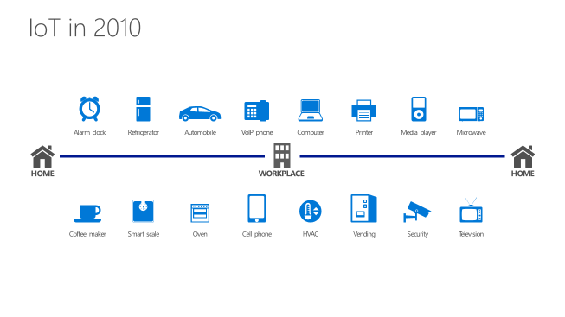

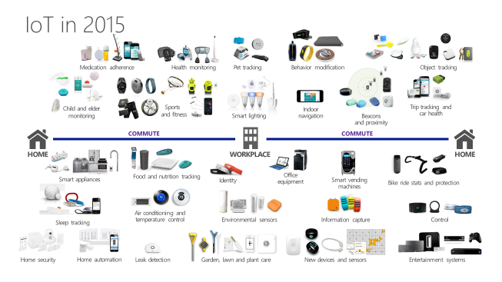

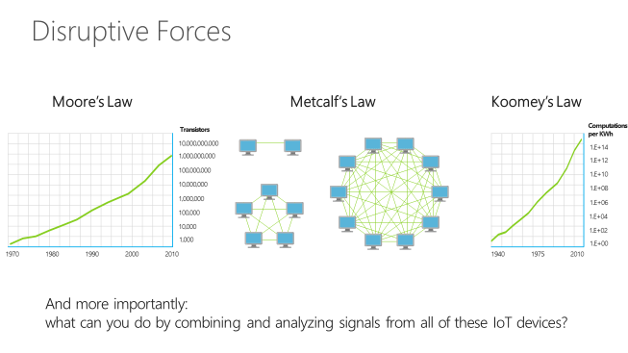

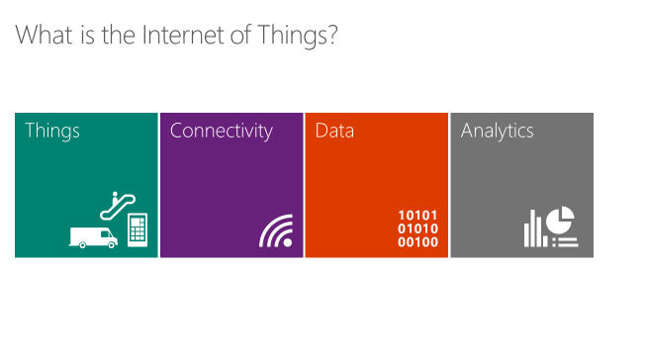

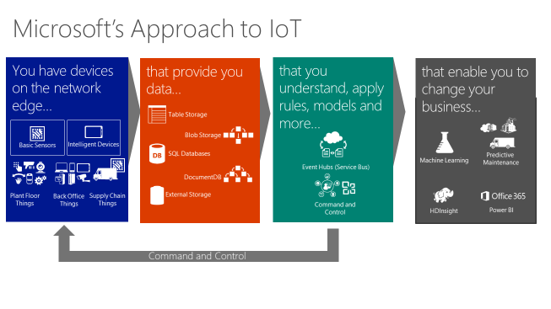

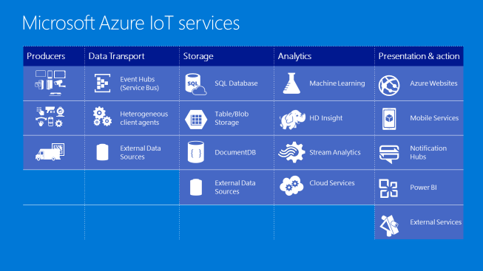

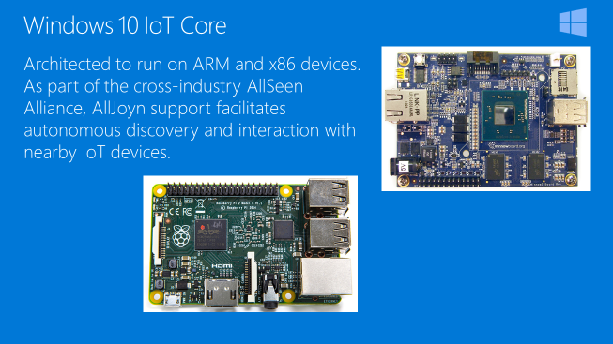

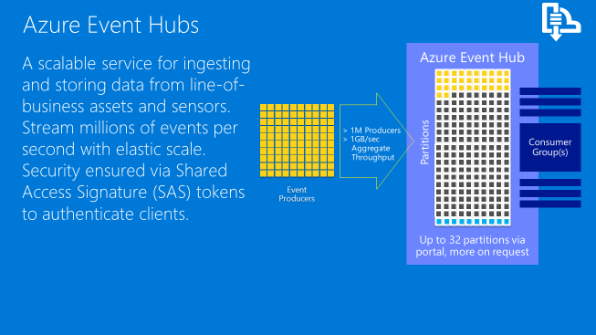

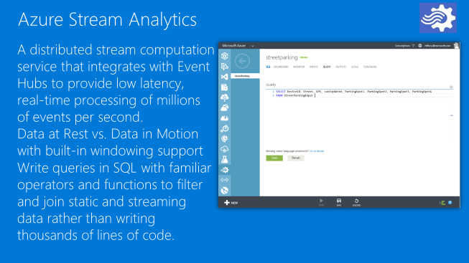

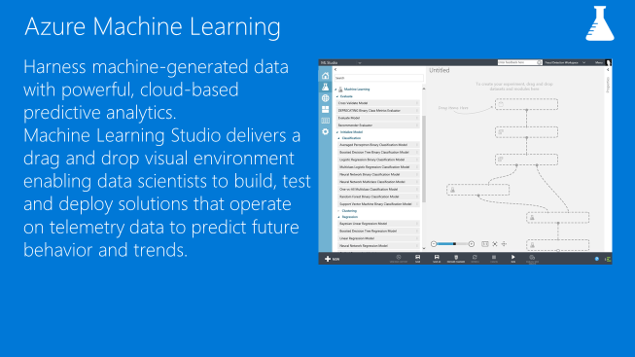

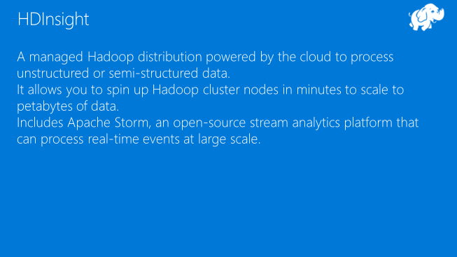

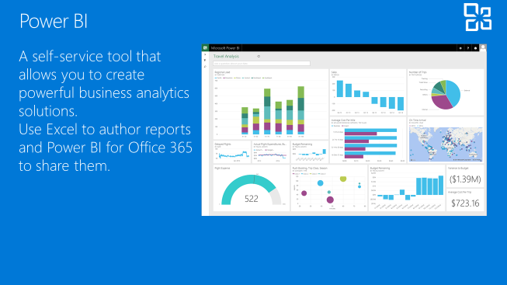

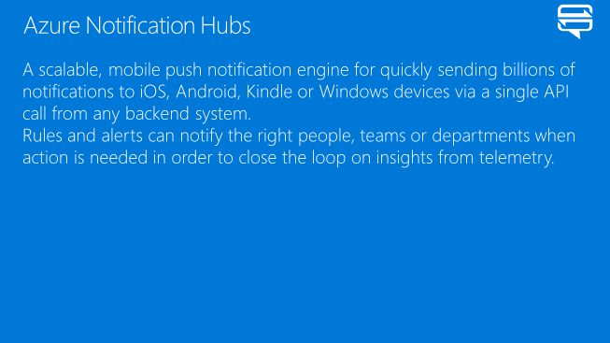

In essence, because of IoT, our Big Data, is going to be getting Bigger. Cloud Computing is the future of computing.

End-of-Class Module.

Questions? Please email to me, or post it on Blackboard.

Thank you.