## Schedule of Course Activities: Session 2

## *[CS 519: Introduction to Cloud Computing Online-Based]*

## *[Instructor: John C. Chan]*

|  |  |
| --- | --- |
| **Overview of Session** |  |
| We will answer the following questions: | 1. What is Cloud Computing? 2. Why Cloud Computing? 3. Why Cloud Computing does NOT exist 10 years ago? 4. … |

**What is Cloud Computing?**

* **Cloud computing is a model for enabling ubiquitous network access to a shared pool of configurable computing resources. (NOTE: We need to have high speed network access).**
* **Cloud computing and storage solutions provide users and enterprises with various capabilities to store and process their data in third-party data centers. (NOTE: We need to have huge, “unlimited” free storage).**
* **Cloud resources are usually not only shared by multiple users but are also dynamically reallocated per demand. (NOTE: we need to have vast free computing power).**
* **Forget the notion of my PC, my laptop, my … (Does your PC has enough computing power, storage capacity, or the bandwidth for sharing by others? Can you keep your PC software up to date? Really, Uh…?)**
* **My personal example experience example: Seattle City Transit/Bus Planner (I love it, and depend on it!):** [**http://tripplanner.kingcounty.gov/**](http://tripplanner.kingcounty.gov/)

**(It is a mobile app. It uses GPS, identify my location, lookup its complex transit routes database, and tells me the next Bus/Train arrival/departure info that will take me to my destination.)**

* **This video will help for further understanding of Cloud Computing:** [**https://www.youtube.com/watch?v=uYGQcmZUTaw**](https://www.youtube.com/watch?v=uYGQcmZUTaw)
* **…**

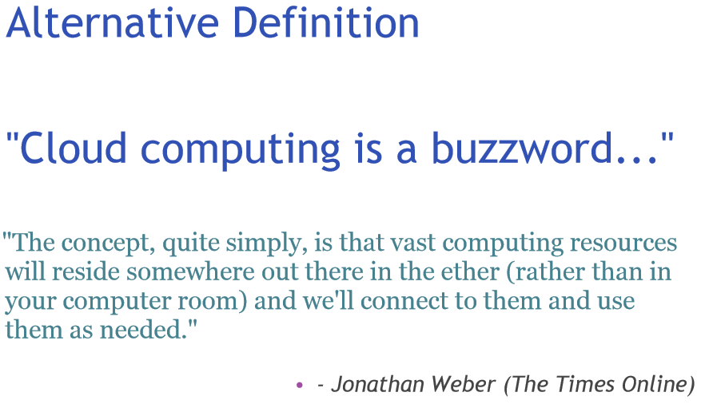

**Why Cloud Computing?**

* **This Video largely explains the commercial reasons on Cloud Computing.** [**https://www.youtube.com/watch?v=ojDnOyIQeJU**](https://www.youtube.com/watch?v=ojDnOyIQeJU)
* **Key Take Ways:**
  + **Access from anywhere.**
  + **Quick Deployment (Both hardware, and Software).**
  + **Backup/Recovery is much easier.**
  + **Cost Efficient (Your PC is idle most of the time).**
  + **Security. Your info are being processed in shared computing resources.**
  + **…**

**Thought provoking questions about Cloud Computing:**

* + **Does this means the PC (Personal Computer) Era is over?**
  + **What happen, if I am away from the Cloud? (e.g. Camping in a remote National Park?)**
  + **Are your comfortable: All your digital data (e.g. photos, videos) are stored by few corporate cloud providers? Uhh…?**
  + **Your thoughts on alternatives/inventions, please…?**

**Class Assignment: What is your 1st Cloud Compute experience?**

**Cloud Computing, its essence, and advantages, as captured in the professional community:**

[**http://www.salesforce.com/uk/socialsuccess/cloud-computing/why-move-to-cloud-10-benefits-cloud-computing.jsp**](http://www.salesforce.com/uk/socialsuccess/cloud-computing/why-move-to-cloud-10-benefits-cloud-computing.jsp)

**In this class we are going to explore each subject in further detail.**

End-of-Class Module.

Questions? Please email to me, or post it on Blackboard.

Thank you.