## Schedule of Course Activities: Session 33

## *[CS 519: Introduction to Cloud Computing Online-Based]*

## *[Instructor: John C. Chan]*

|  |  |
| --- | --- |
| **Overview of Session** |  |
| We will answer the following questions: | 1. Example of API Interfaces. 2. Facebook’s Graph API 3. Google API 4. The major features. 5. … |

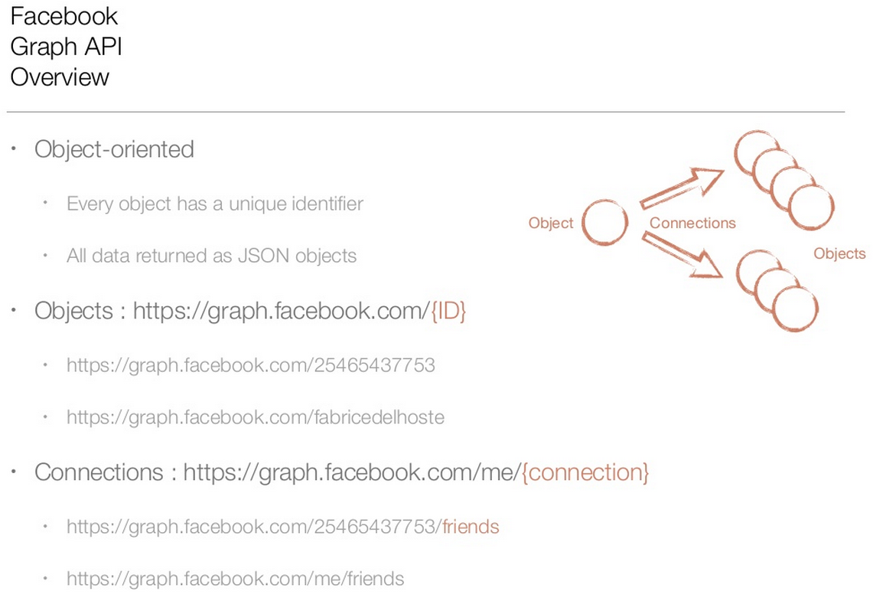

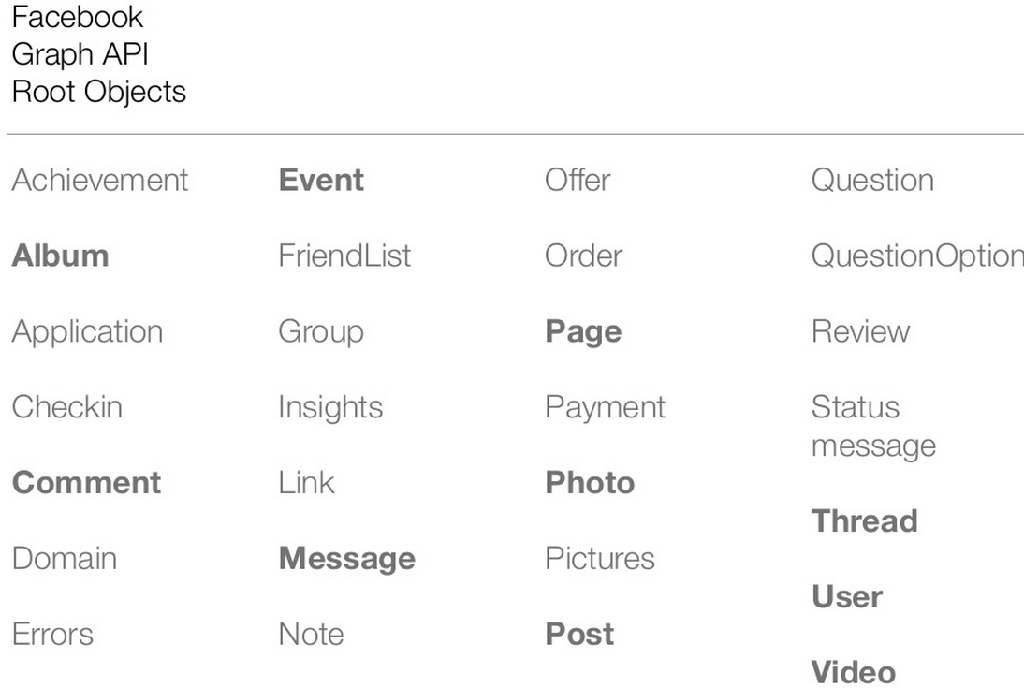

Let’s learn Facebooks Graph API with this video:

<https://www.youtube.com/watch?v=WteK95AppF4>

Key Take-Away:

* All data in Facebook is represented as an object/node in a graph.
* Try Facebook’s Graph API Explorer.
* Access token is needed for retrieval of other’s data.
* Show how your normal Facebook query is seen in programmer’s view.

# **Google APIs**

### There are APIs offered for almost all of Google's popular consumer products, like Google Maps, YouTube, Google Apps, and others.

### The site also features a variety of developer products and tools built specifically for developers. Google App Engine is a hosting service for web apps. Project Hosting gives users version control for open source code. Google Web Toolkit (GWT) allows developers to create Ajax applications in the Java programming language.

### To get a latest glimpse of Google’s APIs, check out this link:

<https://developers.google.com/apis-explorer/#p/>

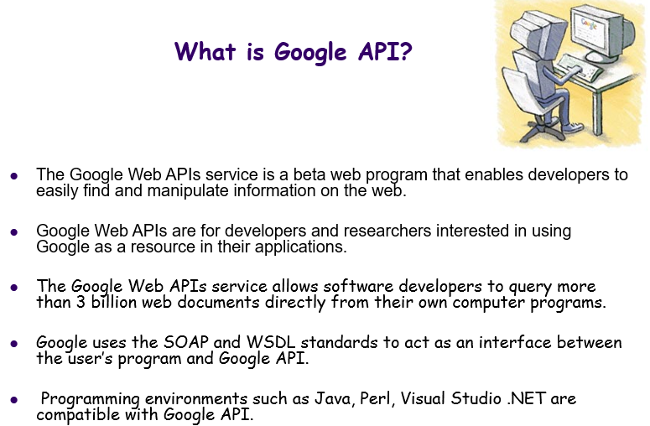

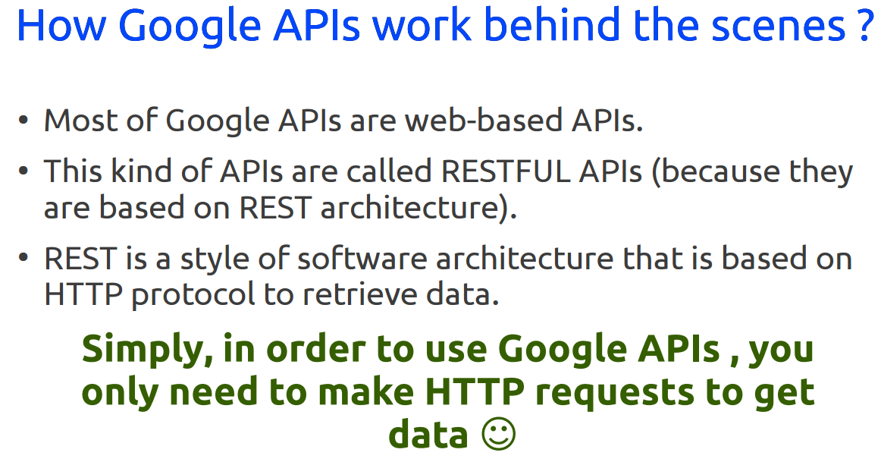

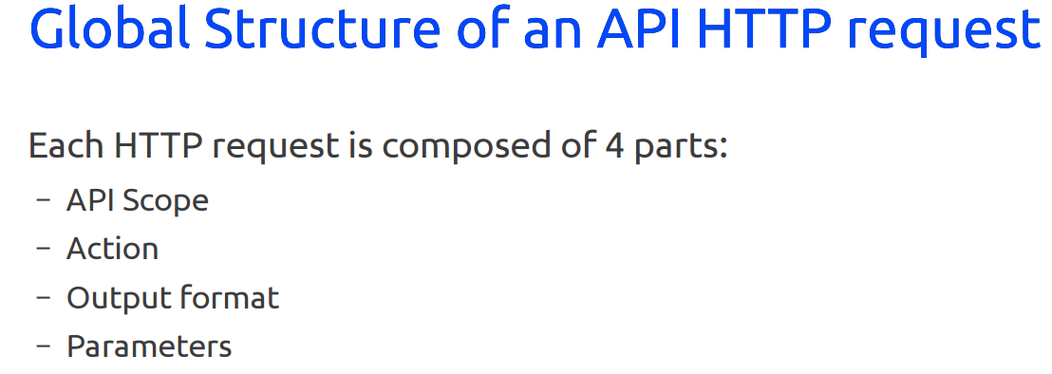

Details of each parts are as follows:

1. API Scope: Defines the Web address of the API.
2. Action: Which function call to be placed.
3. Output Format: JSON, XML
4. Parameter: What parameters to pass onto Action.

### There are 2 kinds of Google web APIs:

### – Public APIs:

● Interact with public content: Google Maps API, Google Places API.

● Need an authentication key to be able to retrieve data.

### – Private APIs:

● Interact with user private date: Google+ API, Google Latitude API, Google Drive SDK.

● Need an authorization process before accessing to user data.

Google APIs Client Libraries:

<https://developers.google.com/discovery/libraries?hl=en>

● Google created some libraries to do those tasks for you: It's Google API Client Libraries.

● Google API Client Libraries are available in many languages (e.g: PHP, Python, C# and .NET, Java ..)

### Example: Google Maps API

Google launched the Google Maps API in June 2005 to allow developers to integrate Google Maps into their websites. It is a free service, and currently does not contain ads, but Google states in their terms of use that they reserve the right to display ads in the future.

By using the Google Maps API, it is possible to embed Google Maps site into an external website, on to which site specific data can be overlaid. Although initially only a JavaScript API, the Maps API was expanded to include an API for Adobe Flash applications (but this has been deprecated), a service for retrieving static map images, and web services for performing geocoding, generating driving directions, and obtaining elevation profiles.

Let’s finish this session by watching how it works, the Google Map API Tutorial 1:

<https://www.youtube.com/watch?v=FuL-OX_O-vQ>

Key Take-Away:

* Creating the first map.
* Make adjustments to the parameters.
* Feel free to explore further, the other videos.

End-of-Class Module.

Questions? Please email to me, or post it on Blackboard.

Thank you.