## Schedule of Course Activities: Session 3

## *[CS 519: Introduction to Cloud Computing Online-Based]*

## *[Instructor: John C. Chan]*

|  |  |
| --- | --- |
| **Overview of Session** |  |
| We will answer the following questions: | 1. Review Cloud Computing, the latest. 2. Cloud Computing Trends. 3. Get a clearer view of the cloud. 4. … |

**Why Cloud Computing (Public) does NOT exist 10 years ago?**

* **Internet Speed/Access: It was a premium then, few can afford. Slow internet access is no fun!**
* **Storage: The notion of FREE storage was beyond common sense then. Yes, it is here today (almost 100% free…).**
* **Computing Power: This is less obvious. 10 years ago, the computing power of the computer servers (used in the data center) are not adequate to meet the large/concurrent demanding by so many different users.**
* **Freedom: Some governments are still paranoid about shared knowledge, share data, share resources. E.g. Google, YouTube…**
* **Internet Security: Both the software, and hardware infrastructures simply were NOT adequate to handle this 10 years ago.**
* **…**

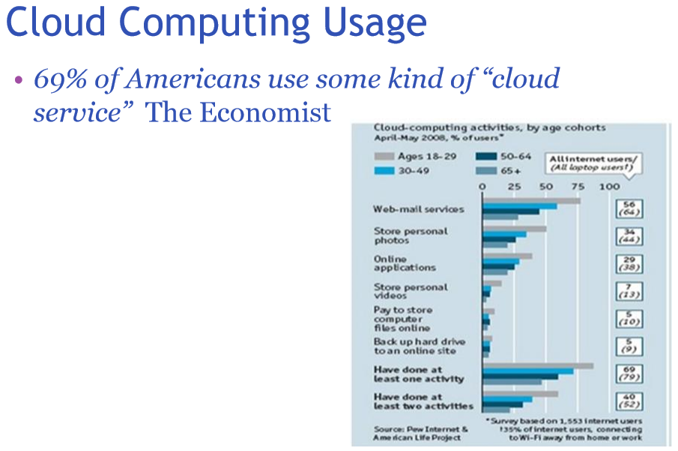

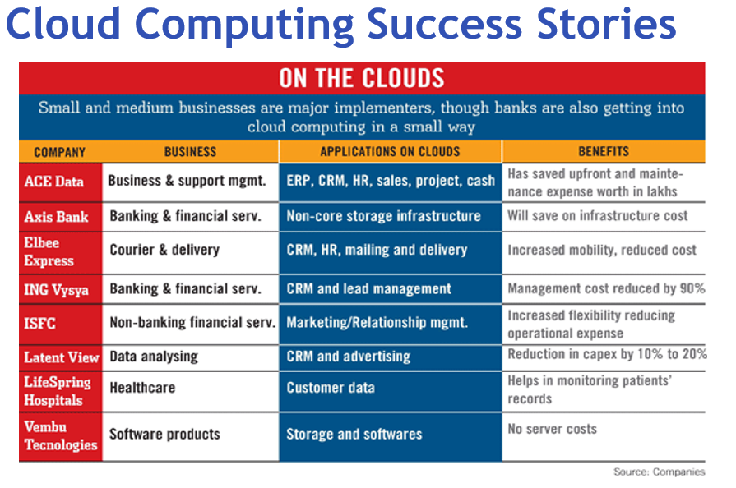

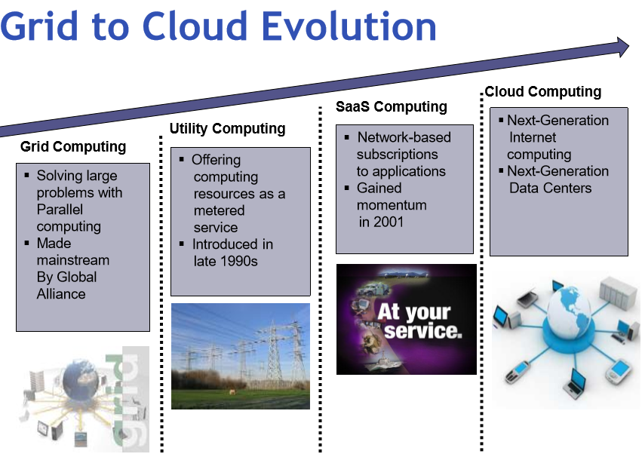

**NOTE:**

SaaS=”Software as a Service “, we are going to learn about it in more detail, later in the class.

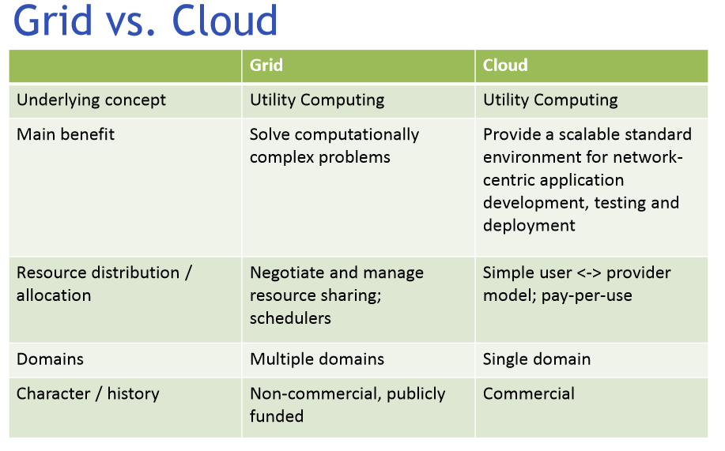

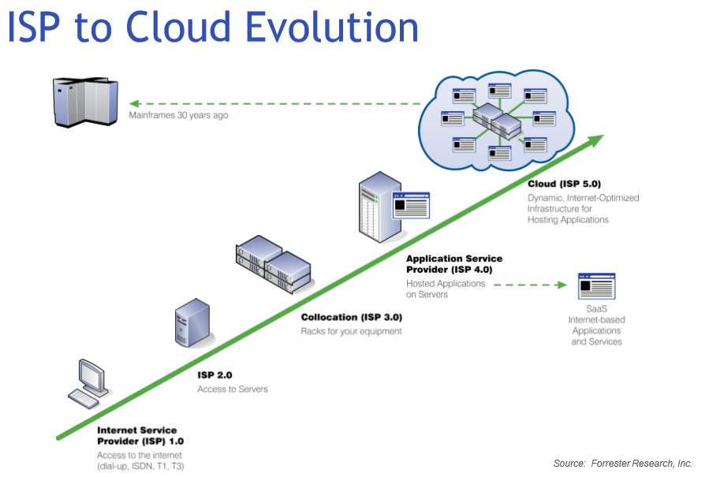

NOTES:

* ISP=”Internet Service Provider”. (This terminology is broaden to include Google, MS, Amazon etc, instead of just Comcast, AOL, ATT etc.)
* Please note the time-line of its progression. Cloud Computing: Are we going back to the Mainframe Computer Usage Model some 30+ years ago??? (Mainframe Usge Model: Schedule you computer appointment, fully watched/charged your session/activity time… Yike!...)

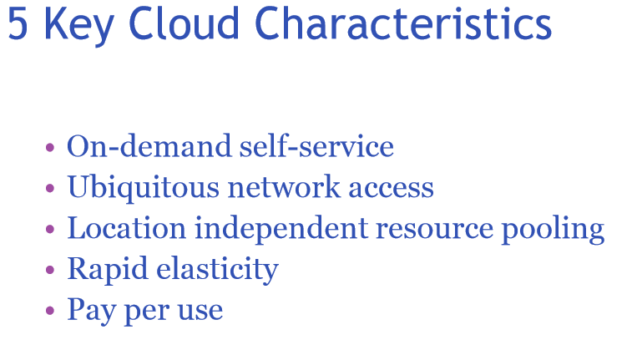

**An Architectural Over View of Cloud Computing:**

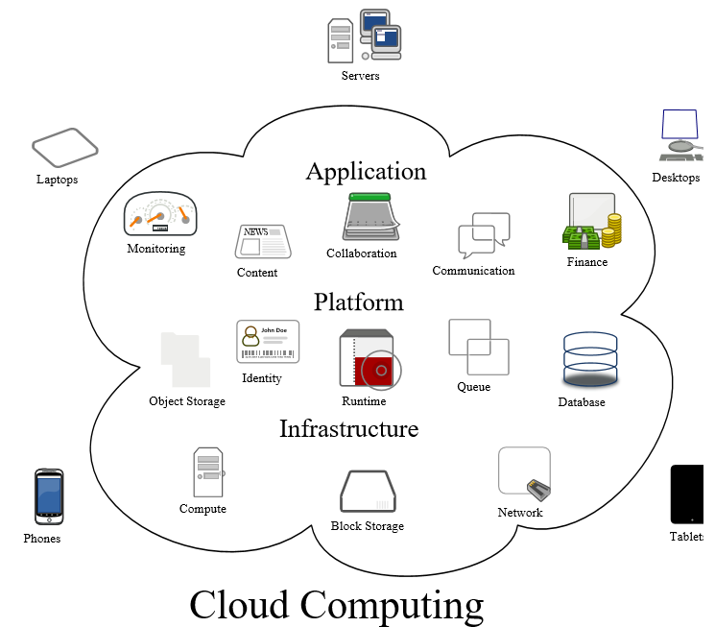

Outside the Cloud: Cloud Clients (Referring to the Picture):

Users access cloud computing using networked client devices, such as desktop computers, laptops, tablets and smartphones and any Ethernet enabled device such as Home Automation Gadgets.

*Cloud clients* – rely on cloud computing for all or a majority of their applications so as to be essentially useless without it.

Examples are thin clients and the browser-based Chromebook. Many cloud applications do not require specific software on the client and instead use a web browser to interact with the cloud application.

With Ajax and HTML5 these Web user interfaces can achieve a similar, or even better, look and feel to native applications.

Within the Cloud (Referring to the Picture): Virtualization

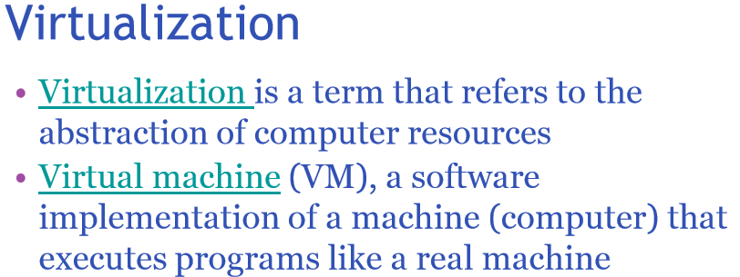

**Virtualization is another driving force behind Cloud Computing. It means, everything is Software Defined. Users is totally shielded from the underlying hardware resources.**

**This video explain the concept of Virtualization well:**

[**https://www.youtube.com/watch?v=7a0kCODjR7s**](https://www.youtube.com/watch?v=7a0kCODjR7s)

Key take-away:

* Better utilization of resources.
* Multiple virtual machines, on a single hardware machine.
* Manage only one hardware machine, lower operating cost.
* …

**In this class, we are going focus on**

**1) Infrastructure.**

**2) Platform.**

**3) Some aspects of Application.**

**(How can you know about the cloud, without looking into what is inside the cloud? Yogi Berra would say so!)**

End-of-Class Module.

Questions? Please email to me, or post it on Blackboard.

Thank you.