## Schedule of Course Activities: Session 4

## *[CS 519: Introduction to Cloud Computing Online-Based]*

## *[Instructor: John C. Chan]*

|  |  |
| --- | --- |
| **Overview of Session** |  |
| We will answer the following questions: | 1. Review Cloud Computing Service. 2. Important terminologies. 3. The major abstract layers. 4. … |

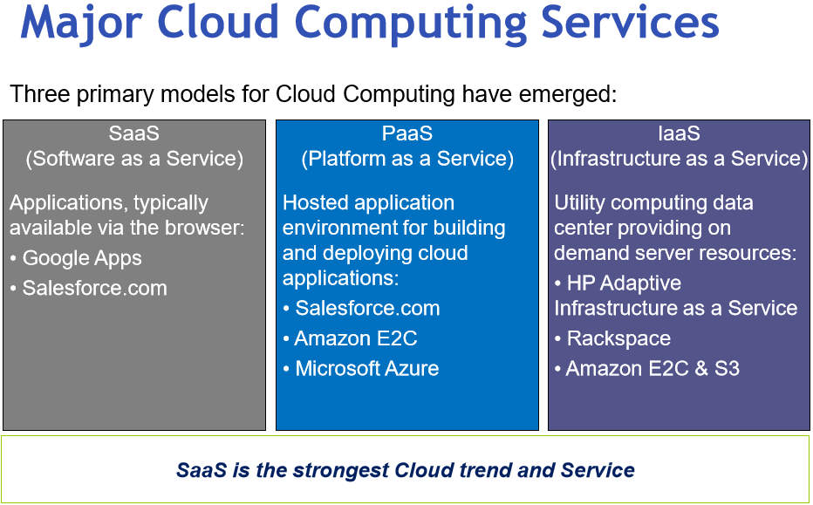

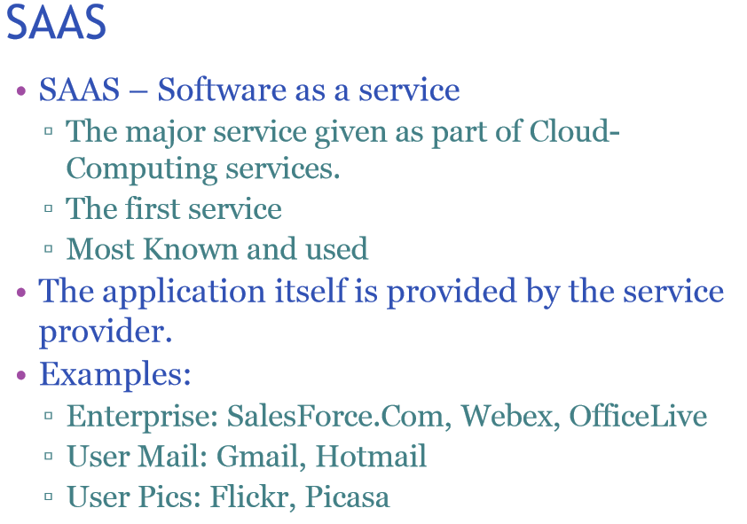

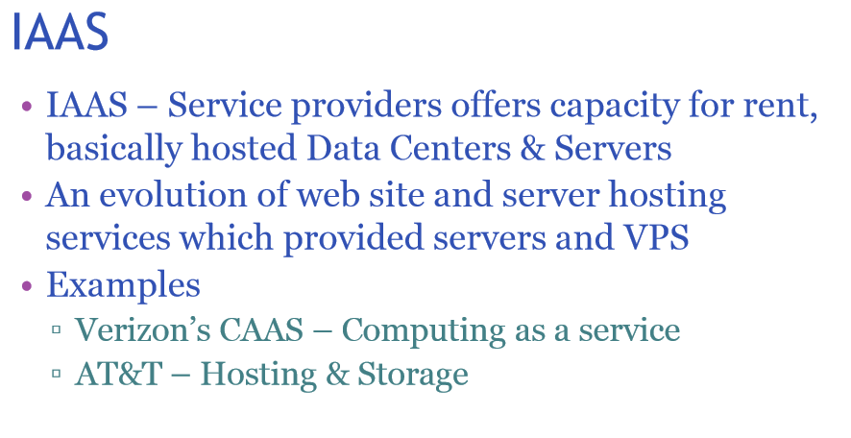

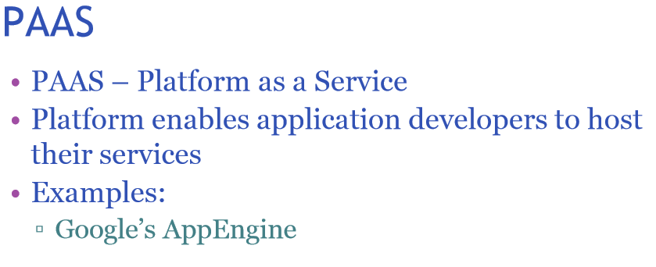

**Cloud Service Models: the definitions.**

### **Infrastructure as a service (IaaS):**

IaaS offer computers – physical or (more often) virtual machines – and other resources. Iaas refers to online services that abstract user from the detail of infrastructure like physical computing resources, location, data partitioning, scaling, security, backup etc.

Example of providers include VMWare, Oracle VrtualBox. Here the cloud operational system can support large numbers of virtual machines and the ability to scale services up and down according to customers' varying requirements.

### **Platform as a service (PaaS):**

PaaS vendors offers a development environment to application developers. The provider typically develops toolkit and standards for development and channels for distribution and payment.

In the PaaS models, cloud providers deliver a computing platform, typically including operating system, programming-language execution environment, database, and web server. Application developers can develop and run their software solutions on a cloud platform without the cost and complexity of buying and managing the underlying hardware and software layers.

Example: MobileApp Software Development Platform for Android Phones: <http://phonegap.com/>

### **Software as a service (SaaS):**

In the software as a service (SaaS) model, users gain access to application software and databases. Cloud providers manage the infrastructure and platforms that run the applications. SaaS is sometimes referred to as "on-demand software" and is usually priced on a pay-per-use basis or using a subscription fee.

Example: Flight/Trip Reservations.

**Other types of cloud services are shown next.**

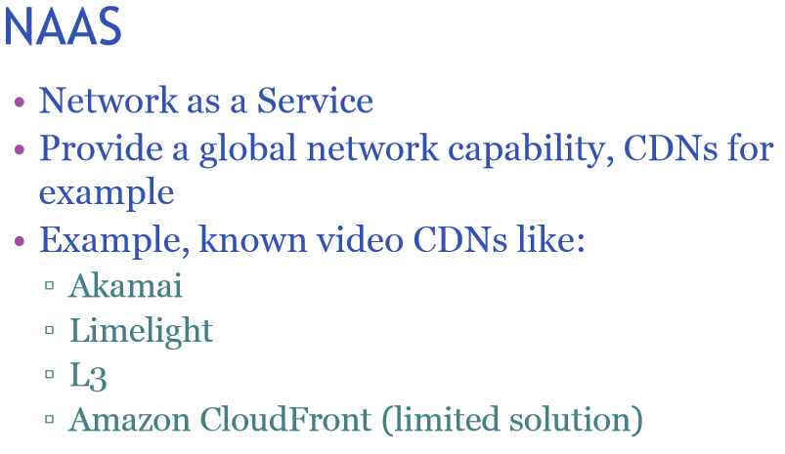

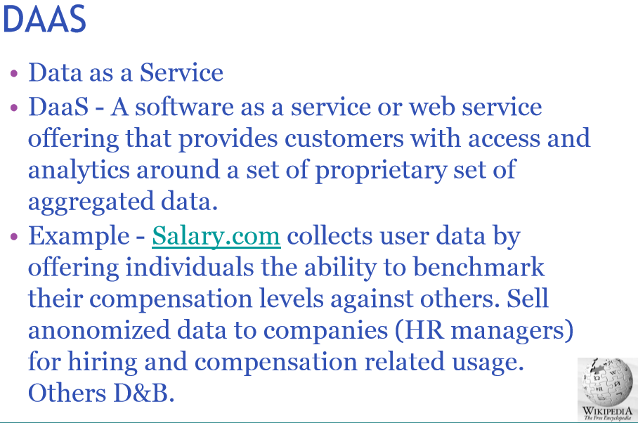

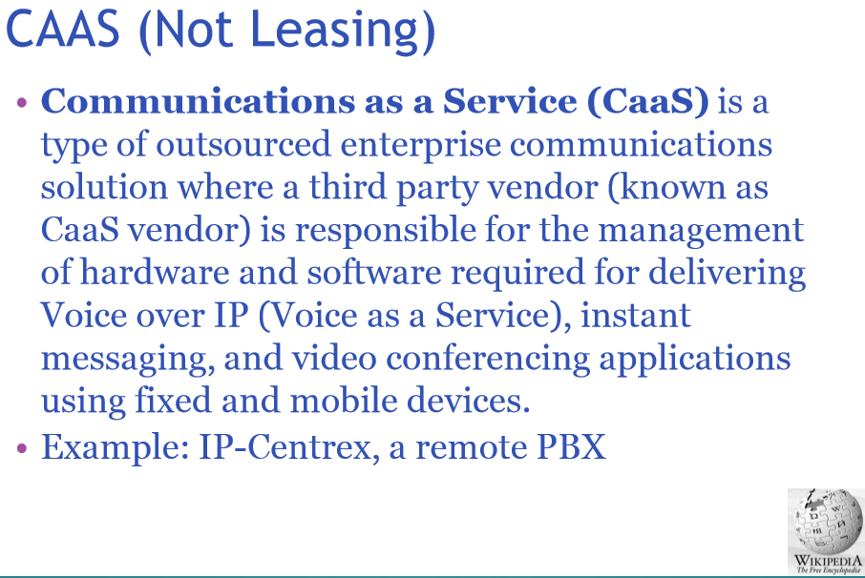

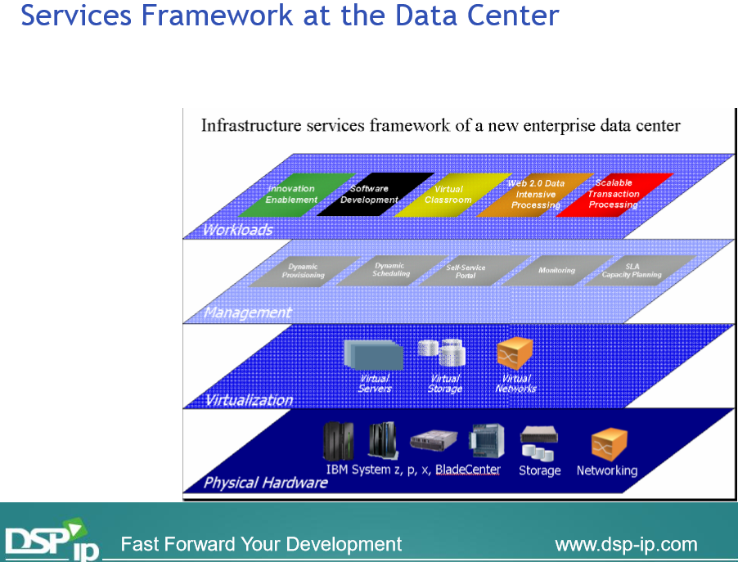

**Back to solid ground, this video explains cloud storage, from a user point of view (i.e. You and I can relate to, like storing files, phones in the cloud).**

[**https://www.youtube.com/watch?v=2vAzP5yegJE**](https://www.youtube.com/watch?v=2vAzP5yegJE)

Key take-away:

* Reliability.
* Security, encryption.
* Speed.
* Ease-of-use.

We are going to explore each of these subjects later in the class.

End-of-Class Module.

Questions? Please email to me, or post it on Blackboard.

Thank you.