## Schedule of Course Activities: Session 5

## *[CS 519: Introduction to Cloud Computing Online-Based]*

## *[Instructor: John C. Chan]*

|  |  |
| --- | --- |
| **Overview of Session** |  |
| We will answer the following questions: | 1. Review Cloud Computing Types. 2. Important terminologies. 3. The major players. 4. … |

**Cloud Models:**

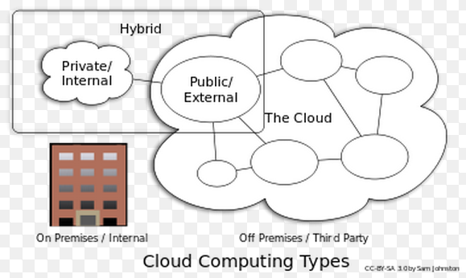

### Private Cloud**:**

Private cloud is cloud infrastructure operated solely for a single organization, whether managed internally or by a third-party, and hosted either internally or externally. Undertaking a private cloud project requires a significant level and degree of engagement to virtualize the business environment, and requires the organization to reevaluate decisions about existing resources.

Example of large organizations with its own private cloud: DoD, NASA, Large Pharmaceutical Companies. etc.

### Hybrid cloud**:**

Hybrid cloud is a composition of two or more clouds (private, community or public) that remain distinct entities but are bound together, offering the benefits of multiple deployment models. Hybrid cloud can also mean the ability to connect collocation, managed and/or dedicated services with cloud resources.

Example: IRS, Large Retail Organizations.

### Distributed cloud**:**

A cloud computing platform can be assembled from a distributed set of machines in different locations, connected to a single network or hub service.

Example: Facebook, Google YouTube.

**Deployment Model:**

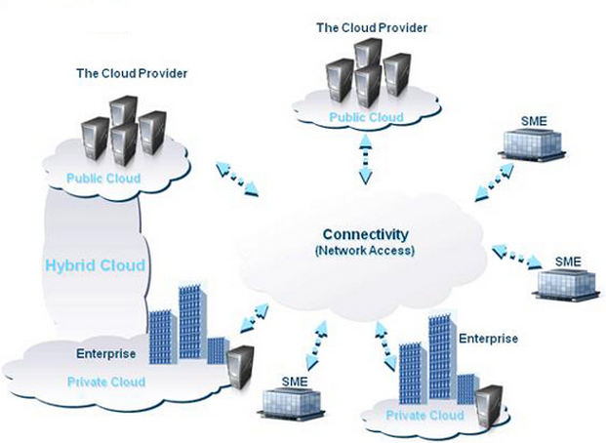

NOTE: SME stands for ”System Management Entity”

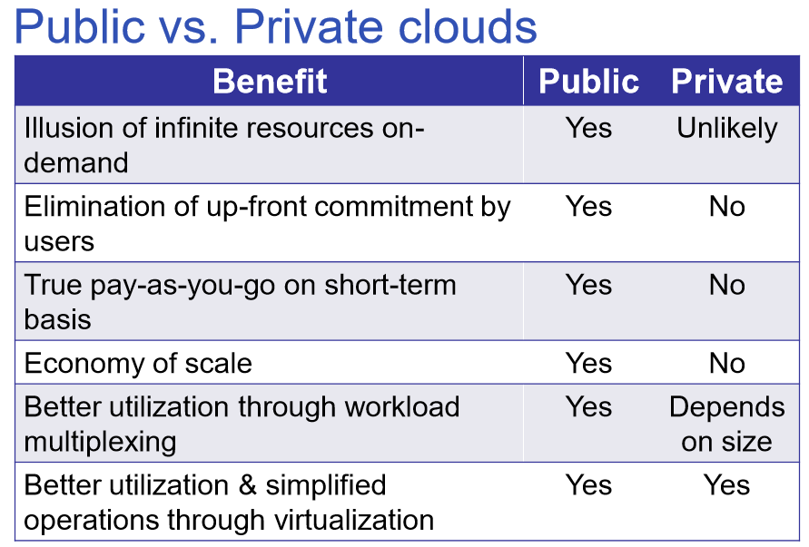

**In Corporate America today, the Cloud Deployment Model is more like below:**

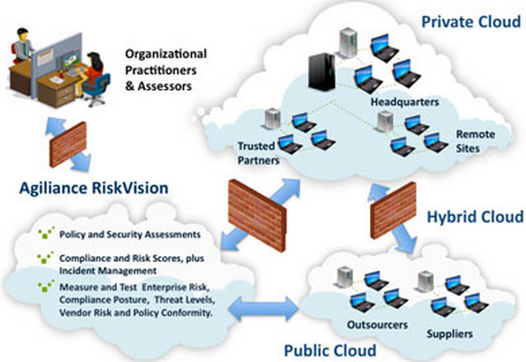

**Cloud Computing:**

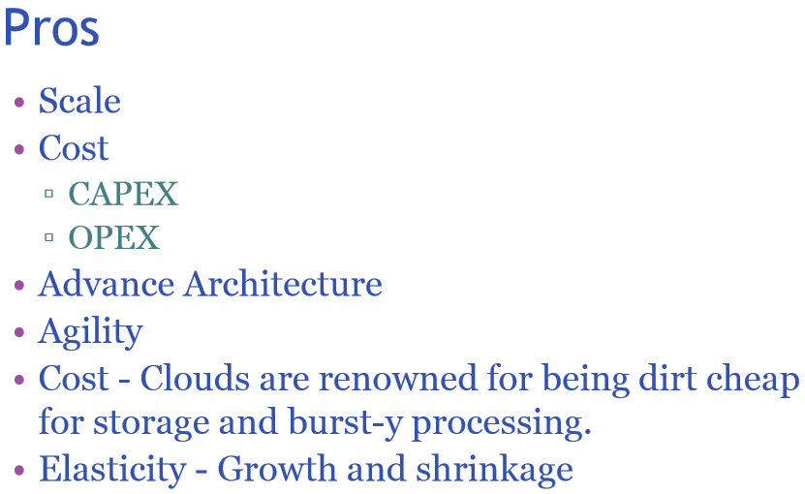

**Cloud Computing:**

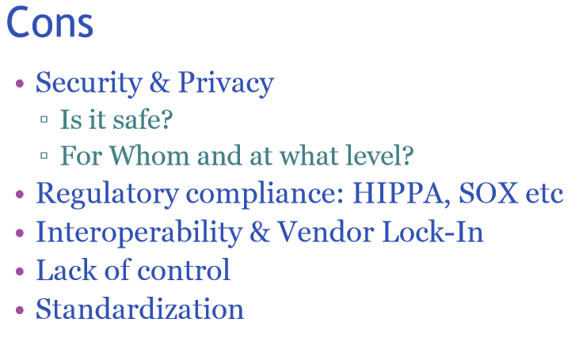

**Cloud Computing:**

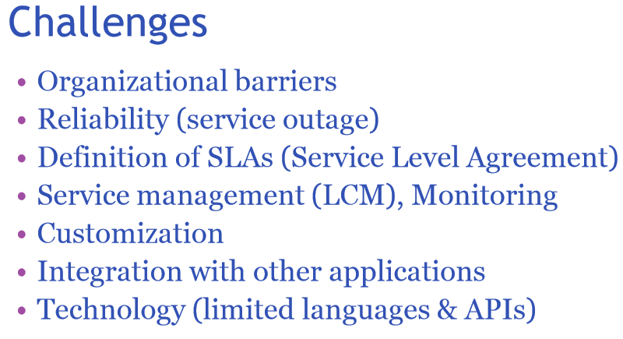

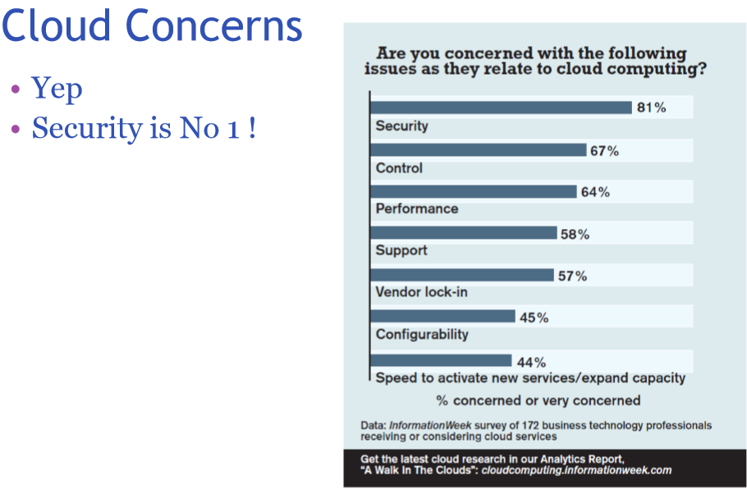

**The Major Public Cloud Player, and Service:**

* **Google: gmail, YouTube, Photos etc. You almost has unlimited free storage.**
* **Microsoft: Hotmail/livemail, SkyDrive, Azure.**
* **Amazon Web Service.**

**Class Exercise: Name another Public Cloud Service Provider?**

**We are going to explore Azure, AWS in more details. For now, get your thought together for the next video:**

[**https://www.youtube.com/watch?v=SgujaIzkwrE**](https://www.youtube.com/watch?v=SgujaIzkwrE)

**Key Take-Away:**

* **SaaS.**
* **Major players. Vendor Lock-in.**
* **Virtualizations.**
* **All cloud resources, is a SERVICE.**

**Class Assignment:**

**Is Cloud computing, a return to IBM’s mainframe computer mantra, where you have to sing-up, approved, usage charged in each computing session?**

End-of-Class Module.

Questions? Please email to me, or post it on Blackboard.

Thank you.