## Schedule of Course Activities: Session 6

## *[CS 519: Introduction to Cloud Computing Online-Based]*

## *[Instructor: John C. Chan]*

|  |  |
| --- | --- |
| **Overview of Session** |  |
| We will answer the following questions: | 1. Review Cloud Security Issues 2. Important terminologies. 3. … |

**Cloud Security:**



Cloud Security and Privacy**:**

Internet Security is an urgent issue to Cloud Computing. You hear news on the subject daily.

Cloud computing poses privacy concerns because the service provider can access the data that is on the cloud at any time. It could accidentally or deliberately alter or even delete information.

Examples of threats in the cloud: "Insecure Interfaces and API's", "Data Loss & Leakage", and "Hardware Failure".

Example of information leakage: Information for one customer is mistakenly given to other.

Physical control of the computer equipment (private cloud) is more secure than having the equipment off site and under someone else's control (public cloud). This delivers great incentive to public cloud computing service providers to prioritize building and maintaining strong management of secure services.

Some small businesses that don't have expertise in IT security could find that it's more secure for them to use a public cloud.

**We are going to explore this subject in further detail next.**

**There are many facts to the issue of Cloud Security:**

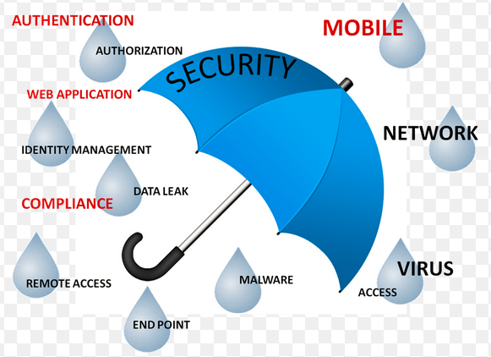

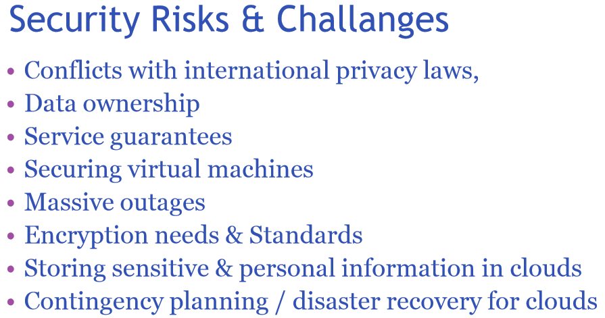

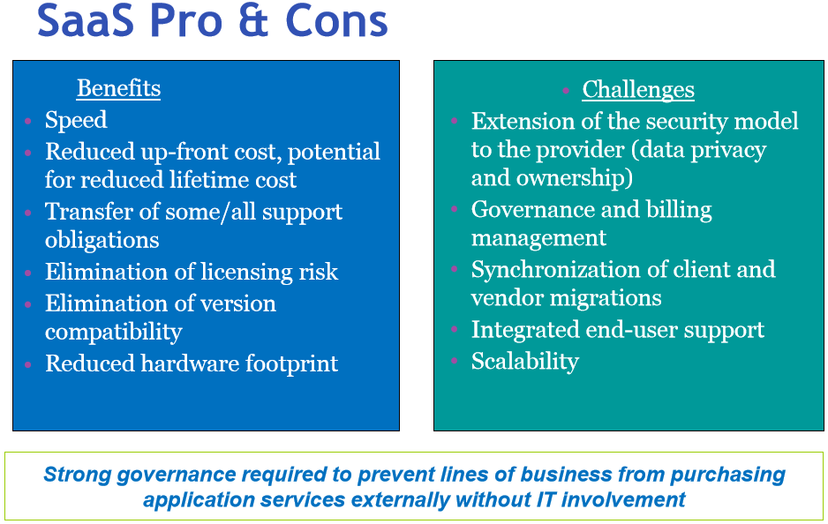

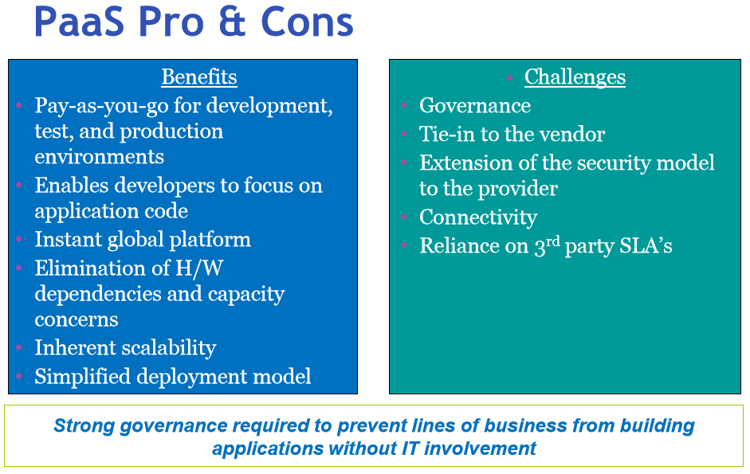

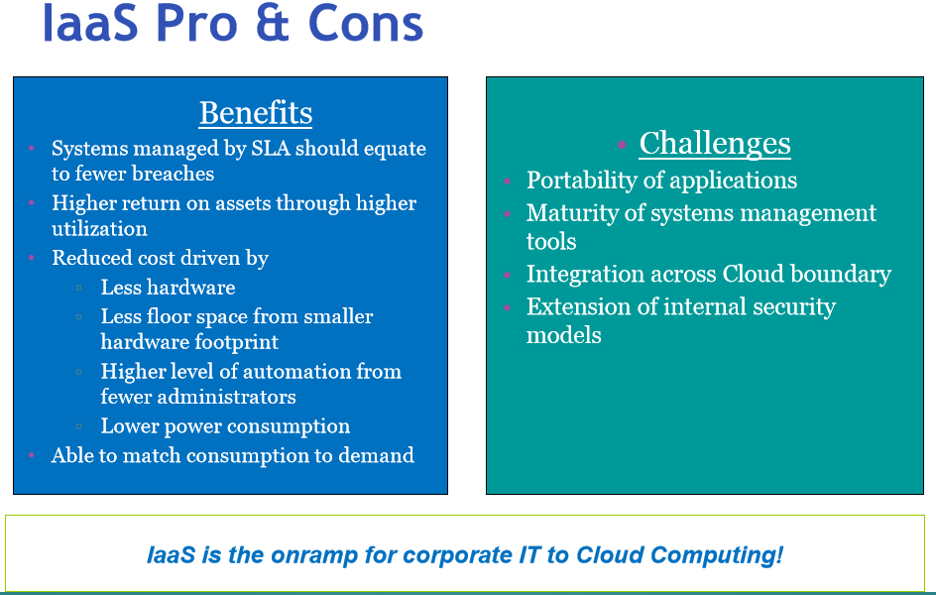

**Cloud Security Issue, Example 1:**

[**https://www.youtube.com/watch?v=L-cC-JjYos0**](https://www.youtube.com/watch?v=L-cC-JjYos0)

**Key take-away:**

* **Apps that has malicious viruses.**
* **Solution: Monitor the cloud, who is responsible for the offense.**
* **Password compromise, a simple case.**
* **Security is a journey …**

**Class Assignment: Has your password ever being compromised? What was your experiences like?**

**Cloud Security Issue, Example 2:**

[**https://www.youtube.com/watch?v=t8AuXEjBzjI**](https://www.youtube.com/watch?v=t8AuXEjBzjI)

**Key take-away:**

* **Types of security threats: Outsider, Insider, End User.**
* **Insider: background check, limit trust, limit usage time…**
* **Data Breach; Data center access protocol. Data encryption.**
* **Data Loss: Backup, recovery.**
* **Shadow IT, e.g. file sharing.**
* **Account Credential Compromise.**

**Any Best-Known-Methods on making your cloud compute experience secure? Please share it to the class!**

End-of-Class Module.

Questions? Please email to me, or post it on Blackboard.

Thank you.