## Schedule of Course Activities: Session 7

## *[IS 519: Introduction to Cloud Computing Online-Based]*

## *[Instructor: John C. Chan]*

|  |  |
| --- | --- |
| **Overview of Session** |  |
| We will answer the following questions: | 1. Cloud migration, and its issues 2. Challenges in the migration. 3. Migration considerations 4. … |

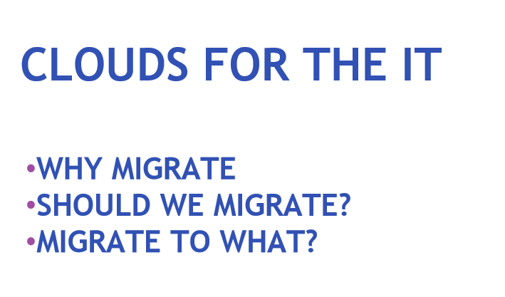

**We are going to explore this subject in further detail next.**

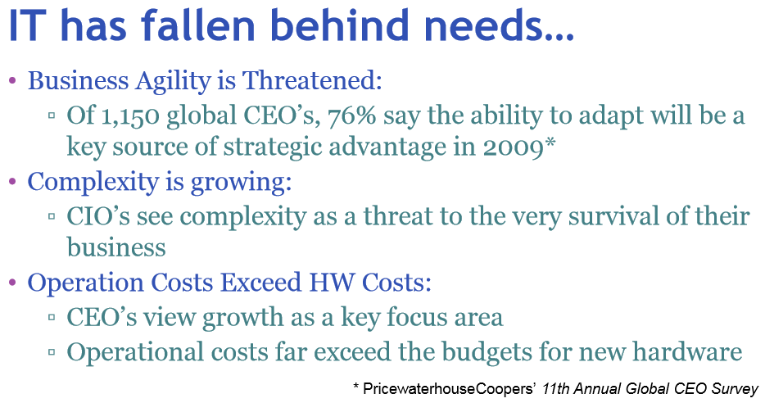

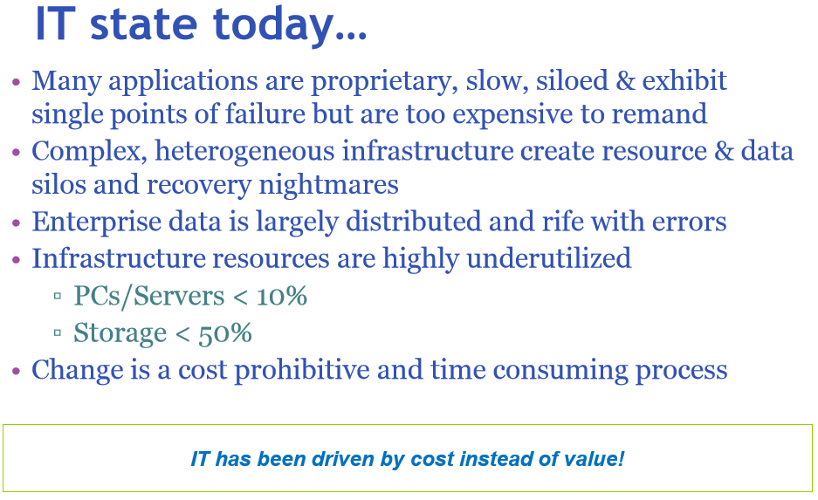

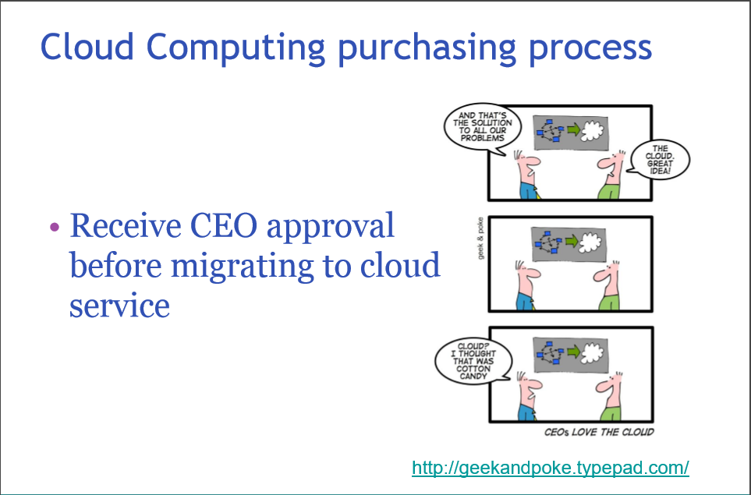

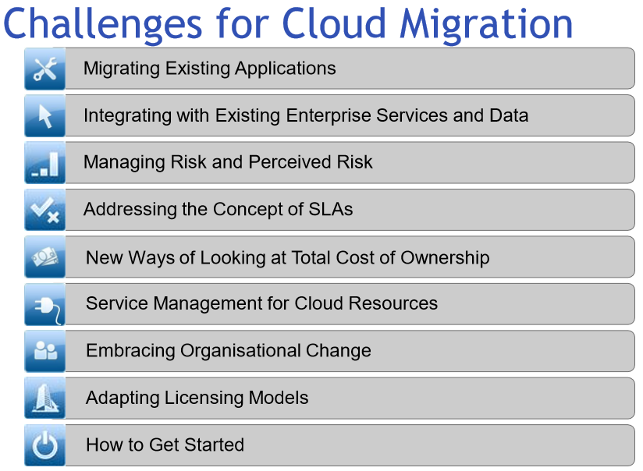

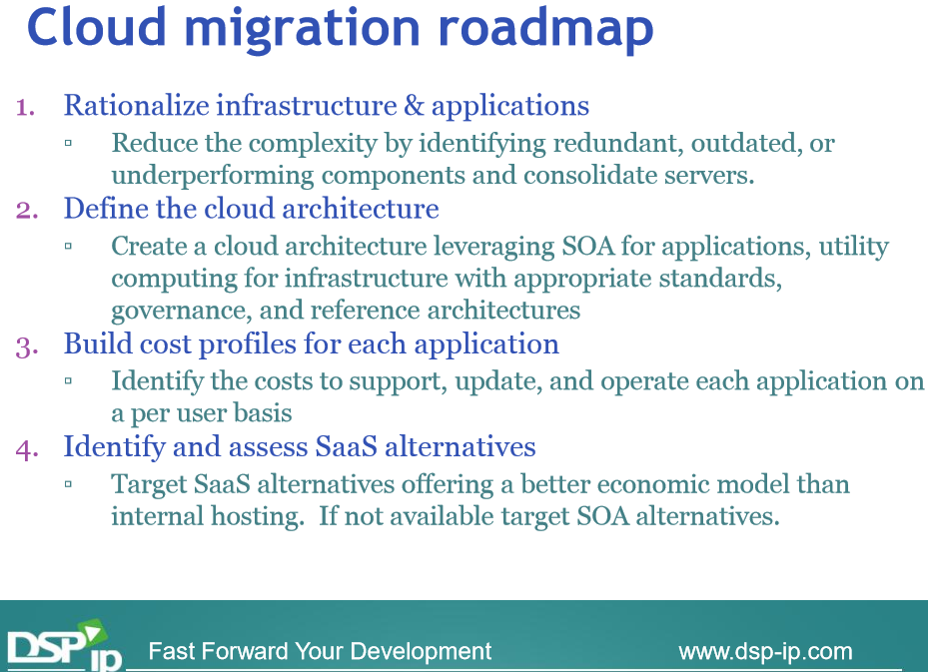

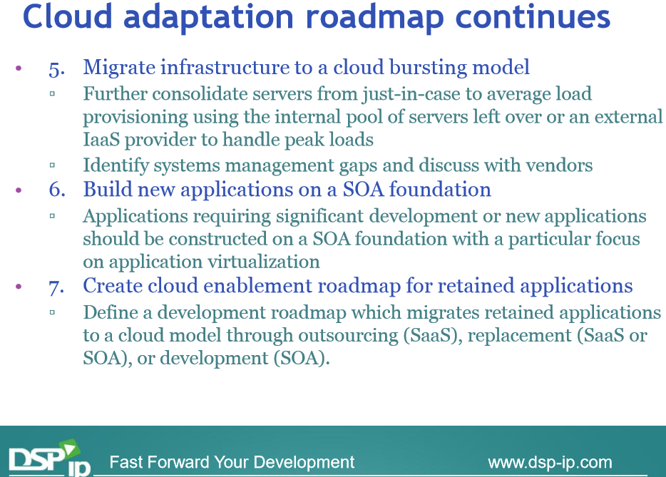

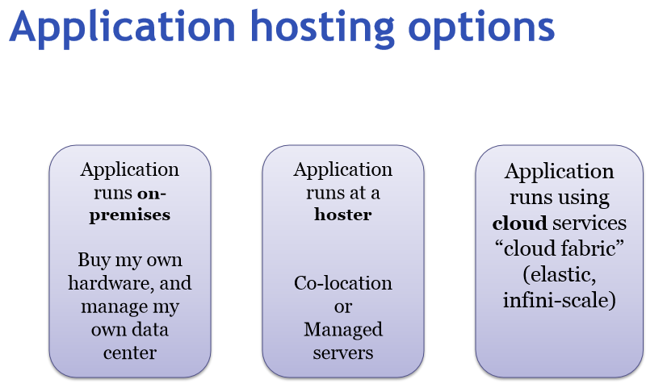

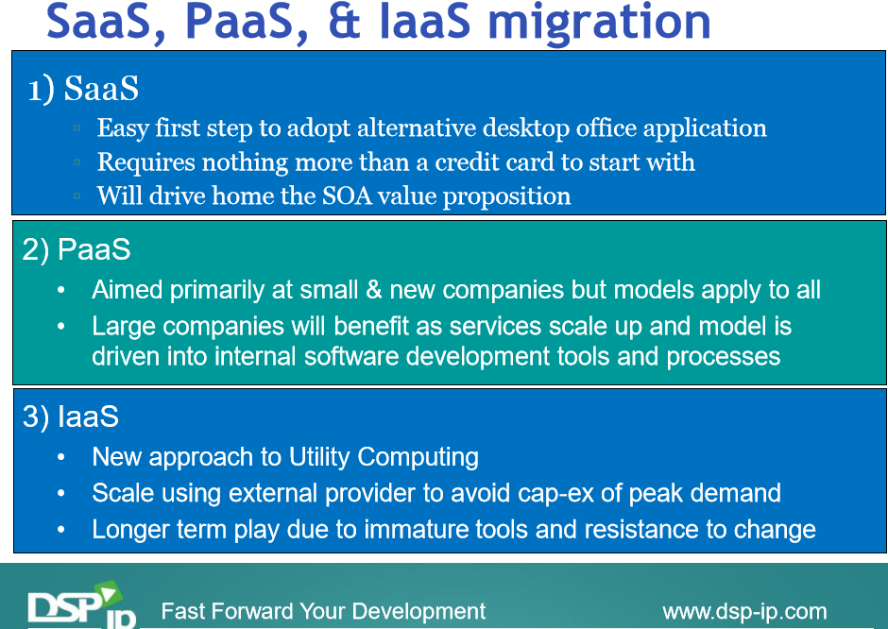

**Migration to the cloud is a complex under taking. Start-up companies are born and exists to serve this need. What we have learned so far, is a high level perspectives only.**

**This video shown next, wraps up the presentation of this module well (enjoy).**

[**https://www.youtube.com/watch?v=sEywo-eMTEU**](https://www.youtube.com/watch?v=sEywo-eMTEU)

**Key Take-Away:**

* **Anticipate resistance to risk taking, that of cloud migration.**
* **Cloud migration, the analogy to that of moving, the moving truck…**
* **The nuts, and bolts of IT apprehensions.**
* **IaaS migration, to that of renting a new car, good comparison, but may NOT be your 1st migration step. SaaS is a better 1st step, to get your feet’s wet.**

**Class Assignment: In the corporate world, do you think cloud migration is a piece by piece step-process; or that of cut loose of the bad IT, and start fresh with the latest/greatest Cloud Computing?**

End-of-Class Module.

Questions? Please email to me, or post it on Blackboard.

Thank you.