## Schedule of Course Activities: Session 8

## *[CS 519: Introduction to Cloud Computing Online-Based]*

## *[Instructor: John C. Chan]*

|  |  |
| --- | --- |
| **Overview of Session** |  |
| We will answer the following questions: | 1. Introduction to Could Hardware Infrastructure. 2. General concept of data center. 3. … |

**Inside of a Data Center:**

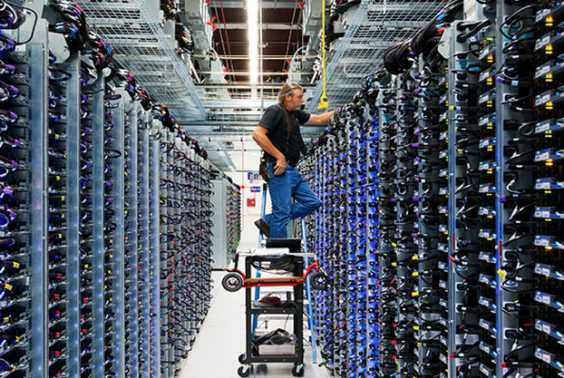

**What is data center?**

A **data center** is a facility used to house computer systems and associated components, such as telecommunications and storage systems. It generally includes redundant or backup power supplies, redundant data communications connections, environmental controls (e.g., air conditioning, fire suppression) and various security devices. Large data centers are industrial scale operations using as much electricity as a small town.

**Google Data Center, as an example:**

[**https://www.youtube.com/watch?v=XZmGGAbHqa0**](https://www.youtube.com/watch?v=XZmGGAbHqa0)

**Key Take-away:**

* **Security: Both physical and information securities.**
* **Google’s data center operates at 80 degree Fahrenheit’s. What happen if there is no thermal control?**
* **What happen is a disk drive fail?**
* **Do you really want to work in a data center?**
* **…**

**Thought provoking questions:**

* **It is very expensive to create, and operate a data center (just power usage alone). How does Google, or others make a profit?**
* **Data center, are located in area where electricity is plentiful, and cheap (e.g. near a hydro-electrical dam). Is the thermal issue in cloud computing, the next frontier of data center?**
* **Is cloud computing, as fluffy like you thought…?**

**Class Assignment: What is a rack in a data center? What does a rack host?**

**Data Center Considerations:**

A data center can occupy one room of a building, one or more floors, or an entire building. Most of the equipment is often in the form of servers mounted in 19 inch rack cabinets, which are usually placed in single rows forming corridors (so-called aisles) between them. This allows people access to the front and rear of each cabinet. Servers differ greatly in size from 1U servers to large freestanding storage silos which occupy many square feet of floor space. Some equipment such as mainframe computers and storage devices are often as big as the racks themselves, and are placed alongside them. Very large data centers may use shipping containers packed with 1,000 or more servers each;when repairs or upgrades are needed, whole containers are replaced (rather than repairing individual servers).

**Example of a rack seen in data center:**

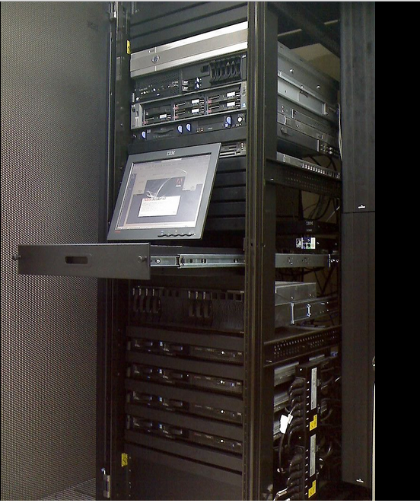

**NOTES:**

* **A rack can host server, storage clusters, and the networking equipment.**
* **A rack is finely partition into units. The smallest unit is 1U. Any computer server, storage node, network gear, must fit within this form factor.**
* **Exact dimension of 1U is NOT standardized among the hardware suppliers. But a good reference is: 19" x 1.75" x 17.7"**

**There are massive cabling, interconnectivity going-on, within the rack, and its peripheries, as seen in the photos shown next.**

**Photo of cabling on the backside of a rack:**

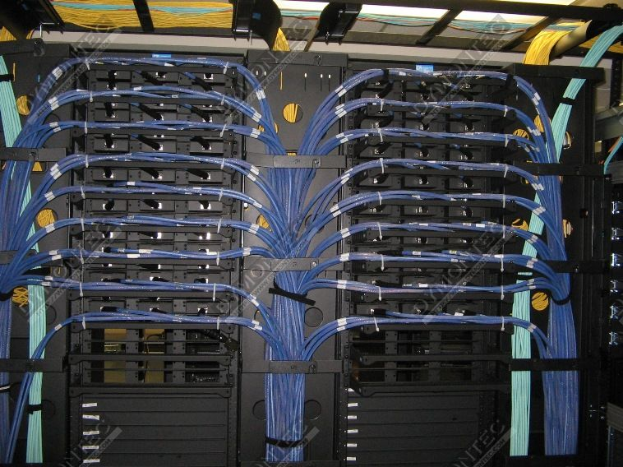

**Under Floor Cable Runs that feeds the rack:**

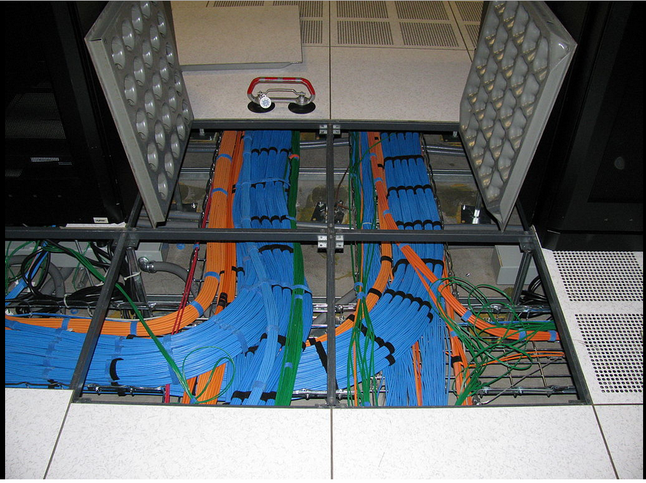

**NOTES:**

* **Cables are usually colored coded, so it is tidy, and minimize mistakes.**
* **What if an un-authorized person, enter the data, and swap the cable connections? This can cause a huge disrupt to the data center! (This is one of the many reasons data center access is so strict!)**

**What are common types of cables on the back of a rack?**

* **Power cords (Notes: there are different power supply needs, voltage domains etc).**
* **Ethernet cables. (Both electrical, and optical).**
* **Storage Network Cables (e.g. Infiniband cables).**
* **Display port cables.**
* **Your usual PC cables.**
* **Serial port cables.**
* **…**

**In fact, a data center operator‘s top skill, is his/her cabling expertise. An example is shown next.**

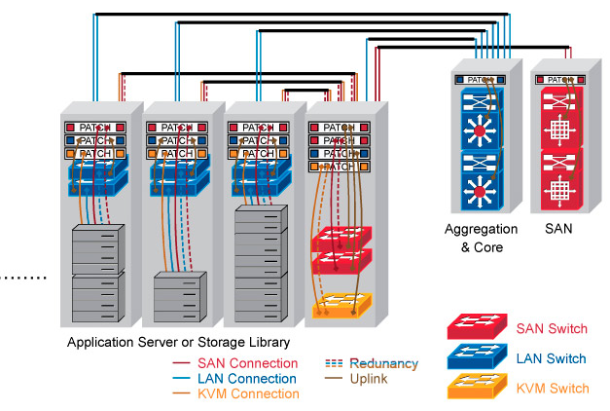

**This is an example of how data storage nodes are clustered together, to support large data storage (“Big Data”).**

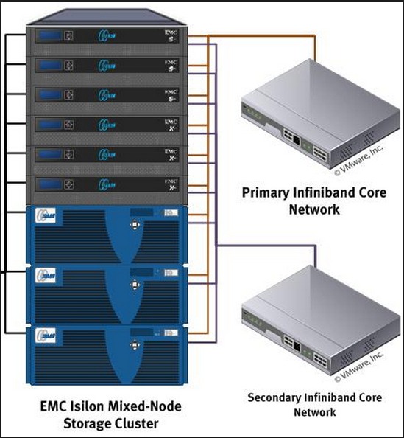

End-of-Class Module.

Questions? Please email to me, or post it on Blackboard.

Thank you.