## Schedule of Course Activities: Session 9

## *[IS 519: Introduction to Cloud Computing Online-Based]*

## *[Instructor: John C. Chan]*

|  |  |
| --- | --- |
| **Overview of Session** |  |
| We will answer the following questions: | 1. Major corporate players in cloud computing. 2. Over view of the services provided by the players. 3. … |

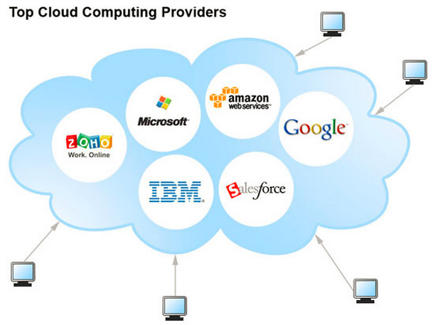

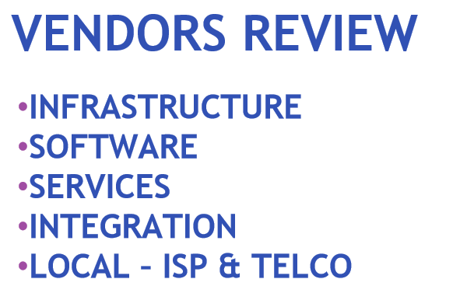

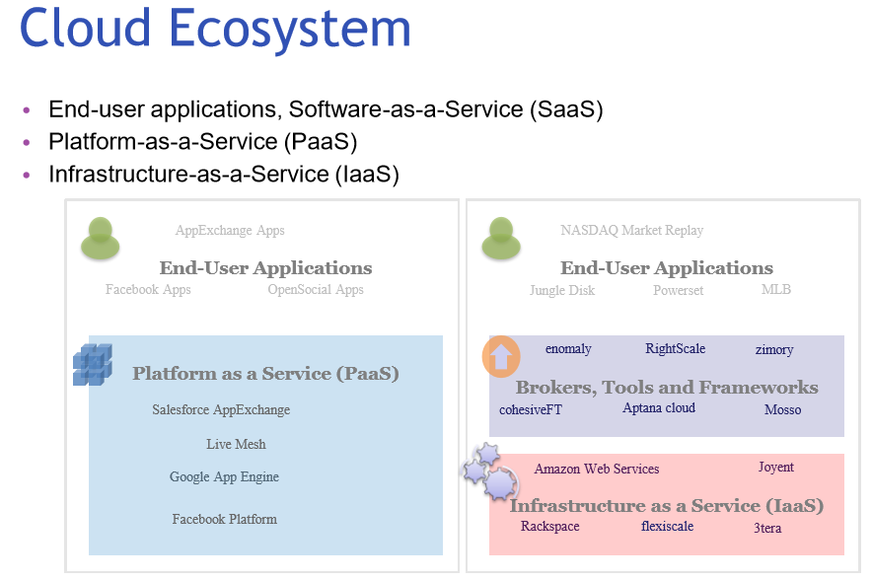

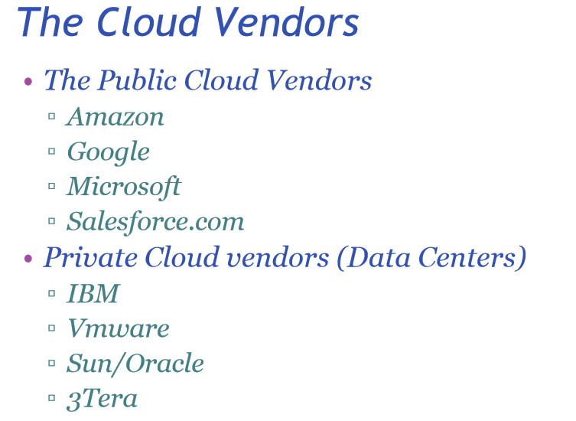

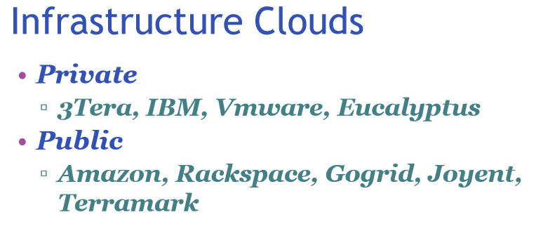

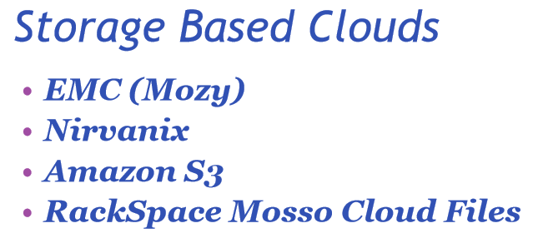

**Lastly, the service providers. These are the companies like AT&T, Verizon, Centry-Link etc. They are the ones that operate the internet backbone. This video explains their role to cloud computing.**

[**https://www.youtube.com/watch?v=qX3jTM3dbN8**](https://www.youtube.com/watch?v=qX3jTM3dbN8)

**Key Take-Away:**

* **Service providers, Telco companies owns network, storage infrastructure.**
* **Service providers ensures cloud operations reliability, performance etc.**
* **The cloud eco-system depends on their role.**

**Class Assignment: Google is testing/deploying high speed internet access on selected cities in the US. Do you think one day, it may replace Telco companies, like AT&T?**

End-of-Class Module.

Questions? Please email to me, or post it on Blackboard.

Thank you.