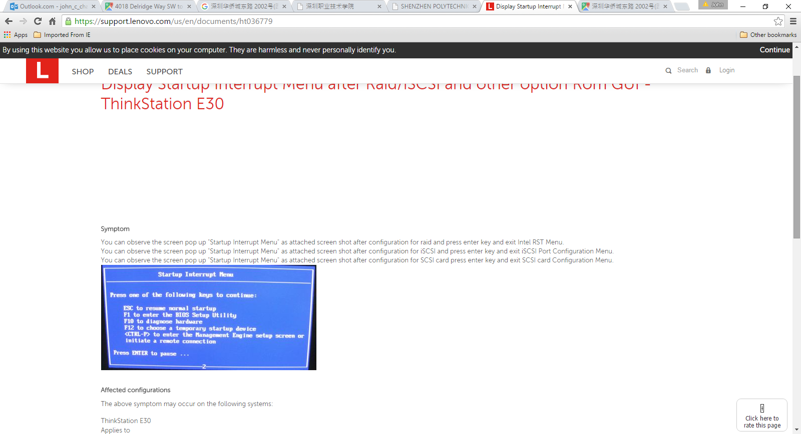

Bing Search of Boot interrupts

Lenovo: Properties, to find memory.

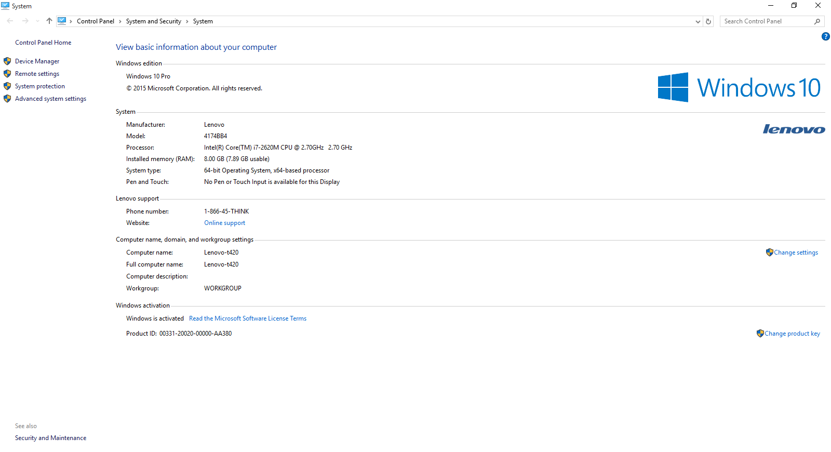

SSD Disk Space.

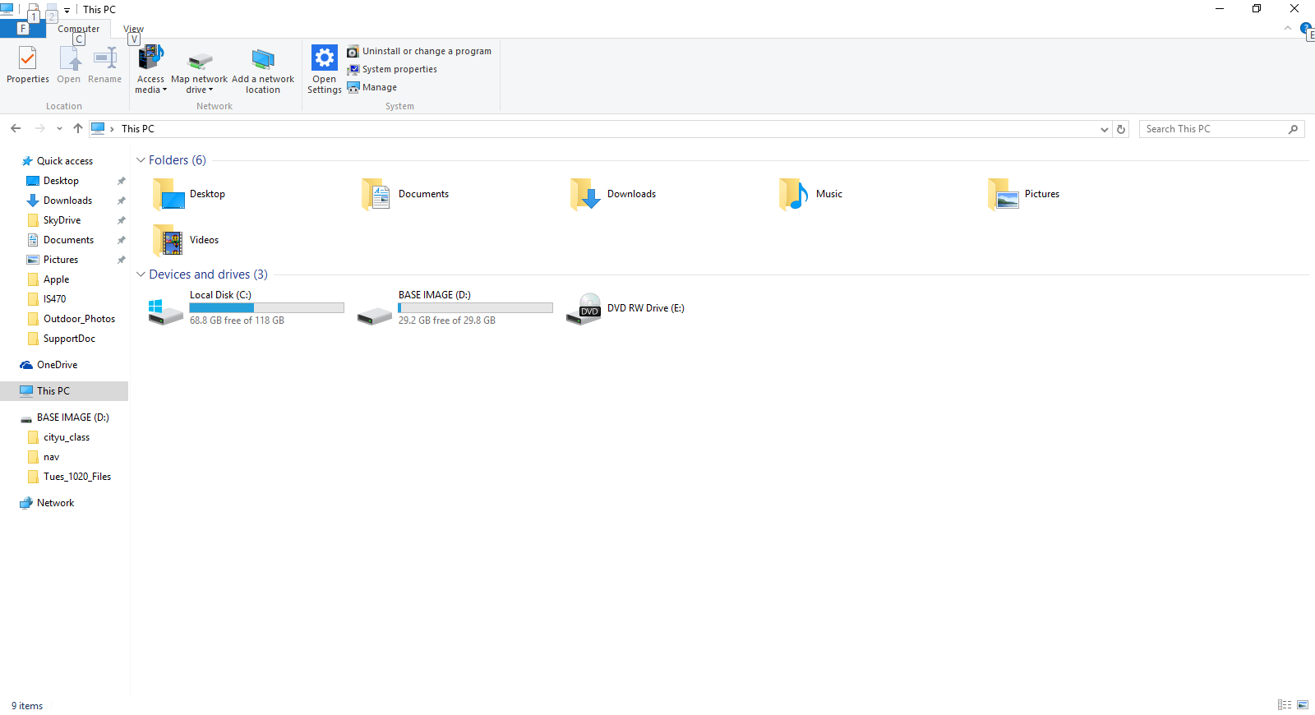

Bing Search human Arterial Pulse reading information

About Shenzhen Products:

<http://www.smife.cn/p_show.asp?id=234>

Bing search: images of serial port

Snipping tool

Regular Expression Test:

<http://regexpal.com/>

.\*Shenzhen$

This is Shenzhen

Another github visit, and Linux:

<https://github.com/jlevy/the-art-of-command-line>