In this class project, we are going to explore the idea of migrating our IT to the Cloud Computing.

**Phase 1: Team Charter (Team):**

Students will form teams for work on group assignments. The charter will contain at a minimum the following sections:

1. Statement of Need (Current State and Future State)

2. Approach Strategy.

3. Scope.

4. Project Deliverables,

5. Work Breakdown Structure.

6. Timeline.

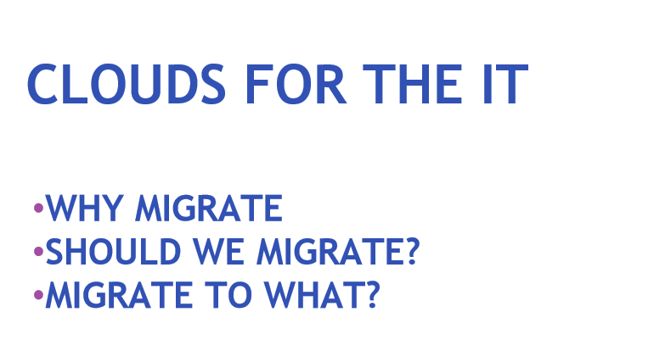

# 

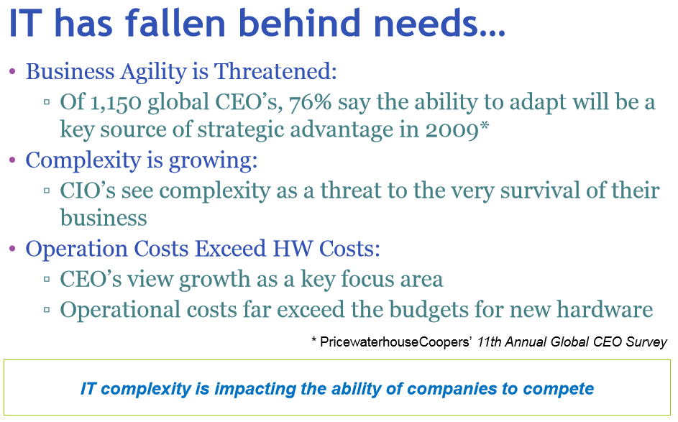

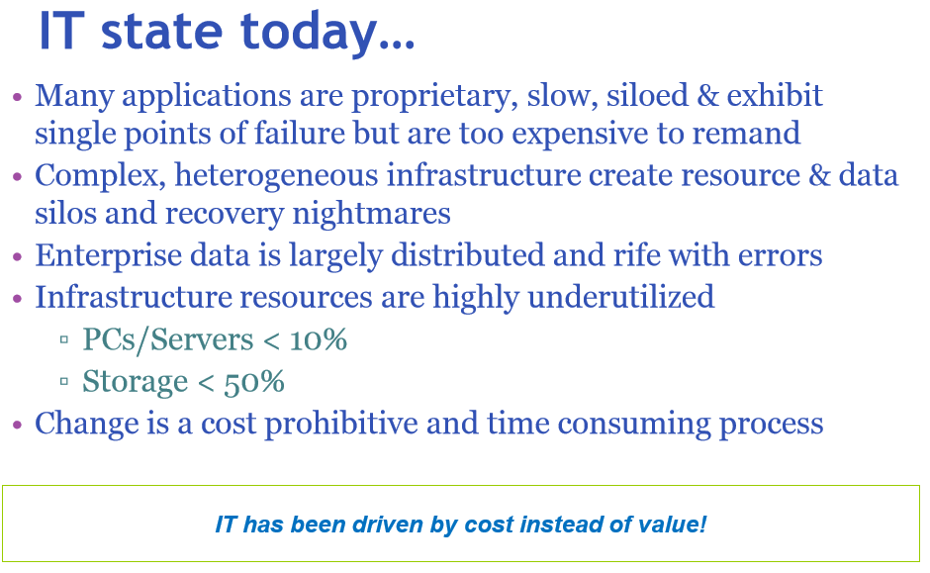

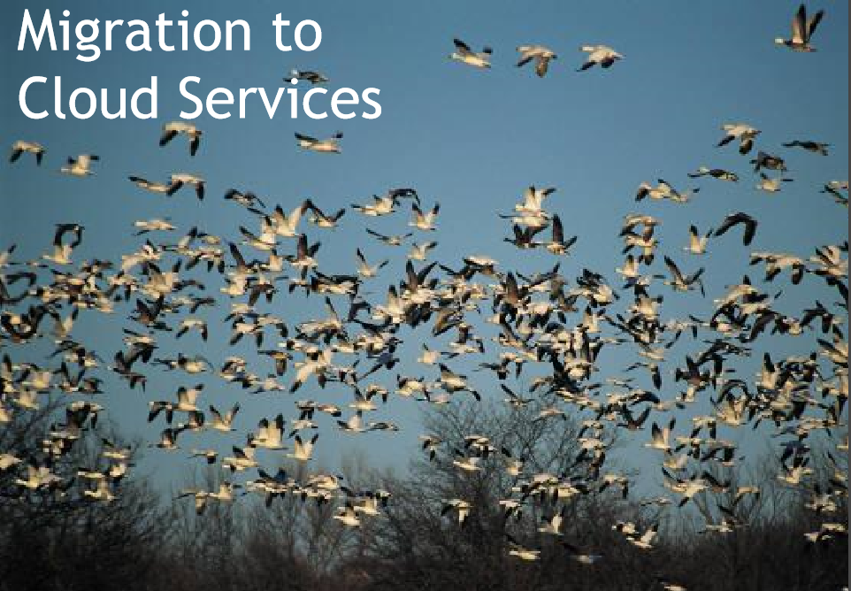

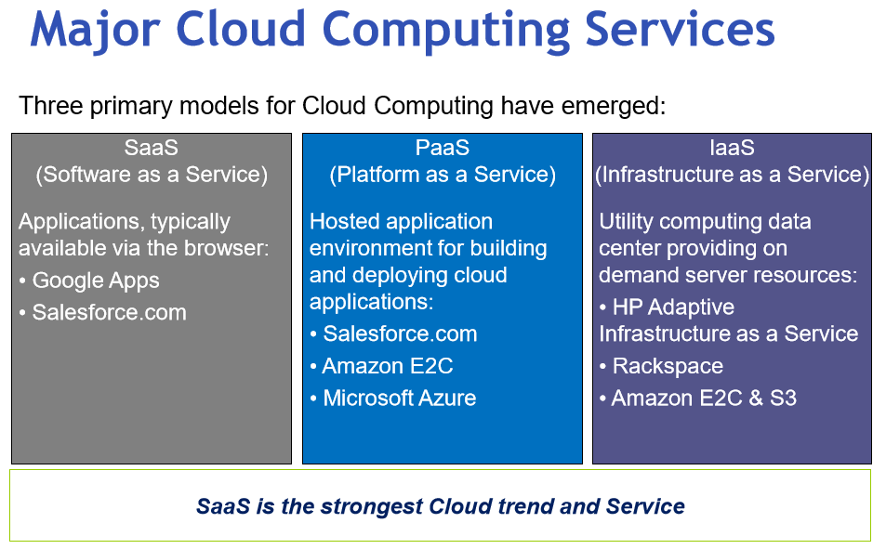

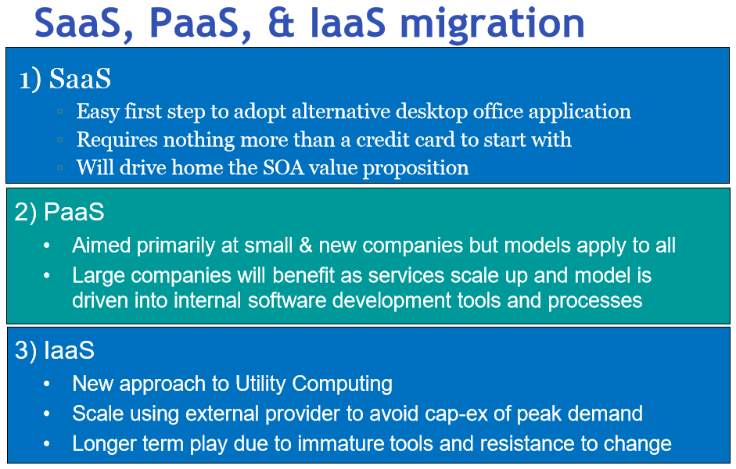

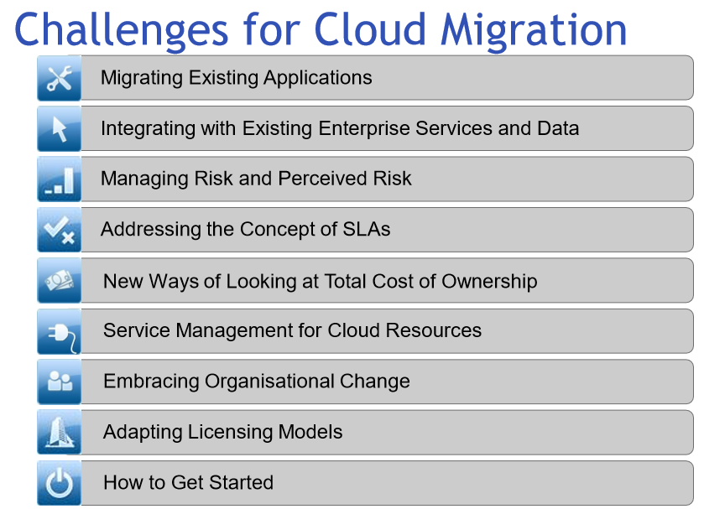

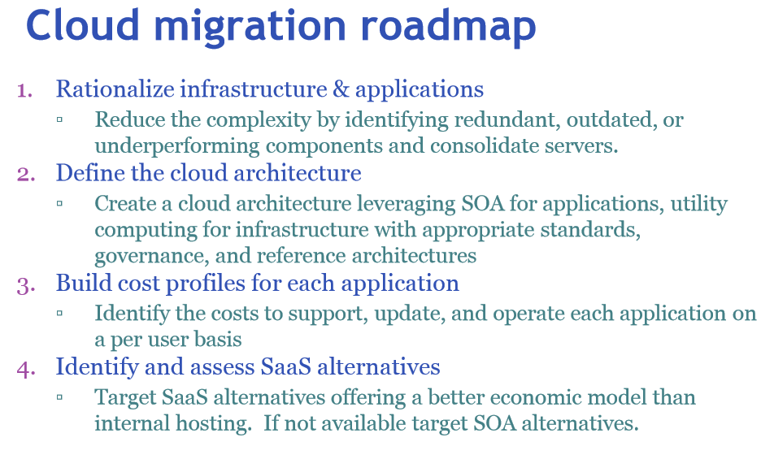

SOA: Service Oriented Architecture.

