[Reminder: Where are we?]

|  |  |
| --- | --- |
| **Core phase** | **Sub-processes and functions** |
| Service Strategy | 1. Financial Management  2. Service Portfolio Management  3. Demand Management  4. Strategy Generation |
| Service Design | 1. Service Level Management  2. Capacity Management  3. Availability Management  4. IT Service Continuity Management  5. Service Catalogue Management  6. Supplier Management  7. Information Security Management |
| Service Transition | 1. Change Management  2. Service Asset and Configuration Management  3. Release and Deployment Management  4. Service Validation and Testing  5. Evaluation  6. Knowledge Management  7. Transition Planning and Support |
| Service Operation | 1. Incident Management  2. Problem Management  3. Event Management  4. Request Fulfilment  5. Access Management  6. Service Desk Function  7. Technical Management Function  8. Application Management Function  9. IT Operations Management Function |
| Continual Service Improvement | 1. Seven-Step Improvement Process |

The Overall Picture:

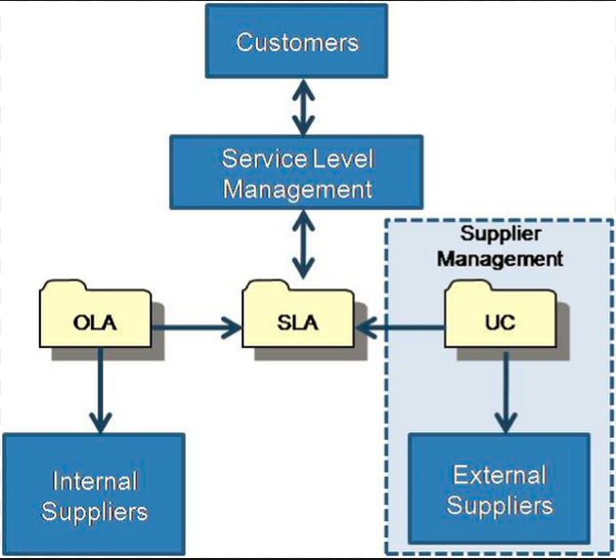

Service Level Management

* Service Level Agreement
  + Operational Level Agreements
    - Internal
  + Underpinning Contracts
    - External Organisation
    - Supplier Management
  + Can be an annexe to a contract
  + Should be clear and fair and written in easy-to-understand, unambiguous language
* Success of SLM (KPIs)
  + How many services have SLAs?
  + How does the number of breaches of SLA change over time (we hope it reduces!)?

**SLM, and SLA Usage models:**

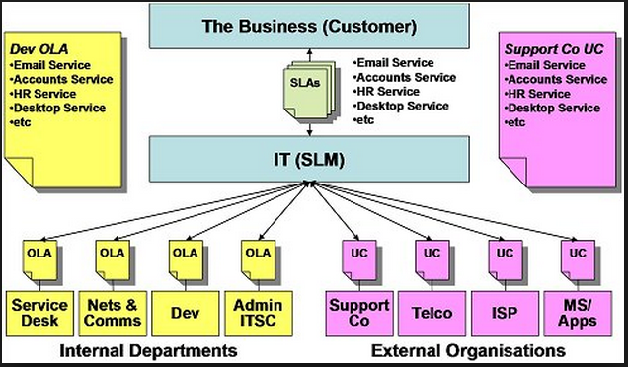

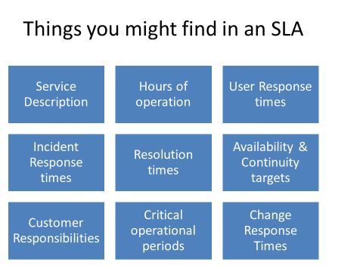

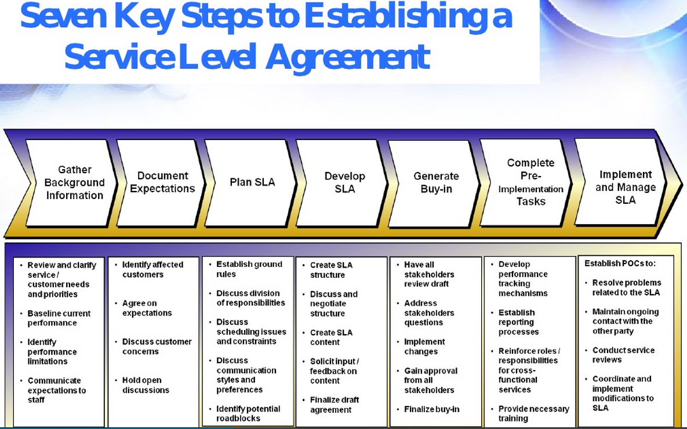

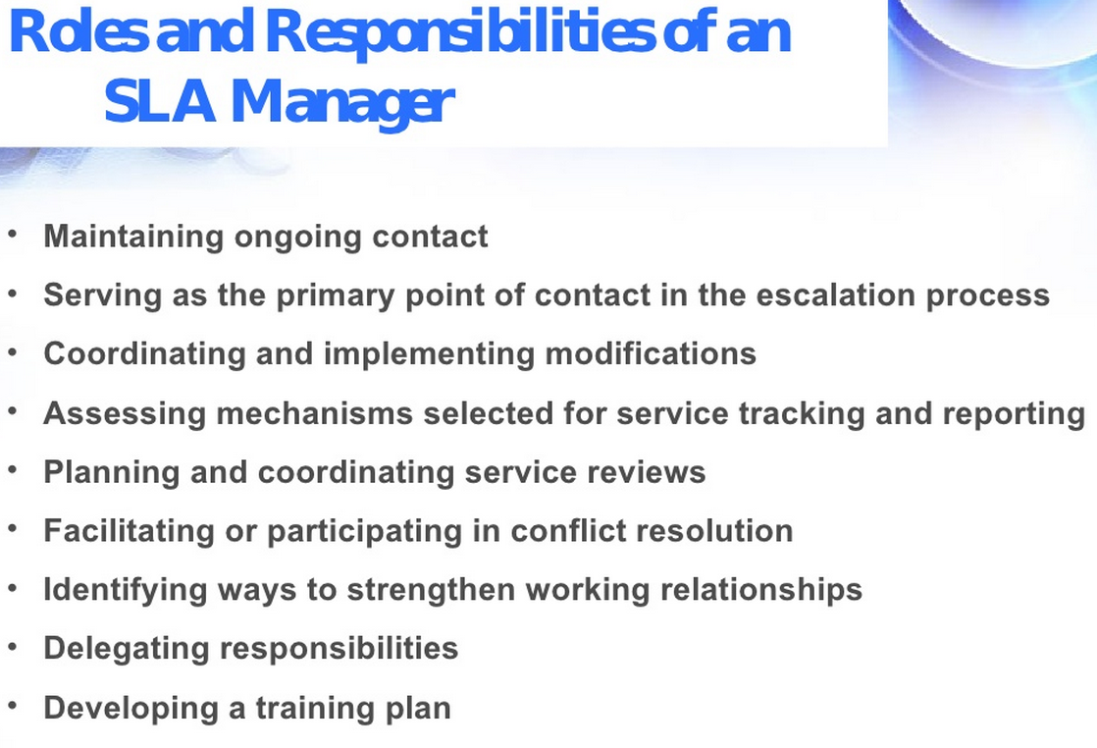

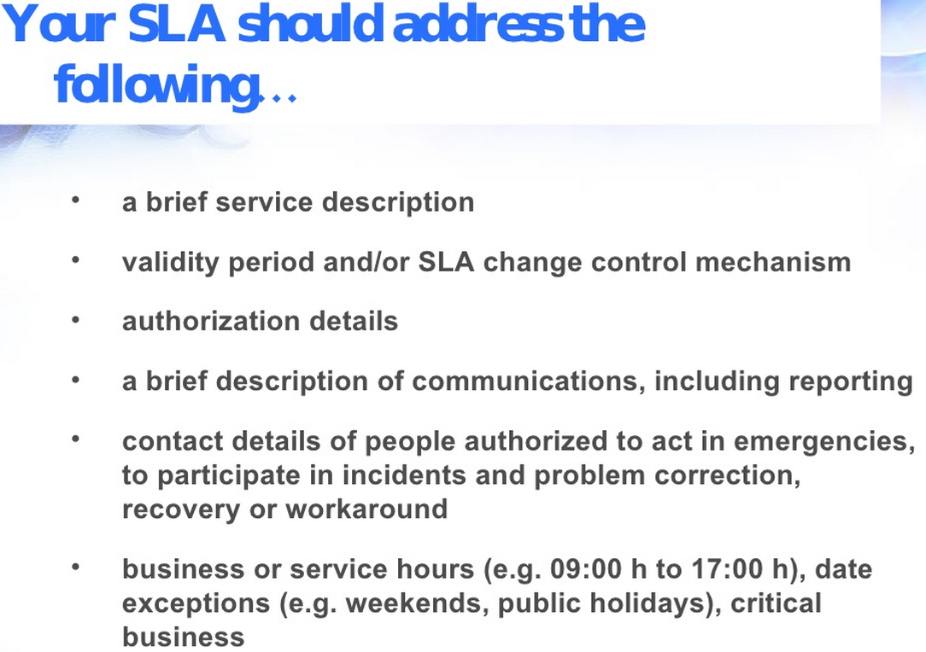

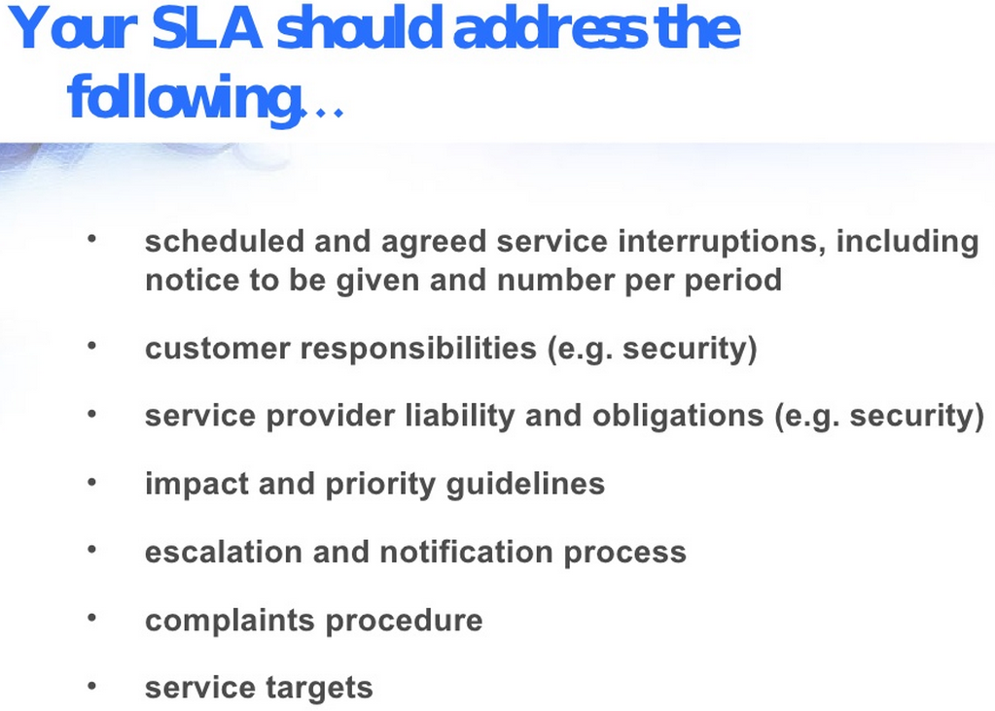

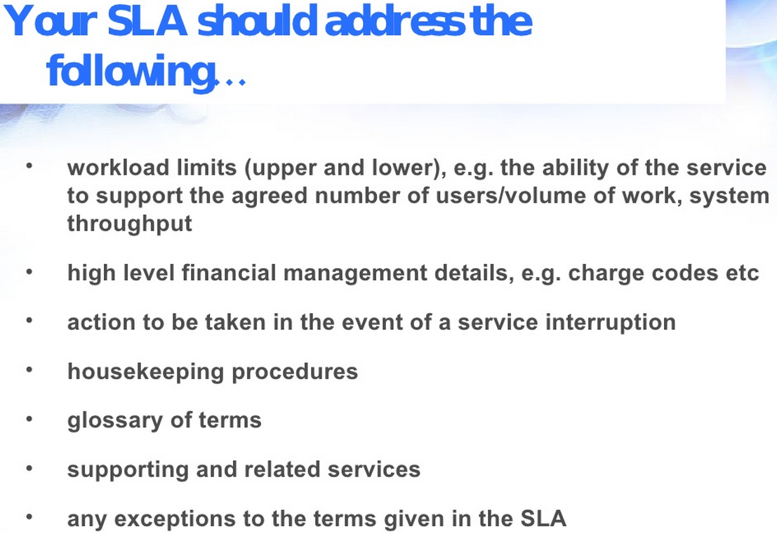

SLA is company/issue specific. Our class project’s outcome, is to produce an SLA for IT Cloud migration!

A Few Remarks on SLA:

* **Certainty**: How much do I want? How much am I willing to pay for it?
* **Un-Certainties**: e.g. Oil Price, the commodity, how do you handle it in an SLA? (Let this be a routine in your analysis, instead of apprehension…)
* What is the price for my trial-and-error run?
* …
* Dell just bought EMC, how long do you think to come up with the “Contract/SLA”? (I particularly interested on the escape clauses… what about you?)